Background Information Sheet
Name | Class | Date | Lesson Type | Length
Minsu Kim | 206 WD | 11/04/2020 | TBL | 25min

Lesson
Topic | How to solve the bridge riddle
Main Aim | Students will practice their speaking fluency.
Secondary Aim | Students will promote the positive sense of collaborative learning.
Materials and References
Materials  - worksheets  - whiteboard | - computer with sound (for videos)  - markers
References
https://www.ted.com/talks/alex_gendler_can_you_solve_the_bridge_riddle?language=en#t-204286
The Bridge Riddle (~1:56)

Student Profile
Level | Advanced
Age | Adults | Number of Students | 3
Detail | This is a general English speaking class, composed of highly motivated learners. The students are all Korean, and have confidence in expressing their ideas without any difficulties. They are accustomed to pair/group works.
Assumptions about students’ knowledge as required for this lesson:
- Ss are expected to have a certain amount of vocabulary to solve communicative tasks
- Ss enjoy solving riddles.

Anticipated Difficulties and their Solutions:
- Technical failure read the instructions with the teacher’s voice
- Lack of time for activities announce time is over and discuss solutions together as a whole
- Solve the riddle earlier than expected prepare extra riddle(s) to play with

My Personal Aim
What I hope most to demonstrate in this lesson is the ability to lead speaking class with the maximum amount of student talk time and the minimum amount of teacher talk time.

Stage Name: Pre Task
Purpose of this stage: Create interest in the topic. Brainstorm ideas which will be useful for the next stage. Students are given a communicative task. The aim is to relax students, activate their schemata, and gather useful ideas for the upcoming task(s).
Materials: whiteboard, markers, computer, video file, worksheet
Time | Interaction | Procedure
30 sec  30 sec  2 min  1 min 30 sec | T-S  T  S  T-S | Greeting & Brief Rapport  Hi guys, how have you been this week?  (If anyone says bad or not good, ask him/her why he/she feels that way)  Introduction of Task  (Write on the board ‘The Bridge Riddle’)  Today we are going to play riddles for fun. The first one is called The Bridge Riddle. I will give you background information on the riddle. Listen carefully.  Play the video for 2 minutes. Students watch the video of The Bridge Riddle and get a brief sense of what the riddle is about.  Let’s recall the information as much as you can. Call out the what you heard and I will write it down if correct. (Encourage all students to participate.)  Create a list of the clues on the board.  Conditions: The Bridge Riddle  - There are 4 people: you, janitor, lab assistant, old professor.  - You can dash across in a minute, while the lab assistant takes two minutes. The janitor is a bit slower and needs five minutes, and the professor takes a whole ten minutes.  - The zombies will catch up to you in just over 17 minutes  - The bridge can only hold two people at a time.  - It's so dark out that you can barely see, and the old lantern you grabbed on your way only illuminates a tiny area.

Stage Name: Task Preparation
Purpose of this stage: This is a student centered stage to give students time to prepare for the speaking task which they will perform in Task Realization. Clear detailed instructions are given once again in the written forms, so that every student knows what to do.
Materials: worksheet
Time | Interaction | Procedure
1 min  7 min  1 min | T  S-S  T  T  T-S | Instructions  Now it’s time to solve the riddle. Have a seat with your partner on each side of the classroom. Don’t worry. I will give you guys the worksheet with the full information written. Read as many times as you need, and discuss the possible solution with your partner. You have 5 minutes.  ICQs  - Do we work in a pair or a group? (In a pair)  - Do we have to recall the information from the video? (No)  - How much time do we have? (5 minutes)  Begin now.  Students start to solve the riddle together as a pair. Monitor from a distance.  Announce when there is 1-minute remaining.  If students are still discussing their ideas when time is finished, simply announce that preparation time is finished. Time’s up.  Students go back to their chairs.  Ask students if they figure out the answer. There’s an old saying, “two heads are better than one”. Then don’t you think four would be way better than two? This time let’s find the answer as a group. But keep in mind that every student takes turns in presenting the final answer on the board.  Students sit in a circle.

Stage Name: Task Realization
Purpose of this stage: This is a very student centered stage to maximize speaking fluency and promote collaborative learning. Monitor each student from a distance and take note of incorrect language. Students perform their task without any interruptions from the teacher.
Materials: whiteboard, markers, worksheet, computer, video file
Time | Interaction | Procedure
6 min  1 min  1 min | S-S  S  T-S | Students begin discussion to figure out the final answer, sharing what they have found out while working as a pair. Monitor from a distance noting how effectively each student communicate and what kind of mistake each of them make. Once the solution is found, students make sure every member knows the step-by-step answer so that they can present it in front of the class.  Students come in front of the class. Taking turns, each student shows a step to reach the final answer on the board. Monitor from a distance and make sure that everyone participates.  Students go back to their seats.  The teacher and Students check if the answer is right or wrong. Are you guys sure with the final answer? Then let’s check the answer with the video.

Stage Name: Post Task
Purpose of this stage: To end the lesson with a final student centered task such as voting, summarizing, discussing, deciding etc. The teacher may offer delayed error correction to the previous stage, as well as mention positives and points to improve for next time such as useful strategies.
Materials: worksheet
Time | Interaction | Procedure
30 sec  2 min  1 min | T  S-S  T-S | Now talk about what was the most interesting part and the hardest part from the activity that we’ve done today. And feel free to think about what you learned from the activity. You have 3 minutes.  Students discuss as a whole class while sitting on their seats.  Ask what students like the most interesting and feel the hardest. Empathize with them while listening carefully. Offer encouragement to keep engaging actively in class.  END
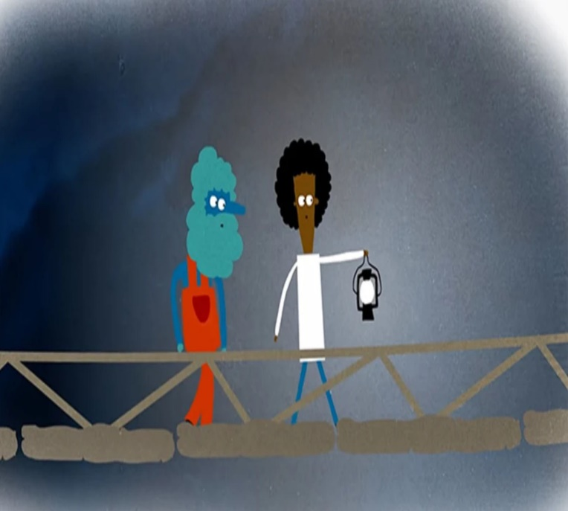
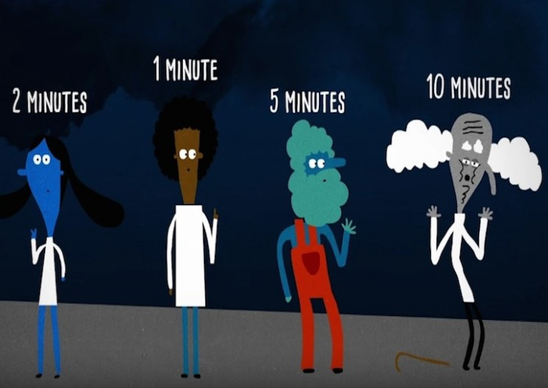
Worksheet

1. There's only one way to get away from the zombies: across an old rope bridge spanning a massive gorge.
2. With you are the janitor, the lab assistant, and the old professor.
3. You can dash across in a minute, while the lab assistant takes two minutes. The janitor is a bit slower and needs five minutes, and the professor takes a whole ten minutes.
4. The zombies will catch up to you in just over 17 minutes, so you only have that much time to get everyone across and cut the ropes.
5. Unfortunately, the bridge can only hold two people at a time.
6. To make matters worse, it's so dark out that you can barely see, and the old lantern you grabbed on your way only illuminates a tiny area.

Transcript: The Bridge Riddle
(Time: 1 min 43 seconds)
Taking that internship in a remote mountain lab might not have been the best idea. Pulling that lever with the skull symbol just to see what it did probably wasn't so smart, either, but now is not the time for regrets because you need to get away from these mutant zombies fast. With you are the janitor, the lab assistant, and the old professor. You've gotten a headstart, but there's only one way to safety: across an old rope bridge spanning a massive gorge. You can dash across in a minute, while the lab assistant takes two minutes. The janitor is a bit slower and needs five minutes, and the professor takes a whole ten minutes, holding onto the ropes every step of the way. By the professor's calculations, the zombies will catch up to you in just over 17 minutes, so you only have that much time to get everyone across and cut the ropes. Unfortunately, the bridge can only hold two people at a time. To make matters worse, it's so dark out that you can barely see, and the old lantern you grabbed on your way only illuminates a tiny area. Can you figure out a way to have everyone escape in time? Remember: no more than two people can cross the bridge together, anyone crossing must either hold the lantern or stay right next to it, and any of you can safely wait in the dark on either side of the gorge. Most importantly, everyone must be safely across before the zombies arrive. Otherwise, the first zombie could step on the bridge while people are still on it. Finally, there are no tricks to use here. You can't swing across, use the bridge as a raft, or befriend the zombies.

Extra Worksheet
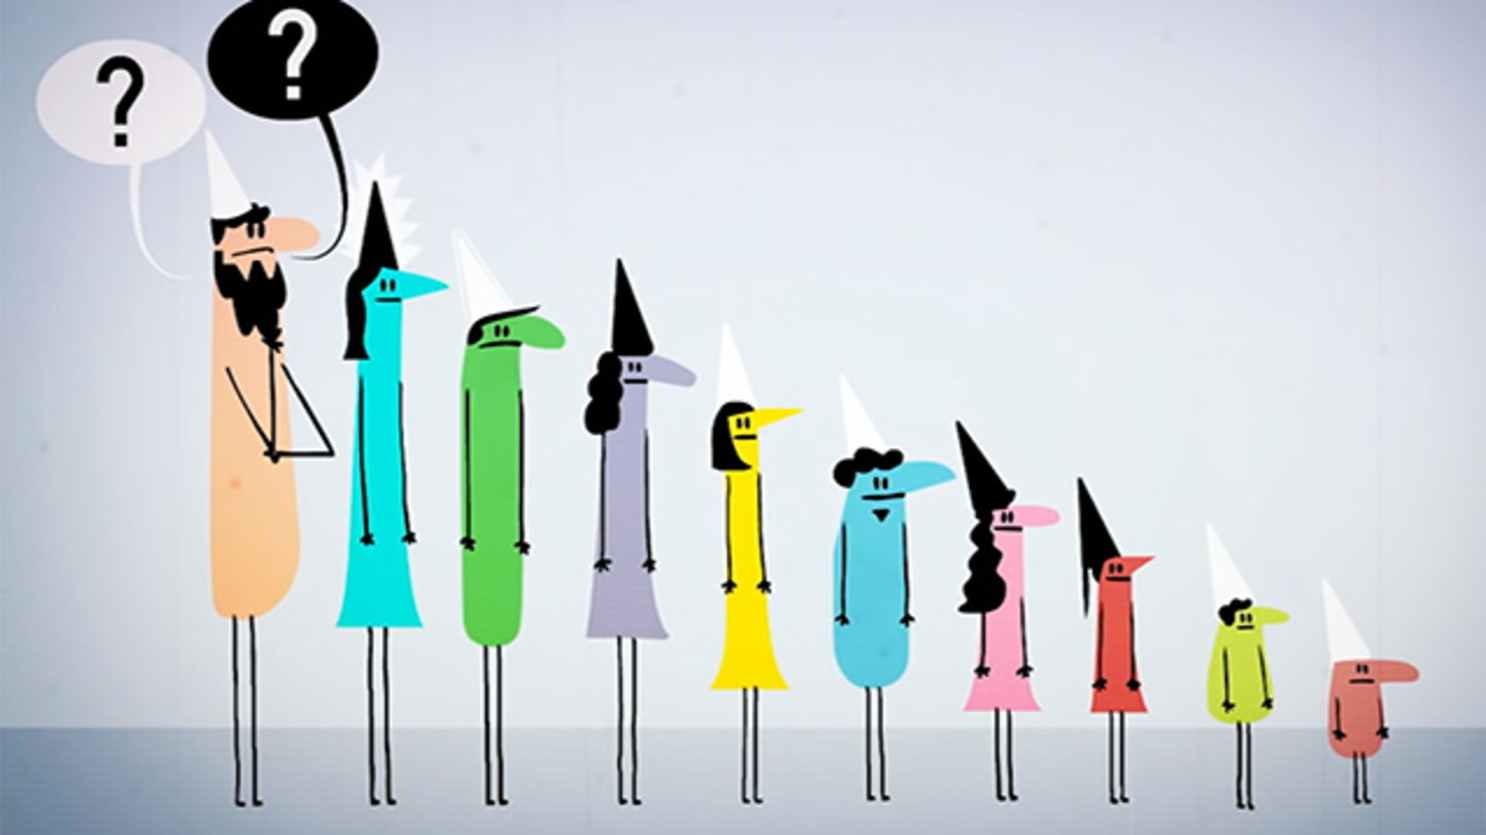
You will be placed in a single-file line facing forward in size order so that each of you can see everyone lined up ahead of you. You will not be able to look behind you or step out of line. Each of you will have either a black or a white hat on your head assigned randomly, and I won't tell you how many of each color there are. When I say to begin, each of you must guess the color of your hat starting with the person in the back and moving up the line. And don't even try saying words other than black or white or signaling some other way, like intonation or volume; you'll all be eaten immediately. If at least nine of you guess correctly, you'll all be spared. You have five minutes to discuss and come up with a plan, and then I'll line you up, assign your hats, and we'll begin.

Instructor’s Comments and Assessment
Pros
Cons
Change
Overall Comments
Grade
Above Standard 85%-100% | Standard 70%-84% | Below Standard 69%-0%
Instructor | Student Signature | Date
Taute, David

