Background Information Sheet
Name | Class | Date | Lesson Type | Plan type | Length
Jinny Kwon | 206 WK | 18/04/20 | Grammar | PPP | 25min

Lesson
Topic | Superlative Award
Main Aim | Students will learn the Superlative.
Secondary Aim | Students will practice their speaking fluency.

Materials and References
Picture#1-2,Board, marker; worksheet, paper

Student Profile
Level |  | Lower Intermediate
Age |  | Adults |  | Number of Students | 3
Detail |  | This is a general English class. Students are visual learner and one of students love basketball.
Assumptions about students’ knowledge as required for this lesson:
- Students know the vocabulary used in this lesson
- Students have learned about the subject and ‘be’ verb relationship
- Students know the opposite adjectives. (tall-short, old-young, etc.)
- Students have learned about the comparatives.
- Students know how to make WH-questions.
What language difficulties to expect when presenting, and how to deal with it:
- Meaning: “Brian is the tallest player.” Make a clear visual context and C.C.Q.
- Show the picture of basketball players and ask who are they? (They are basketball players.)
- What’s the word that we can describe them? They are____. (mouthing & Body language: tall) Tall!
- Is Brian tall? (Yes) Is Dan as tall as Brian? (No.) Is Brian taller than Brown? (Yes) Then how can we describe him in one sentence? (Brian is the tallest player.)
- Form: Students may confuse with the rules of superlative such as when they need to add -est or add the most before adjectives to make superlatives. Give them a few examples.
1 syllable: tall → the tallest two more syllables: handsome → the most handsome
2 syllables end in -y: funny → the funniest.
- Pronunciation: Students may not know where to put natural sentence stress. Drill several times chorally, then individually. Ask, “Which words sound stressed?” Board the stress markers in red.
Anticipated Classroom Management Difficulties and their Solutions:
The quantity of new language points to be learned about the superlatives is too much for students to handle in a short 25 minutes lesson. This could lead to anxiety, rushing, and a lot of teacher talk. For this lesson I will manage this by selectively presenting only a few rules about the superlatives. The remaining new language points can be presented in the next lesson.
My Personal Aim
What I hope most to demonstrate in this lesson is the ability to
- present the target language using a situational presentation
- to be an involver type teacher
Stage Name: Lead-in
Purpose of this stage: To relax both the teacher and students. To focus attention on the lesson. Create a situation for students to experience or think about, and then to elicit the target language.
Materials: Picture#1, magnet
Timings | Interactions |  | Procedure
1:30 | T-S |  | Draw, mime, show a picture etc. to create a clear and understandable situation related to your target language. Try elicit the model sentence (a sentence that contains the target language) by referring to the situation.  Hello everybody!  - Show picture#1 and ask who are they? (They are basketball players.)  - What’s the word that we can describe them? They are____. (mouthing: tall) Tall!  - Is Brian tall? (Yes) Is Dan as tall as Brian? (No.) Is Brian taller than Brown? (Yes) Then how can we describe him in one sentence? (Brian is the tallest player.)
Stage Name: Presentation
Purpose of this stage: Make the students think about the situation. To clarify the meaning, form, and pronunciation features of the target language.
Materials: picture#1, magnet, board, marker
Timings | Interactions |  | Procedure
10sec  1min  4min  3min | T  T-S  T-S  T-S |  | Board the model sentence (if students are unable to tell you, just board it).  Brian is the tallest player.  CCQ – ask questions, and use time lines or scales where appropriate.  - Involves student, making them think about the situational context.  - Don’t rush, and don’t answer your own ccqs.  - Use the context to help students realize the correct answer.  Did we compare? (Yes.)  Did we compare one to one? (No.)  Did we compare one thing in a group? (Yes.)  Does it say that the thing has the most of a quality? (Yes.)  Form – clarify the affirmative, negative, question form, or other special features. Substitution tables may be of use.  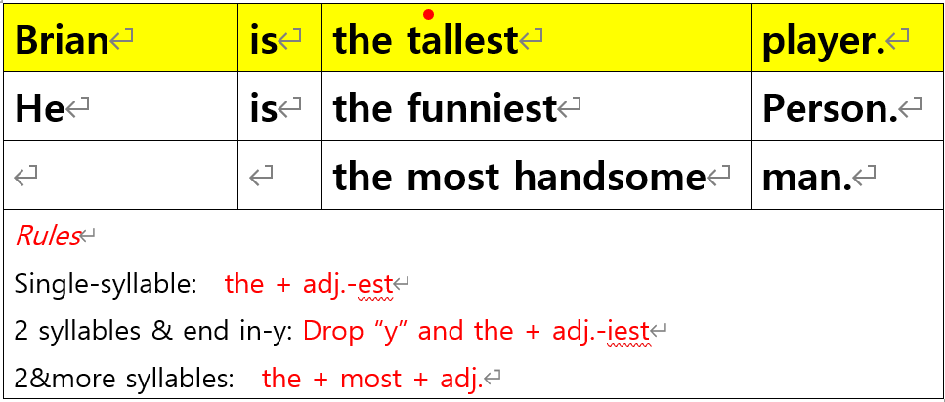  Rule #1  What is difference between tall and this(tallest)? (Ss might find the difference and say add -est.)  Yes. Adj+-est.  Where is “the”? Is it before this or after this? (Ss might say before tallest)  Rule#2  I want to make a sentence with funny. Can you help me to make? (wait until Ss answer)  Write on the board Brian is the funnyest person.  Is it right? Students might notice the error if they know the error ask can you help me to correct? If they don’t know just correct them as the funniest.  Funny, How many syllables? (2) 2syllables end in y, we drop y and add -iest.  Rule #3  Can we say Brian is the handsomest? (Ss might say No)  Handsome, how many syllables? (2)  If adjective is more than 2 syllables what do we do?  We add most. Where we can put it? (Ss might say after “the” or before “handsome”.)  Write on the board. Most handsome  Can we remove “the”? (No.) Why? Ask students. If they don’t know explain. This is because there's only one (or one group) of the thing we are talking about.  Drill – drill the spoken form, focusing on contractions, stress and intonation.  - Say and gesture “Listen and repeat: [Brian is the tallest player.]”  -Choral drilling & Drill individually.  Ask them “Which words sound stressed?”  - Make special pronunciation features visible on the board, using color.  - Kevin: Make a sentence with negative form.  Julie: Make a sentence with adjective “Intelligent”.  Min: Make a question with WHO.  If student’s pronunciation doesn’t sound natural, drill once again.  “Can you say more faster/more natural?”
Stage Name: Controlled Practice
Purpose of this stage: students practice working with the form (scrambled sentences, split sentences, select the correct form of the verb, correct incorrect sentences, and change one form into another form). Accuracy must be checked.
Materials: worksheet, pen; board, marker
Timings | Interactions |  | Procedure
30sec  2min  30sec  1min | T  S  S – S  T - S |  | Instructions.  You will work with exercise1. Complete the sentence using the superlative form.  It will be individual work and you have 2mins.  ICQ.  Do you work alone? (Yes.)  Hand out.  Students do a worksheet. (Worksheets should be properly designed. See examples in a course book. Also, don’t do too many questions; 5 is probably enough. Please vary the questions so students work with the complete form.)  -Monitor students.  Pair check.  Feedback to check accuracy. Board correct answers visually.  “What is the answer?” or “Answer no.1 point with gesture”  - If the answer is not correct, nominate other students to share it.  1 question is tricky. Good is irregular. So, the superlative will be “the best”. Good → the best
Stage Name: Less Controlled Practice
Purpose of this stage: students practice working with the meaning (match a timelines to sentences, choose the sentence that matches a picture, gap-fill a paragraph). Accuracy must be checked.
Materials: worksheet, pen
Timings | Interactions |  | Procedure
30sec  2min  30sec  1min | T  S  S – S  T - S |  | Instructions.  Now turn over your paper. We are going to work on with exercise 2. Look at the monsters and their things. Make 5 sentences using superlative form. It will be individual work.  How many sentences do you make? (5)  Students do a worksheet. (Worksheets should be properly designed. See examples in a course book. Also, don’t do too many questions; 5 is probably enough. Please vary the questions so students work with the complete form.)  Pair check.  Now you can check together.  Feedback to check accuracy.  (Ss’ name) Can I have your sentence? Point with gesture the next students to answer.
Stage Name: Production – Freer Practice
Purpose of this stage: is to get students to practice the grammar communicatively.
Materials: picture#2, Board, marker
Timings | Interactions |  | Procedure
1min  5 min | T  S-S |  | Instructions.  Show picture#2. What is it? (award, certificate)  It’s time for class award. You are gonna give your classmates an Award using superlative. For example, I will give you an award to Kevin. Kevin has the neatest handwriting in our class. And tell the reason why I give this award to him. Each of you will give an award to your partners. For example, Min will give an award to Julie and Kevin.  Any interesting findings can be discussed more in detail. You have 5mins to talk and no writing.  I.C.Q  Do you need to write down? (No.)  Students do a productive task which requires natural communication. For example, if the grammar taught in this lesson was about the present simple to talk about general truths or facts, then getting students to talk about general truths and facts would be suitable. E.g. Talk to your partner about the weather in your country. [It rains in summer, and it’s hot. Winter is cold….etc.]  Teacher monitor.  - Error  - Time
findStage Name: Wrap-up
Purpose of this stage: is to end the lesson on a positive note so that students feel they have achieved progress.
Materials: Board, pen
Timings | Interactions |  | Procedure
1 min  10 sec  10 sec | T – S  T  T |  | Offer delayed corrections to the previous stage.  - “Look at the board. Here are some sentences I heard. Tell me how to correct them.”  - Don’t mention the name!  Set homework.  For homework you will make 5 sentences about animals using the superlative forms.  Inform students about the topic for the next lesson.  Next lesson we will talk about more rules about the superlative.  Now you can pack your things and go home.  Class dismissed.
Instructor’s Comments and Assessment
Pros
Cons
Change
Overall Comments
Grade
Above Standard 85%-100% | Standard 70%-84% | Below Standard 69%-0%
Instructor | Student Signature | Date
Taute, David

[Picture#1]
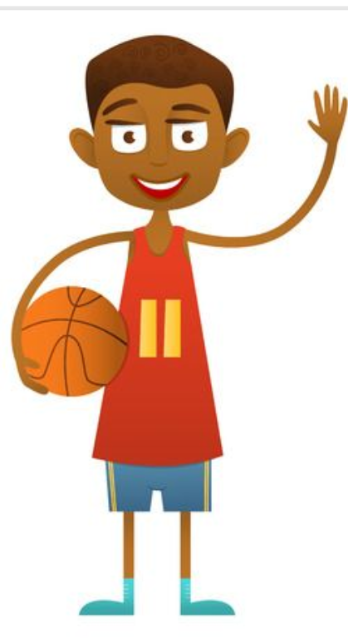
Brian Brown Dan

WORKSHEET - Superlative

Exercise 1.
Complete the sentence using the superlative form.
Brian | is | the tallest | player.
He | is | the funniest | person.
 |  | the most handsome | man.
Rules
1 syllable: the + adj.-est
2 syllables & end in-y: Drop “y” and the + adj.-iest
2&more syllables: the + most + adj.

- My brother is the tallest person in my family. (tall)
- Who is ________________person in your class? (young)
- Math is ________________subject. (difficult)
- She is ________________girl I’ve ever met. (funny)
- He is not ________________soccer player. (good)
- Who has ______________ hair? (long)

Exercise 2.
►Look at the monsters and their things. Write 5 sentences using the superlative form.
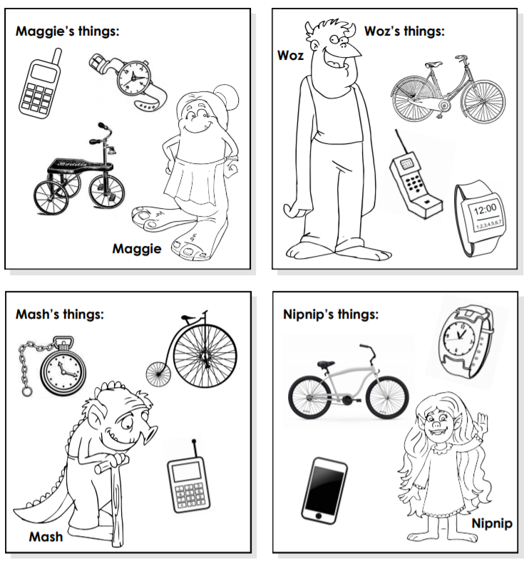
Ex) Woz is the tallest.
1.
2.
3.
4.
5.

WORKSHEET (W/ANSWER)

Exercise 1.
Complete the sentence using the superlative form.
Brian | is | the tallest | player.
He | is | the funniest | person.
 |  | the most handsome | man.
Rules
1 syllable: the + adj.-est
2 syllables & end in-y: Drop “y” and the + adj.-iest
2&more syllables: the + most + adj.

- My brother is the tallest person in my family. (tall)
- Who is the youngest person in your class? (young)
- Math is the most difficult subject. (difficult)
- She is the funniest girl I’ve ever met. (funny)
- He is not the best soccer player. (good)
- Who has the longest hair? (long)

Exercise 2.
►Look at the monsters and their things. Write 5 sentences using the superlative form.
Ex) Woz is the tallest.
1. Nipnip has the most expensive cellphone.
2. Mash is the oldest.
3. Maggie has the biggest foot.
4. Woz has the heaviest phone.
5. Nipnip has the newest bicycle.

