Background Information Sheet
Name | Class | Date | Lesson Type | Plan type | Length
Minsu Kim | 206 WK | 18/04/20 | Grammar | PPP | 25 min

Lesson
Topic | Campus Life in University
Main Aim | Students will learn to use the present progressive for events happening in the extended present.
Secondary Aim | Students will practice their speaking fluency.

Materials and References
Unit 15. Present Progressive: Affirmative and Negative Statements <PEOPLE WATCHING>
Unit 17. Simple Present and Present Progressive; Non-Action Verbs <SMARTPHONES>

Student Profile
Level |  | Lower Intermediate
Age |  | 18 – 19 years old |  | Number of Students | 3
Detail |  | This is an EFL English grammar class, composed of highly motivated learners. The students are all Korean, majoring in linguistics, and have confidence in expressing their ideas. They are familiar with the grammatical terms used due to grammar-centered lesson, having done by Korean teachers, but do not know tense and aspect exactly due to the differences between L1 and L2.
Assumptions about students’ knowledge as required for this lesson:
- Students know the vocabulary used in this lesson
- Students have learned how to express their past habits with ‘used to’ construction
- Students have learned about various uses of the present tense
What language difficulties to expect when presenting, and how to deal with it:
- Meaning: “He is taking a karate class (these days).” Students may think it is talking about a situation happening at the moment when it is uttered because of the phrase ‘I am taking’. Make a clear context and compare with that of present continuous.

- Form: Students may confuse how to negate the present continuous form e.g. ‘I’m taking a karate class (these days).’
Identify two negative sentences with the present tense and present continuous. Highlight the differences between the two different structures.
E.g. ‘He is not taking a karate class,’ ‘He doesn’t take a karate class.’

- Pronunciation: Students may not know where to put natural sentence stress. Drill several times chorally, then individually. Ask, “Which words sound stressed?” Board the stress markers in red.

Anticipated Classroom Management Difficulties and their Solutions:
There is a possibility that students are not able to get a clear sense of the present continuous form for the events happening around now even after the presentation stage, which could lead to successive failures in later stages. I will manage this by presenting new sentences applied to each student’s hobby or job.
My Personal Aim
- To minimize unnecessary Teacher Talking Time (TTT)
- To be an enabler type teacher
Stage Name: Lead-in
Purpose of this stage: To relax both the teacher and students. To focus attention on the lesson. Create a situation for students to experience or think about, and then to elicit the target language.
Materials: whiteboard, markers
Timings | Interactions |  | Procedure
2 min | T-S |  | Show PICTURE 1 on the screen to create a clear and understandable situation related to the present progressive. Try to elicit the model sentence from students.
Stage Name: Presentation
Purpose of this stage: Make the students think about the situation. To clarify the meaning, form, and pronunciation features of the present progressive for the events happening around now.
Materials: PPT, whiteboard, markers
Timings | Interactions |  | Procedure
10 sec  2 min  2 min  1 min | T  T-S  T-S  T-S |  | Board the model sentence (if students are unable to tell you, just board it).  CCQs – ask questions, with PICTURE 1 on the screen.  - Is he taking a karate class right now? (No.)  - Did he take a karate class before? (Yes.)  - Is he likely to take a karate class in the future? (Yes.)  Form – clarify the affirmative, negative, interrogative form on the board.  - Affirmative: “He is taking a karate class (these days).”  - Negative: “He is not taking a karate class (these days).”  - Interrogative: “Is he taking a karate class (these days)?”  Drill – drill the spoken form, focusing on contractions, stress, and intonation.  - Say and gesture “Listen and repeat: He is taking a karate class (these days).”  - Practice with energy and enthusiasm  - Present sentence stress visible on the board, using colors
Stage Name: Controlled Practice
Purpose of this stage: students practice working with the form (scrambled sentences, split sentences, select the correct form of the verb, correct incorrect sentences, and change one form into another form). Accuracy must be checked.
Materials: worksheet, whiteboard, markers
Timings | Interactions |  | Procedure
45 sec  3 min  30 sec  1 min | T  S  S-S  T-S |  | Before distributing the handouts, teacher explain students what to do in detail.  ICQs – ask questions to check whether students clearly understand the instructions  - Are we doing Exercise A or B? (Exercise A.)  - Are we working alone or as a group? (Alone.)  - How much time do we have? (3 minutes.)  Worksheet distributed.  Students do the worksheet.  Pair check.  Feedback to check accuracy. Board correct answers visually.
Stage Name: Less Controlled Practice
Purpose of this stage: students practice working with the meaning (match a timelines to sentences, choose the sentence that matches a picture, gap-fill a paragraph). Accuracy must be checked.
Materials: worksheet, whiteboard, markers
Timings | Interactions |  | Procedure
45 sec  3 min  30 sec  1 min | T  S  S-S  T-S |  | Instruction is give before distributing the handouts. Teacher explains students what to do in detail.  ICQs – ask questions to check whether students clearly understand the instructions  - Are we doing Exercise A or B? (Exercise B.)  - Are we working alone or as a group? (As a group.)  - How much time do we have? (3 minutes.)  Students do worksheets gathering together.  Pair check.  Feedback to check accuracy. Board correct answers visually.
Stage Name: Production – Freer Practice
Purpose of this stage: is to get students to practice the grammar communicatively.
Materials:
Timings | Interactions |  | Procedure
30 sec  5 min | T  S-S |  | Instruction is given. Students are asked to talk about courses they are taking this semester, and choose one that he/she like the most and the one he/like the least with reasons.  Students have discussion in a group.
Stage Name: Wrap-up
Purpose of this stage: is to end the lesson on a positive note so that students feel they have achieved progress.
Materials: whiteboard, markers
Timings | Interactions |  | Procedure
1 min  10 sec  5 sec | T – S  T  T |  | Offer delayed corrections to the previous stage.  - “Look at the board. Here are some sentences I heard. Tell me how to correct them.”  - Write ungrammatical sentence(s) on the board and correct them together.  Assign homework.  Inform students about the topic for the next lesson.

<Picture 1>
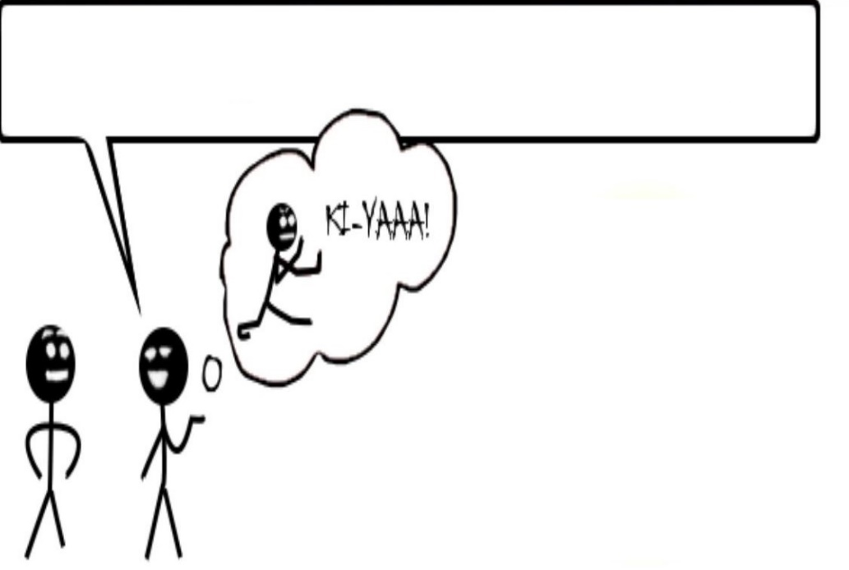

<Handout: Present Progressive>
Present Progressive: For Extended Periods of Time
Use the present progressive for actions that are happening at this time, but may not be happening at this moment.
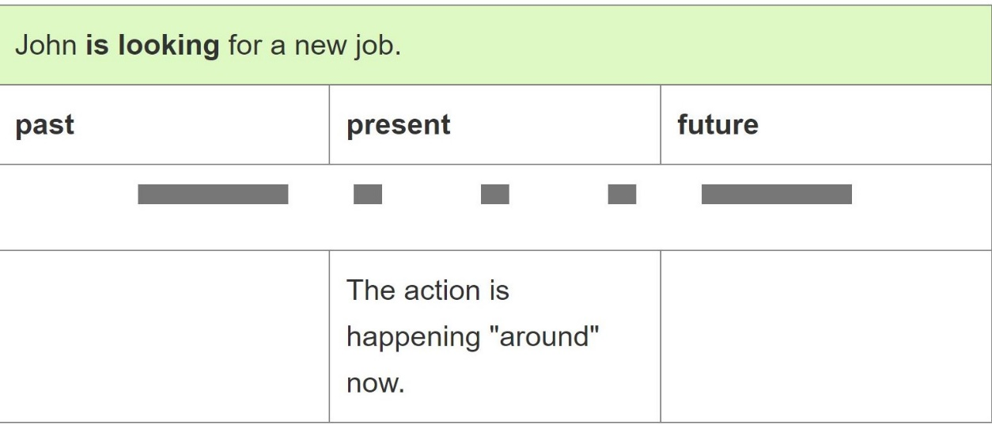
With this use of the present progressive, we often use these time expressions:
- nowadays
- these days
- this year
Subject | Be | Base Form of  Verb + -ing
I | am | studying linguistics.
You | are
We
They
He | is
She
It
Subject | Be | Not | Base Form of  Verb + -ing
I | am | not | studying English.
You | are
We
They
He | is
She
It
Affirmative Sentences Negative Sentences

Interrogative Sentences
Make a question form by switching the subject and ‘be’ verb
e.g. John is looking for a new job these days. (statement)
Is he (John) looking for a new job these days? (question)
<Worksheet: Present Progressive>
Exercise A
Change the sentence to the new forms. Write your answers neatly.
- Affirmative: She is taking five courses this semester.
Negative: _______________________________________________________________________.
Interrogative: ___________________________________________________________________?

- Affirmative: _____________________________________________________________________.
Negative: They are not working at Dr. Lee’s lab this year.
Interrogative: ___________________________________________________________________?

- Affirmative: _____________________________________________________________________.
Negative: _______________________________________________________________________.
Interrogative: Are you looking for a husband?

- Affirmative: We are preparing for an upcoming event.
Negative: _______________________________________________________________________.
Interrogative: ___________________________________________________________________?

- Affirmative: _____________________________________________________________________.
Negative: He isn’t reading a mystery novel these days.
Interrogative: ___________________________________________________________________?
Exercise B
Work as a group. Complete the conversation by making inference from the given picture. Use the simple present or present progressive forms of the verbs in parenthesis. Use contractions when possible.

JEN: I’m worried about Tim. He _______________ (not / do) well in school. He was always a good student, but this term he ________________ (play) games or ____________ (text) friends all the time.

RAY: What ______________ (want) Tim ______________?

JEN: I _________________________(not/know). He _________________________ (play) some new games these days. He ___________________ (love) those computer games so much.

RAY: My son used to be like that. But he __________________ (study) really hard this semester. Your son will be getting better soon.

<Answer sheet>
Exercise A
Change the sentence to the new forms. Write your answers neatly.
- Affirmative: She is taking five courses this semester.
Negative: She isn’t taking five courses this semester.
Interrogative: Is she taking five courses this semester?

- Affirmative: They are working at Dr. Lee’s lab this year.
Negative: They are not working at Dr. Lee’s lab this year.
Interrogative: Are they working at Dr. Lee’s lab this year?

- Affirmative: I am looking for a husband.
Negative: I am not looking for a husband.
Interrogative: Are you looking for a husband?

- Affirmative: We are preparing for an upcoming event.
Negative: We are not preparing for an upcoming event.
Interrogative: Are we preparing for an upcoming event?

- Affirmative: He is reading a mystery novel these days.
Negative: He isn’t reading a mystery novel these days.
Interrogative: Is he reading a mystery novel these days?
Exercise B
Work as a group. Complete the conversation by making inference from the given picture. Use the simple present or present progressive forms of the verbs in parenthesis. Use contractions when possible.

JEN: I’m worried about Tim. He isn’t doing well in school. He was always a good student, but this term he is playing games or texting friends all the time.

RAY: What does Tim want?

JEN: I don’t know. He is playing some new games these days. He loves those computer games so much.

RAY: My son used to be like that. But he is studying really hard this semester. Your son will be getting better soon.

Pros
Cons
Change
Overall Comments
Grade
Above Standard 85%-100% | Standard 70%-84% | Below Standard 69%-0%
Instructor | Student Signature | Date
Taute, David
Instructor’s Comments and Assessment

