Background Information Sheet
Name | Class | Date | Lesson Type | Plan type | Length
Minsu Kim | 206 WK | 25/04/20 | Reading | PPP | 25 min

Lesson
Topic | Work-Life Balance
Main Aim | Students practice their reading comprehension and useful skills.
Secondary Aim | Students practice their speaking fluency.

Materials and References
Picture 1 ~ 4; Reading material; worksheet; whiteboard; markers; PC and audio
http://learnenglish.britishcouncil.org/skills/reading/upper-intermediate-b2/work-life-balance

Student Profile
Level | Advanced
Age | Adults | Number of Students | 3
Detail | This is an EFL English reading class, composed of highly motivated learners. The students are all Korean adults and have no difficulty understanding materials of any level, due to 10+ years of English education. Each of them has worked more than 3 years after graduating from university..

Assumptions about students’ knowledge as required for this lesson:
- Students knew how to scan and skim based on given questions
- Students have learned how conditional sentences look like and the meaning of them
- Students have been commuting for 3 years and started to work home due to personal circumstances

Anticipated Difficulties and their Solutions:
- The monitor couldn’t work prepare a hardcopy of the pictures which will be used during the lesson
- Nervousness at the start of the lesson check the equipment is working; to start the lesson, sit down and follow the planned teacher talk
- Students may not know some words that I don’t teach give them synonyms of the words and show them how it is used with a clear example(s).

My Personal Aim
- to design a level-appropriate reading lesson plan that consists of student-centered activities
- to give a clear instruction for each activity
- to lead a class without any mistake, minimizing unplanned teacher talk

Stage Name: Lead-in
Purpose of this stage: To relax both the teacher and students. To focus attention on the lesson. To lead in to the topic, activating background knowledge – this will help to contextualize the text.
Materials: PC, Picture 1, Picture 2
Timing | Interaction | Procedure
30 sec  1 min  1 min  10 sec | T  S-S  T-S  T | Greet and introduce the topic. (Show Picture 1 and Picture 2 on the screen)  “Hi guys, look at these two pictures and discuss about each of them as a group. You have 1 minute to talk.” (Give a gesture for students to start discussion)  Students have a discussion as a group. (Monitor from a distance)  Nominate each student and ask for the opinions.  “Can you tell me about what those pictures are about?”  Give positive feedback if necessary

Stage Name: Presentation
Purpose of this stage: To pre-teach keywords if necessary, and answer a guiding questions (such as a predicting task, or a specific question). These steps provide extra help for students to comprehend the text.
Materials: PC, Board, Markers, Picture 3, Picture 4, Picture 5
Timing | Interaction | Procedure
2.5 min  10 sec  1 min | T-S  T  S-S | Pre-teach keywords: pro-rata, bounce off, concession  1) pro-rata  Elicit - (show picture 3 on the screen)  “What do you see?” “Think about the relationship between the two variables X and Y.”  CCQs – “Are the variables (X and Y) totally unrelated?” (No)  “Are these related then?” (Yes)  “Is Y increasing in proportion to X?” (Yes)  Drills – “Listen and repeat three times together.” (Gesture)  Nominate all the students individually. (Gesture)  Board - Write pro-rata on the board.  “How many syllables?” (3) Mark with a color pen.  “Where is the stress?” (2nd) Mark with another color pen.  “What Part of Speech?” (Adjective) Mark with a black pen.  2) concession  Elicit – (show picture 4 on the screen)  “What do you see from this picture?” “What do you think the man is doing?”  CCQs – “Is it something that you give to someone?” (Yes)  “Is it something that you give to someone as a right?” (Yes)  “Is it because you want to end or continue an argument?” (to end an argument)  Drills – “Listen and repeat three times together.” (Gesture)  Nominate all the students individually. (Gesture)  Board - Write concession on the board.  “How many syllables?” (3) Mark with a color pen.  “Where is the stress?” (2nd) Mark with another color pen.  “What Part of Speech?” (Noun) Mark with a black pen.  3) (to) bounce off  Elicit – (show Picture 5 on the screen)  “What do you see from this picture?” “What do you think SHE is doing?”  CCQs - “Is she talking to someone else?” (Yes)  “Is she sharing her ideas with no purpose?” (No)  “Then Is she sharing her ideas to get some feedback?” (Yes)  Drills – “Listen and repeat three times together.” (Gesture)  Nominate all the students individually. (Gesture)  Board – Write bounce off on the board.  “How many syllables?” (2) Mark with a color pen.  “Where is the stress?” (1st) Mark with another color pen.  “What Part of Speech?” ((Phrasal) verb) Mark with a black pen.  Guiding Question  “What are some advantages and disadvantages of working from home? Discuss with your partners. You guys have 1 minute.”  Students discuss the question with partners. Monitor from a distance.

Stage Name: Practice – Literal Comprehension
Purpose of this stage: is to get students to practice reading for literal detail. They will also practice fast reading (skimming and scanning)
Materials: Board, Markers, Reading material, Worksheet
Timing | Interaction | Procedure
30 sec  2 min  1 min  (1 min) | T  S  S-S  T-S | Give instructions for Activity A.  (Hold up the worksheet) “Now you are going read 4 stories who have a trouble working home or in the office. Read the questions given in PART A first, and write down the correct answers on your worksheet. Do not share your answers with partners.”  ICQ – “Do you have to work on Activity A or B?” (Activity A)  “Do you need to write an answer on the worksheet?” (Yes)  “Do you work individually or as a group?” (Individually)  “Good. Let’s move on” (Handout Distributed)  Students scan and skim the text for the 1st time, and write answers on the worksheet.  “Time’s up. Let’s check the answers with your partners. You guys have 1 minute.”  Pair check. Monitor from a distance.  Feedback to check accuracy. (if necessary)  “What is the answer for question number 1?” (students answer)  ... (do the same for the rest)

Stage Name: Practice – Interpretive Comprehension
Purpose of this stage: is to get students to get students to practice interpreting a text correctly This will require more detailed, careful reading, and thinking time to arrive at the correct answer.
Materials: Board, Markers, Reading material, Worksheet
Timing | Interaction | Procedure
30 sec  2 min  1 min  1 min | T  S  S-S  T-S | Give Instructions for Activity B.  (Hold up the worksheet) “This time, read the questions given in PART B, and write down the correct answers on your worksheet. You can discuss the answers with your partners and write it down when all of you agree on the answers.”  ICQs – “Do you have to work on Activity A or B?” (Activity B)  “Do you need to write an answer on the worksheet?” (Yes)  “Do you work individually or as a group?” (As a group)  “Good. Let’s move on”  Students scan and skim the text, and write answers on the worksheet.  “Time’s up. Let’s check the answers with your partners. You guys have 1 minute.”  Pair check. Monitor from a distance.  Feedback to check accuracy. (if necessary)

Stage Name: Production - Applied Comprehension
Purpose of this stage: is for students to practice their speaking fluency on a topic related to the lesson.
Materials: Board, Markers, Reading material, Worksheet
Timing | Interaction | Procedure
30 sec  6 min  1.5 min | T  S-S  T-S | Give instructions for Activity C.  “This time Let’s talk about your own work life balance. Discuss about what is good and what is bad. And think about some changes that you wish to make for the better work life balance. You guys have 6 minutes to talk”  ICQs – “Do you have to work on Activity A, B, or C?” (Activity C)  “Do you need to write anything on the worksheet?” (No)  “Do you work individually or as a group?” (As a group)  “Good. Let’s move on”  Students discuss. Monitor from a distance while taking notes of student errors  “Time’s up. Let’s check the answers together.”  Teacher nominate each student and ask his/her ideas and give them feedback

Stage Name: Wrap-up
Purpose of this stage: is to end the lesson on a positive note so that students feel they have achieved progress.
Materials: Board, Markers
Timing | Interaction | Procedure
1 min  10 sec | T  T | Offer delayed feedback to the previous stages  Assign homework and tell them briefly about the next lesson

Picture 1
Picture 2
Picture 3
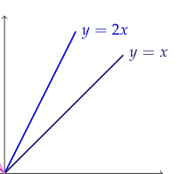
Picture 4
Picture 5

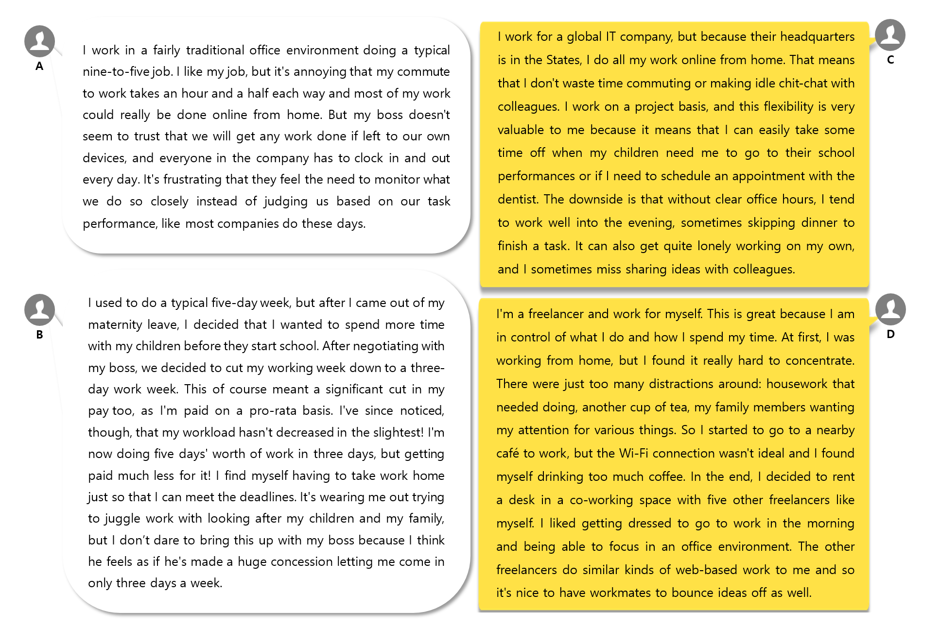
Reading Material
Worksheet
Activity A: Answer the questions individually and compare your answers with partners.
1. What are the reasons for B's pay cut?

2. What is something that A does not satisfy with his/her working condition?

3. What are some advantages of his/her job that C mentioned? What about disadvantages?

4. Why is D unable to concentrate on work while working from home?

Activity B: Answer the questions as a group and find the clues within the given text.
1. Do you think D have a good work life balance? Why or why not?

2. Why do you think B is unable to complain about her current working condition? If she were to complain, what is her boss most likely to say for the complaint?

Activity C: Feel free to discuss about the given questions as a group.
Do you think you maintain a work life balance? Why or why not? What would you change if you could change 3 things for the better work life balance? You MUST give legitimate reasons for the changes.
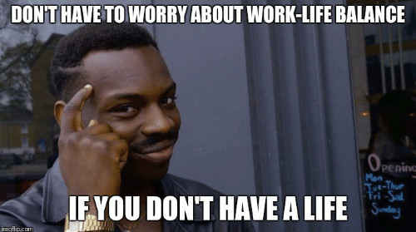
Answer Sheet
Activity A: Answer the questions individually and compare your answers with partners.
1. What are the reasons for B's pay cut?
Because her working week is cut down to a three-day work week after her maternity leave and she is paid on a pro-rata basis.
2. What is something that A does not satisfy with his/her working condition?
She is unsatisfied with her boss who doesn't seem to trust employees and want to monitor their every movement.
3. What are some advantages of his/her job that C mentioned? What about disadvantages?
He doesn't have to waste time commuting or making idle chit-chat with colleagues. Most importantly, the flexibility of his work is valuable for him. Since there is no clear office hours and colleagues, however, he sometimes skips dinner and can't get helps from his colleagues.
4. Why is D unable to concentrate on work while working from home?
Because there are lots of distractions at home, including housework and family members who want her attention for many things.

Activity B: Answer the questions as a group and find the clues within the given text.
1. Do you think D have a good work life balance? Why or why not?
He seems to have a good work life balance since he is control of his life. He could choose to work at other places even if there were housework or some other things to do for his family members.

2. Why do you think B is unable to complain about her current working condition? If she were to complain, what would her boss say for the complaint?
Because her boss would think he let her cut her working hours after negotiation and made a fair decision based on how long she works at the office.

Instructor’s Comments and Assessment
Pros
Cons
Change
Overall Comments
Grade
Above Standard 85%-100% | Standard 70%-84% | Below Standard 69%-0%
Instructor | Student Signature | Date
Taute, David

