Name | Class | Date | Lesson Type | Plan Type | Length
Bonnie | TESOL | 05.08.2020 | Listening | PPP | 35 min
Lesson
Topic | Spycat
Main Aim | Students will practice their listening comprehension using an integrated listening model.
Secondary Aim | Students will practice their speaking fluency.
Materials and References
Reference: https://learnenglishkids.britishcouncil.org/short-stories/spycat
Materials: Worksheet, pc, audio equipment, PPT
Student Profile
Level | Low Intermediate
Age | 8 or 9 |  | Number of Students | 10
Detail | This is a general English class and students are highly motivated learners. The students are all Koreans, and they are accustomed to pair work, however, still need to be relaxed before they will open up to communicate freely. They engage actively in kinaesthetic learning and tend to favor the visual learner mode, but, auditory learning still needs developing. And also, they need patience to attend a class.
Anticipated Classroom Management Difficulties and their Solutions
The audio equipment could fail – Replace the equipment to my smart phone.
Outside is so noisy – Close the window and door.
My personal Aim
What I aim to demonstrate is the ability to write out a complete, detailed lesson plan.
Background Information Sheet
Stage Name: Lead – in
Purpose of this stage: To relax both the students and the teacher; to increase student talk through the sharing of ideas or experiences; to introduce the topic, or something topic-related.
Materials: PPT1
Time | Interaction | Procedure
1 min  1 min  1 min | T  S – S  T - S | Organize seating arrangements so everyone has a partner, with one group of 5 sitting together, and all can easily see the screen.  (Show PPT1) “Hello everyone. Look at this picture. Talk to your partner about where are they. I mean, Which country has them? You have 1 minute.”  (Gesture) “Let’s start.”  Students talk to their partners. And teacher monitors them.  (Feedback. Nominate 2 students in each group and ask.)  (Point to Eiffel Tower) “Can you tell me about where is it?” (It is in France.)  (Point to Pyramid) “Can you tell me about where is it?” (It is in Egypt.)

Stage Name: Presentation
Purpose of this stage: To offer any needed help which students may need in order to comprehend the text more easily. This includes teaching from 1 to 4 key words using the C.C.C. technique, and asking a guiding question which will allow students the opportunity to think of and share ideas they are likely to encounter when listening. This encourages the use of their schema when comprehending a text.
Materials: PPT2
Time | Interaction | Procedure
1 min  1 min  10 sec  2 min  1 min | T – S  T – S  T  S – S  T - S | Pre-teach keywords: spy, clue.  Elicit – (Show PPT2) “What does he do?” (He’s a spy.)  CCQ – “Does he work secretly?” (Yes)  “Does he try to get friend?” (No)  “Does he go to other country? (Yes)  Drill – “Listen and repeat 3 times together.” (Gesture.)  Nominate 3 student individually. (Gesture.)  Board – Write spy on the left of the board.  Elicit – (Point to PPT2) “What does he get?” (He can get clue.)  CCQ – “Is it use in a mystery situation?” (Yes)  “Can it get easily?” (No)  “Is it important to solve problem?” (Yes)  Drill – “Everybody listen and repeat 3 times.” (Gesture.)  Nominate 3 student individually. (Gesture.)  Board – Write clue bottom of the spy.  Guiding Question  “Talk to your partners. Why does spy get clue? You have 2 minutes.”  Students discuss with their partners  (Feedback. Nominate each student in their group and share ideas.)  “Good. All ideas are perfect. The spy tries to get clues because he needs to carry out his work.”

Stage Name: Practice – Literal Comprehension Listening
Purpose of this stage: For students to listen for the first time in order to get the facts. This may include the overall idea or topic of the text; to notice who the speakers are; where they are; and perhaps why they are speaking. The responses are short, objective, and are only a surface understanding. This is an accuracy focused stage.
Materials: Worksheet
Time | Interaction | Procedure
1 min  2 min  1 min  2 min | T  S  S – S  T - S | Instructions. Set the purpose for listening before handing out worksheets.  (Hold up the worksheets.) “Now, it’s time to listen short story about spycat. As you listen, you have to answer some question on this worksheet. If you catch answer, you can move next question, but you must answer exercise one only. Don’t do exercise2.”  I.C.Q – “Do you need to answer exercise 2?” (No)  “What do you need to answer?” (Exercise 1 only.)  Read each question for the students. Then hand out the worksheets.  Students listen only one time, and write answers on the worksheet.  Pair check. “Please compare your answer with your partner.”  Teacher monitor the students.  Feedback to check accuracy. Nominate 4 students for answer one by one.  “Young Ju, can you read question 1 and answer?”  checking if others have the same or different answers.  “Does anyone else have a different answer?”  “Who agrees with this answer?”  Then give the right answer.  “Yes right. The question one answer is …”

Stage Name: Practice – Interpretive Comprehension Listening
Purpose of this stage: Students listen a second time, more carefully, to infer or interpret meaning of the literal facts. This is still an accuracy focused stage – answers need to be checked for accuracy. Students are required to think about the why in order to support their answers. They may need to focus on things like the overall situation, tone of voice, multiple pieces of information, or a single statement to explain the unspoken, intended meaning.
Materials: Worksheet
Time | Interaction | Procedure
1 min  4 min  3 min  2 min | T  S  S – S  T - S | Instructions. “Listen again. This time, answer exercise 2. This question is more difficult than question 1, but you can do it if you listen carefully. So, after listening, you write your answer below the question. I’ll give you some time for you thinking about it. So, don’t worry.”  I.C.Q – “When you answer your question?” (After listening.)  “Don’t you have time to write?” (No, you give some time for thinking and writing.)  Read the questions for the students.  Students listen for the second time, and write their answers.  Pair check. “Please compare your answer with your partner.”  The teacher monitors their work.  Feedback to check accuracy. Nominate 2 students for answer one by one.  “Manny, can you read question 1 and answer?”  checking if others have the same or different answers.  “Does anyone else have a different answer?”  “Who agrees with this answer?”  Then give the right answer.  “Yes right. The question one answer is …”

Stage Name: Production – Applied Comprehension Speaking
Purpose of this stage: For students to practice their speaking fluency. Therefore, this stage should be no less than 6 minutes to allow students to practice. Give them a few questions to help them communicate without intervention from the teacher. This is a fluency focused stage.
Materials: Worksheet
Time | Interaction | Procedure
1 min  6 min  1 min | T  S – S  T - S | Make 2 groups of 5 students. Wait for students to move.  “Now, turn over your worksheets.” (Students do it.)  “Alright. Talk to your partner about any of these questions you want. But, remember to listen and ask questions to your partner. Don’t write anything on your paper. You have 6 minutes.”  I.C.Q – “Can you write your answer on your worksheet?” (No)  “Ok. Let’s start.”  Students discuss. Teacher monitors them.  Feedback. Nominate some students. Teacher ask some question to them, and listen their own thinking.

Stage Name: Wrap – up
Purpose of this stage: To end the lesson on a positive note. This will give students a sense of accomplishment, encourage students to continue progressing, and realize how to improve in future. A teacher may also get valuable feedback from students regarding the activities used in the lesson.
Materials:
Time | Interaction | Procedure
2 min | T | Lesson feedback. Tell the class what they did well, and what needs to improve.  “Well done guys. Thank you so much for sharing your ideas!”  “Which part of question is most difficult?” (Student answer)  “Yes right. It is little bit hard, but you guys did it very good. So, I really happy”  Set homework. “For homework, listen any other short story and review it tomorrow.”  Inform students about the topic for the next lesson. “Tomorrow we have a reading lesson of Spycat story.”  Dismissed.

PPT1
PPT2
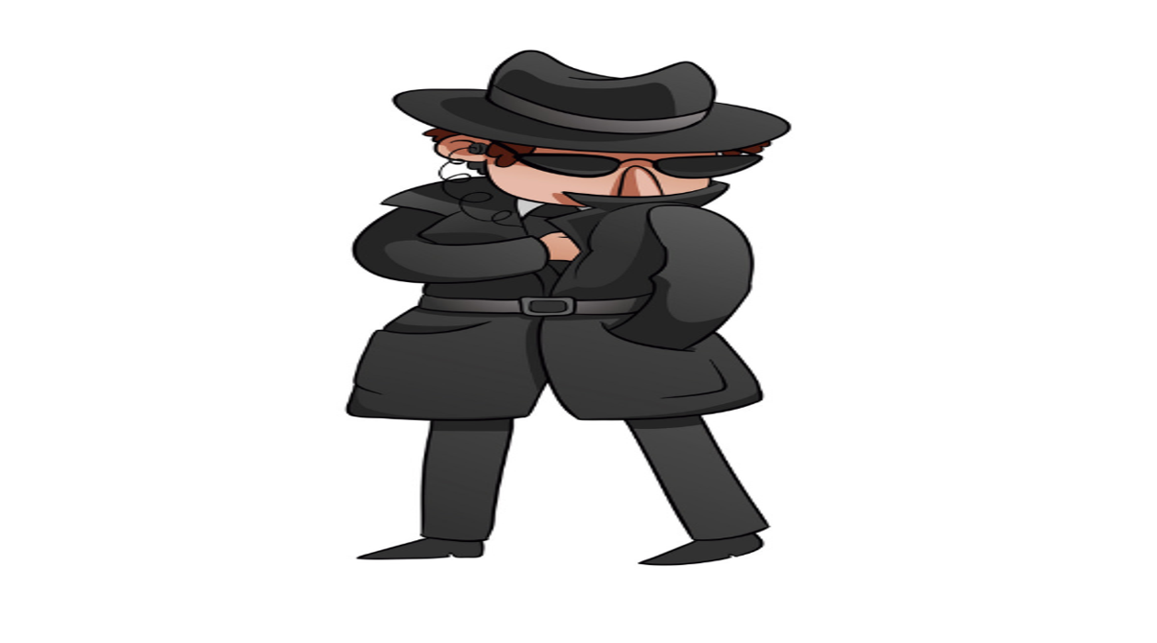
Worksheet – Spycat
Exercise 1: Listen and write the answer next to the question.
- Where did spycat go in Paris?
- Where did spycat visit in Egypt?
- Where did spycat get on the ferry?
- Where did spycat go in London?

Exercise 2: Listen carefully, think, and write your answer.
- What is a Ratty’s job?

- Finally, does spycat find Ratty?

Exercise 3: Talk to your partner freely about any of the questions below. No writing!
- If you go to Paris, what do you want to do?
- If you go to Egypt, what do you want to do?
- Can you explain why cat is smarter than rat?

Answersheet – Spycat
Exercise 1: Listen and write the answer next to the question.
- Where did spycat go in Paris? – Eiffel Tower
- Where did spycat visit in Egypt? – The Pyramids
- Where did spycat get on the ferry? – Hong Kong
- Where did spycat go in London? – Big Ben

Exercise 2: Listen carefully, think, and write your answer.
- What is a Ratty’s job?
☞ Ratty is a computer programmer. Because, He made new super rat virus for destroying all computers.

- Finally, does spycat find Ratty?
☞ Yes, because the story mention “Spycat cracks the code.” It means spycat finally know where Ratty is.

Transcript
Time: 1 minute 18 seconds
