Background Information Sheet
Name | Class | Date | Lesson Type | Plan type | Length
YUK YUNGJU | TESOL | 05/08/2019 | Listening | PPP | 35 min
Lesson
Topic | The ugly duckling
Main Aim | Students will practice their listening comprehension using an integrated listening model.
Secondary Aim | Students will practice their speaking fluency.
Materials and References
Video : file:///C:/Users/%EC%9C%A1%EC%9E%AC%EC%98%81/Desktop/short-stories-story-time-the-ugly-duckling-transcript.pdf. Worksheet : board pens ; P.C and audio equipment.

Student Profile
Level | Low intermediate
Age | 6-12 years | Number of Students | 10 students
Detail | This is a general English and students are highly motivated learners. The students are all Korean and enjoy simple story. They are accustomed to pair work, but still need to be relaxed before they will open up to communicate freely. They engage actively in kinesthetic learning and tend to favor the visual learner. They need to practice their speaking fluency.
Anticipated Classroom Management Difficulties and their Solutions
The audio equipment could fail – before class start send class content to my smartphone and print picture of my PPT.

Nervousness at the start of the lesson – check the equipment is working to start the lesson, sit down and follow the planned teacher talk.
My Personal Aim
What I aim to demonstrate is the ability to writhe out a complete, detailed lesson plan

Stage Name: Lead-in
Purpose of this stage:
To relax both the students and the teacher, to increase student talk through the sharing of ideas or experiences: to introduce the topic, or something topic-related

Materials:
Time | Interaction | Procedure
1 min  1 min  1 min | T  T-S/S-S  T-S | Greet. Instructions.  They are sitting together each one has a partner, with one group of 2 sitting together. And all can easily see the screen. Show picture.  Hello guys look at this picture. What can you see in this picture? How do you think this picture?  Please discuss with your partner. I will give you 1 minute for discuss.  (Gesture for students to begin talking to their partners)  Students talk with their partner. Monitoring them.  Ask their idea / opinion. And give some feedback if appropriate.

Stage Name: Presentation

Purpose of this stage: To offer any needed help which students may need in order to comprehend the text more easily. This includes teaching from 1 to 4 key words using the C.C.C. technique and asking a guiding question which will allow students the opportunity to think of and share ideas they are likely to encounter when listening. This encourages the use of their schema when comprehending a text.

Materials:
Time | Interaction | Procedure
1 min  1min  1 min  1 min  1 min | T-S  T  S-S  T-S | Pre-teach keywords: Swan, pond  Elicit – point to PPT1. What is it? (Swan)  CCQ – is it bird? (yes)  Can it swim? (yes)  Drill – listen and repeat 3 times together, (Gesture)  Board – highlight special areas of pronunciation  How many syllables? (3) Mark with a blue pen  Where is the stress? (2) Mark with a red pen  Point to PPT 1. What is it? (Pond)  CCQ – Swan can swim here? (No)  Is it big? (No)  Drill- listen and repeat 3 times together (Gesture)  Board- highlight special areas of pronunciation  How many syllables? (2) Mark with a blue pen  Where is the stress? (2st) Mark with a red pen  Guiding Question  How do you think swan? is it beautiful?  Students discuss the question with a partner.  Feedback. Nominate a few students to share their ideas, if necessary.

Stage Name: Practice - Literal Comprehension Listening
Purpose of this stage:
For students to listen for the first time in order to get the facts. This may include the overall idea or topic of the text; to notice who the speakers are; where they are; and perhaps why they are speaking. The responses are short, objective, and are only a surface understanding. This is an accuracy focused stage.

Materials:
Time | Interaction | Procedure
1 min  2 min  2 min  1 min | T  S  S-S  T-S | Instructions. Set the purpose for listening. Hand out worksheets.  Ok guys. Now we will listen to a story about this.  When you listen, you must answer these questions in exercise one only.  You do not need to write down exercise two. Also do not show your answer to anyone.  When you listen and catch the answer, please write it down in the paper.  If you cannot catch the answer you do not need to worry.  It is ok! Do not worry!  I.C.Q – Do you need to write down answer? (yes)  Do you need to do exercise two? (No)  Can you share your answer? (No)  Give worksheet to them.  Students listen for the 1st time and write answers on the worksheet.  Pair check.  Ok! Please compare your answer with your partner. (Monitor)  Feedback to check accuracy.  Ask student answer, checking different answer. If they have different answer, ask why you think? then listen and give feedback to correct answer.

Stage Name: Practice - Interpretive Comprehension Listening
Purpose of this stage:
Students listen a second time and they should listen more carefully. This is still an accuracy focused stage- answer need to be checked for accuracy. Students are required to think about the why in order to support their answers. They may need to focus on things like the overall situation. Tone of voice, multiple pieces of information. And Singapore statement to explain the unspoken, intended meaning. Increase more communication skills.

Materials:
Time | Interaction | Procedure
1 min  3 min  2 min  2 min | T  S  S-S  T-S | Instructions. Set the purpose for listening. Hand out worksheets.  Ok now we will do exercise two. These questions can be more difficult, but if you listen carefully and think about the answer you can solve the question.  I will give you time afterwards to think and write answer. And after, we will share your answer.  So, you cannot show your answer to anyone.  I.C.Q – Do you need to listen carefully? (yes)  Students listen for the 2nd time. And writhe answer.  Pair check. Monitor.  Ok. How was it? please compare your answer with your partner!  Feedback to check accuracy.

Stage Name: Production - Applied Comprehension Speaking
Purpose of this stage: For students to practice their speaking fluency. Therefore, this stage should be no less than 5 minutes to allow students to practice. Give them a few questions to help them communicate without intervention from the teacher. This is a fluency focused stage.

Materials:
Time | Interaction | Procedure
1 min  7 min  2 min | T  S-S  T-S | Instructions. Give students a question to discuss in pairs or groups.  Make 2 group of 5 students. Wait for students to move  Now, turn over your worksheets. You don’t need to writhe this part.  Talk to your partner about any of these questions.  And discuss your opinion about questions.  You have 7 minutes to discuss.  I,C,Q – Do you need to writhe anything? (No)  Students discuss. (Monitor their a discuss and form distance)  Feedback. Students share their ideas with the class.  What is your idea?

Stage Name: Wrap-up
Purpose of this stage:
To end the lesion on a positive note. This will give students a sense of accomplishment, encourage students to continue progressing and realize how to improve in future. A teacher may also get valuable feedback from students regarding the activities used in the lesson.

Materials:
Time | Interaction | Procedure
3 min | T | Lesson feedback. Tell the class what they did well, and what needs to improve.  Offer delayed corrections to the previous stage.  Set homework.  How was class on today ? No homework on today! Very well done guys!  Inform students about the topic for the next lesson.  Tomorrow we will do a reading lesson about The Story of the Little Mole. It will be very fun and you can enjoy it.

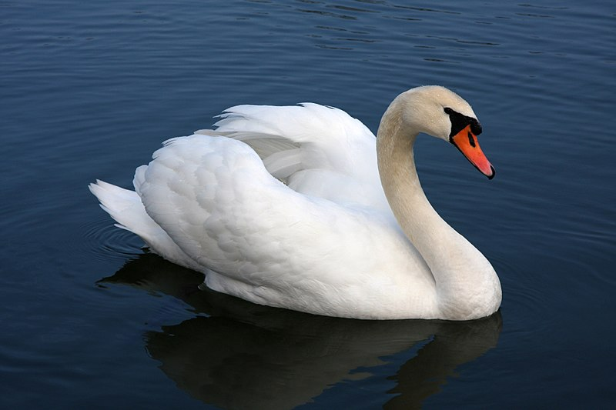

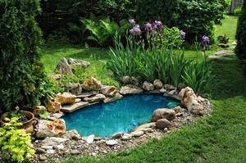

Worksheet 1 – The ugly duckling

Exercise one: Listen and write the answer next to the question
1) What cane out of the egg?
2) How many eggs?
3) His brother and sister do not want play with him?

Exercise two: Listen carefully, think, and writhe your answer
1) Why nobody wants to be his friend?
2) why the ugly duck goes in to the empty

Exercise Three: Talk to your partner freely about any of the questions below. No need to writing.
1) what do you think about friend?
2) Do you have a best friend? Who and why?
3) What do you like to do with your friends?

Transcript
Time : 2 min 24 seconds

Mummy Duck lived on a farm. In her nest, she had five little eggs
and one big egg. One day, the five little eggs started to crack.
Tap, tap, tap! Five pretty, yellow baby ducklings came out.
Then the big egg started to crack. Bang, bang, bang! One big,
ugly duckling came out. ‘That’s strange,’ thought Mummy Duck.
Nobody wanted to play with him. ‘Go away,’ said his brothers and sisters. ‘You’re ugly!’
The ugly duckling was sad. So he went to find some new friends.
‘Go away!’ said the pig.
‘Go away!’ said the sheep.
‘Go away!’ said the cow.
‘Go away!’ said the horse.
No one wanted to be his friend. It started to get cold. It started to snow! The ugly duckling
found an empty barn and lived there. He was cold, sad and alone.
Then spring came. The ugly duckling left the barn and went back to the pond. He was very
thirsty and put his beak into the water. He saw a beautiful, white bird! ‘Wow!’ he said. ‘Who’s
that?’
‘It’s you,’ said another beautiful, white bird.
‘Me? But I’m an ugly duckling.’
‘Not any more. You’re a beautiful swan, like me. Do you want to be my friend?’
‘Yes,’ he smiled.
All the other animals watched as the two swans flew away, friends forever.

Answer sheet
Worksheet 1 – The ugly duckling
Exercise one : Listen and write the answer next to the question
1) What cane out of the egg? - duckling
2) how many eggs? - Five
3) His brother and sister do not want play with him? - Yes

Exercise two: Listen carefully, think and writhe your answer
- Why nobody wants to be his friend?
Because he is ugly. They don’t want to ugly friend.
- why the ugly duck goes in to the empty?
the water become to cold. But nobody doesn’t like him so he finds the empty and stay alone during the winter.

Exercise Three: Talk to your partner freely about any of the questions below. No need to writing.
1) what do you think about friend
2) Do you have a best friend? Who and why?
3) What do you like to do with your friends?

Pros
Cons
Change
Overall Comments
Grade
Above Standard 85%-100% | Standard 70%-84% | Below Standard 69%-0%
Instructor | Student Signature | Date
Taute, David
Instructor’s Comments and Assessment

