Background Information Sheet
Name | Class | Date | Lesson Type | Plan type | Length
Manny Kim | TESOL | 05/08/2020 | Listening | PPP | 35 min
Lesson
Topic | The Storm
Main Aim | Students will practice their listening comprehension using an integrated listing model.
Secondary Aim | Student will practice their speaking fluency.
Materials and References
PPT, Oxford Reading Tree audiobook file, worksheet, board pens, P.C, and audio equipment.

Student Profile
Level | Low intermediate
Age | Children  6-12 years old | Number of Students | 10 Students
Detail | This is a general English class, and students are highly motived learners. The students are all Koreans and enjoy storybook. They are accustomed to pair work, but they still need to be relaxed before they open up to communicate freely. They engage actively in kinesthetic learning  and tend to favor the visual learner mode, but auditory learning still needs developing.
Anticipated Classroom Management Difficulties and their Solutions
The audio equipment could fail Bring a set of portable speakers to use with my tablet PC, print an A4 size picture of
my PPT.
Too many teacher talks at the start lesson à sit down and followed the planned teacher talk.

My Personal Aim
What I am to demonstrate is the ability to write out a complete, detailed lesson plan.

Stage Name: Lead-in
Purpose of this stage: To relax both the students and the teacher, to increase student talk through the sharing of ideas or experience, to introduce the topic or something topic related.

Materials:
Time | Interaction | Procedure
30 sec  2 min  20 sec | T  S-S  T-S | Organize seating arrangements, so everyone has a partner, with one group of 3 sitting together, and all can easily see the screen, show PPT1  Hello guys, look at this picture. What do you see? Talk to your partner about the weather. For example,  What kind of weather do you like? Do you like rainy? Have you experienced a storm before?  You have 1 minute.  Gesture for students to begin talking to their partners.  Students talk to their partners. Monitor for any use of keywords.  Feedback, if appropriate.

Stage Name: Presentation
Purpose of this stage: To offer any needed help that students may need to comprehend the text more easily.
This includes teaching from 1 to 4 keywords using the C.C.C technique and asking a guiding question that will allow students to think of and share ideas they are likely to encounter when listening. This encourages the use of their related topics and suitable topics when comprehending a text.
Materials:
Time | Interaction | Procedure
1 min  30 sec  1 min  30 sec  1 min  30 sec  10 sec  2 min  1 min | T-S  T-S  T-S  T  T-S | Pre-teach keywords: Storm, Blow, Mend.  Elicit – Point to PPT 1, what do you see? (Storm)  CCQ – Is it bad weather? (Yes)  Are this weather with heavy rain and strong winds?  Can it be destroyed the house? (Yes)  It called a “storm.”  Drill – Everybody listens and repeats three times together. (Gesture.)  Nominate 2 or 3 individually.  Board – Write a storm on the right of the board.  How many syllables? (2) Mark with a blue pen.  Where is the stress? (2nd) Mark with a red pen.  Elicit – Point to PPT 1, what is he doing? (blow)  CCQ – Does it makes a bubble? (Yes)  Can you do it with nose? (No)  If you make a balloon bigger, what will you do by mouth?  It called “blow.”  Drill – Everybody listens and repeats three times together. (Gesture.)  Nominate 2 or 3 individually.  Board – Write a blow on the right of the board.  How many syllables? (2) Mark with a blue pen.  Where is the stress? (2nd) Mark with a red pen.  Elicit – Point to PPT 1, what is he doing? (mend)  CCQ – Is he fixing something? (Yes)  When your cell phone is broken, what will you do?  It called “mend.”  Drill – Everybody listens and repeats three times together. (Gesture.)  Nominate 2 or 3 individually.  Board – Write mend on the right of the board.  How many syllables? (2) Mark with a blue pen.  Where is the stress? (1st) Mark with a red pen.  Guiding Question  Talk to your partners. Can you blow a whistle? What song can you sing with blowing a whistle?  Students discuss it with their partners.  Feedback. Nominate a few students to share their ideas, draw out ideas that children are like to blow bubble and balloon.

Stage Name: Practice 1 - Literal Comprehension Listening
Purpose of this stage: For students to listen for the time to get the facts. This may include the overall idea or topic of the text, notice who the speakers are, where they are, and perhaps why they are speaking. The responses are short, objective, and are only a surface understanding. This is an accuracy focused stage.

Materials:
Time | Interaction | Procedure
1 min  3 min  1 min  1 min | T  S  S-S  T-S | Instructions. Set the purpose for listening. Handing out worksheets.  Hold up the worksheet.  Now it’s time to listen to a story about the storm.  As you listen, you must answer these questions in an exercise one only.  When you catch the answer, write it down next to the question.  Don’t do exercise 2.  I.C.Q – Do you need to write your answers? (Yes.)  Do we need to read the questions for in exercise 2? (No.)  Do you have a pen or pencil ready? (Yes.)  Read each question aloud for the students. Hand out the worksheet.  Students listen for the 1st time and write answers on the worksheet.  Pair check. Compare your answers with your partner. Monitor.  Feedback to check accuracy.  Ask students for answers, checking if others have the same or different answers.  Does anyone else have a different answer? Who agrees with this answer? How did you know who found a box near the tree?

Stage Name: Practice 2 - Interpretive Comprehension Listening
Purpose of this stage: Students listen a second time, more carefully, to infer or interpret the meaning of the literal facts. This is still an accuracy focused stage – answers need to be checked for accuracy. Students are required to think about the why in order to support their answers. They may need to focus on things like the overall situation, tone of voice, multiple pieces of information, or a single statement to explain the unspoken, intended meaning.

Materials:
Time | Interaction | Procedure
30 sec  4 min  2 min  2 min | T  S  S-S  T-S | Listen again. This time, answer exercise 2.  These questions are more difficult, but if you listen carefully and think about what you know, you can find the answers.  Write your answers next to the questions. I will give you time afterwards to think and write.  I.C.Q – Do you need to rush to answer these questions? (No, we will have time afterwards to write.)  Read the questions aloud for the students.  Students listen for the 2nd time. And write their answers.  Pair check. Monitor. If students need, then replay the audio a 3rd time.  Feedback to check accuracy.

Stage Name: Production - Applied Comprehension Speaking
Purpose of this stage: For students to practice their speaking fluency. Therefore this stage should be no less than 5 minutes to allow students to practice. Give them a few questions to help them communicate without intervention from the teacher. This is a fluency focused stage.

Materials:
Time | Interaction | Procedure
1 min  5 min  2 min | T  S-S  T-S | Instructions. Give students a question to discuss in pairs or groups.  Make three groups of three students. Wait for students to move.  Now, turn over your worksheets.  Talk to your partner about any of these questions.  You should talk freely, and remember to listen and ask questions to your partner.  You have 6 minutes.  I.C.Q – Do you write anything? (No.)  Students discuss. Monitor from a distance.  Feedback. Students share their ideas with the class.

Stage Name: Wrap-up
Purpose of this stage: To end the lesson on a positive note. This will give students a sense of accomplishment, encourage students to continue progressing, and realize how to improve in the future. A teacher may also get valuable feedback from students regarding the activities used in the lesson.

Materials:
Time | Interaction | Procedure
2 min | T | Lesson feedback. Tell the class what they did well and what needs to improve.  Set homework. For homework, listen to the next storybook “The Magic Key.” Summarize it by writing no more than 50 words. It is due tomorrow. I will text the homework in the class chatroom.  Inform students about the topic for the next lesson.  Tomorrow we will do a reading lesson about “The flying elephant”  Dismissed.

Worksheet 1 – The Storm

Exercise One: Listen and write the answer next to the question.
- Who mended the roof of the treehouse?
- Who painted the door?
- What did children do in the treehouse after finishing mend?
- Who found a box near the tree?
- Who opened the box?
- What was in the box?

Exercise Two: Listen carefully, think, write your answer.

- Why children mended treehouse?

- Why did Moms and Dads come to school?

Exercise Three: Talk to your partner freely about any of the questions below. No writing!
- Have you played at the tree house?
- If you make a treehouse, what kinds of things you want to put in the treehouse?
- Can the storm make a tree down?

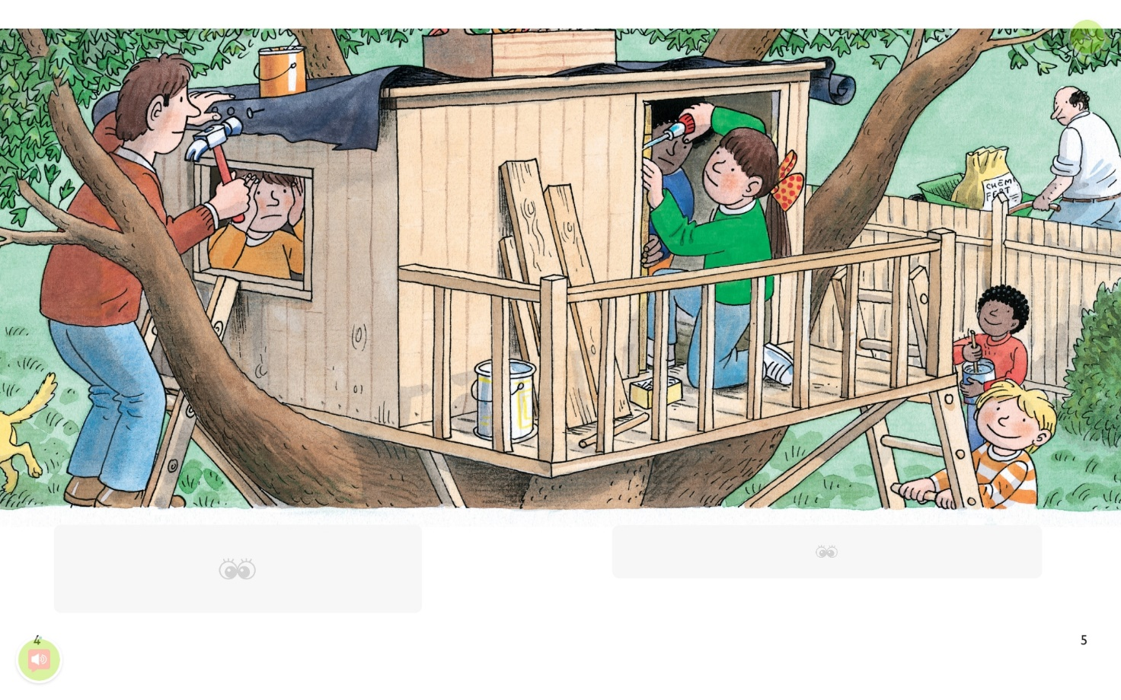

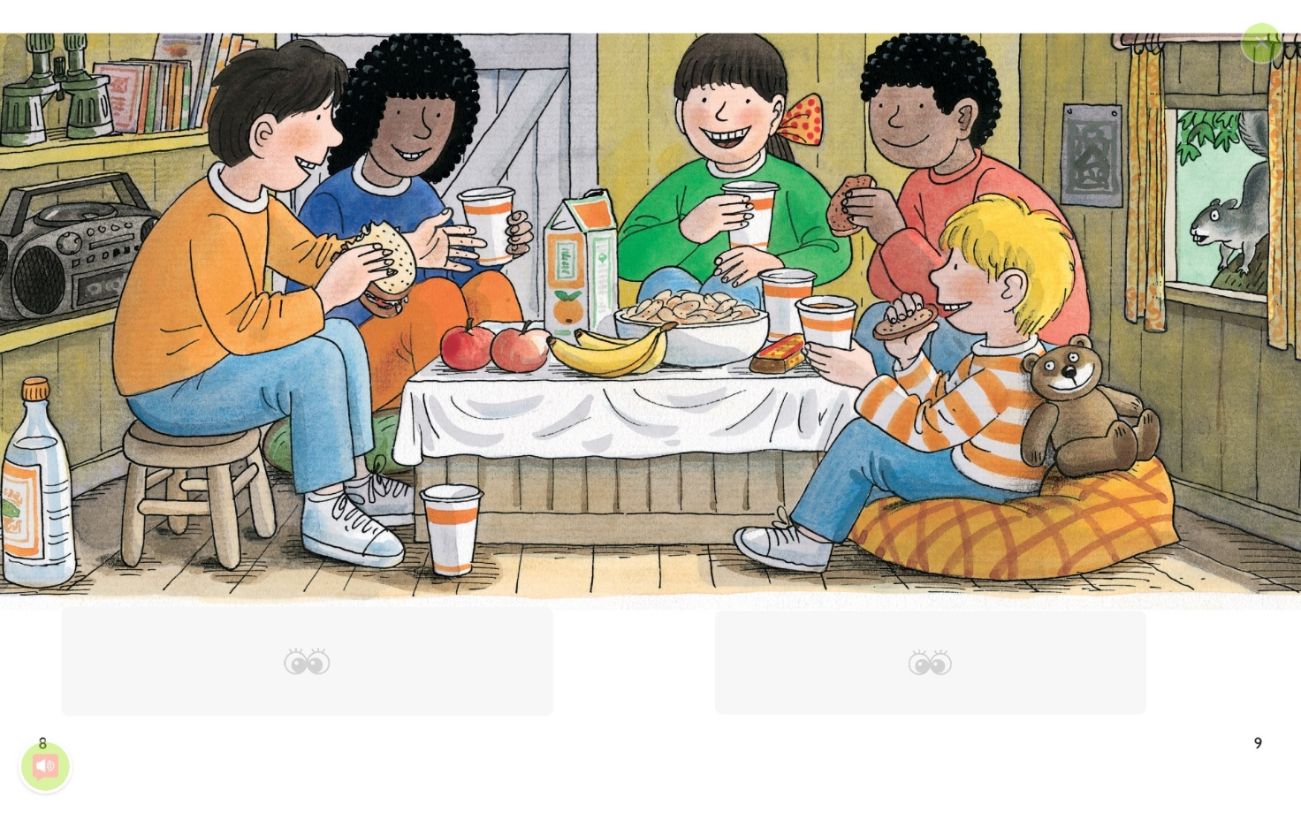

Transcript
Time: 3 minutes

Wilf and Wilma came to the house. They came to play.
The children went outside. They climbed the tree.
They looked in the treehouse. “What a mess!” said Biff.
Dad helped the children. He mended the roof.
Biff and Wilma mended the door. Chip and Wilf painted the treehouse.
Wilf painted the door. Chip painted the walls.
The tree house looked good. The children put things inside.
They had a party in the treehouse.
It was bedtime. Biff was in her room. Biff looked outside. There was a storm.
It was time for school. Wilf and Wilma came. “What a storm!” Said Mum.
The wind blew. The rain came down. “What a storm!” said Mrs. May.
It was time to go home. The mums and dads came. “What a wind” they said”
“Oh no!” Said Biff. The tree was down. “What a mess!” said Kipper.
The children climbed on the tree. Floppy barked and barked.
Floppy found something. It was a box.
Everyone looked at the box. Mum opened it. They found a key inside.
Chip wanted the box. He put it in his room.

Answer sheet – The Storm

Exercise One: Listen and write the answer next to the question.
- Who mended the roof of the treehouse? (Dad)
- Who painted the door? (Wilf)
- What did children do in the treehouse after finishing mend? (Party)
- Who found a box near the tree? (Floppy)
- Who opened the box? (Mum)
- What was in the box? (Key)

Exercise Two: Listen carefully, think, write your answer.

- Why children mended treehouse?
Because children wanted to play and have a party inside the
treehouse. That’s why they cleaned up and mended the tree house.

- Why did Moms and Dads come to school?
Because of a bad storm and children’s safety, Moms and Dads wanted to pick up their children.

Instructor’s Comments and Assessment
Pros
Cons
Change
Overall Comments
Grade
Above Standard 85%-100% | Standard 70%-84% | Below Standard 69%-0%
Instructor | Student Signature | Date
Taute, David

