Background Information Sheet
Name | Class | Date | Lesson Type | Length
Bonnie | TESOL | 12.08.2020 | Speaking | 20 minutes

Lesson
Topic | Picture differences
Main Aim | Students will practice their speaking fluency.
Secondary Aim | Students will practice their listening comprehension about what another student say.
Materials and References
References: https://www.pinterest.co.kr/hendrickson0128/puzzles/
Materials: worksheets

Student Profile
Level | Advanced
Age | Adult | Number of Students | 2 students
Detail | This is a general English class and students are highly motivated learners. The students are all Koreans, and they are accustomed to pair work, however, still need to be relaxed before they will open up to communicate freely. One of my student little bit shy, but it isn’t big problem. Another student is talkative, so it makes good mood in the classroom.
Assumptions about students’ knowledge as required for this lesson:
Students already know about picture differences and they did this activity before. All students can do it and have opinions to share.

Anticipated Difficulties and their Solutions:
Outside is so noisy – Close the window and door.
My USB is not working – Use back up files of my kakaotalk chat.

My Personal Aim
What I hope most to demonstrate in this lesson is the ability to write out a complete, detailed lesson plan.

Stage Name: Pre Task
Purpose of this stage: Create interest in the topic. Brainstorm ideas which will be useful for the next stage. Students must be given a communicative task e.g. discuss, arrange/sort, create a list, etc.
The aim is to relax students, activate their background information, and gather useful ideas for the lesson.
Materials: Picture1
Time | Interaction | Procedure
30 sec  1 min 30 sec | T  S | Organize seating arrangements for comfortable to talk together.  (Hold picture1) “Hello everyone. Today, we do some funny activity for your speaking more fluency. Before start this activity, I’ll give a paper for you guys and you describe what is different about this picture. But, don’t turn of your paper.”  (Give a paper) “Can you start first Manny?”  Student answer by their turn.

Stage Name: Task Preparation
Purpose of this stage: This is a student centered stage, to give students time to prepare and practice a speaking task which they will perform in Task Realization. Clear detailed instructions or a demonstration must be provided so students know what is expected. Prepared materials may be provided to assist their preparation. Monitor and offer brief tips if necessary.
Materials: Picture2
Time | Interaction | Procedure
30 sec  3 min  10 sec  2 min | T  S – S  T  S | “Good. Ok turn to the next page please?” (Students do)  “This is a whole picture just you did. Now, you find more differences about this picture and circle on the paper. But, before that, must talk to each other and describe what is different. After that you can do the circle. You have 3 minutes.”  Students do the activity. Teacher monitor them.  (Clap) “Times up. Can you show your picture?” (Students do)  “Good, please describe what is different? Can you start Young Ju?”  Students presentation what is different by their turn.

Stage Name: Task Realization
Purpose of this stage: This is a very student centered stage to allow for maximum speaking fluency practice. Monitor discretely and take note of incorrect language. Students perform their task without interruptions from the teacher. Classroom management may be an important consideration here.
Materials: Picture3
Time | Interaction | Procedure
30 sec  4 min  10 sec  2 min | T  S – S  T  S – S | Organize seating arrangements for facing each other.  “Can you have a seat here?” (Students do)  (Hold picture3) “Now, we go to little bit different activity. I’ll give you a picture, but you don’t show your picture for your partner. You can share it just by speech. If you find different part of something, you just circle on your paper. You have 4 minutes. Do you understand?” (Yes)  “Let’s start.”  Students do the activity, and teacher monitor them from a distance.  (Clap) “Time’s up guys. From now, you share your picture each other, and find more other differences. You have 2 minutes. Start ”  Students do the activity for 2 minutes.

Stage Name: Post Task
Purpose of this stage: To end the lesson with a final student centered task such as voting, summarizing, discussing, deciding etc. The teacher may offer delayed error correction to the previous stage, as well as mention positives and points to improve for next time such as useful strategies.
Materials: Picture3
Time | Interaction | Procedure
20 min  3 min  2 min | T  S – S  T | “Well done. Now, you make a story together about this picture. I believe you can make really funny story. Can you start Manny?”  Students make a story  “Good It’s really funny story.”  Error correction. If they are not sure some words, teacher remember it and deliver.  (Point picture) “Do you know what is it called?”  “It is called …” And drill.  Encourage. “Good job everyone. Really thanks for doing the best all work. Thank and see you next time~”  Dismissed.

Picture 1
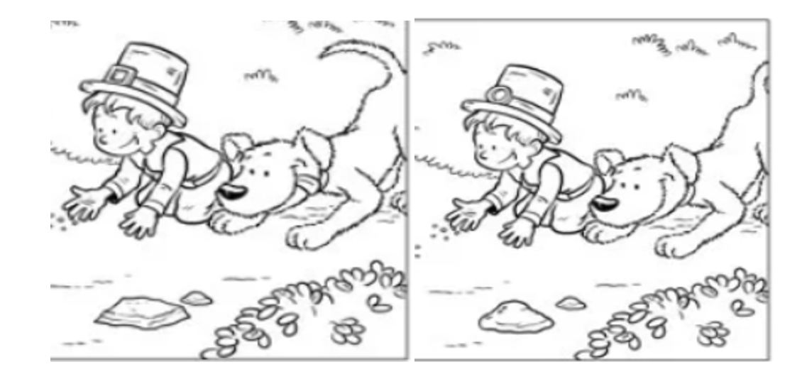

Picture 2
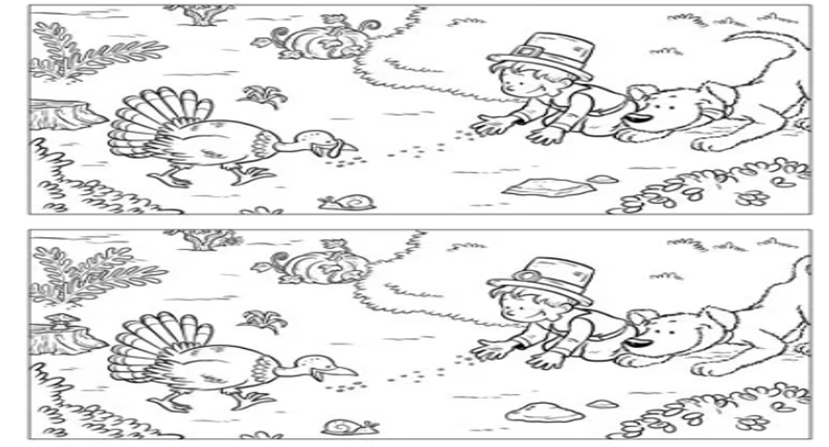

Picture 3
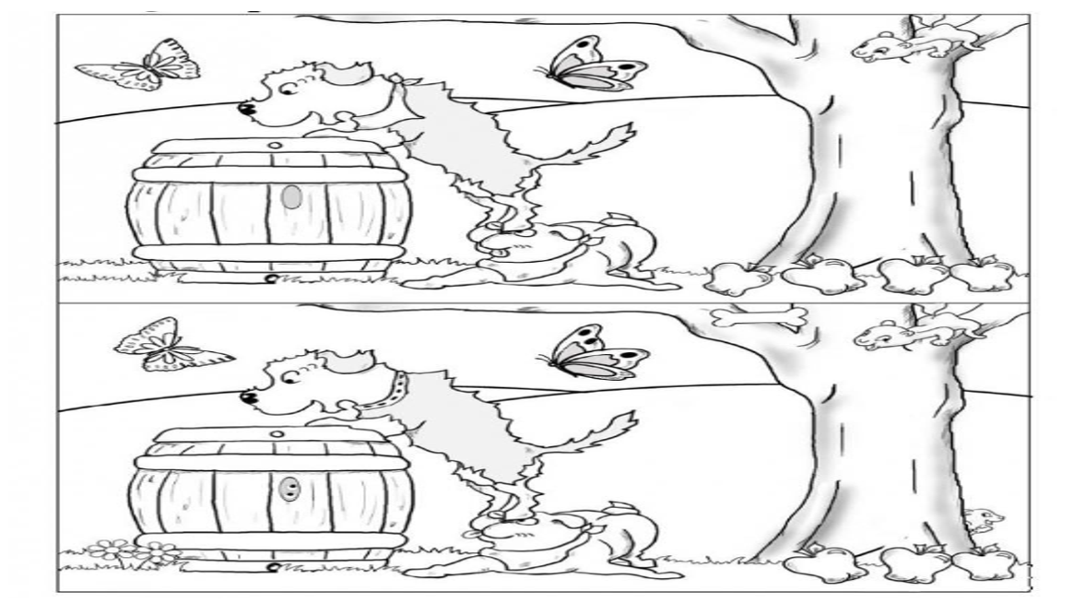
Picture 2 Answer (For teacher)
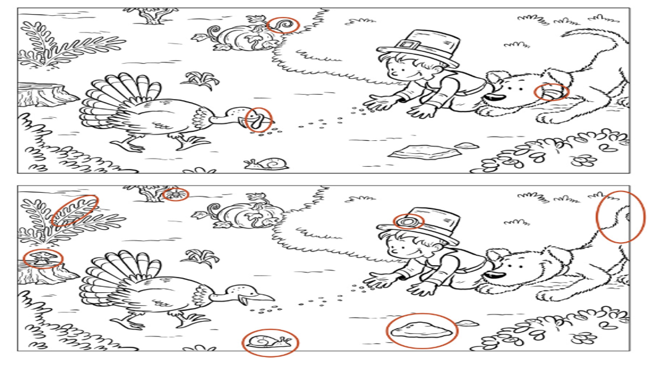

Picture 3 Answer (For teacher)
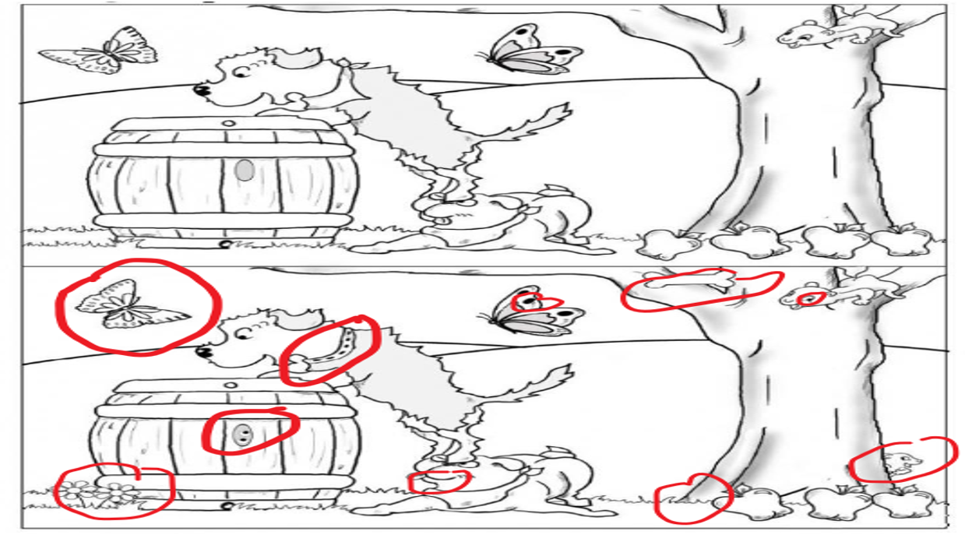
Instructor’s Comments and Assessment
Pros
Cons
Change
Overall Comments
Grade
Above Standard 85%-100% | Standard 70%-84% | Below Standard 69%-0%
Instructor | Student Signature | Date
Taute, David

