Background Information Sheet
Name | Class | Date | Lesson Type | Length
Manny | 211th WD | 12/8/2020 | Speaking | 20 min

Lesson
Topic | Shopping
Main Aim | Students will practice their speaking fluency.
Secondary Aim | Students can use natural language by practicing at with friends in situation are real and can gain confidence in speaking English.
Materials and References

Student Profile
Level | Advanced
Age | Adults | Number of Students | Two Students
Detail | They are both females, and Korean.  They have shopping experiences.
Assumptions about students’ knowledge as required for this lesson:
Students are adults, and they have lots of shopping experience. They have experienced ‘bargaining’
in marketplaces before and it would be easy for them to understand what the bargain is.

Anticipated Difficulties and their Solutions:
The media equipment could fail Print an A4 size picture of my PPT.

My Personal Aim
What I hope most to demonstrate in this lesson is the ability to write out a complete, detailed speaking lesson plan.

Stage Name: Pre Task
Purpose of this stage: Create interest in the topic. Brainstorm ideas which will be useful for the next stage. Students must be given a communicative task e.g. discuss, arrange/sort, create a list, etc.
The aim is to relax students, activate their background information, and gather useful ideas for the lesson.
Materials: White board, Picture 1 and 2, Magnetic or tape
Time | Interaction | Procedure
30sec  30sec  1min  1min  1min | T  T-S  S-S  T-S  T-S | Organize seating arrangements. put picture 1 on the white board.  “Good morning class, how are you? (Good)  Point picture 1, have you ever been shopping in a marketplace?  Talk to your partner about your recent clothing shopping experience within one minute.  Student talk each other. (Teacher monitor them + prepare task preparation)  Okay times up. point picture 2. In the marketplace, what do we call it when you ask for a lower price? (Bargain)  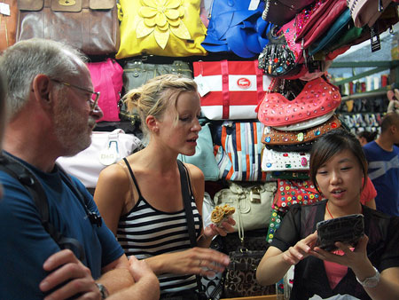  Yes, trying to lower price is the “bargaining.”
Stage Name: Task Preparation
Purpose of this stage: This is a student-centered stage, to give students time to prepare and practice a speaking task which they will perform in Task Realization. Clear detailed instructions or a demonstration must be provided so students know what is expected. Prepared materials may be provided to assist their preparation. Monitor and offer brief tips if necessary.
Materials: Worksheet, envelope, money
Time | Interaction | Procedure
1min  5min | T-S  S-S  T | “In some places, you cannot bargain, but today, in our market, we can have fun and bargain. Handing out worksheet 1 and money  In this worksheet, it has a dialogue about the bargaining situation between shopper and shop keeper. discuss your partner who will be a shopper and shop keeper. after you decide your role, you’ll have 5 minutes to prepare the role-play.  Students discuss about their roll and prepare the roll play.  Teacher monitor them and put picture 3 and 4 on the white board.

Stage Name: Task Realization
Purpose of this stage: This is a very student centered stage to allow for maximum speaking fluency practice. Monitor discretely and take note of incorrect language. Students perform their task without interruptions from the teacher.
Materials: White board, Picture 3 and 4, worksheet.
Time | Interaction | Procedure
4min | S-S | Okay. It’s time to do role play!  Which is which?  Okay. let’s begin.  Students do the roll play, and teacher monitor them from a distance.

Stage Name: Post Task
Purpose of this stage: To end the lesson with a final student centered task such as voting, summarizing, discussing, deciding etc. The teacher may offer delayed error correction to the previous stage, as well as mention positives and points to improve for next time such as useful strategies.
Materials: Use note monitoring from <Task realization> stage.
Time | Interaction | Procedure
10sec  4min  1min  50sec | T-S  S-S  T-S  T-S | Well done, let’s change rolls now.  Students do the roll play, and teacher monitor them from a distance.  Error correction. If student made a mistake on their conversation, teacher will make corrections.  Encourage. Great job. You guys are all doing very well. what do you think?  Student response. Yes. that’s good point.  All right. thanks for the passionate participation. See you next class.

Instructor’s Comments and Assessment
Pros
Cons
Change
Overall Comments
Grade
Above Standard 85%-100% | Standard 70%-84% | Below Standard 69%-0%
Instructor | Student Signature | Date
Taute, David

Picture 1

Picture 2

Worksheet 1 – dialogue about the bargaining

# Situation 1
Shopper: How much are the apples?
Shop Keeper: They are five dollars a kilo.
Shopper: That’s very expensive.
Shop Keeper: But they taste very good!
Shopper: How about four dollars a kilo?
Shop Keeper: Okay, four dollars a kilo.
Shopper: Here
Shop Keeper: Thank you.

# Situation 2
Shopper: How much is this scarf?
Shop Keeper: It’s 30 dollars.
Shopper: Oh, that’s too much.
Shop Keeper: But it’s really beautiful!
Shopper: How about 20 dollars?
Shop Keeper: Sorry, but I will take 40 dollars for two scarves.
Shopper: Okay, I want to buy two.
Shop Keeper: Thank you!
Picture 3

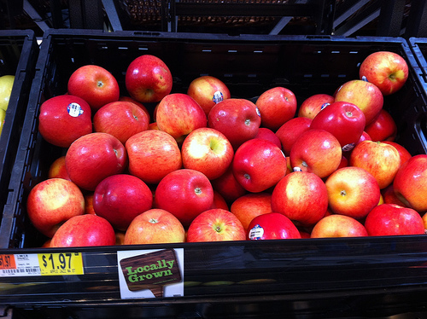

Picture 4

Money – 1 dollar

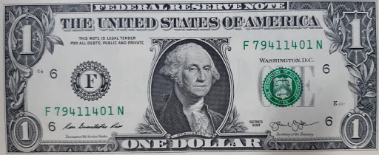

Money – 10 dollars

