Background Information Sheet
Name | Class | Date | Lesson Type | Plan type | Length
Yuk YungJu | TESOL | 2020.08.19 | Grammar | PPP | 25 min
2
Lesson
Topic | Progressive Tenses (She is studying new language)
Main Aim | Students will learn the 2nd conditional.
Secondary Aim | Students will practice their speaking fluency.

Materials and References
Board and coloured markers, worksheets

Student Profile
Level |  | Lower Intermediate
Age |  | Children |  | Number of Students | 2
Detail |  | They are all Korean. They can satisfy basic survival needs and very routine social demands. They can understand simple learned phrases easily and some new simple phrases containing familiar vocabulary, spoken slowly with frequent repetition. They can read and write simple material on familiar topics. So, I will try to make they can understand easily.
Assumptions about students’ knowledge as required for this lesson:
- Students know the vocabulary used in this lesson
- Students have learned about the present progressive (am/is/are +ing)
- Students know how to make the negative form using ‘not’
What language difficulties to expect when presenting, and how to deal with it:
- Meaning: Present progressive is used for an activity that is in progress at the moment speaking. Also, used for something generally in progress with this week, this month, this year, etc. They know first meaning of present progress. I will teach them second meaning of present progressive. Make a clear visual context and C.C.Q.

- Form: Students may confuse how to use present progressive. they know present progressive can use only now but it can use these days. So, I will teach this them. Make clear and help to understand.

- Pronunciation: Students may not know where to put natural sentence stress. Drill several times chorally, then individually. Ask, “Which words sound stressed?” Board the stress markers in red.

Anticipated Classroom Management Difficulties and their Solutions:
The quantity of new language points to be learned about the 2nd conditional is too much for students to handle in a short 25-minute lesson. This could lead to anxiety, rushing, and a lot of teacher talk. For this lesson I will manage this by selectively presenting only a few new concepts about the 2nd conditional. The remaining new language points can be presented in the next lesson.

My Personal Aim
What I hope most to demonstrate in this lesson is the ability to
- present the target language using a situational presentation
- to be an involver type teacher

Stage Name: Lead-in
Purpose of this stage: To relax both the teacher and students. To focus attention on the lesson. Create a situation for students to experience or think about, and then to elicit the target language.
Materials: List all materials that will be needed in this stage.
Timings | Interactions |  | Procedure
1 min 3o sec | T-S |  | Draw, mime, show a picture etc. to create a clear and understandable situation related to your target language. Try elicit the model sentence (a sentence that contains the target language) by referring to the situation.  Hello, guys look at this picture. Tell me about them. Make a sentence  (Show picture)  What is she doing?
Stage Name: Presentation
Purpose of this stage: Make the students think about the situation. To clarify the meaning, form, and pronunciation features of the target language.
Materials: List all materials that will be needed in this stage.
Timings | Interactions |  | Procedure
1 min 30 sec  3 min  1 min 30 sec | T  T-S  T-S  T-S |  | Board the model sentence (if students are unable to tell you, just board it).  Write down she is studying new language.  CCQ – ask questions and use timelines or scales where appropriate.  - Does she study one day? (No)  - Does she study thesedays? (Yes)  - Is this in the past, present or future? (Present)  - Does she study forever (NO)  Form – clarify the affirmative, negative, question form, or other special features. Substitution tables may be of use.  Make sure to draw the timeline.  Past__________________Now_x_______________Future  We can use this present progressive not only for now. we can use nowadays, these days and this year.  She is studying about new language. Look at this sentence. Which word tell us this is about the present? (studying)  - Can I say she is studied? (No because it is present)  The present progressive always has a form of be+ the verb in the -ing form.  Use am,is or are and the verb+ing to form the present progressive.  So what tense is it (studying)? = present progressive.  Ok well, now how we make this into a negative sentence? – ask student  (I am not studying new language)  If you want to make negative, put not after am.is, or are to form the negative.  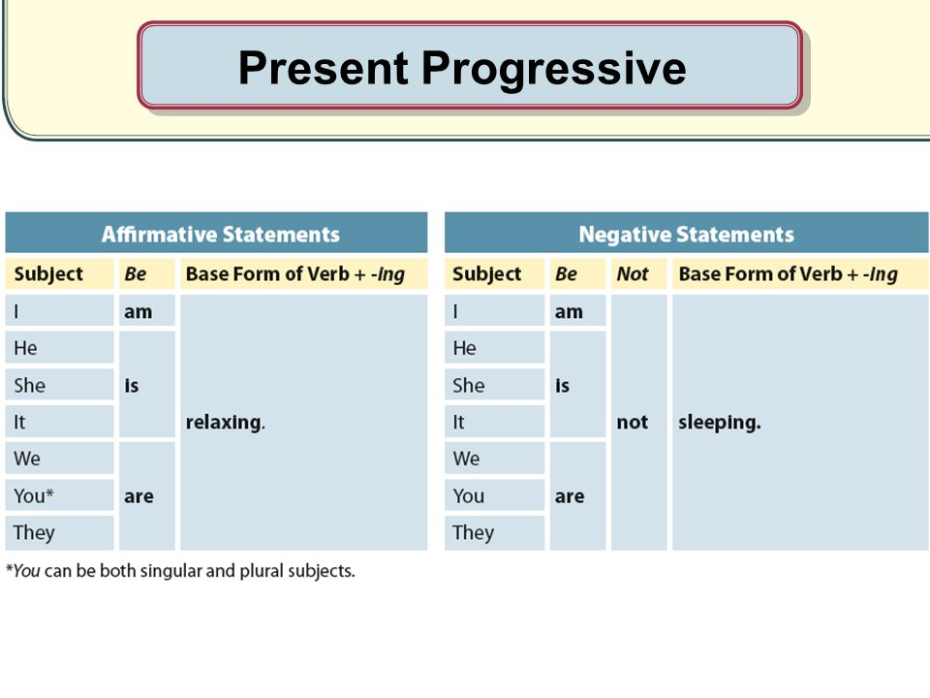  Like that!  Drill – drill the spoken form, focusing on contractions, stress and intonation.  Everybody listens and repeat 3 (gestures) after Ask individual.  Where is stress? ( studying) check with red pen.
Stage Name: Controlled Practice
Purpose of this stage: students practice working with the form (scrambled sentences, split sentences, select the correct form of the verb, correct incorrect sentences, and change one form into another form). Accuracy must be checked.
Materials: List all materials that will be needed in this stage.
Timings | Interactions |  | Procedure
30 sec  3 min  1 min 30 sec  1 min | T  S  S – S  T - S |  | Instructions.  Now we goanna do some activity. We have two exercises. But now please do exercise A only. It is individual work. you have 3 minutes. After 3 minute we will pair check.  ICQ.  1. Are we doing Exercise A or B? (Exercise A.)  2. Are we working alone or as a group? (Alone.)  3. How much time do we have? (3 minutes.)  Students do a worksheet.  Pair check.  Feedback to check accuracy. Board correct answers visually.
Stage Name: Less Controlled Practice
Purpose of this stage: students practice working with the meaning (match a timelines to sentences, choose the sentence that matches a picture, gap-fill a paragraph). Accuracy must be checked.
Materials: List all materials that will be needed in this stage.
Timings | Interactions |  | Procedure
30 sec  3 min  1 min 30 sec  1 min | T  S  S-S  T-S |  | Instructions.  Turn over your worksheet. Now please do Exercise B.  You have 3 minutes for this activity.  Students do the worksheet (Monitor)  Pair check  Feedback to check accuracy.
Stage Name: Production – Freer Practice
Purpose of this stage: is to get students to practice the grammar communicatively.
Materials: List all materials that will be needed in this stage.
Timings | Interactions |  | Procedure
30 sec  4 min | T  S-S |  | Instructions. (Visual.)  What are you doing these days? Please talk to partner. For example) I am starting new exercise. I am studying TESOL these days. Talk about like that.  Students do a productive task which requires natural communication. For example, if the grammar taught in this lesson was about the present simple to talk about general truths or facts, then getting students to talk about general truths and facts would be suitable. E.g. Talk to your partner about the weather in your country. [It rains in summer, and it is hot. Winter is cold…. etc.]
Stage Name: Wrap-up
Purpose of this stage: is to end the lesson on a positive note so that students feel they have achieved progress.
Materials: List all materials that will be needed in this stage.
Timings | Interactions |  | Procedure
1 min | T – S |  | Give Feedback.  How was it? Do you understand present progressive?  Can we use present progressive only for now? (No)  Yes correct! You guys do well. I am so glad to you.  We do not have homework.  See you guys!

Instructor’s Comments and Assessment
Pros
Cons
Change
Overall Comments
Grade
Above Standard 85%-100% | Standard 70%-84% | Below Standard 69%-0%
Instructor | Student Signature | Date
Taute, David

Exercise A
Change the sentence to the new form. Write your answers neatly.
Example
Positive: Hannah is studying English.
Negative: Hannah isn’t studying English
Question: Is Hannah studying English?

1) Positive: I am living in London.
Negative: ____________________________________________________________________________________________ Question: ____________________________________________________________________________________________

2) Positive: ____________________________________________________________________________________________
Negative: I am not taking this subject. Question: ____________________________________________________________________________________________

3) Positive: ______________________________________________________________________________________
Negative: ____________________________________________________________________________________________
Question: Am I looking for a new job?

4) Positive: He is wearing a mask.
Negative: ____________________________________________________________________________________________
Question: ____________________________________________________________________________________________

5) Positive: ____________________________________________________________________________________________
Negative: she is not working at the library. Question: ____________________________________________________________________________________________
Exercise B

- Oh! You look different, how are you?
I am ___________ (exercise) more these days.

- Who do you live with?
I am __________ (not / live) with parents I am ______(stay) with Bonnie and Yungju.

- Where is Bonnie?
She is ______________(travel) in USA.

4. How do you spend your time these days?
I am ________ (learn) English these days.

5. How many courses are you taking in this term?
I am ______(take) five course in this term.

Answer Sheet
Exercise A
Change the sentence to the new form. Write your answers neatly.
1) Positive: I am living in London.
Example
Positive: Hannah is studying English.
Negative: Hannah isn’t studying English
Question: Is Hannah studying English?
Negative: I am not living in London.
Question: Am I living in London?

2) Positive: I am taking this subject.
Negative: I am not taking this subject. Question: Am I taking this subject?

3) Positive: I am looking for a new job.
Negative: I am not looking for a new job.
Question: Am I looking for a new job?

4) Positive: He is wearing a mask.
Negative: He is not wearing a mask.
Question: Is he wearing a mask?

5) Positive: She is working at the library
Negative: she is not working at the library. Question: Is she working at the library?

Exercise B

- Oh! You look great, how are you?
I am exercising more these days.

- Whom do you live with?
I am not living (not / live) with parents I am staying with Bonnie and Yungju.

- Where is Bonnie?
She is taking a trip to the USA

4. How do you spend your time these days?
I am learning English these days.

5. How many courses are you taking in this term?
I am taking five courses in this term.

