Background Information Sheet
Name | Class | Date | Lesson Type | Plan type | Length
Manny Kim | TESOL | 26.08.2020 | Reading | PPP | 30min

Lesson
Topic | Singing Dad
Main Aim | Students will practice their reading comprehension.
Secondary Aim | Students will practice their speaking fluency.

Materials and References
PPT, TV, Board, colored markers and worksheets.

Student Profile
Level | Elementary
Age | 8 Years old. | Number of Students | 2
Detail | Students are elementary level of Korean. They are both females and is motivated to learn English.  They need to be relaxed before they will join the class and to communicate freely.

Anticipated Difficulties and their Solutions:
-Nervousness at the beginning of the lesson Check all materials are ready (picture, story to read, worksheets, back up activity, white board and colored markers). Follow teacher’s script and speak slowly. gain students’ attention with assured voice and gesture. Time management will be checked by smartphone stopwatch.
-Every student may not have similar reading speed Prepare an appropriate level and length of the text for student can be read in time. Monitor the students carefully to make sure every students are focusing to follow the lesson.
-Keywords The students may not know all the vocabulary in the text. Teach the students keywords by asking them appropriate CCQs in the presentation stage, so that they can be gained comprehensible information before reading the text.

My Personal Aim
What I hope most to demonstrate in this lesson is the ability to
- be an enabler type of teacher in teaching reading comprehension
- give good instructions, monitor students carefully and give them proper feedback.

Stage Name: Lead-in
Purpose of this stage: To relax both the teacher and students. To focus attention on the lesson. To lead in to the topic, activating background knowledge – this will help to contextualize the text. This is a BEFORE READINING stage.
Materials:
Timing | Interaction | Procedure
30 sec  1 min  30 sec | T  T-S  S-S  T-S | Organize seating arrangements, two students are sitting together, so that they can do pair work and can easily see the board.  Hello, everyone. Do you like singing? Can you hum to sing? Guess what song it is?  (Do hum with ‘London bridge is falling down’)  Which song do you hum most in your life?  Talk to your partners about it. You have 1 min.  Monitor student for any use of keywords.  Feedback. Teacher ask the students to share what they talked about.

Stage Name: Presentation
Purpose of this stage: To pre-teach keywords if necessary, and answer a guiding questions (such as a predicting task, or a specific question). These steps provide extra help for students to comprehend the text. This is a BEFORE READINING stage.
Materials: White board, Colored pen
Timing | Interaction | Procedure
1 min  1 min  1min  10 sec  1 min  50 sec | T-S  T-S  T-S  T  S – S  T – S | Pre-teach keywords: shed, digging, chopping  Elicit-shed  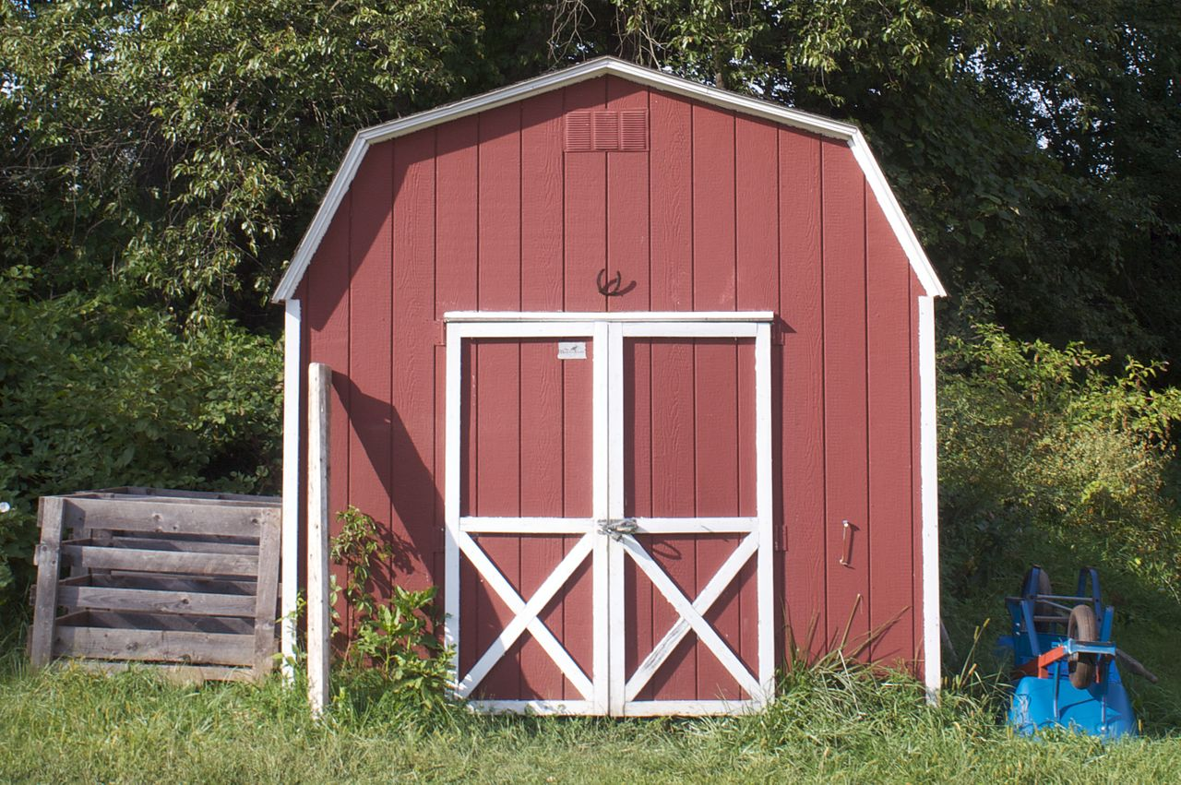  Loot at this picture. What do you see?  Yes. That’s right. It looks like a small house. In America or UK, you can often see this small house to store things to fix something. What is it called? (shed)  Listen to answers from students. If students don’t seem to know the word, tell them the word to save time.  CCQ – Is ‘shed’ related to store something? (Yes.)  Do people fix something in this place? (Yes.)  Can it usually describe a small warehouse? (Yes.)  Drill – Listen and repeat 3 times. (Gesture)  Nominate 2 or 3 individually.  If needed, correct students’ pronunciation.  Board – Write ‘shed’ on the board.  How many syllables? (1) Mark with a blue pen.  Where is the stress? (on the ‘e’) Mark with a red pen.  What type? (Noun)  Elicit-digging  Loot at this picture. What do you see?  Yes. That’s right. It’ is dog. What is he doing? What is it called? (shed)  Listen to answers from students. If students don’t seem to know the word, tell them the word to save time.  CCQ – Is it acting? (Yes)  Can you do it with a shovel? (Yes)  Drill – Listen and repeat 3 times together. (Gesture)  Nominate 2 or 3 individually.  If needed, correct students’ pronunciation.  Board – Write ‘digging’ on the board.  How many syllables? (2) Mark with a blue pen.  Where is the stress? (first ‘i’) Mark with a red pen.  Elicit-chopping  Loot at this picture. What do you see?  Yes. That’s right. What is he doing? What is it called? (chopping)  Listen to answers from students. If students don’t seem to know the word, tell them the word to save time.  CCQ – Is it cutting something? (Yes.)  Do you use knife or ox to cut it? (Yes.)  Drill – Listen and repeat 3 times together. (Gesture)  Nominate 2 or 3 individually.  If needed, correct students’ pronunciation.  Board – Write ‘chopping’ on the board.  How many syllables? (1) Mark with a blue pen.  Where is the stress? (on the ‘o’) Mark with a red pen.  Guiding Question  Why people like to sing? Why some other people don’t like to sing?  “Talk to your partner about the reasons?”  Students discuss the question with a partner.  Feedback. Nominate students to share their ideas.

Stage Name: Practice – Literal Comprehension
Purpose of this stage: is to get students to practice reading for literal detail. They will also practice fast reading (skimming and scanning). This is a WHILE READINING stage.
Materials: List all materials that will be needed in this stage.
Timing | Interaction | Procedure
30 sec  2 min  10 Sec  30 Sec  1 min | T | Instructions. Prepare the story book. Hand out the story book and worksheets.  Hold up the story book and the worksheet. I’m going to give you a short story book and worksheet. Work individually and do Exercise A only. Answer the questions as quickly as possible.  I.C.Q:  What do we do? (Exercise A)  Do you work with your partners? (No.)  Do you do Exercise B? (No.)  Hand out the worksheet. You have 2 min.  Students read the whole text for the 1st time, and write answers on the worksheet.  Students do the worksheet individually. Monitor the students to see who has the right answers and who has wrong answers. Also check who is finished.  Time’s up. Please compare your answers with your partners.  Pair checks (group check). Monitor.  Feedback to check accuracy.  Ask students for their answers, checking if their answers are same or different

Stage Name: Practice – Interpretive Comprehension
Purpose of this stage: is to get students to get students to practice interpreting a text correctly This will require more detailed, careful reading, and thinking time to arrive at the correct answer. This is a WHILE READINING stage.
Materials: List all materials that will be needed in this stage.
Timing | Interaction | Procedure
30 sec  4 min  10 sec  1 min  2 min | T  S  T  S-S  T-S | Instructions. Set the purpose for reading.  Okay, let’s do answer to the question in Exercise B.  This question requires more deep thoughts. Read carefully and write down the answers individually.  I.C.Q:  What do we do now? (Exercise B)  Do you work with your partners? (No.)  You have 4 minutes.  Students read for the 2nd time. Students write their answers down.  Students do the worksheet individually. Monitor the students to see who has the right answers and who has wrong answers. Also check who is finished.  Time’s up. Please check your answers with your partners.  Pair checks (group check). Monitor.  Feedback to check accuracy.  Ask students for their answers, checking if their answers are same or different

Stage Name: Production - Applied Comprehension
Purpose of this stage: is for students to practice their speaking fluency and is related to the lesson topic. This is an AFTER READINING stage.
Materials:
Timing | Interaction | Procedure
30 sec  8 min  1 min | T  S-S  T-S | Instructions. Give students a question to discuss in pairs.  Okay, clear your story book from your desk. And do exercise C.  “All right. Talk about it with your partner. It doesn’t have right answer, you can just share your thought about it. You don’t need to write on your paper. I’ll give you enough time to talk.  Now, let’s begin.”  Students discuss. Teacher monitor from a distance.  Feedback. Students share their ideas with the class.  Ask the students to share what they talked about.

Stage Name: Wrap-up
Purpose of this stage: is to end the lesson on a positive note so that students feel they have achieved progress. This is an AFTER READINING stage.
Materials:
Timing | Interaction | Procedure
2 min | T | Offer delayed corrections to the previous stage.  Make some correction and then move to the wrap up.  “Well done guys. Thank you for sharing your ideas.”  “Which part is the most?” (Student answers)  “Yes, It is a little bit hard, but you guys did it very well. I could see a lot of valued answers.  Set homework.  ‘For homework, bring some story book and share the story in the class tomorrow.  But you need to pick one of the Oxford reading tree stage 4 and introduce to the class. Thank you.  Dismissed  Thank you for attending the class today. See you tomorrow.

Instructor’s Comments and Assessment
Pros
Cons
Change
Overall Comments
Grade
Above Standard 85%-100% | Standard 70%-84% | Below Standard 69%-0%
Instructor | Student Signature | Date
Taute, David

PPT 1

PPT 2
PPT 3

Worksheet

Exercise A : Read the text and answer the questions.
- Who likes to sing the most amoing the family?

- Which animals did dad sing to?

- What did mom say to day?

4. Who sang with dad?

5. What did mom do in the end of the story?

Worksheet

Exercise B : Read the text and answer the questions.
- Why the mom told to dad ‘I’m fed up with that song?

- Does mom don’t like to sing?

- Does the doughter likes to sing eighter?

Worksheet
Exercise C
1. Do you have experiences that your family didn’t suppurt you when you
Really like to do?

2. Do you think family means that always support other family member?

3. If your dad says, ‘I want to be a singer’ but your dad can’t sing very well.
Whad would you say to dad?

4. Do you think that your family think you that you are support them?

