Background Information Sheet
Name | Class | Date | Lesson Type | Plan type | Length
MARYAM | TESOL | 8/29/2020 | Reading | PPP | 30 min

Lesson
Topic | “The blue door”
Main Aim | Students will practice their reading comprehension.
Secondary Aim | Students will practice their speaking fluency.

Materials and References

Student Profile
Level | Intermediate
Age | Adults | Number of Students | 2
Detail | Students are both Koreans, they are motivated to learn English, their listening skills are good, but they have some difficulties in reading.

Anticipated Difficulties and their Solutions:
Students may have some difficulties to pronounce words ~> Give them easy words to pronounce, and speak clearly, drill several times chorally.
Time management ~> If you’re running out of time, tell the students to skip some questions to gain more time.

My Personal Aim
What I hope most to demonstrate in this lesson is the ability to write out a complete, detailed reading plan, and to help students to read effectively and faster.
Stage Name: Lead-in
Purpose of this stage: To relax both the teacher and students. To focus attention on the lesson. To lead in to the topic, activating background knowledge – this will help to contextualize the text. This is a BEFORE READINING stage.
Materials: None.
Timing | Interaction | Procedure
30 sec  2 min  30 sec | T  T-S/S-S  T-S | Good morning guys! Please clean up your desks, we will talk together a little.  Yesterday, I saw a scary movie about ghosts and I couldn’t sleep well, because I was scared. By the way do you believe in ghosts? Please talk to each other and let me know what do you know about them. (If the students said that they don’t believe in ghosts, ask them about the raison.)  That’s enough for now. Thank you for sharing your beliefs with us.

Stage Name: Presentation
Purpose of this stage: To pre-teach keywords if necessary, and answer a guiding questions (such as a predicting task, or a specific question). These steps provide extra help for students to comprehend the text. This is a BEFORE READINING stage.
Materials: Pictures, board, colored markers.
Timing | Interaction | Procedure
2 min  10 sec  1 min  1 min | T-S  T  S-S  T-S | Pre-teach keywords  Elicit – “Temptation”  Show the picture (Look at this picture what do you see?) If the students couldn’t know the word just say it.)  CCQ  - Is she trying to steal something? (Yes.)  - Is she doing something good? (No.)  - Does she look scared? (Yes)  Drill  Listen and repeat Temptation X3 (Nominate for individual drilling.)  Board  Write the word on the right side of the board.  How many syllables we have? (3) Mark with a blue marker. (Temp•ta•tion)  Where is the stress? (2nd) Mark with a red marker. (Temp’tation)  Elicit – “Bored”  Show the picture (Look at this picture what do you see? How does he look?) (Bored.)  CCQ  - Does he feel happy? (No.)  - Does he have something to do? (No.)  - Is he doing something interesting? (No.)  Drill  Listen and repeat Bored X3 (Nominate for individual drilling.)  Board  Write the word on the board.  How many syllables we have? (1) Mark with a blue marker.  Where is the stress? (‘Bored)  Elicit – “Chase”  Show the picture (Look at this picture and tell me what are they doing)  CCQ  - Is the policeman following the criminal? (Yes.)  - Is the policeman walking or running? (Running.)  - Did the policeman catch the criminal? (No.)  Drill  Listen and repeat chase X3 (Nominate for individual drilling.)  Board  Write the word on the board.  How many syllables we have? (1) Mark with a blue marker.  Where is the stress? (‘Chase)  Guiding Question  If your mother warns you not to go to a certain place, and she doesn’t tell you the reason, but you insist on going, would you go? And why would you not heed the warning? (discuss with your partner.)  Students discuss the question with a partner.  Feedback. Nominate students to share their ideas.

Stage Name: Practice – Literal Comprehension
Purpose of this stage: is to get students to practice reading for literal detail. They will also practice fast reading (skimming and scanning). This is a WHILE READINING stage.
Materials: Worksheets.
Timing | Interaction | Procedure
30 sec  2 min  1 min  1 min | T  S  S-S  T-S | Okay guys, it’s time to read a really nice story about the blue door.  Instructions  First read the question for exercise A, and try to find the answer quickly in the story, when you find the answer underline the answer. Don’t answer the exercise B.  I.C.Q  - Are you going to read carefully first? (No.)  - Are you going to read the questions first or the story first? (The story first.)  - Do you go slowly or quickly? (Quickly.)  - Do you turn over and do the exercise B? (No.)  - Are you ready? (Yes.)  Hand out the worksheets.  Students read the whole story for the 1st time, and write answers on the worksheet.  Monitor from distance  Pair check. Now compare your answers with your partner (Students talk to each other and sharing answers.)  Feedback to check accuracy. Ask students for answers, check if the other student has the same or different answer.

Stage Name: Practice – Interpretive Comprehension
Purpose of this stage: is to get students to get students to practice interpreting a text correctly This will require more detailed, careful reading, and thinking time to arrive at the correct answer. This is a WHILE READINING stage.
Materials: Worksheets.
Timing | Interaction |  | Procedure
30 sec  4 min  1 min  2 min | T  S  S-S  T-S |  | Instructions  Turn over your worksheet, it’s time to do the exercise B, these questions are more difficult. So, read the story slowly and carefully and write your answer.  I.C.Q  - Are you going to read carefully and slowly? (Yes.)  - Do you write your answer or just think about it? (Write the answer)  - Do you have to answer individually or with the group? (Individually)  Students read for the 2nd time. and write their answers down.  Monitor from distance  Pair check. Now compare your answers with your partner (Students talk to each other and sharing answers.)  Feedback to check accuracy. Ask students for answers, check if the other student has the same or different answer. And agree about one answer.
Stage Name: Production - Applied Comprehension
Purpose of this stage: is for students to practice their speaking fluency and is related to the lesson topic. This is an AFTER READINING stage.
Materials: None.
Timing | Interaction | Procedure
30 sec  9 min | T  S-S | Alright guys. Now I want to ask you: Has something strange ever happened to you, and you thought it was something supernatural, in your house or somewhere? (Please talk with your partner about it.)  Students discuss. Students share their stories.

Stage Name: Wrap-up
Purpose of this stage: is to end the lesson on a positive note so that students feel they have achieved progress. This is an AFTER READINING stage.
Materials: None.
Timing | Interaction | Procedure
2 min | T | Lesson feedback.  Now tell me which question was the hardest for you? (Student: Q 2 ex B) Ask the other student (Do you agree with her?) If they agree then tell them: Yes, it was a really hard question I know, but well done for trying so hard. Keep up the good work you’re getting better.  Set a homework.  Next time we will learn the writing lesson, so I want you to try to write a short story on any topic of your choice, and come to tell it to your friends in the class.
Instructor’s Comments and Assessment
Pros
Cons
Change
Overall Comments
Grade
Above Standard 85%-100% | Standard 70%-84% | Below Standard 69%-0%
Instructor | Student Signature | Date
Taute, David
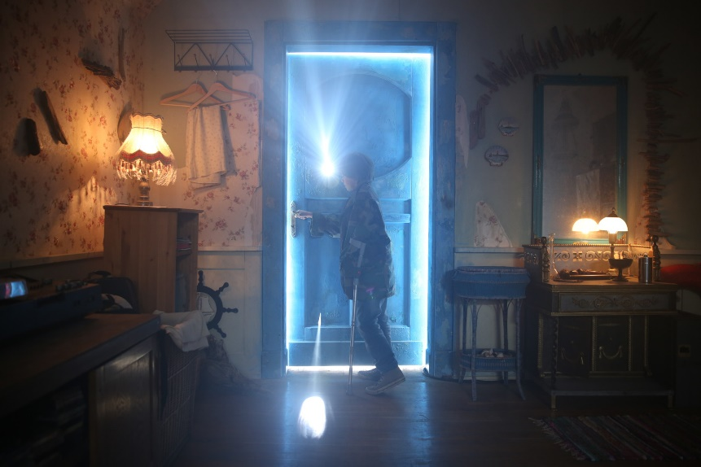
The blue door

One upon a time, there was a young boy who was bored sitting at home. He decided to go for a walk around this house, but just before he left, his father said "Walk where you want, but don't open that blue door."
The boy was walking all around the house, opening and closing doors. He quickly grew bored again, but then he came to the blue door.
Temptation got the better of him and, even though his father had forbidden him to open the door, he decided to open it anyway.
He twisted the door know and opened it a crack. Suddenly, a horrible skeleton popped out and chased him around the house.
Running down the stairs with the skeleton in hot pursuit, the boy began shouting for his father.
“Dad! Dad!”, he screamed.” There’s a skeleton chasing me!”
His father appeared, holding an axe, and chopped the skeleton into little pieces.
“I told you not to open that door” said his father. “Now, go back to what you were doing, but make sure you don’t open the blue door again.”
The boy began walking around the house again, and soon he got bored. He went back upstairs and opened the blue door. Suddenly, a terrible headless man popped out and chased him around the house.
The boy ran back downstairs and screamed for his father.
“Dad! Dad!”, he cried.” There’s a headless man chasing me!”
His father appeared, holding a shotgun, and blasted the headless man with both barrels.
“This is the last time I’m going to warn you”, said his father. “Do not open that blue door. If you do, you only have yourself to blame.”
The boy began walking around the house again, for things to do. Soon he was out of ideas. He stood in front of the blue door, wondering if he should risk opening it again. Curiosity got the better of him and he twisted the knob. The door swung open wide and his father was standing inside, holding an axe.
“I warned you!” screamed the father as he chopped his son into little pieces.
Worksheet 1: “The blue door”

Exercise A: Read the story quickly and write the answer next to the question.

- Why did the boy decide to walk around the house? Because he was

bored.

- What did the father say to the boy? He said to the boy “ Don’t open the

blue door.”

- What was the first thing that popped out of the door? A skeleton.

- What did the father do to the headless man? He blasted the headless

man with both barrels.

- How many times did the boy open the door? Three times.

Exercise B: Read the story for the 2nd time carefully and write the answer next to the question.

- Why did the father warn the boy not to open the blue door? Because

he knew what was behind the door, so he was trying to hide the truth

from the boy.

- Why did the boy keep opening the door for the second and third times, after getting chased by a skeleton and a headless man? Because his

curiosity was stronger than his fear, so he just wanted to see what will

come out of the door every time.

- Why did the father use two different weapons to kill the skeleton and the headless man? He uses the axe because it was the way he killed

the mother, and he used the shotgun because it was the weapon the

real father used when he was trying to kill the man, so he took it from

him and shot him in the head.

- What was the father doing inside the blue door? He was waiting for the

boy to kill him, because the boy has already figure out the truth behind

the blue door.

- Why did the father kill his son? He is not his real son, because there’s

no father can kill his son just because he has opened a door.

