Background Information Sheet
Name | Class | Date | Lesson Type | Length
Seojun Lee (Jason) | 212WD | 20/10/11 | Speaking | 20minutes

Lesson
Topic | What is a healthy lifestyle?
Main Aim | Students will practice their speaking fluency.
Secondary Aim | Students will practice speaking spontaneously.

Materials and References
Worksheet

Student Profile
Level | Advanced
Age | Adults | Number of Students | 3
Detail | This is a general English class and the students are highly motivated learners. The students are all Korean, and there is a strong rapport among the students. They are accustomed to group work, but still need to be relaxed before they will open up to communicate freely. They engage actively in kinaesthetic learning and tend to favor the visual learner mode, but auditory learning still needs developing.
Assumptions about students’ knowledge as required for this lesson:
Students are quite familiar with speaking activities and have a general idea about the topic.

Anticipated Difficulties and their Solutions:
Some students are likely to dominate the discussion -> Get students to take turns speaking, and make them wait for their turn.
Desk arrangements -> Move desks in U-shape

My Personal Aim
What I hope most to demonstrate in this lesson is the ability to correct an error made by the students.

Stage Name: Pre Task
Purpose of this stage: Create interest in the topic. Brainstorm ideas which will be useful for the next stage. Students must be given a communicative task e.g. discuss, arrange/sort, create a list, etc.
The aim is to relax students, activate their background information, and gather useful ideas for the lesson.
Materials:
Time | Interaction | Procedure
30 sec  2 mins  1 min | T - S  S - S  T - S | Today we are going to discuss what a healthy lifestyle is and what we can do to stay healthy.  First, we need to understand what a healthy lifestyle is.  (Give an example.)  Personally I think getting an adequate amount of sleep is very important. Somewhere between 7 to 9 hours a day.  Ask students if they agree.  Now discuss as a group what you think makes a healthy lifestyle? And explain the reasons behind it.  I will give you 2 mins. Begin (Gesture to begin)  Students discuss.  Clap to inform time is up and grab their attention.  Feedback. Nominate one student to share their idea with the class.  Ask the rest of the group if they agree.

Stage Name: Task Preparation
Purpose of this stage: This is a student centered stage, to give students time to prepare and practice a speaking task which they will perform in Task Realization. Clear detailed instructions or a demonstration must be provided so students know what is expected. Prepared materials may be provided to assist their preparation. Monitor and offer brief tips if necessary.

Materials: List all materials that will be needed in this stage.
Time | Interaction | Procedure
1 min  4 mins  2 mins | T  S - S  T - S | Now I will give each of you this handout which contains a list of daily activities for a healthy lifestyle. First discuss some of the activities as a group then individually choose one that you think is the most important. And everyone has to choose a different one. So it’s important to discuss as a group first so that you guys don’t pick the same one.  ICQ - Do you need to write anything? (No)  Do you choose one or two from the list? (One)  Can you choose the same one as the person next to you? (No)  Distribute the list, one per student.  You have 4 mins. Begin.  Students discuss as a group and they each choose one from the list. They cannot choose the same one so monitor for persuasive and reasoning language.  Feedback. Nominate 1 student from the group. Draw out some reasoning behind why they chose the particular activity.

Stage Name: Task Realization
Purpose of this stage: This is a very student centered stage to allow for maximum speaking fluency practice. Monitor discretely and take note of incorrect language. Students perform their task without interruptions from the teacher. Classroom management may be an important consideration here.
Materials: List all materials that will be needed in this stage.
Time | Interaction | Procedure
30 sec  5 mins | T  S - S | Now that we all have one from the list. I’d like you guys to work together as a group and rank them in order of importance from 1 to 3 but you have to all agree. You can explain why you think yours is more important and maybe you can talk about your own experiences.  I will give you 5 minutes. Begin  Students discuss as a group to compromise on ranking.

Stage Name: Post Task
Purpose of this stage: To end the lesson with a final student centered task such as voting, summarizing, discussing, deciding etc. The teacher may offer delayed error correction to the previous stage, as well as mention positives and points to improve for next time such as useful strategies.
Materials: List all materials that will be needed in this stage.
Time | Interaction | Procedure
30 sec  3 min  30 sec | T  S - S  T | Now as a group discuss if there is anything you’d like to add to the list?  Explain.  Students discuss.  Feedback. Nominate 1 student to share what they have added to the list.  END.

Worksheet

- Wake up early
- Get good quality sleep (7-9 hours a day)
- Drink 2 litres of water a day
- Drink alcohol every day
- Manage stress with self-care activities (meditation, prayer, read)
- Practice gratitude - writing one thing you’re grateful for
- 30 minutes of exercise every day (gym, walk, bicycle)
- Have a positive mindset
- Include fruits and vegetables in your diet
- Floss and brush your teeth every two days
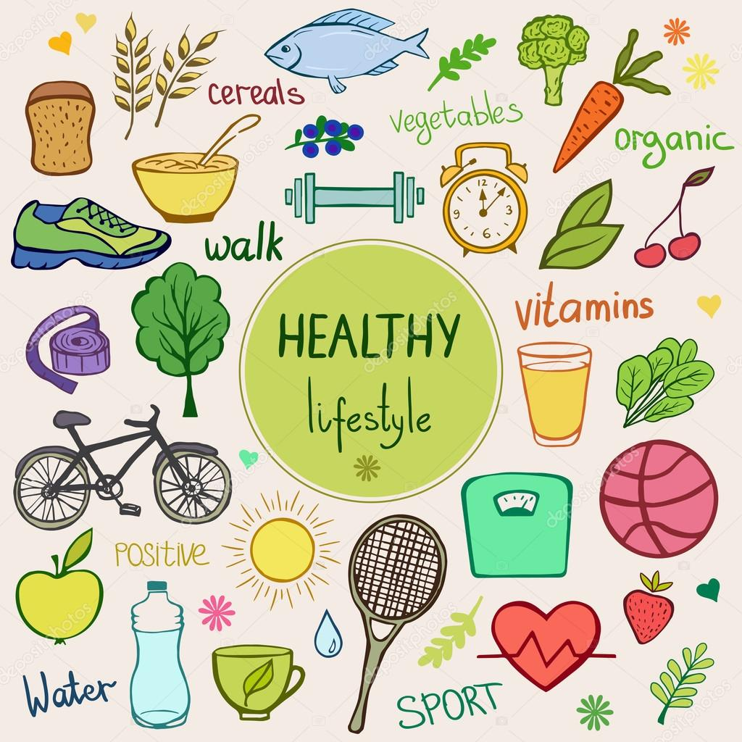

Instructor’s Comments and Assessment

Pros
Cons
Change
Overall Comments
Grade
Above Standard 85%-100% | Standard 70%-84% | Below Standard 69%-0%
Instructor | Student Signature | Date
Taute, David

