Background Information Sheet
Name | Class | Date | Lesson Type | Plan type | Length
Kim hyeonghae(KIM) | TESOL | 28/10/2020 | Reading | PPP | 30min

Lesson
Topic | Advice from elderly for younger generation.
Main Aim | Ss practice their reading comprehension.
Secondary Aim | Ss practice their speaking fluency.

Materials and References
PPT, Quiz(https://www.buzzfeed.com/emmget853/answer-these-questions-and-i-will-give-you-some-ad-bea92iq2ng), Article(https://metro.co.uk/2020/10/20/elderly-people-care-home-share-advice-to-younger-generations-13449325/), Board with colorful board pens, Worksheet

Student Profile
Level | Intermediate
Age | 20-35 | Number of Students | 3
Detail | Students are highly motivated to learn English. They are able to understand the main points of clear standard text which are familiar to them. They can produce simple connected text on topics which are familiar or of personal interest.

Anticipated Difficulties and their Solutions:
1) Students could spend much time than they’re supposed to do when doing the “skim/scan”.
→give clear instruction about time limit, so they can read fast and don’t re-read.
2) Students could not be interested in the topic.
→ make a proper lead-in so that the students could be interested in the topic.

My Personal Aim
What I hope most to demonstrate in this lesson is the ability to lead the lesson with proper time management, clear instructions.

Stage Name:Lead-in
Purpose of this stage:To relax both the teacher and students. To focus attention on the lesson. To lead in to the topic, activating background knowledge – this will help to contextualize the text. This is a BEFORE READINING stage.
Materials: Quiz(https://www.buzzfeed.com/emmget853/answer-these-questions-and-i-will-give-you-some-ad-bea92iq2ng)
Timing | Interaction | Procedure
30 sec  1 min  1 min-  30sec | T  S  T-S | Greet. Instructions.  Hello guys, I want you to go to the website which I sent you already.  Let’s have a quick quiz.  Students are doing the quiz and get the result.  Ask students few questions related with the main topic.  T: So how is the advice you got? In general, why is the advice beneficial for us?

Stage Name:Presentation
Purpose of this stage:To pre-teach keywords if necessary, and answer a guiding questions (such as a predicting task, or a specific question). These steps provide extra help for students to comprehend the text.This is a BEFORE READINING stage.
Materials: PPT, board with colorful board pens
Timing | Interaction | Procedure
4 min  20 sec  1 min  30 sec | T-S  T  S-S  T-S | Pre-teach keywords ; reflect, experience, thoughtful  <reflect>  1) Elicit  show a picture, and try to elicit the word with questions.  T: what do you think he’s doing? / S: He’s thinking about something.  T: Right, he’s thinking hard about something. How can you describe what he’s doing in another word?  S: Reflect?  T: what word, again? Reflect.  2)CCQ  1) Does he think of something carefully? (yes)  3)Drill  Ask students repeat the word 3 times, chorally. Then, individually.  4)Board  Write the word “reflect” on the board. And ask three questions related with syllables, stress, and type of word.  -how many syllables? Two  -where is the stress? 2nd  -what type of the word is it? Verb  <experience>  1) Elicit  show a picture, and try to elicit the word with questions.  T: What is she doing?  S: Travelling?  T: Yes, travelling, then what can she gain/get from it?  S: Experience.  T: what word, again? Right, experience.  2)CCQ  1) She got a lot of experience, did she get the knowledge of life?(yes)  2) Did she get the experience from one situation, or different situations? (from different situations)  3)Drill  Ask students repeat the word 3 times, chorally. Then, individually.  4)Board  Write the word “experience” on the board. And ask three questions related with syllables, stress, and type of word.  -how many syllables? four  -where is the stress? 2nd  -what type of the word is it? Noun  <thoughtful>  1) Elicit  show a picture, and try to elicit the word with questions.  T: Do you know the women? Right, mother Teresa. How can you describe her?  S: Helpful, kind..  T: Right, similar to kind?  S: Thoughtful?  T: What word, again? Right, thoughtful.  2)CCQ  1) Did she always think for others, to make them happy and comfortable? (yes)  3)Drill  Ask students repeat the word 3 times chorally. Then, individually.  4)Board  Write the word “thoughtful” on the board. And ask three questions related with syllables, stress, and type of word.  -how many syllables? Two  -where is the stress? 1st  -what type of the word is it? Adjective  Guiding Question  Give out the small paper with the headline of the article.  Ask the students to discuss “what kind of advice could be in the article.”.  Students discuss the question with classmates.  Ask them to share their opinion.

Stage Name:Practice – Literal Comprehension
Purpose of this stage:is to get students to practice reading for literal detail. They will also practice fast reading (skimming and scanning). This is a WHILE READINING stage.
Materials: article, worksheet
Timing | Interaction | Procedure
30 sec  2 min  1 min  1 min | T  S  S-S  T-S | Instructions. Set the purpose for reading. Hand out worksheets.  T: Now, please read the article and do the exercise 1 on the worksheet. Only exercise 1.  It’s an individual work. I’ll give you 2 min.  Ask I.C.Q for checking if the students understand the instruction.  -Which exercise are you going to do? (exercise A)  -How much time do you have? (2min)  Students read the whole text for the 1sttime, and write answers on the worksheet.  Pair check  T: Now, check your answers together with your classmates.  Feedback to check accuracy.  T: Let’s check the answers together.

Stage Name:Practice –Interpretive Comprehension
Purpose of this stage:is to get students to get students to practice interpreting a text correctly This will require more detailed, careful reading, and thinking time to arrive at the correct answer.This is a WHILE READINING stage.
Materials: article, worksheet
Timing | Interaction | Procedure
30 sec  3 min  1 min  2 min | T  S  S-S  T-S | Instructions. Set the purpose for reading. Hand out worksheets.  T: Now, let’s do the exercise 2. This time I want you read the article carefully and write the answer down below the question. Also, individual work. I’ll give you 3 min.  Ask I.C.Q. for checking if the students understand the instruction.  -Are you going to do together with your classmates? (no)  -Are you ready with your pen? (yes)  Students read for the 2nd time. Students write their answers down  .  Pair check. Monitor.  T: Now please check your answer with your classmates.  Feedback to check accuracy.  T: Now, let’s check the answer together. Can you share your opinion?

Stage Name:Production - Applied Comprehension
Purpose of this stage:is for students to practice their speaking fluency and is related to the lesson topic.This is an AFTER READINING stage.
Materials: worksheet
Timing | Interaction | Procedure
30 sec  7 min  1 min | T  S-S  T-S | Instructions. Give students a question to discuss in pairs or groups.  T: Now, we’re going to have a discussion time. Turn over your worksheet. Exercise 3. Firstly, choose your favorite question among two of them. Then discuss about it. I’ll give you 7 min.  Ask I.C.Q. for checking if the students understand the instruction.  -How much time do you have? (7min)  Students discuss  Feedback. Students share their ideas with the class. (Optional.)  T: Now, can you share your opinion?

Stage Name:Wrap-up
Purpose of this stage:is to end the lesson on a positive note so that students feel they have achieved progress.This is an AFTER READINING stage.
Materials: board with colorful board pens
Timing | Interaction | Procedure
1min-  40sec | T | Offer delayed error correction, if there’s any.  Give some compliments for encouraging the students.  T: Thank you for your participation, and happy to see you enjoy the class.  No homework for today, and tomorrow, we will have another article and have a discussion time mainly for your speaking practice. Thank you.

PPT

PPT

PPT

<Small paper with title of the article>
Elderly people in care home share advice for younger generations.

Elderly people in care home share advice for younger generations.
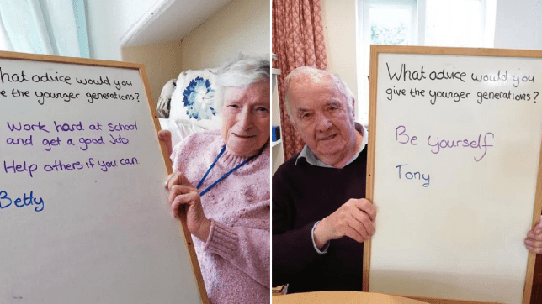
Elderly people in Yelverton Residential Home have shared some pearls of wisdom for younger generations.
The messages from the OAPs, who are aged between 75 and 104, have caught the attention of people online after they were posted on Facebook. The residents, who live at the home in Devon, were asked to reflect on their life experiences and offer any advice to young people.

They wrote their answers on a whiteboard, which they were then photographed next to. And it’s safe to say their responses have been making people smile.
One resident, Margaret, said it’s best to ‘spend all your money, enjoy yourself while you’re young, have some cheek and don’t be pushed around.’
She added: ‘If you’re nice to people more often than not they will be nice to you.’
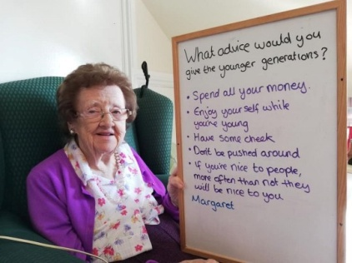 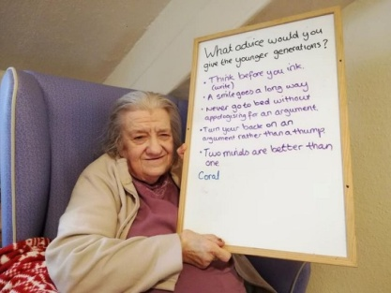
Coral had some very thoughtful advice for couples and relationships. She said: ‘Think before you ink, never go to bed without apologising for an argument, turn your back on an argument rather than a thump.’

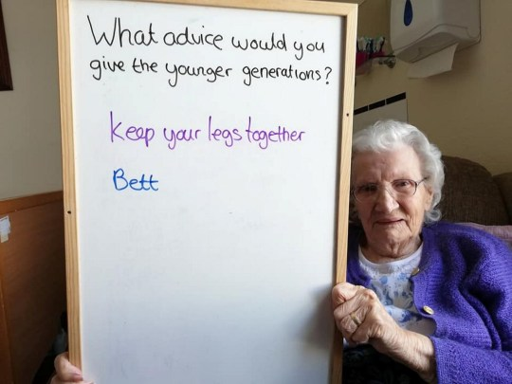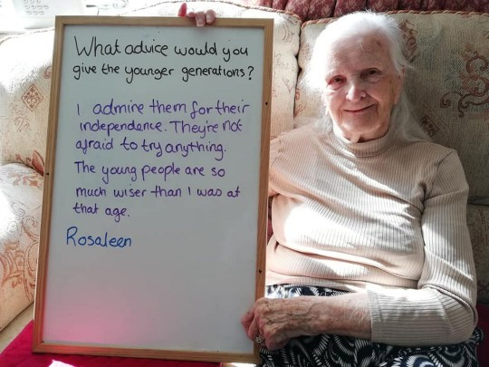

Bett, on the other hand, had some straight-talking advice. She simply said: ‘Keep your legs together.’
The oldest resident in the home, 104-year-old Rosaleen, wrote: ‘I admire them for their independence. They’re not afraid to try anything. The young people are so much wiser than I was at that age.’
Dottie said: ‘Always be helpful, and merry and bright.’
Alternatively, Betty told young people to ‘work hard at school, get a good job and help others if you can.’
Tony simply said: ‘Be yourself.’
Manager Peter Gaffney said the activity was part of the home’s varied programme to lift spirits during the coronavirus pandemic.
He commented: ‘In the early days of Covid it was to show everyone we were fine and in good spirits. But then we thought we have got a lot of life experience in here, our oldest resident is 104, and they are good characters so we thought we would give this a go.
We had seen it elsewhere but we were not expecting it to go off like it has on Facebook. But our residents have made a few wise comments that have made people laugh. ‘We just asked them to put their comments down and put it out there. We want to show that without visitors life is continuing and we can still connect with them.
‘It just shows all staff and residents are in good spirits even with all the anxieties with Covid.’

Worksheet

1) Exercise 1 : Read the text and answer the questions.
A) What kind of advice are being told from the elderly? Mark it with lines in the article.
B) When have the messages caught the attention of people online?
C) Who gave advice especially for couples and relationships?
D) Can they have visitors nowadays?

2) Exercise 2 : Read the text and answer the questions.
A) Why the advice from the elderly made people laugh?

Worksheet

3) Exercise 3 : Discuss the question with your classmates.
A) Among the advice in the articles, which one do you like most?

B) What needs to be considered before giving advice?

Answer sheet
1) Exercise 1 : Read the text and answer the questions.
A) What kind of advice are being told from the elderly? Mark it with lines in the article.
B) When have the messages caught the attention of people online?
(After they were posted on Face book)
C) Who gave advice especially for couples and relationships? (Coral)
D) Can they have visitors nowadays? (No)

2) Exercise 2 : Read the text and answer the questions.
A) Why did the advice from the elderly make people laugh?
(Because some of the advice are out of our expectation. For example, usually we expect to be told “Save money.”. But here they said, “Spend all your money.”. Also, the advice like “Keep your legs together.” is not expected to be told from them. That’s why people could laugh with it.

Instructor’s Comments and Assessment
Pros
Cons
Change
Overall Comments
Grade
Above Standard 85%-100% | Standard 70%-84% | Below Standard 69%-0%
Instructor | Student Signature | Date
Taute, David

