Keywords
Club

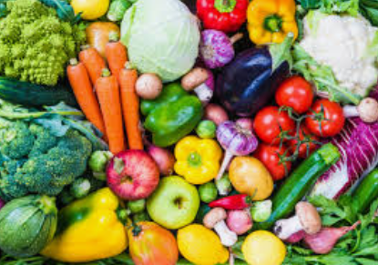
Veggies

Allowed
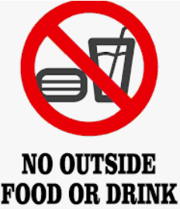

Worksheet 1

- Who can get into a club?
- What does Polly do?
- What vegetable is Polly?
- What do they do inside the club?
- Why did the water turn orange?
- What does Polly say to carrots?
Worksheet 2

- What made carrots change their minds about allowing other veggies to join the club? And why?
- Why did Polly paint herself?
- Why does Clive say that “who would have thought that a parsnip could be so interesting?”
- Why is there a rumor that the odd piece of fruit can come to the club?

