Background Information Sheet
Name | Class | Date | Lesson Type | Plan type | Length
Sammi Yoo | TESOL | 2/12/2020 | Listening | PPP | 30 min
Lesson
Topic | Planet Earth
Main Aim | Students will practice listening comprehension.
Secondary Aim | Students will communicate about the topic.
Materials and References
https://learnenglishkids.britishcouncil.org/short-stories/planet-earth

Student Profile
Level | Intermediate
Age | 7-8 year old | Number of Students | 3
Detail | Students are 1st/2nd graders in elementary school. They are familiar with topics related to planets, environment, and nature which many books/classes for those ages cover.  Students are all Koreans and they have experience in group work, discussion, and worksheet activity. They are highly motivated learners.
Anticipated Classroom Management Difficulties and their Solutions
Desk arrangements should be proper for group discussions.
The audio equipment could fail → Use my cellphone
Don't forget to print out work sheets in advance!!!!

My Personal Aim
I aim to make a complete lesson plan with which I can follow/complete without nervousness.

Stage Name: Lead-in
Purpose of this stage: To ease the mood and to get the students ready to participate in the class.
Teacher introduces topics.
Students will increase student talk by sharing their ideas with group.

Materials:
Time | Interaction | Procedure
30 sec  1 min  1 min | T  T-S/S-S  T-S | Hello everyone, What is this planet we are living on? (Earth) Planet Earth has many places such as mountain, river, and ocean.  Some people like forests, others like the sea. What is your favorite nature that you would like to go?  Share with your partners.  Tell me about the place you like, OOO

Stage Name: Presentation
Purpose of this stage: To make students to warm up their brain 1) by teaching 3 key words using the C.C.C and 2) giving students a guiding question. Through the discussion on the G.Q, students will have opportunity to think about something related to the listening topic and to communicate with others.

Materials:
Time | Interaction | Procedure
1 min  1 min  1 min  10 sec  2 min  1 min | T-S  T-S  T-S  T  S-S  T-S | Pre-teach keywords(oxygen, absorb, pollute)  ∙ oxygen : a gas that has no color or smell, is present in air, and is necessary for most animals and  plants to live. It is a chemical element: symbol O  ★ Elicit – What do we need in the air to breathe? People cannot live without this.  (Hint, if needed) A candle goes out if this is not around. Blood transports this around the body.  CCQ – Is oxygen a gas? (Yes)  Does it have color or smell? (No)  Who needs oxygen to live? (Animals, plants, people…)  Drill – Listen and repeat three times, oxygen 1/2/3. (Ask individual practice by indicating students in turn.)  Board – (Write the word on the board) “How many syllables?” (Three : ox/y/gen)  “Where is the stress?” (ox/y/gen) “Noun or verb?” (Noun)  ∙ absorb : to take in liquid, gas, or another substance from the surface or space around something.  ★ Elicit – (Putting dry coin tissue into a plate containing water) What is it doing with water?  CCQ – When something absorbs, does it take in or give out? (take in)  Let's take an example of plants. What do plants absorb? (Water, oxygen..)  So, do plants absorb liquid? (Yes) / Do plants absorb gas? (Yes)  Drill – Listen and repeat three times, absorb 1/2/3. (Ask individual practice by indicating students in turn.)  Board – (Write the word on the board) “How many syllables?” (Two : ab/sorb)  “Where is the stress?” (ab/sorb) “Noun or verb?” (Verb)  ∙ pollute : to make air, water, soil etc. dangerously dirty and not suitable for people to use.  ★Elicit – Look at this picture. What do you see? What does the gas from the factory do to the air?  CCQ – Is the water clean? (No)  Can people use the water? (No) Why not? (It's too/dangerously dirty)  Drill – Listen and repeat three times, "It's polluted" 1/2/3. (Ask individual practice by indicating students in turn.)  Board – (Write the word on the board) “How many syllables?” (Two : pol/lute)  “Where is the stress?” (pol/lute) “Noun or verb?” (Verb)  Guiding Question  What can happen/How would it affect nature if we do not recycle plastic bottles, paper bags, and cans?  Please discuss with your partners.  Students discuss with the group.  Feedback. Nominate a few students to share their ideas, if necessary.

Stage Name: Practice - Literal Comprehension Listening
Purpose of this stage: This is an accuracy focus step of listening. Students will listen to the audio for the first time. They should understand literal components; topic, words, changes of the subtopic. If they find it difficult to get the literal facts, play one more time with video this time.

Materials:
Time | Interaction | Procedure
1 min  3 min  1 min  1 min | T  S  S-S  T-S | Instructions. Set the purpose for listening. Hand out worksheets.  Now it's time to listen to a story about planet earth.  As you listen, you will do exercise 1. Don't read exercise 2 yet.  (Showing the paper,) Please fill in the blank when you catch the answer.  I.C.Q - Do you need to write down missing word on the line? (Yes)  Do we need to read the questions for exercise 2? (No)  Do you have a pencil and an eraser? (Yes)  ★ Read the question aloud for the students. Hand out the work sheet ★  Students listen for the 1st time, and write answers on the worksheet.  Pair check.  Compare your answer with others. Monitor.  Feedback to check accuracy.

Stage Name: Practice - Interpretive Comprehension Listening
Purpose of this stage: This is also an accuracy focus stage of listening. Students will listen a second time, more carefully to infer or interpret the meaning. In order to do the exercise, they should understand the literal facts and use general knowledge.

Materials:
Time | Interaction | Procedure
1 min  3 min  1 min  2 min | T  S  S-S  T-S | Instructions. Set the purpose for listening.  We will listen again and answer exercise 2.  Questions are more difficult this time, but if you listen carefully and think about what you know, you can find the answer. I will give you more time afterwards this time.  Write down your answer next to the question.  I.C.Q - Do you need to write down your answer next to the question? (Yes)  Do you need to rush to answer these questions?  (No. There will be more time to think and write after listening)  ★ Read the question aloud for the students. ★  Students listen for the 2nd time.  30 secs left.  Pair check. Monitor. If students need, then replay the audio a 3rd time.  Feedback to check accuracy.

Stage Name: Production - Applied Comprehension Speaking
Purpose of this stage: To make the students improve speaking fluency by talking to their friends. They also can express their thoughts in drawing and writing short/simple sentences.

Materials:
Time | Interaction | Procedure
15 sec  5 min  1 min | T  S-S  T-S | Instructions. Give students a question to discuss in pairs or groups.  Now, turn over you worksheets.  Talk to your partner about any of these questions.  You can share your ideas, listen to others, and ask questions freely.  I.C.Q. - Do you need to write anything for question a.? (No)  Do you need to draw and write for question b.? (Yes) Long writing for b.? (No)  Students discuss. (Monitor from a distance)  Feedback. Students share their ideas with the class.

Stage Name: Wrap-up
Purpose of this stage: To end the lesson on a positive note. Give them accomplishment, encourage students to continue progressing. Let them know what to do next.

Materials:
Time | Interaction | Procedure
2 min | T | Lesson feedback. Tell the class what they did well, and what needs to improve.  You guys did a good job on the challenged work, today. Guys don't forget the new words. We learned oxygen, absorb and pollute. You may see one of those words on your homework.  Set homework. This is your homework. ★ Hand out homework sheet(Make it right!).★  There are mistakes in the sentence. Underline it and write the correct word.(Read the example)  Do you have any questions?  Inform students about the topic for the next lesson.  Tomorrow we will do a reading lesson about Planet Earth.  Dismissed

Worksheet - Planet Earth
Exercise1 : Listen to the story.
Write the missing words in the sentences.
a. Forests are home to over half of the world’s animals and plants.
b. clean the air and produce oxygen for us to breathe.
c. The are home to millions of marine animals.
d. They absorb the ’s heat and transfer it to the atmosphere.
e. At opposite ends of the world, the and Antarctic are
freezing cold lands.
f. It is so cold that the sea is covered in .
g. Rivers collect water and carry it to the oceans.
h. Along the way, absorb and clean the water so it is safe
for us to drink.

Exercise2 : Listen carefully, think, and write your answer.
a. Why did the speaker talk about interesting facts about the world
we live in?

b. Why did the speaker mention 36 football fields of forest?

Exercise3 : Talk to your partner freely about questions below.

a. What can you do in daily activities to keep our world green?

b. Write and Draw.
Imagine living in the green world at the end of the story.
How do you respect nature Draw a picture and write about it!

Homework
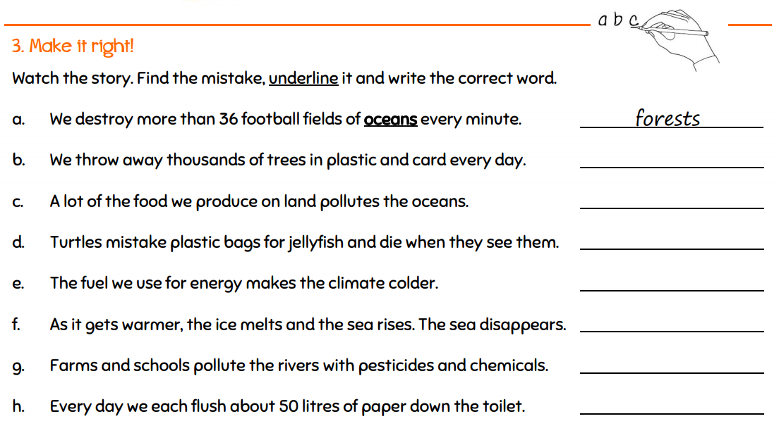
Make it right!

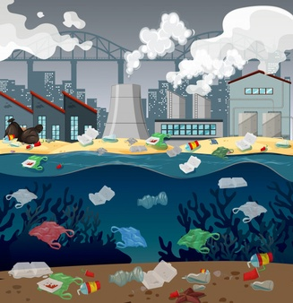

Transcript
Time : 2 min 30 secs

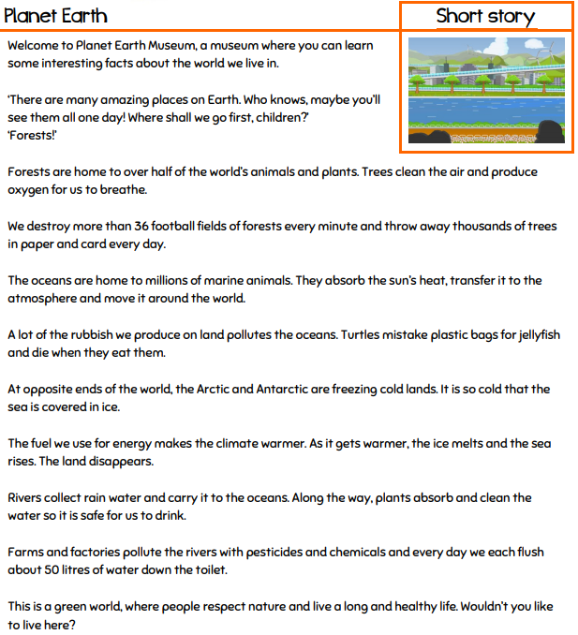

Answer Sheet - Planet Earth
Exercise1

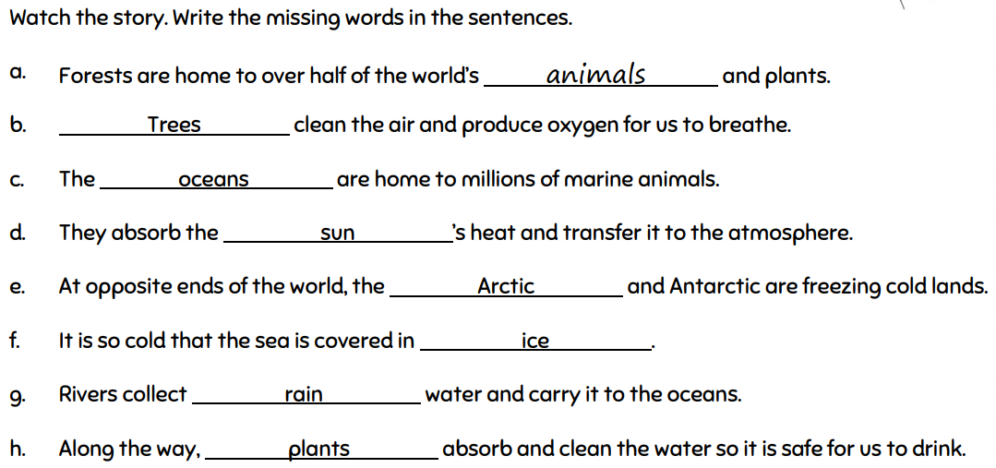

Exercise2

a. Why did the speaker talk about interesting facts about the world we live in?

☞ To inform the function of nature and alarm that our green world is being destroyed due to
the use of resources.

b. Why did the speaker mention 36 football fields of forest?

☞ To emphasize how much and how fast the forests are being destroyed by people.

Exercise3

a. What can you do in daily activities to keep our world green?
Use bicycle, less shampoo, no trash on the street, etc.

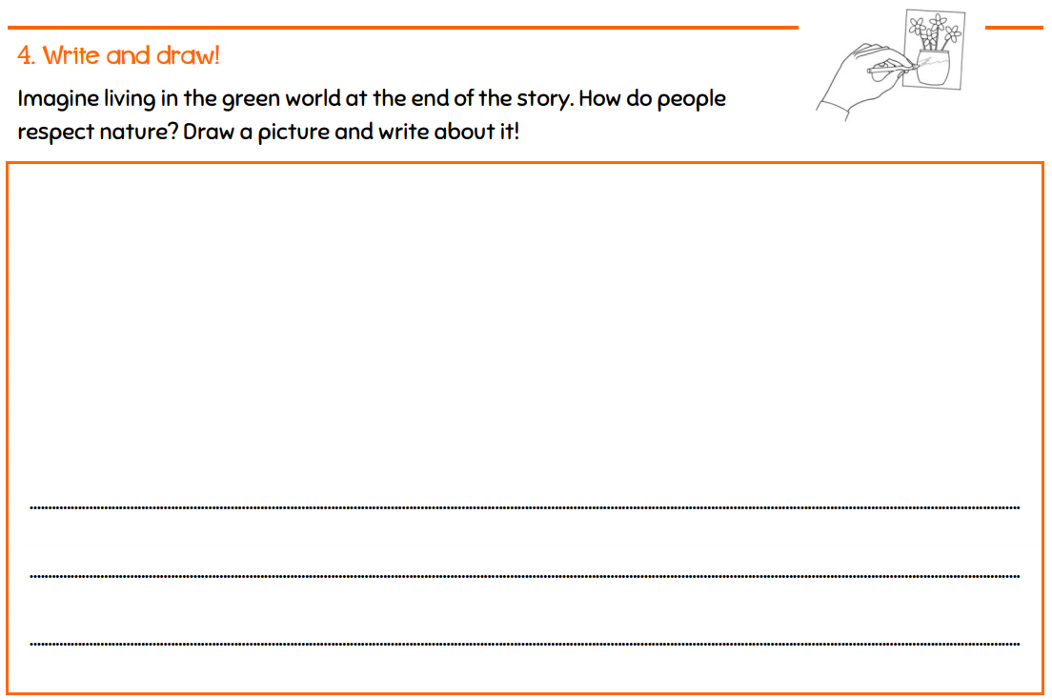
b. Write and draw

Homework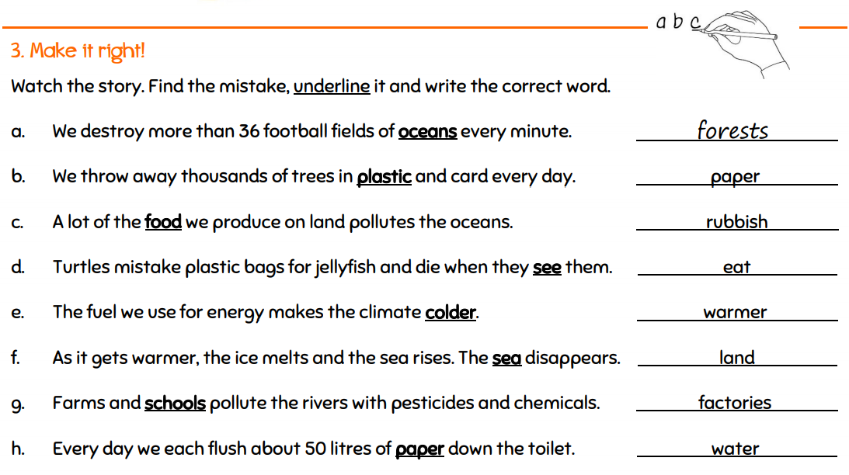
Make it right!

Instructor’s Comments and Assessment
Pros
Cons
Change
Overall Comments
Grade
Above Standard 85%-100% | Standard 70%-84% | Below Standard 69%-0%
Instructor | Student Signature | Date
Taute, David

