Background Information Sheet
Name | Class | Date | Lesson Type | Plan type | Length
Kyla | TESOL | 08/12/2020 | Listening | PPP | 30 min
Lesson
Topic | A princess From Mars
Main Aim | Students will practice their listening comprehension using an integrated listening model.
Secondary Aim | Students will practice their speaking fluency.
Materials and References
PPT, USB, https://youtu.be/sD1UsOdLMKA, Work sheet, board pens, P.C and audio equipment

Student Profile
Level | Upper Intermediate
Age | Teens | Number of Students | 8
Detail | This is a general English class and students are expecting to be able to speak fluently through this class. They are all Koreans, and enjoy cooperation work. However, they need to be relaxed. They actively participate in class discussions even if there are some corrections to be made in grammar, vocabularies and pronunciation. They tend to prefer visuals and kinesthetic learning ,but auditory learning still needs developing.
Anticipated Classroom Management Difficulties and their Solutions
The PPT file could not be worked – bring the photos (A4 size) and show it.
The audio equipment could fail – print the script and read it aloud.
Nervousness at the start of the lesson – check if the equipment is working.

My Personal Aim
What I aim to demonstrate is less teacher talk time and detailed lesson plan.

Stage Name: Lead-in
Purpose of this stage: To relax both students and the teacher; to increase student talk through the sharing of ideas. to introduce the topic or something topic-related.
Materials: PPT1
Ppt | Interaction | Procedure
30 sec  1 min  30 sec | T  S-S  T-S | Make all of students have a partner, with one group of 2 and sit together. Everyone should be ale to see the picture (PPT1) easily.  Hello everyone, look at this picture. Let’s talk about this picture with your partner. Guess their feeling and the situation. I will give you 1 minute.  Gesture for students to begin talking to their partners.  Monitor and check who talk about the key word while students are talking to their partners.  Feedback if appropriate. Point a few students asking “share about your think”

Stage Name: Presentation
Purpose of this stage: This is to give students the help they need to understand the text more easily. This includes teaching two key words using C.C. techniques, and asking guide questions that provide students with the opportunity to think and share ideas that are easy to encounter when listening. This encourages them to use their schema when understanding text.

Materials: PPT1,2, pens
Time | Interaction | Procedure
1 min  1 min  10 sec  1 min  50 sec | T-S  T-S  T  S-S  T-S | Pre-teach keywords  Elicit – Show the PPT 1. How do you think they feel now? (They are excited or happy)  CCQ – Are they unenthusiastic? (No)  Are they eager? (Yes)  Is it a great feeling or bad feeling? (Great feeling)  Drill – Listen and repeat 3 times together (Gesture, do choral and individual)  Board – write excitement on the left side of the board.  How many syllables? (3) Mark with a blue pen.  Where is the stress? (1st) Mark with a red pen.  Write noun next to the word “it is a noun”  Elicit – Show the PPT 2. What kind of relationship do you think they are?  CCQ – Are they the same country? (No)  Is it unformal situation or formal situation? (formal)  Do they cooperate? (Yes)  Drill – Listen and repeat 3 times together (Gesture, do choral and individual)  Board – write ally on the left side of the board.  How many syllables? (2) Mark with a blue pen.  Where is the stress? (1st) Mark with a red pen.  Write noun next to the word “it is a noun”  Guiding Question  Talk to your partner What do you do when you are excited?  Students talk about the question.  Feedback. Nominate a few students to share their ideas, if necessary.

Stage Name: Practice - Literal Comprehension Listening
Purpose of this stage: For students to listen for the first time in order to get the facts. This may include the overall idea or topic of the text; to notice who the speakers are; where they are; and perhaps why they are speaking. The responses are short, objective and are only a surface understanding. This is an accuracy focused stage.

Materials: worksheets
Time | Interaction | Procedure
1 min  1 min  2 min  2 min | T  S  S-S  T-S | Instructions. Set the purpose for listening. Hand out worksheets.  Hold up the work sheet.  We are going to listen a short story.  You should write down the answers of the questions in exercise 1. Don’t do exercise 2.  I.C.Q- Don’t we need to write down the answer? (No)  Do we need to solve the exercise 2? (No)  Read all the questions in the exercise 1 aloud for the students then hand out the work sheet.  Students listen for the 1st time, and write answers on the worksheet.  Pair check. Compare your answers with your partner. Monitor  Feedback to check accuracy. Ask the answers and check if some students have a different answer.  Do you agree this answer?

Stage Name: Practice - Interpretive Comprehension Listening
Purpose of this stage: Students listen second, more carefully, to infer or interpret the literal meaning of facts. This is still a step focused on accuracy. The answer needs to be checked for accuracy. Students should think about the reasons to support their answers. They may need to focus on things like the whole situation, tone of voice, multiple pieces of information, or one statement to explain the intended meaning of words and words.

Materials:
Time | Interaction | Procedure
1 min  1 min  3 min  2 min | T  S  S-S  T-S | Let’s listen to the story again and answer the exercise 2.  The questions in the exercise 2 could be more difficult, so you should listen carefully to catch the answer.  Write down the answers of the questions.  I will give you enough time to think and write down.  I.C.Q-Do we have to finish writing the answers during listening? (No)  Read the questions aloud.  Students listen for the 2nd time.  Pair check. Monitor. If students need, then replay the audio a 3rd time.  Feedback to check accuracy.

Stage Name: Production - Applied Comprehension Speaking
Purpose of this stage: For students to practice their speaking fluency. Therefore this stage should be no less than 5 minutes to allow students to practice. Give them a few questions to help them communicate without intervention from the teacher. This is a fluency focused stage.

Materials:
Time | Interaction | Procedure
1 min  7 min  1 min | T  S-S  T-S | Make 4 groups of 2 students. Wait for students to move.  This time exercise 3. Talk to your partner about the questions.  You should talk freely and ask questions to your partner.  You have 7 mins.  I.C.Q –Do you need to write anything? (No)  Students discuss.  Feedback. Students share their ideas with the class.

Stage Name: Wrap-up
Purpose of this stage: To end the lesson on a positive note. This will give students a sense of accomplishment, encourage students to continue progressing, and realize how to improve in future. A teacher may also get valuable feedback from students regarding the activities used in the lesson.
Materials:
Time | Interaction | Procedure
2 min | T | Lesson feedback. Tell the class what they did well, and what needs to improve.  Offer delayed corrections to the previous stage.  Set homework.  For homework, listen to the story 3 times and imagine the story behind it, and write it by tomorrow.  I will text it in the class chatroom.  Inform students about the topic for the next lesson.  Tomorrow, we will share our stories and do the next listening class about A princess of Mars part 5.  Dismissed

Worksheet 1 – A Princess of Mars

EXERCISE 1: Listen and write the answer next to the question.
- Did the red men of Helium think they were an attacking army?
- After the red men saw someone, they started to greet. Who it is?
- The green warriors could enter the city as …
- Thief
- Friends and allies
- enemy

EXERCISE 2: Listen carefully, think, and write your answer.
- Why the grandfather cried and could not speak?

EXERCISE 3: talk to your partner freely about the questions below. No writing!
- What do you think what is the tragedy of war?
- What are the pros and cons of the Ally?

PPT1

PPT2

Transcript
Time: 54 seconds
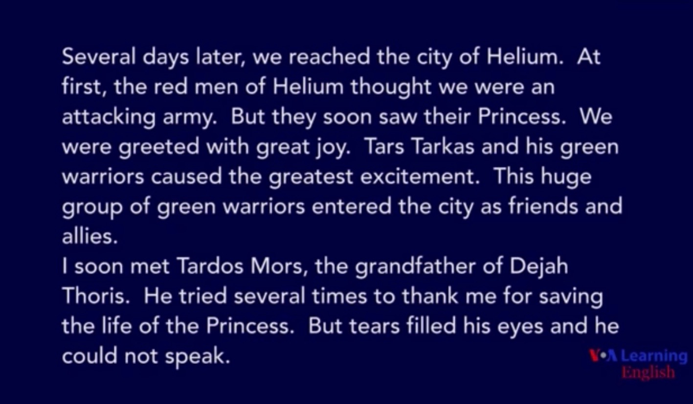

Answer Sheet – A Princess of Mars

EXERCISE 1: Listen and write the answer next to the question.
- Did the red men of Helium think they were an attacking army?
- Yes
- After the red men saw someone, they started to greet. Who it is?
- Their princess
- The green warriors could enter the city as …
- Thief
- Friends and allies
- enemy

EXERCISE 2: Listen carefully, think, and write your answer.
- Why the grandfather cried and could not speak?
- Because he was so happy and touched that his princess came back alive. He loves his granddaughter because they are family.

Instructor’s Comments and Assessment

Pros
Cons
Change
Overall Comments
Grade
Above Standard 85%-100% | Standard 70%-84% | Below Standard 69%-0%
Instructor | Student Signature | Date
Taute, David

