Background Information Sheet
Name | Class | Date | Lesson Type | Plan type | Length
Kyla | 215th WD | 2020/12/22 | Grammar | PPP | 25 min

Lesson
Topic | We are studying grammar at 1 pm.
Main Aim | Students will learn present progressive (future plans)
Secondary Aim | Students will practice their speaking fluency.

Materials and References
Board and colored markers, worksheets, PPT, music

Student Profile
Level |  | Lower Intermediate
Age |  | 6~12 years old |  | Number of Students | 5
Detail |  | Students are all native Koreans. Everyone is motivated to learn English.
Assumptions about students’ knowledge as required for this lesson:
- Students know the vocabulary used in this lesson
- Students have learned about the subject and ‘be’ verb relationship
- Students know how to make the negative form using ‘not’
What language difficulties to expect when presenting, and how to deal with it:
- Meaning: “we are studying grammar at 1 pm.” Students may think it is talking about a real situation because of the word verb+ing. Make a clear visual context and C.C.Q.

- Form: Students can be confused with the 'ing' that represents the action they are doing, so they use it with the time.
“We are studying grammar at 1 pm.”

- Pronunciation: Students may not know where to put natural sentence stress. Drill several times chorally, then individually. Ask, “Which words sound stressed?” Board the stress markers in red.

Anticipated Classroom Management Difficulties and their Solutions:
The quantity of new language points to be learned about present progressive (be+ verb ing) is too much for students to handle in a short 35 minutes lesson. This could lead to anxiety, rushing, and a lot of teacher talk. For this lesson I will manage this by selectively presenting only difference use of this expression. The remaining new language points can be presented in the next lesson.
My Personal Aim
What I hope most to demonstrate in this lesson is the ability to
- present the target language using a situational presentation
- to be an involver type teacher

Stage Name: Lead-in
Purpose of this stage: To relax both the teacher and students. To focus attention on the lesson. Create a situation for students to experience or think about, and then to elicit the target language.
Materials: List all materials that will be needed in this stage.
Timings | Interactions |  | Procedure
2 min | T-S |  | Show a picture(PPT1)  T: hello everyone! Look at this picture. What is the answer in the blank?  S: (probably) we will study grammar or We are going to study Grammar.  T: Yes that’s very good expression! so we can also say it  We are studying grammar at 1 pm!
Stage Name: Presentation
Purpose of this stage: Make the students think about the situation. To clarify the meaning, form, and pronunciation features of the target language.
Materials: List all materials that will be needed in this stage.
Timings | Interactions |  | Procedure
30 sec  1 min  2 min  30 sec  1 min  30 sec  1 min  30 sec | T  T-S  T-S  T-S  T-S |  | Board the model sentence (if students are unable to tell you, just board it).  We are studying grammar at 1 pm  CCQ – ask questions, and use time lines or scales where appropriate.  - Did they study Grammar? (No)  - Did they plan to study grammar before? (Yes)  - Are they studying grammar now? (NO)  Form  Positive: we are studying grammar .  Subject Be verb Verb ing object  What is the subject, verb, object?  Back to the board, write sentence structure and mention present progressive  S + bV + ing + Obj  We are studying grammar at 1 pm.  What is the negative form of the sentence?  We are not studying grammar at 1 pm.  What is the question form?  Are we studying grammar at 1 pm?  Drill – drill the spoken form, focusing on contractions, stress and intonation.  - Say and gesture “Listen and repeat: [we are studying grammar at 1 pm.]”  - Drill chorally then individually  - Which words are stressed?  (Make special pronunciation features visible on the board, using a colour pen.)
Stage Name: Controlled Practice
Purpose of this stage: students practice working with the form (scrambled sentences, split sentences, select the correct form of the verb, correct incorrect sentences, and change one form into another form). Accuracy must be checked.
Materials: List all materials that will be needed in this stage.
Timings | Interactions |  | Procedure
1 min  1 min  1 min  30 sec  30 sec | T-S  S  S – S  T - S |  | Instructions.  “Now, let's do some worksheet activity. We are solving some questions in exercise 1.  Please write down the answer individually both A and B.”  ICQ. Do we solve the questions individually? (Yes)  Do we solve the only A questions in exercise 1? (No)  Hand out. Let’s start !  Students do a worksheet.  Pair check. Please compare your answers with your partner.  Feedback to check accuracy. Board correct answers visually.
Stage Name: Less Controlled Practice
Purpose of this stage: students practice working with the meaning (match a timelines to sentences, choose the sentence that matches a picture, gap-fill a paragraph). Accuracy must be checked.
Materials: List all materials that will be needed in this stage.
Timings | Interactions |  | Procedure
1 min  1 min  1 min  30 sec  30 sec | T-S  S  S-S  T-S |  | Show the worksheet.  Please look at the pictures and make 4 sentences about what the girl is doing.  And you can see the picture not only the paper, but also the screen if you need.  I.C.Q- How many sentences should we make? (4)  Can you see the screen? (yes)  Hand out and show the PPT 2  Students do a worksheet. / Monitor or write on board for any feedback /  Pair check : Please compare your answers with your partner.  Feedback to check accuracy. Board correct answers visually.
Stage Name: Production – Freer Practice
Purpose of this stage: is to get students to practice the grammar communicatively.
Materials: List all materials that will be needed in this stage.
Timings | Interactions |  | Procedure
30 sec  5 min | T  S-S |  | Instructions.  Talk to your partner about your plan on the weekend or Christmas day.  Ss practice the grammar at the communication level. / T monitors /  With music  Feedback to check accuracy. Board student's expression if necessary.  * maybe connected to the beginning of Wrap-up.
Stage Name: Wrap-up
Purpose of this stage: is to end the lesson on a positive note so that students feel they have achieved progress.
Materials: List all materials that will be needed in this stage.
Timings | Interactions |  | Procedure
1 min  10 sec  20 sec | T – S  T  T |  | Offer delayed corrections to the previous stage.  - “Look at the board. Here are some sentences I heard. Tell me how to correct them.”  - How can we fix the sentence?  Set homework or No homework  Today, we have no homework.  Inform students about the topic for the next lesson.  Thank you for the class today. You all did great jobs.  We're studying reading tomorrow. Have a good time.
Instructor’s Comments and Assessment
Pros
Cons
Change
Overall Comments
Grade
Above Standard 85%-100% | Standard 70%-84% | Below Standard 69%-0%
Instructor | Student Signature | Date
Taute, David

EXERCISE 1 be + verb ing (future sentence)
- Choose the correct words.
- Is he ____________ shopping tomorrow?
- going
- goes
- gone

- Ann _____________ computer 2 hours later.
- played
- play
- is playing

- Fill in the blank with be+ verb ing.
- Eat – I _______________________________ pizza with my family in the evening

- Buy – tomorrow, I ________________________ a new mobile

- Not/open – Joe’s store _________________________ next week.

- Not/go – My mother _________________ to the bank tomorrow because it is Sunday.

- Fix - __________ you _____________ your car tonight?

- Visit - ______________ Binnie _______________ Kyla’s home on Christmas ?
Exercise 2
Fill the blanks. What is the girl doing?

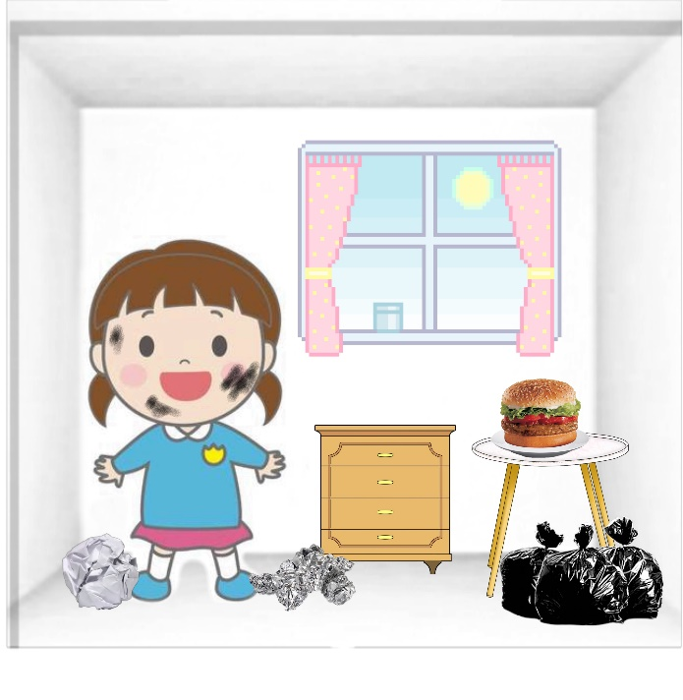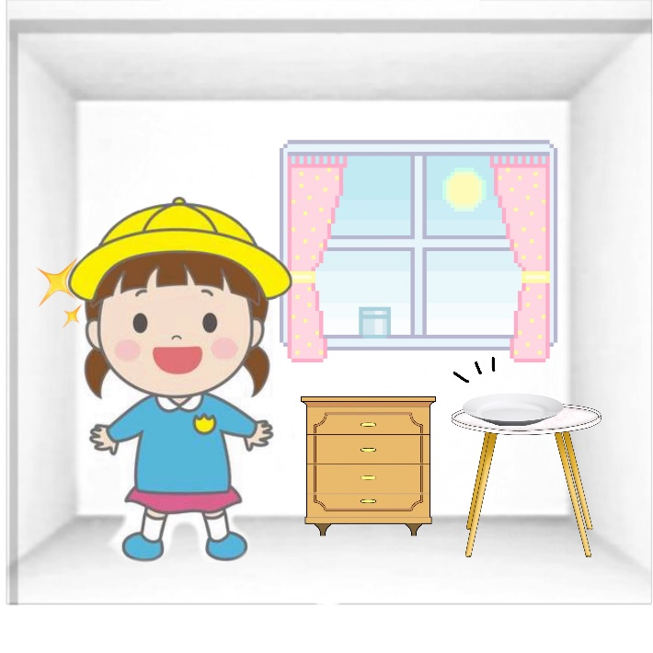

11:00 am
09:00 am

- ___________________________________________________________________________________

- ___________________________________________________________________________________

- ____________________________________________________________________________________

- ____________________________________________________________________________________

Answer sheets
EXERCISE 1 be + verb ing (future sentence)
- Choose the correct words.
- Is he ____________ shopping tomorrow?
- going
- goes
- gone

- Ann _____________ computer 2 hours later.
  - played
  - play
  - is playing

- Fill in the blank with be+ verb ing.
- Eat – I ____am eating_ pizza with my family in the evening

- Buy – tomorrow, I ___am buying________ a new mobile

- Not/open – Joe’s store __________is not opening____ next week.

- Not/go – My mother _____is not going___ to the bank tomorrow because it is Sunday.
- Fix - __ are________ you ___fixing____ your car tonight?

- Visit - ______is________ Binnie ________visiting_______ Kyla’s home on Christmas ?
Exercise 2
Fill the blanks. What is the girl doing?

11:00 am
09:00 am

- I am cleaning my room.

- I am wearing a hat.

- I am washing my face.

- I am eating hamburger.

