Background Information Sheet
Name | Class | Date | Lesson Type | Plan type | Length
Sammi Yoo | TESOL | 2020.12.23 | Reading | PPP | 25 min

Lesson
Topic | Recipe on a food magazine
Main Aim | Ss practice their reading comprehension.
Secondary Aim | Ss practice their speaking fluency.

Materials and References
A few of our favorite things, Taste of Home(2020.12), p52

Student Profile
Level | intermediate
Age | Adult | Number of Students | 2
Detail | Ss are all Koreans who want to learn English for daily use. They are interested in reading practical materials such as magazines.

Anticipated Difficulties and their Solutions:
Maybe they are not used to some vocabularies(ingredients, lbs., oz., tbs, etc.) used in the recipe.
→ I will give the names of food and units of measurement before getting them to read.

My Personal Aim
What I hope most to demonstrate in this lesson is the ability to teach reading lesson smoothly and confidently.

Stage Name: Lead-in
Purpose of this stage: To relax both the teacher and students. To focus attention on the lesson. To lead in to the topic, activating background knowledge – this will help to contextualize the text. This is a BEFORE READINING stage.
Materials: List all materials that will be needed in this stage.
Timing | Interaction | Procedure
30 sec  2 min  10 sec | T  S-S  T-S | Hello everyone! Holidays are coming! We have Christmas and new year's day soon. Do you eat special food in holidays?  Talk to your partner about traditional foods that you have with family or friends on new year's day.  S-S talk * T monitors  Feedback if needed

Stage Name: Presentation
Purpose of this stage: To pre-teach keywords if necessary, and answer a guiding questions (such as a predicting task, or a specific question). These steps provide extra help for students to comprehend the text. This is a BEFORE READINING stage.
Materials: List all materials that will be needed in this stage.
Timing | Interaction | Procedure
1 min  1 min  15 sec  1 min  15 sec | T-S  T-S  T  S-S  T-S | Pre-teach keywords  casserole : food that is cooked slowly in liquid in a covered dish in the oven  Elicit – What is this? (casserole pic)  CCQ – Are casseroles cooked in the oven? (Yes)  Are they cooked fast? (No)  Is lasagna a casserole? (Yes)  Drill – Listen and repeat three times, casserole x 3. * Do chorally and individually  Board – casserole kæsərəʊl  Where is the stress? (1st) How many syllables? (3), Noun or adjective? (noun)  fractional numbers : one-third, two-thirds, a half, one-half, one-fourth( = a quarter)  Elicit – What is this? (draw a glass of water - 1/3)  How much of the cup is filled with water?  CCQ – Is the glass full of water? (No)  Is this one-third cup of water? Is this two-thirds of the cup? (Yes) * Do quickly.  Drill – Listen and repeat three times, one-third cup of water x 3. * Do chorally and individually  Guiding Question * Can change the food if they mentioned other interesting food in lead-in.  One of the new year's foods is Man-doo. Can you teach your partner how to make Mandoo?  Students share recipe with a partner.  Feedback. Nominate a few students to share their ideas. (Optional.)

Stage Name: Practice – Literal Comprehension
Purpose of this stage: is to get students to practice reading for literal detail. They will also practice fast reading (skimming and scanning). This is a WHILE READINING stage.
Materials: List all materials that will be needed in this stage.
Timing | Interaction | Procedure
30 sec  2 min  1 min  1 min | T  S  S-S  T-S | Now, you're gonna read something about food. What type of reading does it look like? (recipe!) It's a recipe in a food magazine. You'll skim this part of magazine article and answer the questions on worksheetA quickly.  CCQ - Are you going to focus on every single word and sentence? (No)  Are you going to do worksheetA only? (Yes)  * Hand out worksheets  (Students read the whole text for the 1st time, and write answers on the worksheet.)  * T Monitors closely  Pair check your answers, please. * T Monitors carefully  Check accuracy by asking, "Cherry, what was your answer for q no. 1?"  Feedback if needed

Stage Name: Practice – Interpretive Comprehension
Purpose of this stage: is to get students to get students to practice interpreting a text correctly This will require more detailed, careful reading, and thinking time to arrive at the correct answer. This is a WHILE READINING stage.
Materials: List all materials that will be needed in this stage.
Timing | Interaction | Procedure
30 sec  3 min  1 min  2 min | T  S  S-S  T-S | This time, read the article again and answer the questions on worksheetB. You will need more time to think this time.  CCQ - Will you take time to think while reading this time? (Yes)  Turn your paper to worksheetB  (Students read for the 2nd time. Students write their answers down.) * T Monitors closely  Talk to your partner and check your answers. * T monitors carefully  Ask Ss, check accuracy and tell them correct answers.

Stage Name: Production - Applied Comprehension
Purpose of this stage: is for students to practice their speaking fluency and is related to the lesson topic. This is an AFTER READINING stage.
Materials: List all materials that will be needed in this stage.
Timing | Interaction | Procedure
15 sec  5 min  30 sec | T  S-S  T-S | Think about any magazines you have read. Discuss what kind of magazines you've read and why you read them.  Students discuss. * T monitors distantly but carefully  Feedback. Students share their ideas with the class. (Optional.)

Stage Name: Wrap-up
Purpose of this stage: is to end the lesson on a positive note so that students feel they have achieved progress. This is an AFTER READINING stage.
Materials: List all materials that will be needed in this stage.
Timing | Interaction | Procedure
1 min | T | Lesson feedback. Tell the class what they did well, and what needs to improve.  Offer delayed corrections to the previous stage.  We found many words today which are commonly used in recipes but are not familiar to us. I attached a wordlist at the end of your worksheets. Go home and review.  See you at the next class!

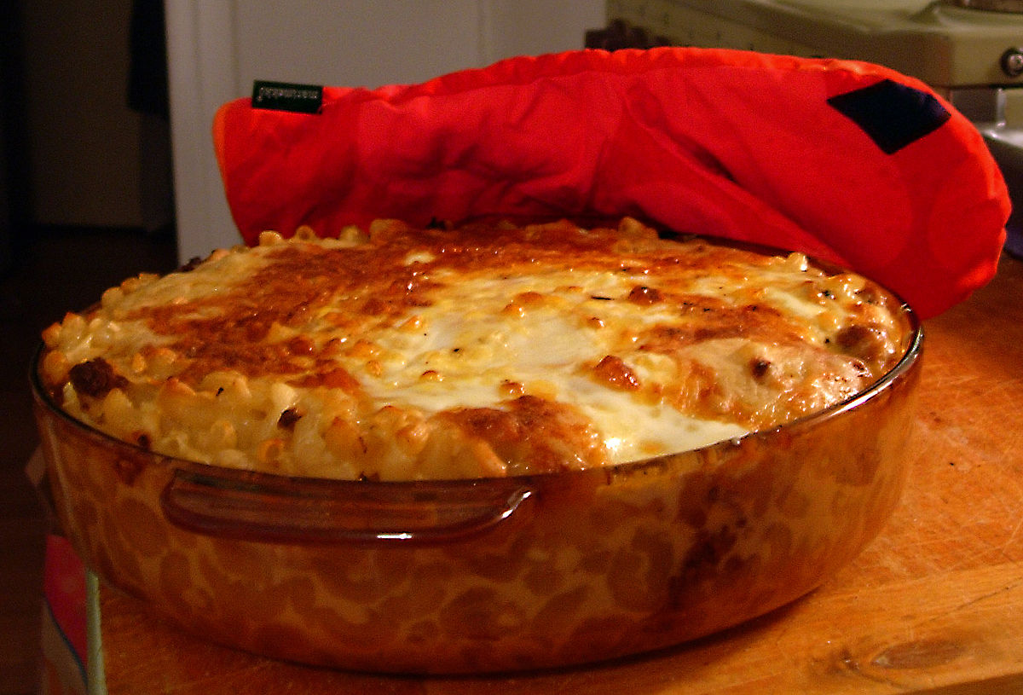
Reading : food magazine
"Taste of Home"

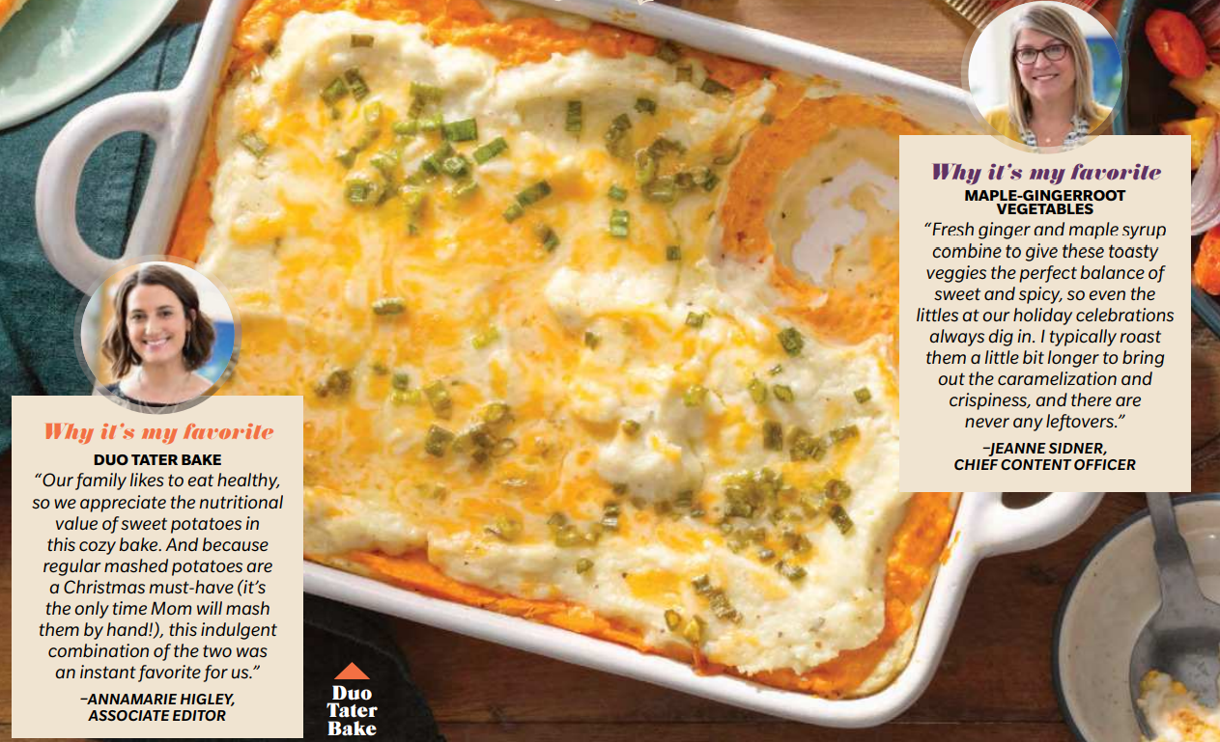
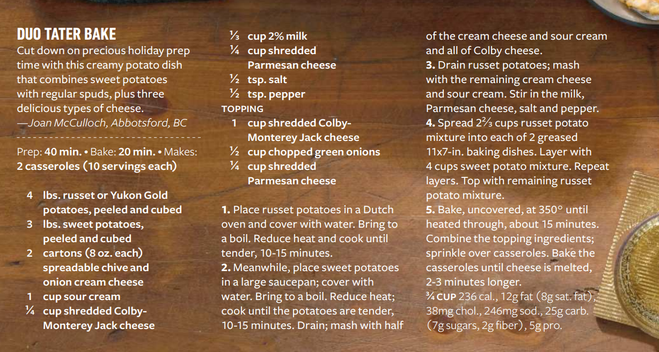

Worksheet A

1. What is the name of food?
(Duo tater bake)

2. What are the two main ingredients to make this food?
(Potatoes and sweet potatoes)

3. Find potato's two other names.
(Spud, tater)

4. Once you finish the layers, how long and at what temperature should you bake
in the oven? (15~20 minutes at 350 degrees)

5. Who wrote an editor's-pick-review in the article?
(Annamarie Higley, Associate Editor)

Worksheet B

1. Why did the writer include someone's complimentary comments about the food?
(To provoke readers' interest by sharing a 3rd person's good experience about the food)

2. Why is this recipe good to be introduced in December's food magazine?
(December is Christmas season when lots of family or people gather.
This recipe can make two casseroles, 10 servings each, which is perfect as a holiday food.)

Vocabulary

Types of potatoes
Russet | Yukon Gold | Red | fingerlings
Brown  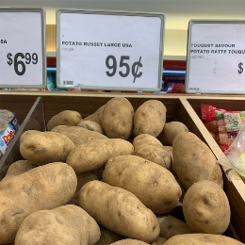 | yellow-fleshed  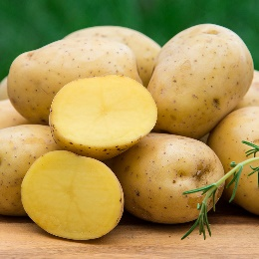 | red-skinned | finger-shaped!

Word | Definition
carton  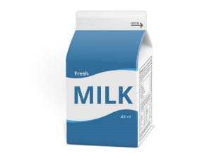 | a small box made of cardboard or plastic that contains food or a drink  Ex. a carton of fruit juice, a milk carton
chives 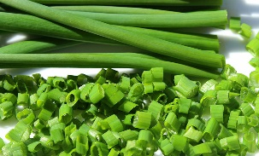 | the long thin green leaves of a plant with purple flowers. Chives taste like onion and are used in cooking.
Dutch oven  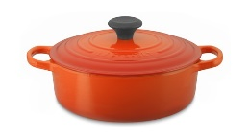 | a large cooking pot with a lid
shred | to cut or tear something into small thin pieces  Ex. Coleslaw is made with shredded cabbage.
grease | to put butter, grease, oil etc. on a pan to prevent food from sticking to it
units of measurement | lb. : written abbreviation for pound, a unit of weight equal to 0.454 kg  tsp. : written abbreviation of teaspoon or teaspoons  oz : written abbreviation of ounce or ounces

Instructor’s Comments and Assessment
Pros
Cons
Change
Overall Comments
Grade
Above Standard 85%-100% | Standard 70%-84% | Below Standard 69%-0%
Instructor | Student Signature | Date
Taute, David

