Background Information Sheet
Name | Class | Date | Lesson Type | Plan type | Length
Evelyn | TESOL | 17/02/2021 | Reading | PPP | 30min

Lesson
Topic | “The Day the Crayons Quit” by Drew Daywalt
Main Aim | Ss practice their reading comprehension.
Secondary Aim | Ss practice their speaking fluency.

Materials and References
picture book, worksheet, colored pencils, board, markers

Student Profile
Level | Intermediate
Age | 10 years old | Number of Students | 2
Detail | Students are all native Korean. Everyone is motivated to learn English.

Anticipated Difficulties and their Solutions:
The audio(computer) equipment could fail → read the picture book
Students might have some problem reading the cursive letters → type in block letter script as well
Nervousness at the start of the lesson → check the equipment is working; to start the lesson, sit down and follow the planned teacher talk.

My Personal Aim
What I hope most to demonstrate in this lesson is the ability to
- write out a complete, detailed lesson plan
- manage my time properly
- be an involver type teacher

Stage Name: Lead-in
Purpose of this stage: To relax both the teacher and students. To focus attention on the lesson. To lead in to the topic, activating background knowledge – this will help to contextualize the text. This is a BEFORE READING stage.
Materials: google sites (contain the information about the lesson)
Timing | Interaction | Procedure
before  1.5 min  1.5 min | T  T-S  S-S | Set up the google sites and organize seating arrangements in advance.  Prepare a box of crayons.  -Hi guys. Do you like coloring in? (Yes, we do./It’s my favorite thing to do.)  -Here is a box of crayons.  -Which colors do you like? (...)  -Which color do you like the most? (...)  -Which colors don’t you like? (...)  -Ok. Today we’re going to read a book about crayons. ;show students the picture book  -The title is… The Day the Crayons Quit.  -What does ‘quit’ mean? (It means that you stop doing it, give up or leave it.)  -Do they look happy? (No.)  -What are they doing? (They’re protesting/complaining.)  -What things did the crayons complain about? (...)  -Guess what. Talk to your partner.  Students discuss.

Stage Name: Presentation
Purpose of this stage: To pre-teach keywords if necessary, and answer a guiding question (such as a predicting task, or a specific question). These steps provide extra help for students to comprehend the text. This is a BEFORE READING stage.
Materials: google sites, board, markers
Timing | Interaction | Procedure
2 min  2min  2min | T  T-S  T-S  T  S-S | -Before we start the lesson, let’s check the keywords first.  -There are 2 of those. Look at the picture.  1. workload  Elicit  - Look at this guy. What is he doing? (He’s loading.)  - What is this guy doing? (He’s pulling/carrying/ working)  Write the word on the board-work + load  - What do we call this? (A workload) -point at the trolley  CCQ  - Is this the amount of work to be done? (Yes.)  Drill  - Ok, listen and repeat. (Gesture)  choral and individual drilling for correct pronunciation  Board  - Write down the word on the right side of the board  - How many syllables? (2) Mark with a blue pen.  - Where is the stress? (1st) Mark with e red pen.  - Is workload a noun? (Yes.) Workload is a noun.  - For example, we can say ‘a heavy workload or a light workload’.  2. wear out  Elicit  - What do you see in this picture? (Getting tired/ Losing energy.)  - What happened to him? (He got tired. His energy is gone. He wore out.)  - You can say this ‘wear out’.  CCQ  - Can a person wear out? (Yes.)  - Can a thing wear out?- hold up a pencil. (Yes)  - Which one is worn out? - hold up two pencils. (The short one.)  Drill  - Repeat after me. (Gesture)  - choral and individual drilling for correct pronunciation  Board  - Write down the word on the right side of the board  - How many syllables? (2) Mark with a blue pen.  - Where is the stress? (1st) Mark with e red pen.  Guiding Question  - Think about crayons like a family.  - Sometimes family members really complain about things, right?  - What would crayons complain about?  - Talk to your partner.

Stage Name: Practice – Literal Comprehension
Purpose of this stage: is to get students to practice reading for literal detail. They will also practice fast reading (skimming and scanning). This is a WHILE READING stage.
Materials: scripts, worksheet1
Timing | Interaction | Procedure
30 sec  2 min  1 min  1 min | T  S  S-S  T-S | -I prepared just 4 letters out of the book.  Hand out scripts and worksheets.  -We’re going to read fast and write answers and color the crayon on the worksheet.  -You have 2 minutes. Begin.  Students read the whole text for the 1st time, and write answers on the worksheet.  -Time’s up.  -Check your answers with your partner.  -How was it? (It was the same./Not that difficult.)  -What’s the first answer? ~ fourth/ (White, Green, Red, Peach)  -Well done!

Stage Name: Practice – Interpretive Comprehension
Purpose of this stage: is to get students to get students to practice interpreting a text correctly This will require more detailed, careful reading, and thinking time to arrive at the correct answer. This is a WHILE READING stage.
Materials: scripts, worksheet2
Timing | Interaction | Procedure
30 sec  3 min  1 min  2 min | T  S  S-S  T-S | -Now turn over your worksheet.  -There are some questions.  -This time, you need to read the letters more carefully and answer the questions.  -You have 3minutes. Go!  Students read for the 2nd time. Students write their answers down.  -Check your answers with your partner.  -What’s the answer for no.1? (a)  -Why do you think so? (Because he wanted to ask Duncan to settle the sun issue.)  -Correct! What’s next? (The answer is b.)  -Why? (Because Duncan peeled off Peach’s wrapping paper.)  -Right! Next? (He can make White happy by coloring in colored papers. White might be visible.)  -Excellent!

Stage Name: Production - Applied Comprehension
Purpose of this stage: is for students to practice their speaking fluency and is related to the lesson topic. This is an AFTER READING stage.
Materials: picture book
Timing | Interaction | Procedure
1 min  6 min  1 min | T  S-S  T-S | -Let me show you the last part of the story.  Read aloud to students the last 2 pages.  -Did Duncan make the crayons happy again?  -Let’s talk about how Duncan tried to solve the problem.  -Talk to your partner.  Students discuss.  -Ok, time’s up.  -What do you think? Share your ideas. (...)

Stage Name: Wrap-up
Purpose of this stage: is to end the lesson on a positive note so that students feel they have achieved progress. This is an AFTER READING stage.
Materials: List all materials that will be needed in this stage.
Timing | Interaction | Procedure
2 min | T | -Well done, everyone!  -Did you enjoy the crayons letters? (Yes.)  -Yes, it was fun. I never thought crayons have their own opinions.  Offer delayed corrections to the previous stage.  -Here’s homework. Record your voice while you read aloud and send me the file in the chat room.  -Next time, we’re going to read more letters out of the book.  -Ok, this is all for today. Have a good one. See you next time!

Instructor’s Comments and Assessment
Pros
Cons
Change
Overall Comments
Grade
Above Standard 85%-100% | Standard 70%-84% | Below Standard 69%-0%
Instructor | Student Signature | Date
Taute, David

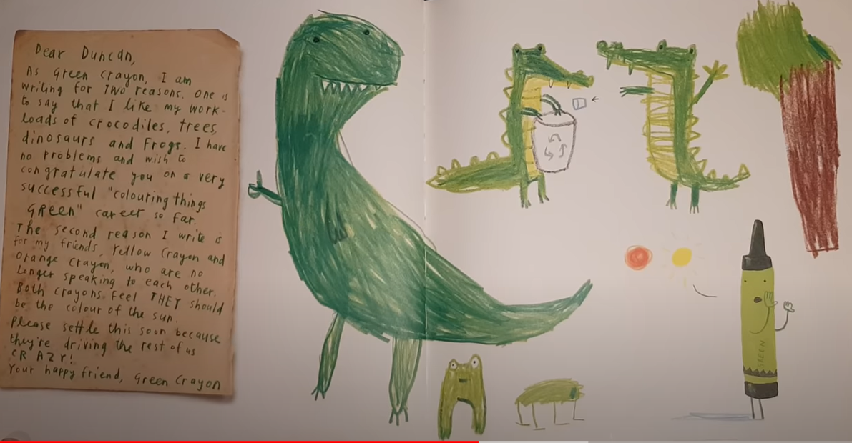
Dear Duncan,
As Green Crayon, I am writing for two reasons. One is to say that I like my workloads of crocodiles, trees, dinosaurs, and frogs. I have no problems and wish to congratulate you on a very successful “coloring things green” career so far. The second reason I write is for my friends, Yellow Crayon and Orange Crayon, who are no longer speaking to each other. Both crayons feel they should be the color of the sun. Please settle this soon because they’re driving the rest of us crazy!
Your happy friend, Green Crayon

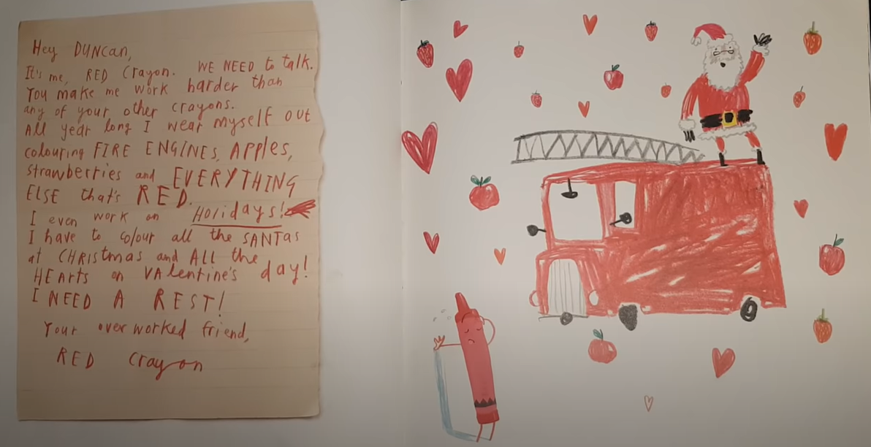
Hey Duncan,
It’s me, Red Crayon. We need to talk. You make me work harder than any of your other crayons. All year long I wear myself out coloring fire engines, apples, strawberries and everything else that’s red. I even work on holidays! I have to color all the santas at Christmas and all the hearts on Valentine’s day! I need a rest!
Your overworked friend, Red Crayon
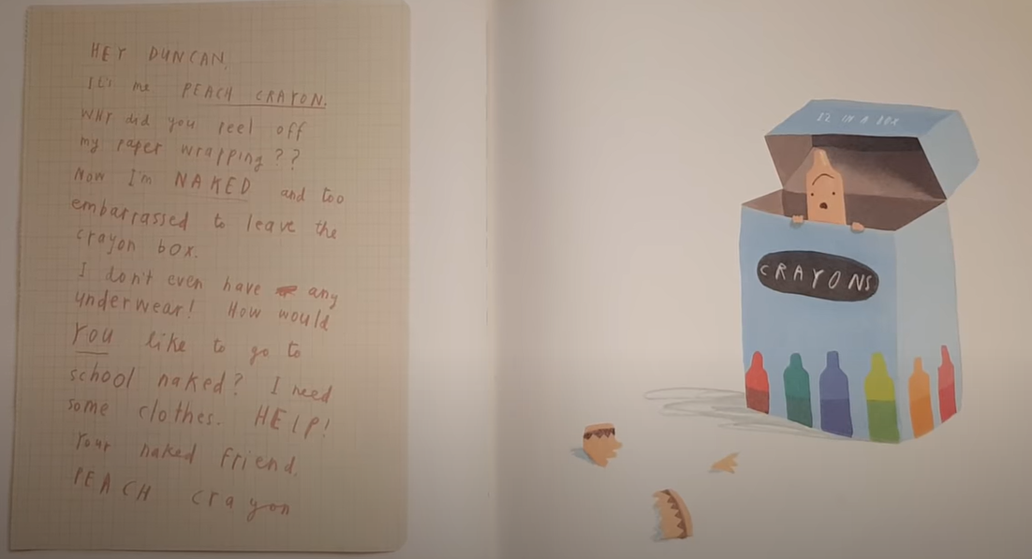
Hey Duncan,
It’s me, Peach Crayon. Why did you peel off my paper wrapping??
Now I’m naked and too embarrassed to leave the crayon box.
I don’t even have any underwear!
How would you like to go to school naked? I need some help!
Your naked friend, Peach Crayon

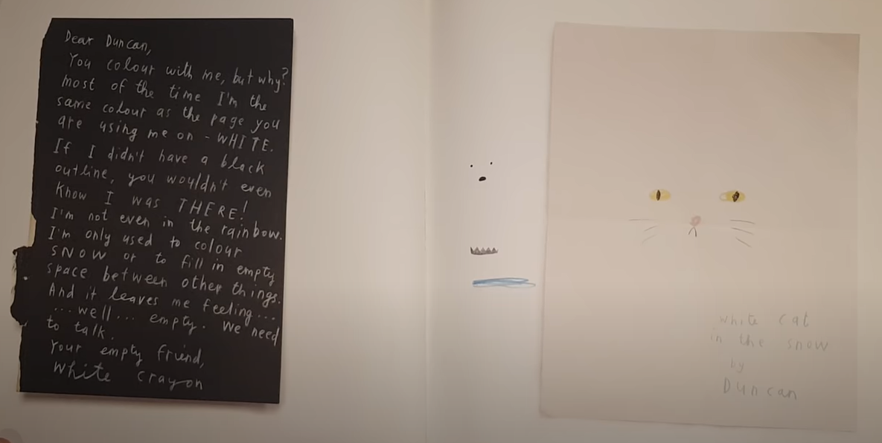
Dear Duncan,
You color with me, but why? Most of the time I’m the same color as the page you are using me on - white. If I didn’t have a black outline, you wouldn’t even know I was there!
I’m not even in the rainbow. I’m only used to color snow or to fill in empty space between other things. And it leaves me feeling… well… empty. We need to talk.
Your empty friend, White Crayon

Worksheet
name____________________ class_____________ date_____________
Exercise 1: Who am I?
Write down the color and color it.
1. I feel so empty Duncan. You cannot even see me if I didn’t have a black outline.  Who am I?  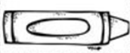 | 2. Duncan, I love my workload. You use me to color dinosaurs and trees and frogs.  Who am I?
3. You use me all year long to color fruits and even holidays. I need a rest!  Who am I? | 4. Duncan, I need your help ASAP! I’m naked and can’t leave the crayon box.  Who am I?
Worksheet

Exercise 2: Answer Me!

1. What is the main reason Green Crayon wrote a letter to Duncan? ( )
- To ask Duncan to make peace between Yellow and Orange
- To say thank him for using Green a lot
- To tell Duncan that Green wants to be the sun as well
- To say Green is satisfied with his workload

2. What help is Peach Crayon asking for? ( )
- She wants Duncan to take off the other crayons’ wrapping paper.
- She wants new wrapping paper.
- Peach is too shy to make friends

3. How could Duncan make White Crayon happy?
( )
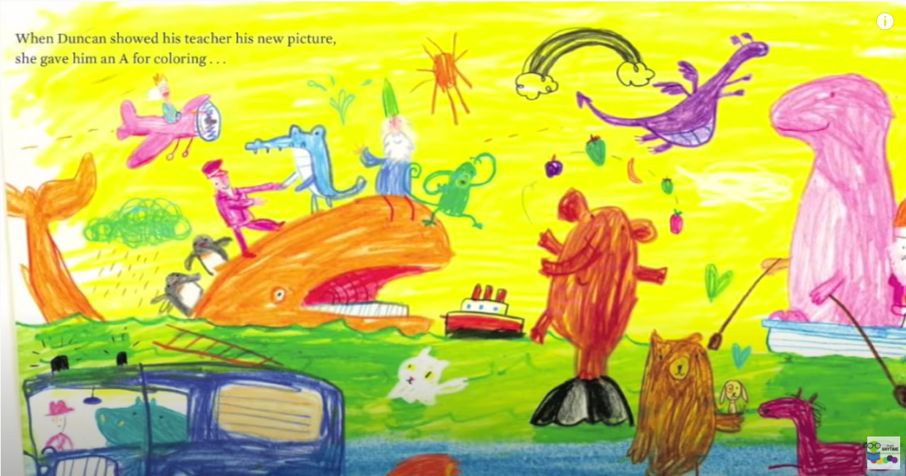
Answer sheet

Exercise 1 : Who am I?
- White
- Green
- Red
- Peach

Exercise 2 : Answer Me!
- a
- b
- Draw(use/ color) White in colored paper. etc...

