Background Information Sheet
Name | Class | Date | Lesson Type | Plan type | Length
Esther Lee | TESOL 220WK | 4/23/2021 | Listening | PPP | 30 min
Lesson
Topic | A Princess of Mars Part 4
Main Aim | Students will practice their listening comprehension using an integrated listening model.
Secondary Aim | Students will practice their speaking fluency.
Materials and References
PPT; https://youtu.be/sD1UsOdLMKA (7:46 – 8:40); worksheet; P.C and audio equipment; board pen

Student Profile
Level | Upper Intermediate
Age | Teenager | Number of Students | 4
Detail | This is a general English class and students are motivated to advance their English skills. The students are all Koreans, and enjoy science fiction. They are accustomed to pair work, and openly communicate with their partner. They engage actively in kinesthetic learning and tend to favor the visual learner mode, but, auditory learning still needs developing.
Anticipated Classroom Management Difficulties and their Solutions
The audio equipment could fail -> bring a set of portable speakers to use with my Smartphone; print an A4 size picture of my PPT.
Nervousness at the start of the lesson -> check the equipment is working; to start the lesson, sit down and follow this planned teacher talk.

My Personal Aim
What I aim to demonstrate is the ability to write out a complete, detailed lesson plan.

Stage Name: Lead-in
Purpose of this stage: To relax both the students and the teacher; to increase student talk through the sharing of experiences; to introduce the topic, or something topic-related.

Materials:
Time | Interaction | Procedure
30 sec  1 min  30 sec | T  T-S/S-S  T-S | Organize seating arrangements for all students to have partners, with one group of 2 sitting together, and all can easily see the board and the screen.  Hello class,  Q: Have you ever experienced any unexpected visits that make you feel very excited?  For example, when I heard that my friends are visiting me from America, I felt very excited!  Talk to your partner about it. You have 1 min.  Gesture for students to begin talking to their partner.  Students talk to their partner. Monitor for both students to speak in each group.  Feedback. Gesture to a few groups and ask.  “Tell me about your partner’s experience.”

Stage Name: Presentation
Purpose of this stage: To offer any need help which students may need in order to comprehend the text more easily. This includes teaching key words using the C.C.C. technique, and asking a guiding question which will allow students the opportunity to think of and share ideas they are likely to encounter when listening. This encourages the use of their schema when comprehending a text.

Materials: PPT1&2; https://youtu.be/sD1UsOdLMKA (7:46 – 8:40); worksheet; P.C and audio equipment; board pen
Time | Interaction | Procedure
1 min  1 min  10 sec  1 min  50 sec | T-S  T-S  T  S-S  T-S | Pre-teach keywords: ally, excitement  Elicit – Show and point to PPT1  Hook Question – What do you call when the two countries joined like this to support each other?  CCQ – Are the soldiers of two countries united in peace? (Yes)  Are they in political disagreement? (No)  Will the two countries provide support in war or not provide support in war? (Provide support)  Are the U.S. and South Korean soldier allies? (Yes, they are allies)  Drill – Listen and repeat 3 times together (Gesture)  Let each student to take turn to say the word. (Gesture)  Monitor for correct pronunciation.  Board – Write ‘ally’ on the right of the board.  How many syllables? (2) Mark with a blue pen.  Where is the stress? (1st) Mark with a red pen.  What kind of a word is it? (Noun) Write (n) next to the word.  Elicit – Show and point to PPT2  Hook Question – What are some of the words that would describe their feeling?  CCQ – Are they showing happiness? (Yes)  Do they look they extremely discouraged? (No)  Are they showing their excitement by themselves or sharing together?  (Sharing excitement together)  What are some examples of actions that show excitement?  (Jump, shout, cheer, laugh, tears of joy etc.)  Drill – Listen and repeat 3 times together (Gesture)  Let each student to take turn to say the word. (Gesture)  Monitor for correct pronunciation.  Board – Write ‘excitement’ on the right of the board.  How many syllables? (3) Mark with a blue pen.  Where is the stress? ( I ) Mark with a red pen.  What kind of a word is it? (Noun) Write (n) next to the word.  Guiding Question  Talk to your partners.  Q: How would the two countries act towards each other when they are allies?  Students discuss with their partners.  Feedback. Nominate a few students to share their ideas.

Stage Name: Practice - Literal Comprehension Listening
Purpose of this stage: For students to listen for the first time in order to get the facts. This may include the overall ideas or topic of the text; to notice who the speakers are; where they are; and perhaps why they are speaking. The responses are short, objective, and are only a surface understanding. This is an accuracy focused stage.

Materials: https://youtu.be/sD1UsOdLMKA (7:46 – 8:40); worksheet; P.C and audio equipment
Time | Interaction | Procedure
30 sec  1 min &  30 sec  1 min  1 min | T  S  S-S  T-S | Instructions. [Set the purpose for listening. Hand out worksheets.]  Hold up the worksheet.  Now it’s time to listen to a story.  As you listen, you must answer these questions in exercise 1 only.  When you catch the answer, write it down next to the question.  Don’t do exercise 2.  I.C.Q. – Do you need to write your answers? (Yes)  Do we need to read or answer questions for exercise 2? (No)  Read each question aloud for the students.  Individual Work.  [Students listen for the 1st time, and write answers on the worksheet.]  Q1) What did the red men of Helium thought of the green warriors at first? (An attacking arm.)  Q2) Who did the red men of Helium saw soon after? (Their princess)  Q3) As what relationship did the green warriors entered the city? (As friends and allies)  Q4) Why did Tardos Mors try to give thanks several times? (For saving the life of the princess.)  Pair Check.  Compare your answers with your partner. Monitor  Feedback to check accuracy.  Ask students for answer, checking if others have the same or different answers.  Does anyone else have a different answer?  Who agrees with this answer?  Who did the red men of Helium saw soon after they saw the green warriors?

Stage Name: Practice - Interpretive Comprehension Listening
Purpose of this stage: Students listen a second time, more carefully, to infer or interpret meaning of the literal facts. This is still an accuracy focused stage – answers need to be checked for accuracy. Students are required to think about the reason in order to support their answers. They may need to focus on things like the overall situation, tone of voice, multiple pieces of information, or a single statement to explain the unspoken, intended meaning.
Materials: https://youtu.be/sD1UsOdLMKA (7:46 – 8:40); worksheet; P.C and audio equipment
Time | Interaction | Procedure
30 sec  3 min  1 min  2 min | T  S  S-S  T-S | Instructions. Set the purpose for listening. Hand out worksheets.  Listen again. This time, answer exercise 2.  These questions are more difficult, but if you listen carefully, and think about what you know, you can find the answer.  Write your answers next to the questions.  I will give you time afterwards to think and write.  I.C.Q. – Do you need to rush to answer these questions? (No, we will have time afterwards to write.)  Read the questions aloud for the students.  Individual Work. [Students listen for the 2nd time.]  Q1) Why did Tars Tarkas and his green warriors enter the city of Helium as friends and allies?  (Because Tars and the green warriors saved the princess of Helium and came to the city of Helium together with a princess. By saving the princess, Tars and the green warriors gained the trust from the people of Helium that they are not against to them to make a war, but to unite with them in peace.)  Q2) Why did Tardos Mors’ eyes were filled with tears and he could not speak? Explain.  (Because Tardos Mors was very thankful for saving the life of the princess. He wanted to say how thankful he was several times, but he couldn’t speak out any words because of strong feeling of happiness and relief about it. Tardos Mors, as a grandfather of the princess, thought his granddaughter died already but when he saw the princess and found that she was alive, he was strongly happy and relieved.  Pair Check.  Monitor. If students need, then replay the audio a 3rd time.  Feedback to check accuracy.  Ask students for answer, checking if others have the same or different answers.  Does anyone else have a different answer?  Who agrees with this answer?

Stage Name: Production - Applied Comprehension Speaking
Purpose of this stage: For students to practice their speaking fluency. Therefore this stage should be no less than 5 minutes to allow students to practice. Give them a few questions to help them communicate without intervention from the teacher. This is a fluency focused stage.

Materials:
Time | Interaction | Procedure
1 min  9 min  &  30 sec  1 min | T  S-S  T-S | Instructions. [Give students a question to discuss in pairs or groups.]  Talk to your partners freely, and remember to listen and ask questions to your partner.  You have 9 minutes and 30 seconds.  I.C.Q. – Do you need to write anything? (No)  Q1) What was the greatest joy you’ve ever experienced in your life?  Q2) How would you respond when you are very thankful to someone?  Students discuss. Monitor from a distance  Feedback. Students share their ideas with the class.

Stage Name: Wrap-up
Purpose of this stage: To end the lesson on a positive note. This will give students a sense of accomplishment, encourage students to continue progressing, and realize how to improve in future. A teacher may also get valuable feedback from students regarding the activities used in the lesson.

Materials:
Time | Interaction | Procedure
2 min | T | Lesson feedback.  Tell the class what they did well, and what needs to improve.  Set homework.  For homework, listen to the next 2 minutes of the story. Summarize it by writing few sentences. It is due on the next week.  Inform students about the topic for the next lesson.  Tomorrow we will do a reading lesson in continue to the story ‘A Princess on Mars Part 4’.  Dismissed.

PPT1
PPT2
Transcript

Time: 1 minutes 6 seconds

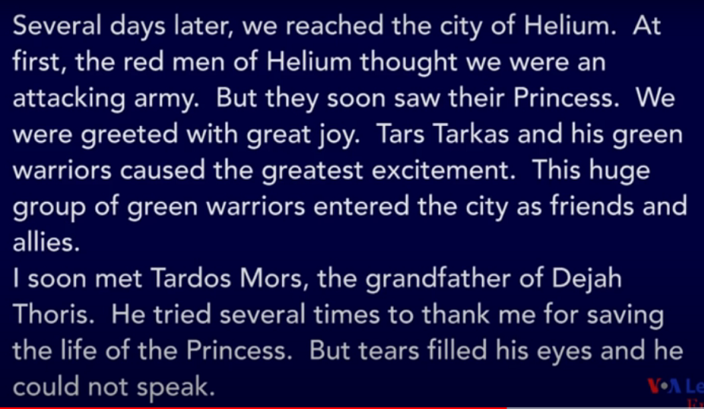

Worksheet - A Princess of Mars Part 4

Exercise One: Listen and write the answer next to the question.

Q1) What did the red men of Helium thought of the green warriors at first?
Q2) Who did the red men of Helium saw soon after?
Q3) As what relationship did the green warriors entered the city?
Q4) Why did Tardos Mors try to give thanks several times?

Exercise Two: Listen carefully, think, and write your answer.

Q1) Why did Tars Tarkas and his green warriors enter the city of Helium as friends and allies?

Q2) Why did Tardos Mors’ eyes were filled with tears and he could not speak? Explain.

Exercise Three: Talk to your partner freely about any of the questions below. (No writing)

Q1) What was the greatest joy you’ve ever experienced in your life?
Q2) How would you respond when you are very thankful to someone?

Answer Sheet - A Princess of Mars Part 4

Exercise One: Listen and write the answer next to the question.
Q1) What did the red men of Helium thought of the green warriors at first? (An attacking arm.)
Q2) Who did the red men of Helium saw soon after? (Their princess)
Q3) As what relationship did the green warriors entered the city?
(As friends and allies)
Q4) Why did Tardos Mors try to give thanks several times?
(For saving the life of the princess.)

Exercise Two: Listen carefully, think, and write your answer.
Q1) Why did Tars Tarkas and his green warriors enter the city of Helium as friends and allies?
(Because Tars and the green warriors saved the princess of Helium and came to the city of Helium together with a princess. By saving the princess, Tars and the green warriors gained the trust from the people of Helium that they are not against to them to make a war, but to unite with them in peace.)

Q2) Why did Tardos Mors’ eyes were filled with tears and he could not speak? Explain.
(Because Tardos Mors was very thankful for saving the life of the princess. He wanted to say how thankful he was several times, but he couldn’t speak out any words because of strong feeling of happiness and relief about it. Tardos Mors, as a grandfather of the princess, thought his granddaughter died already but when he saw the princess and found that she was alive, he was very happy and relieved.)

Instructor’s Comments and Assessment
Pros
Cons
Change
Overall Comments
Grade
Above Standard 85%-100% | Standard 70%-84% | Below Standard 69%-0%
Instructor | Student Signature | Date
Taute, David

