Background Information Sheet
Name | Class | Date | Lesson Type | Plan type | Length
Yoojin Cho | TESOL  220th WK | 04/24/2021 | Listening | PPP | 30 min
Lesson
Topic | Friends – Rachel – Welcome to the real world
Main Aim | Students will practice their listening comprehension using an integrated listening model.
Secondary Aim | Students will practice their speaking fluency.
Materials and References
https://www.youtube.com/watch?v=uwbRXXsYbUc; PPT; worksheet; board pens; P.C.; 4 printed transcript hard copies and audio equipment.

Student Profile
Level | Upper Intermediate
Age | Teens | Number of Students | 4
Detail | This is a general English class and students are highly motivated learners. The students are all Koreans and enjoy TV show series from YouTube and Netflix. They are accustomed to pair work because they have been in this class for last 3 months. It took them to open up to communicate freely in English at first, but they are getting used to it. They are stimulated on learning conversational English that is frequently used in daily life. They are the visual learners, also they still need to work on improving their listening skills. They like to review at home about what they have learned so easily accessible study materials are useful in this class.
Anticipated Classroom Management Difficulties and their Solutions
The computer could fail bring a portable speaker to use with my smartphone; print an A$ size picture of the most important scene and PPT.
Nervousness in the lesson double check on the materials and follow the lesson plan. Everything needs to be talked is in these sheets.
My Personal Aim
What I aim to demonstrate is the ability to write out a complete detailed lesson plan.
Stage Name: Lead-in
Purpose of this stage: To relax both the students and the teacher; to increase student talk through the sharing of ideas or experiences; to introduce the topic, or something topic-related.

Materials: PPT
Time | Interaction | Procedure
30 sec  1 min  1 min | T  S-S  T-S | Organize the seating arrangement to 2 students in a group.  Show PPT 1  “Good morning everyone. Why do you need a job in the future? Talk to your partner. You have 1 minutes to talk about it.”  Gesture for students to start.  Students talk to their partners. Monitor for any use of the keywords.  Feedback. Ask one person of each group about what they have discussed.

Stage Name: Presentation
Purpose of this stage: To offer any needed help which students may need in order to comprehend the text more easily. This includes teaching from 1 to 4 keywords using the C.C.C. technique, and asking a guiding question which will allow students the opportunity to think of and share ideas they are likely to encounter when listening. This encourages the use of their schema when comprehending a text.
Materials: PPT
Time | Interaction | Procedure
1 min  1 min  1 min  20 sec  1 min  30 sec | T-S  T-S  T-S  T  S-S  T-S | Pre-teach keywords  Elicit – Point to the PPT-keyword 1. “What is going on here?” (The kid is abused.)  CCQ – Is everyone close and friends? (No.)  Are they treating him bad? (Yes.)  Is abuse like bullying? (Yes.)  Drill – Listen and repeat 3 times together. (Gesture)  Individual drilling for correct pronunciation.  Board – Write “abuse” on the right top corner of the board.  How many syllables? (2) Mark with a blue pen.  Here is the stress? (2nd) Mark with a red pen.  What type of word is it? (verb and noun)  Elicit – Point to the PPT-keyword 2. “Let’s say the son in the picture doesn’t have a job. Can you describe the picture?” (He has lived off his father.)  CCQ – Is the son taking money from his father? (Yes)  Do you think the son has a job or not? (Not.)  Is it the only way he makes money? (Yes.)  Does the father give him the money that the son needs to live? (Yes.)  Drill – Listen and repeat 3 times together. (Gesture)  Individual drilling for correct pronunciation.  Board – Write “live off” on the right top corner of the board.  How many syllables in live? (1)  What type of word is it? (phrasal verb)  Elicit – “When your friend keeps putting pressure and bothering you, what can you tell to stop him/her? (OK, that’s enough) “Great. We can also say ‘Give me a break.’”  CCQ – Does it mean you want to actually break something? – with gesture (No.)  Does the person criticize or bother you? (Yes.)  Will the person stop putting you pressure? (Yes.)  Drill – Listen and repeat 3 times together. Give someone a break. (Gesture)  Individual drilling for correct pronunciation.  Board – Write “give someone a break” on the right top corner of the board.  How many syllables in break? (1)  Guiding Question  (PPT-keyword 2) If you are an adult and have no job and not making any money, and you use your father’s credit card to buy your stuff. What will your friends say to you? Talk to your partner.  Students discuss the question with a partner.  Feedback. Nominate a few students to share their ideas.

Stage Name: Practice - Literal Comprehension Listening
Purpose of this stage: For students to listen for the first time in order to get the facts. This may include the overall idea or topic of the text, to notice who the speakers are, where they are; and perhaps why they are speaking. The responses are short, objective, and are only a surface understanding. This is an accuracy focused stage.

Materials: PPT, worksheet
Time | Interaction | Procedure
1 min  20 sec  3 min  1 min  1 min | T  T  S  S-S  T-S | Instructions. Set the purpose for listening.  Hold up the worksheet.  Now I’m going to show you short video clip from TV series, Friends.  While listening, answer these 4 questions in only exercise one.  Write down the answers next to the questions when you catch the answer from the listening.  Don’t do exercise 2.  I.C.Q. – Do you need to write your answers while listening? (Yes.)  Are we doing exercise 2? (No.)  Hand out worksheets.  Nominate each student to read aloud the questions.  “I’m going to stop right before you need to answer A so you will know when question A comes out. Don’t worry”  Students listen for the 1st time, and write answers on the worksheet.  Pair check.  “Compare your answers with your partner.” Monitor.  Feedback to check accuracy.  Ask students for answers, checking if others have the same or different answers.  Does anyone else have a different answer?  How did you know if Rachel is married?

Stage Name: Practice - Interpretive Comprehension Listening
Purpose of this stage: Students listen a second time, more carefully, to infer or interpret meaning of the literal facts. That is still an accuracy focused stage – answers need to be checked for accuracy. Students are required to think about the why in order to support their answers. They may need to focus on things like the overall situation, tone of voice, multiple pieces of information, or a single statement to explain the unspoken, intended meaning.

Materials: PPT, worksheet
Time | Interaction | Procedure
1 min  4min  2 min  1 min | T  S  S-S  T-S | Instructions. PPT 4 on the screen.  Listen again. You’ll answer exercise 2 this time.  This question is more difficult. You’ll need to think to answer this. Understanding the whole situation of this conversation will help you to answer.  Write the answers next to the questions in 1 or 2 sentences.  You’ll be given time afterwards to think and write.  I.C.Q. – Will you have time to think and write after listening? (Yes.)  Read the question aloud for the students.  Students listen for the 2nd time, and write their answers.  Pair check. Monitor. If students need, then replay the audio a 3rd time. (from 2:07, if necessary)  Feedback to check accuracy.  Ask students for answers and check what answers each group has.  Does anyone else have a different answer?

Stage Name: Production - Applied Comprehension Speaking
Purpose of this stage: For students to practice their speaking fluency. Therefor this stage should be no less than 5 minutes to allow students to practice. Give them a few questions to help them communicate without intervention from the teacher. This is a fluency focused stage.

Materials: PPT
Time | Interaction | Procedure
1 min  5 min  1 min | T  S-S  T-S | Instructions.  Make 2 groups of 2 students.  Show PPT 5.  “It can also mean, imagine yourself 15 years from now. What do you think you will be doing 15 years later?”  Talk to your partner.  You have 5 minutes.  I.C.Q. – How many minutes do you have? (5 minutes.)  Students discuss. Monitor from a distance.  Feedback. Students share their ideas with the class.

Stage Name: Wrap-up
Purpose of this stage: To end the lesson on a positive note. This will give students a sense of accomplishment, encourage students to continue progressing, and realize how to improve in future. A teacher may also get valuable feedback from students regarding the activities used in the lesson.

Materials:
Time | Interaction | Procedure
2 min | T | Lesson feedback. Tell the class what they did well, and what needs to improve.  Set homework.  Give the video clip link we used in class with another worksheet to review.  Share the link in the class chatroom.  Inform students about the topic for the next lesson.  “Tomorrow we will be doing role-play with the transcript”.  Hand out the transcript.  Assign the students roles.  Dismissed.

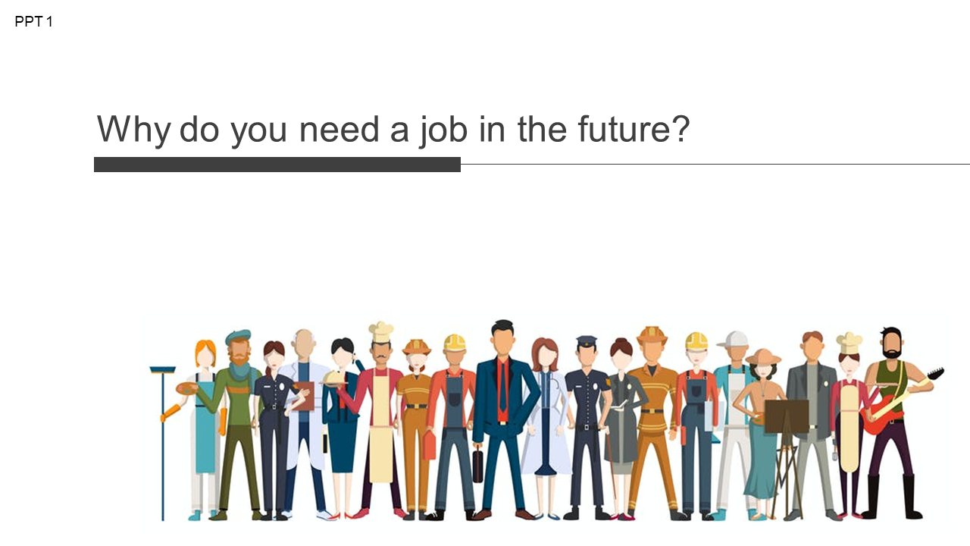
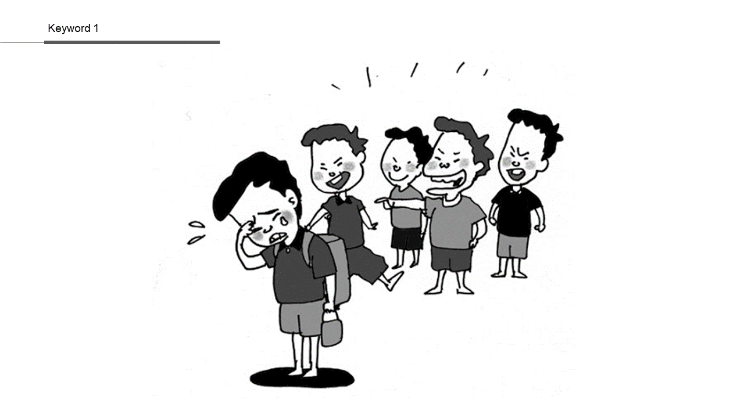
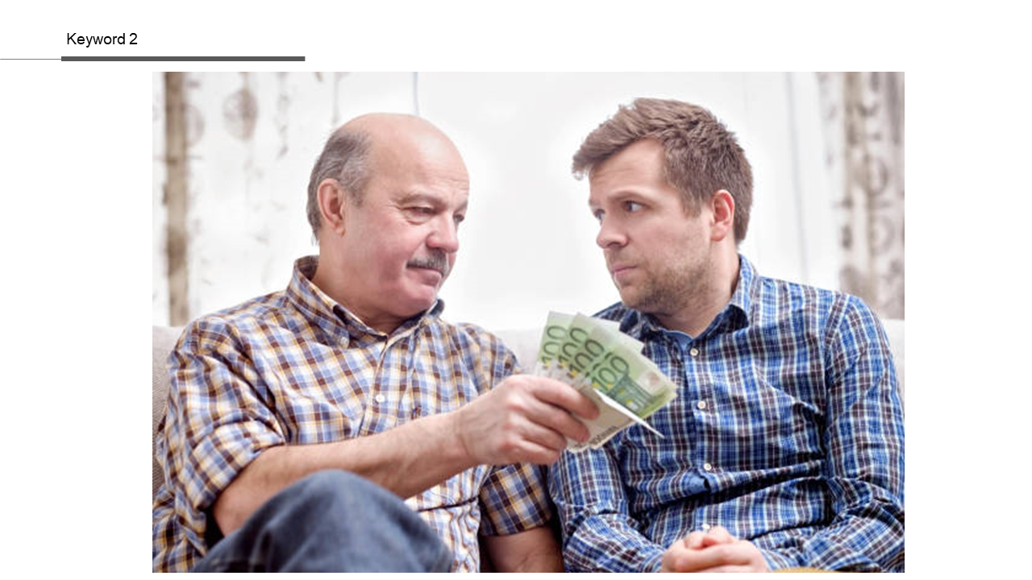
PPT4-Exercise 2
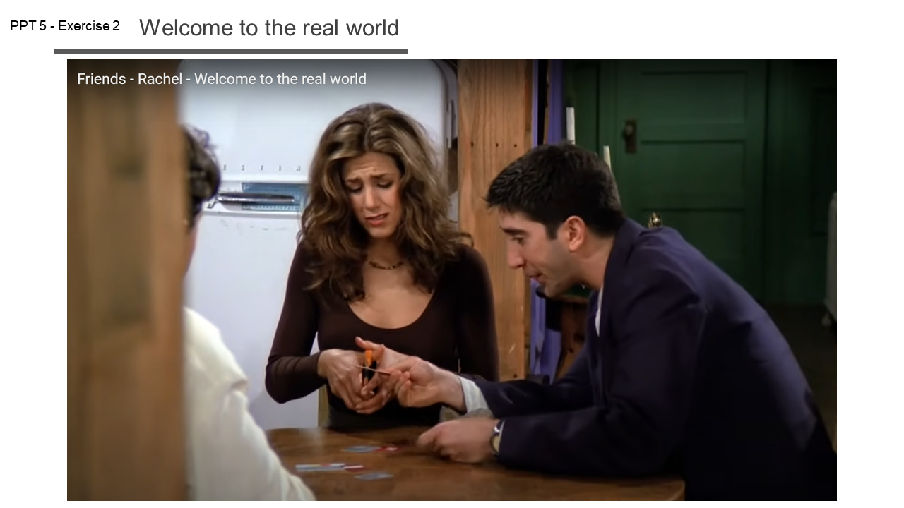
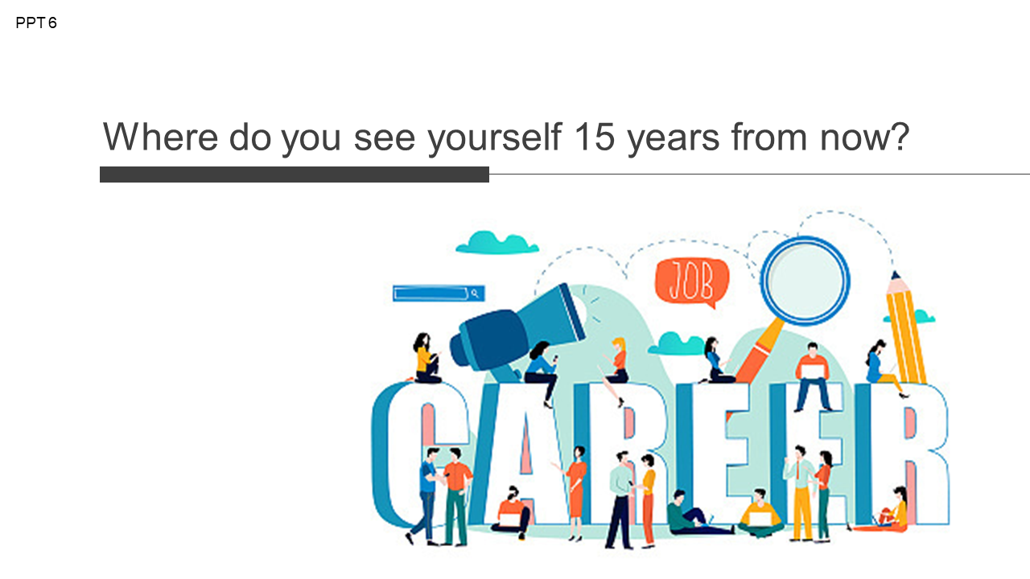
PPT5
Transcript – Time: 2 min 22 sec
Chandler:  Rachel:  Monica:  Joey:  Rachel:  Joey:  Monica:  Chandler:  Joey:  Chandler:  Rachel:  Ross:  Rachel:  Chandler:  Rachel:  Chandler:  Rachel:  Monica:  Rachel:  Monica:  Rachel:  Monica:  Rachel:  Phoebe:  Rachel:  Phoebe:  Ross:  Monica:  Rachel:  Ross:  Everyone:  (except Rachel)  Monica: | All right, kids, I got to get to work.  If I don't input those numbers...it doesn't make much of a difference.  So, like, you guys all have jobs?  Yeah, we all have jobs. See, that's how we buy stuff.  Yeah. I'm an actor.  Have I seen you in anything?  I doubt it. Mostly regional work.  Unless you caught the wee ones production of Pinocchio.  "Look, Geppetto, I’m a real live boy."  I will not take this abuse.  You're right. I'm sorry.  ♪ once I was a wooden boy, a little wooden boy. ♪  Guess what?  You got a job?  Are you kidding? I'm trained for nothing. I was laughed out of 12 interviews.  Yet you're surprisingly upbeat.  You would be, too, if you found Joan and David boots on sale. 50 percent off.  Oh, how well you know me.  They're my new ‘I-don't-need-a-job, I-don't-need-my-parents, I’ve-got-great-boots’ boots.  How did you pay for them?  A credit card.  And who pays for that?  Um... My father.  Come on. You can't live off your parents your whole life.  I know that. That's why I was getting married.  Give her a break. It's hard being on your own the first time.  Thank you.  You’re welcome. I remember when I first came to the city.  I was 14, my mom had just killed herself, and my step-dad was back in prison. I got here and didn't know anybody.  I ended up living with this albino guy who was cleaning windshields outside Port Authority.  And then he killed himself. And then I found aroma therapy.  So, believe me I know exactly how you feel.  The word you're looking for is... "Anyway..."  All right. You ready?  I don't think so.  Oh, come on. Cut. Cut. (2:07)  ( chanting ) Cut. Cut. Cut. Cut. Cut.  ( cheering )  Welcome to the real world. It sucks.  You're going to love it.

work sheet 1 – Friends

Exercise 1
- Listen and fill in the blank. (1:04-1:09)
Rachel: They're my new ‘(I-don't-need-a-jo b), I don’t need my parents,
(I’ve-got-great-boot s)’ boots.

* Listen and write the answer next to the questions below.
- What show was Joey in as an actor?

- How does Rachel pay for the boots?

- Is Rachel married?

Exercise 2
Listen carefully, think, and write your answer.

- When Monica says, “Welcome to the real world.”, why does she say this?

work sheet – answer

Exercise 1
- Listen and Write down (0:59-1:04)
Rachel: They're my new ‘(I don't need a job), I don't need my parents,
(I’ve got great boots)’ boots.

* Listen and write the answer next to the questions below.
- What show was Joey in as an actor?
- Pinocchio

- How does Rachel pay for the boots?
- She paid with her father’s credit card.

- Is Rachel married?
- No.

Exercise 2
Listen carefully, think, and write your answer. (2:07)

- When Monica says, “Welcome to the real world.”, why does she say that?
- Rachel cut her father’s card and it meant she symbolically cut her ties to her old and soiled life. Also Rachel decided to live her own life with the money she earned and decided to be independent.

Instructor’s Comments and Assessment
Pros
Cons
Change
Overall Comments
Grade
Above Standard 85%-100% | Standard 70%-84% | Below Standard 69%-0%
Instructor | Student Signature | Date
Taute, David

