Background Information Sheet
Name | Class | Date | Lesson Type | Plan type | Length
Yoojin Cho | TESOL-220th WK | 05.15.2021 | Grammar | PPP | 25 min

Lesson
Topic | I’m taking piano lessons these days.
Main Aim | Students will learn present progressive with nowadays and these days.
Secondary Aim | Students will practice their speaking fluency.

Materials and References
Board and colored markers, worksheets.

Student Profile
Level |  | Lower Intermediate
Age |  | Children (6-12 years old) |  | Number of Students | 4
Detail |  | Students are from Korea and Philippines. Everyone is motivated to learn English. They did not enjoy grammar lesson in the beginning but now they like to practice speaking with the grammar what they have learned.
Assumptions about students’ knowledge as required for this lesson:
- Students know the vocabulary used in this lesson.
- Students have learned about the subject and ‘be’ verb relationship
- Students know present, present progressive tense from the previous lesson.
What language difficulties to expect when presenting, and how to deal with it:
- Meaning: “I’m taking piano lessons these days.” Students may think it is talking about a situation happening now from what they have learned in the last lesson; present progressive. Also, they know ‘these days’ so they can infer the whole sentence’s meaning.
Make a clear visual context and C.C.Q.

- Form: Students may confuse where to put these days and nowadays. Identify they can go in the beginning and end of the sentence.
Also, students should understand the difference between “I play the piano” and “I am playing the piano these days.”.
- Pronunciation: Students may not know where to put natural sentence stress. Drill several times chorally, then individually. Ask, “Which words sound stressed?” Board the stress markers in red.

Anticipated Classroom Management Difficulties and their Solutions:
Students may not use to use present progressive with nowadays and these days, and 25-minute lesson can be too short. This could lead to anxiety, rushing, and a lot of teacher talk. For this lesson I will manage this by selectively presenting only this grammar point and will not teach more. The remaining new language points can be presented in the next lesson.

My Personal Aim
What I hope most to demonstrate in this lesson is the ability to present the target language using a situational presentation.

Stage Name: Lead-in
Purpose of this stage: To relax both the teacher and students. To focus attention on the lesson. Create a situation for students to experience or think about, and then to elicit the target language.
Materials: Board, colored markers, eraser
Timings | Interactions |  | Procedure
2 min | T - S |  | T - Hello everyone. I met my friend yesterday and she asked me “what do you do in your free time these days?”. Guess my answer.  Mime – playing the piano.  T – I’ll give you a hint.  Write “piano lessons”  S - I’m taking piano lessons these days.  T – Great! That’s a good sentence. Let’s write that down on the board.
Stage Name: Presentation
Purpose of this stage: Make the students think about the situation. To clarify the meaning, form, and pronunciation features of the target language.
Materials: Board, colored markers, eraser
Timings | Interactions |  | Procedure
1min  2min  2min  2min | T  T-S  T-S  T-S |  | Board the model sentence (if students are unable to tell you, just board it).  - I’m taking piano lessons these days.  [Meaning]  CCQ – and use time lines.  - Am I taking the piano lesson right now? (No.)  ---------------------NOW------------------- no dot mark yet  - Did I take the piano lesson last time? (Yes.)  --------------x-------NOW-------------------  - Will I take the piano lesson again? (Yes.)  --------------x-------NOW-------x------------  - --------------(-------NOW-------)----------- circle “NOW” area  T - It’s happening around now so the term “these days” is used to focus on the recent past, the present moment and the near future.  I play the piano permanent (regular) event  I am playing the piano these days temporary (not forever)  [Form] – clarify the affirmative, negative, question form, or other special features. Substitution tables may be of use.  T – We are talking about around now. Which word tell us this is about now?  (are -ing, these days)  Board:  I am taking piano lessons these days.  Subject + be + verb-ing + object (opt.) + these days/ nowadays.  T – What another word can we use instead of these days? (nowadays.)  T – Can we say, “These days, I’m taking piano lessons.”? (Yes) Mark with blue marker.  [Drill] – drill the spoken form, focusing on contractions, stress and intonation.  - Say and gesture “Listen and repeat 3 times. Don’t read.  : [I’m taking the piano lessons these days.]”  - Which words are stressed?  (THESE DAYS) I’m Taking piANo LEssons these DAYS.  Mark the stress with a red marker.
Stage Name: Controlled Practice
Purpose of this stage: students practice working with the form (scrambled sentences, split sentences, select the correct form of the verb, correct incorrect sentences, and change one form into another form). Accuracy must be checked.
Materials: worksheet, board, colored markers, eraser
Timings | Interactions |  | Procedure
30sec  2min  30sec  30sec | T  S  S – S  T - S |  | Instructions. Hold up the worksheet, point to exercise A.  T - Exercise A says to change in the new form.  T - I’ll give you 2 minutes to finish this. This is individual work.  ICQ  - How many minutes do you have? (2 miniutes)  - Do you work with your partner? (No)  Hand out.  Students do a worksheet. (If they don’t finish, give them homework)  Pair check.  Feedback to check accuracy. Board some answers if necessary.
Stage Name: Less Controlled Practice
Purpose of this stage: students practice working with the meaning (match a timelines to sentences, choose the sentence that matches a picture, gap-fill a paragraph). Accuracy must be checked.
Materials: worksheet, board, colored markers, eraser
Timings | Interactions |  | Procedure
30sec  2min  30sec  30sec | T  S  S – S  T - S |  | Instructions. Hold up the worksheet, point to exercise B.  T – Turn over your worksheet. Exercise B says complete the dialog using the correct form.  T - I’ll give you 2 minutes to finish this. This is individual work.  ICQ  - How many minutes do you have? (2 miniutes)  Students do a worksheet.  Pair check.  Feedback to check accuracy. Board some answers if necessary.
Stage Name: Production – Freer Practice
Purpose of this stage: is to get students to practice the grammar communicatively.
Materials: worksheet, board, colored markers, eraser
Timings | Interactions |  | Procedure
30sec  5min  5sec | T  S - S  T |  | Instructions. Pair students.  T – Talk to your partner about your hobbies or how you spend your free time these days.  You don’t need to include [am doing + these days or nowadays] in every sentence.  Students share their experience.  Monitor from a distance. (check tenses)  Write down some errors from student’s talk.  T – Time’s up!
Stage Name: Wrap-up
Purpose of this stage: is to end the lesson on a positive note so that students feel they have achieved progress.
Materials: List all materials that will be needed in this stage.
Timings | Interactions |  | Procedure
2min  10sec  5sec | T – S  T  T |  | Offer delayed corrections to the previous stage.  T - Look at the board. Here are some sentences I heard. Tell me how to correct them.  Set homework.  Inform students about the topic for the next lesson.

Worksheet: be -ing + these days/ nowadays

Exercise A
Change the sentence to the new form.
Example
Positive: I am taking piano lessons these days.
Negative: I am not taking piano lessons these days.
Question: Are you taking piano lessons these days?

- Positive: I’m walking to school these days.
Negative: ________________________________________________

- Positive: __________________________________________
Question: Is she eating healthy nowadays?

- Positive: ___________________________________________
Negative: These days, we are not studying English very hard.

- Positive: He is watching Marble movie series this month.
Question: ____________________________________________

Exercise B
Complete the dialog using the correct form.

Tom Hey, John! Where are you ____________(run) to?
John Tom! I’m late for school.
Tom I thought your mom ________(drive) you to school.
John Oh, she does. But something is wrong with her car, so it’s in the car repair shop now.
They said it is going to take about two weeks, so I _______________(walk) to school these days.
Tom Alright. Don’t be tardy!

a

Worksheet: be -ing + these days/ nowadays [ANSWER SHEET]

Exercise A
Change the sentence to the new form.
Example
Positive: I am taking piano lessons these days.
Negative: I am not taking piano lessons these days.
Question: Are you taking piano lessons these days?

- Positive: I’m going to swim these days.
Negative: I am not going to swim these days.

- Positive: She is eating healthy nowadays.
Question: Is she eating healthy nowadays?

- Positive: These days, we are studying English very hard.
Negative: These days, we are not studying English very hard.

- Positive: He is watching Marvle movie series this month.
Question: Is he watching Marvle movie series this month?

Exercise B
Complete the dialog using the correct form.

Tom Hey, John! Where are you running (run) to?
John Tom! I’m late for school.
Tom I thought your mom drove (drive) you to school.
John Oh, she does. But something is wrong with her car, so it’s in the car repair shop now.
They said it is going to take about two weeks, so I am walking (walk) to school these days.
Tom Alright. Don’t be tardy!

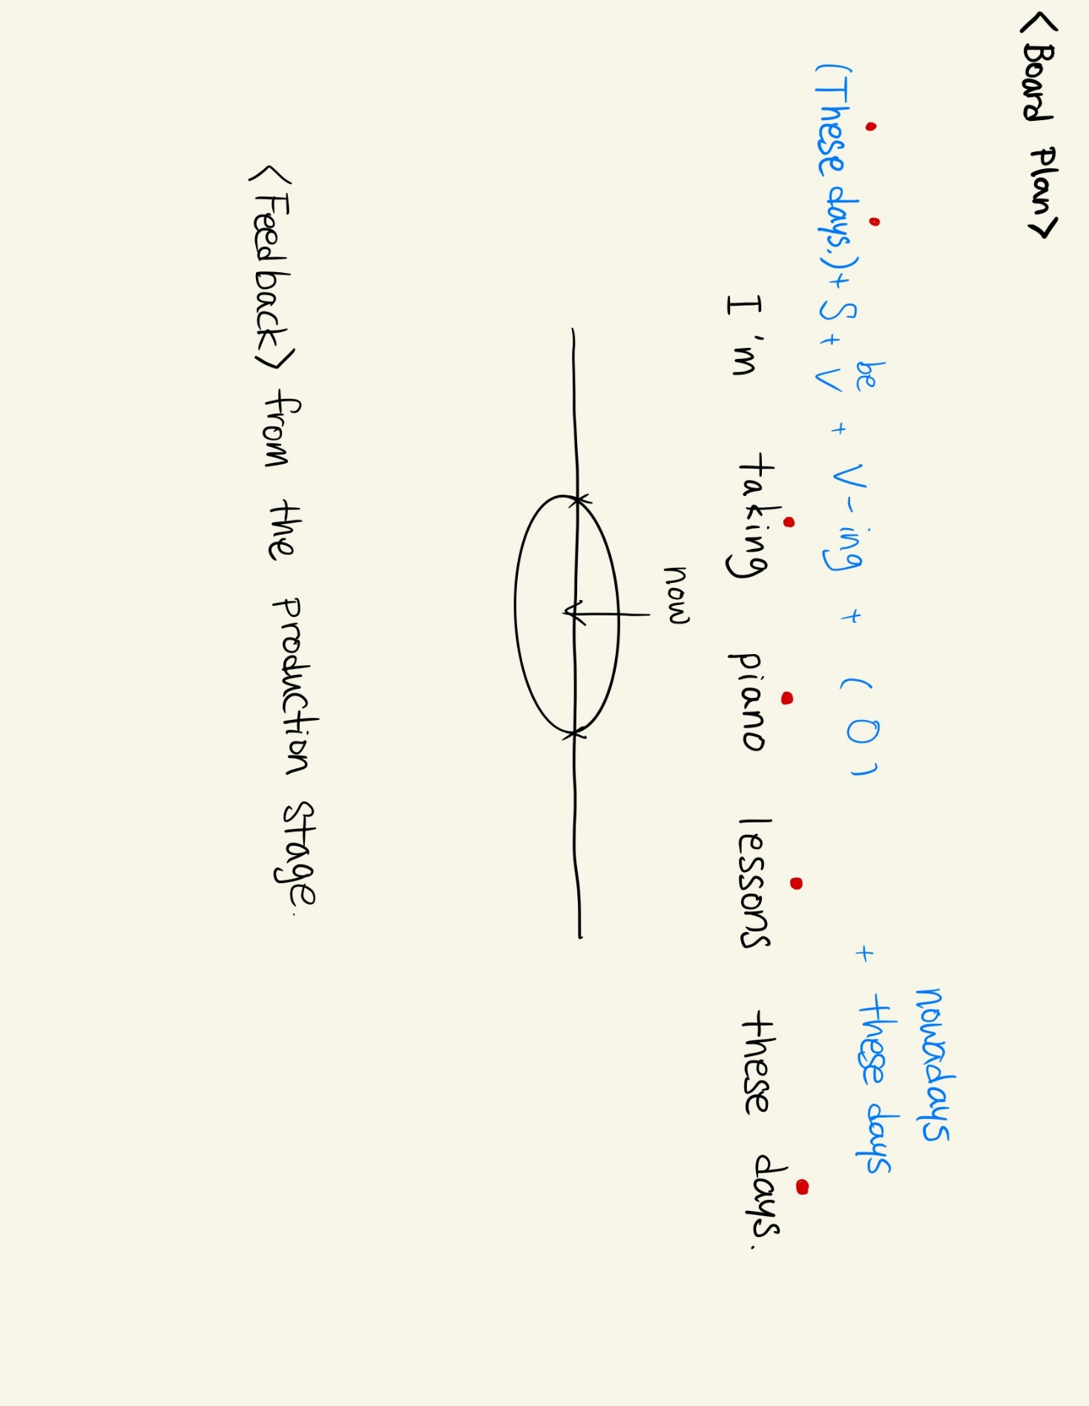

Instructor’s Comments and Assessment
Pros
Cons
Change
Overall Comments
Grade
Above Standard 85%-100% | Standard 70%-84% | Below Standard 69%-0%
Instructor | Student Signature | Date
Taute, David

