e
Background Information Sheet
Name | Class | Date | Lesson Type | Plan type | Length
Summer | Tesol | 15/05/20121 | Grammar | PPP | 25 min

Lesson
Topic | Comparatives
Main Aim | Students will learn the Comparatives.
Secondary Aim | Students will practice their speaking fluency.

Materials and References
White board, markers(black, blue, red), worksheets

Student Profile
Level |  | Lower Intermediate
Age |  | Children(6~12 international age) |  | Number of Students | 4
Detail |  | This is a general English class and students are interactive learners. The students are 3 Koreans and a Filipina. They are accustomed to pair work, but still need to be relaxed before they open up to communicate freely. They engage actively in kinesthetic learning and tend to favor the visual learner mode, but, auditory learning still needs developing.
Assumptions about students’ knowledge as required for this lesson:
- Students know the vocabulary used in this lesson
- Students have learned about the subject and ‘be’ verb relationship
- Students know how to make the negative form using ‘not’
- Students can distinguish between Adjective and Adverb
What language difficulties to expect when presenting, and how to deal with it:
- Meaning: “It is more expensive”. Students may think that “more” means a greater or additional amount. Make a clear context and CCQ.

- Form: Students may get confused on when to use adj-er or more + adj. Explain various rules on which pattern is more suitable. Short words - +er / Long words – more + adj.

- Pronunciation: Students may not know how some words are pronounced. Show the correct syllabication and the correct stress for each word. Mark it with red pen.

Anticipated Classroom Management Difficulties and their Solutions:
Some students could ask more time to do exercise or pair check. I can adjust other process for making extra time. Students could ask some words which are exceptions. (e.g. good-better) Let them know it is exception briefly. For this lesson I will manage this by selectively presenting only a few new concepts about Comparative. The remaining new language points can be presented in the next lesson or be homework.
My Personal Aim
What I hope most to demonstrate in this lesson is the ability to present the target language using a situational presentation.
Stage Name: Lead-in
Purpose of this stage: To relax both the teacher and students. To focus attention on the lesson. Create a situation for students to experience or think about, and then to elicit the target language.
Materials: White board, markers(black, blue, red)
Timings | Interactions |  | Procedure
1min 30sec | whole |  | T: hi, everyone. How are you?  (showing two 2 similar things with different price drawn on the board)  They are same stuff. Which one do you want to buy?  why?  S: Because It is cheaper.  T: That’s right. Good Job!  Then, Why don’t you want to buy it? (point to the expensive one.)  S: Because It is more expensive.
Stage Name: Presentation
Purpose of this stage: Make the students think about the situation. To clarify the meaning, form, and pronunciation features of the target language.
Materials: White board, markers(black, blue, red)
Timings | Interactions |  | Procedure
30sec  30sec  3min  1min | T  T-S  T-S  T-S |  | Board the model sentence (if students are unable to tell you, just board it).  It is cheaper. It is more expensive.  Meaning.  CCQ –  1. Do both things have the same price? (no)  2. Does the B store have high price comparing to A store? (Yes)  3. Are we comparing both? (Yes)  Form.  Where is subject? (it)  Where is verb? (is)  What kind of words is ‘cheaper’? (adjective + er)  Let us find other adjective like cheap.  e.g. old, slow, nice, late…  We can put ‘-er’ after short adjectives which have one syllable.  What kind of words is ‘expensive’? (more + adjective)  Let us find other adjective like expensive.  e.g. careful, polite, interesting.  When we put ‘more’ before the adjective, that word is long, 2/3/4 syllables.  Can you put ‘more’ and ‘-er’ together at the same time? (No)  Drill.  1. Look at me. Listen and repeat. Do not read on the board  ‘It is cheaper. It is more expensive.’  let them read three times each  2. Where is stressed in the sentence?  It is CHEAper.  It is More exPENsive.  (write red point on the board)
Stage Name: Controlled Practice
Purpose of this stage: students practice working with the form (scrambled sentences, split sentences, select the correct form of the verb, correct incorrect sentences, and change one form into another form). Accuracy must be checked.
Materials: White board, markers(black, blue, red), worksheets
Timings | Interactions |  | Procedure
20sec  40sec  2min  1min 30sec  30sec | T  T-S  S  S-S  T - S |  | Instructions.  T: now, everyone. I have a gift for you. (showing the worksheets)  I want you to answer worksheet A individually. You have 2 minutes.  Do not look at the other page. We will do it later.  ICQ.  - How many minutes do you have? (2 minutes)  - Will you do this alone? (yes)  - Will you look at the other page? (No)  Hand out the worksheet  Students do worksheet A.  Monitors from a distance.  Pair check and make students write answers on the board.  Feedback to check accuracy.
Stage Name: Less Controlled Practice
Purpose of this stage: students practice working with the meaning (match a timelines to sentences, choose the sentence that matches a picture, gap-fill a paragraph). Accuracy must be checked.
Materials: White board, markers(black, blue, red), worksheets
Timings | Interactions |  | Procedure
20sec  20sec  2min  1min 20sec  30sec | T  T-S  S  S-S  T - S |  | Instructions. Hold up the worksheet, point to worksheet B.  T: now, take a look at worksheet B. Construct sentences using the Adjectives that is provided. You have 2 minutes to finish the task. Do this individually.  ICQ.  - How many minutes do you have? (2 minute)  - Will you do this alone? (yes)  Students do worksheet B.  Teacher Monitor from a distance.  Pair check and make students board answers.  Feedback to check accuracy. Board correct answers visually.
Stage Name: Production – Freer Practice
Purpose of this stage: is to get students to practice the grammar communicatively.
Materials: White board, markers(black, blue, red)
Timings | Interactions |  | Procedure
30 sec  5 min | T  S-S |  | Instructions Pair students.  T: Talk to your partner about your own characteristics, personalities and differences.  You can use the grammar lesson that you learned today.  Students share their opinion and create sentences,  Monitor from a distance.  Write down some errors among students’ conversations.  T: time is up!
Stage Name: Wrap-up
Purpose of this stage: is to end the lesson on a positive note so that students feel they have achieved progress.
Materials: White board, markers(black, blue, red)
Timings | Interactions |  | Procedure
3min  25 sec  5 sec | T – S  T  T |  | Offer delayed corrections to the previous stage.  T: Look at the board, I have written here the errors I have noticed during the previous activity. Could you help me correct them?  Set homework.  T: There is no homework  (If students ask some questions (e.g. good-better exceptions), make them search at least 3 words.)  Inform students about the topic for the next lesson.  T: In our next class, we will learn how to use “… cheaper than, more expansive than …”

Exercise 1 : Comparative

Complete the sentences below. Use a comparative
- You are not very tall. Your brother is _____________.
- It is not very warm today. It was __________ yesterday.
- Peru isn’t very big. Brazil is ___________.
- This movie is not very interesting. I want to watch something ____________________.
- My chair isn’t very comfortable. Yours is ___________________.
- These flowers aren’t very nice. The blue ones are _______________.
- This knife isn’t very sharp. Do you have a ________________ one?
- Grand mother is not young. Grand daughter is _________________.
- A turtle is not fast. A rabbit is ________________.

Exercise 2 : Comparative
Construct a sentence using the adjective words provided.
Example:
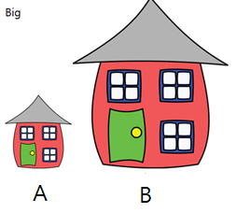Answer: B is bigger. / A is smaller.

1. 2.
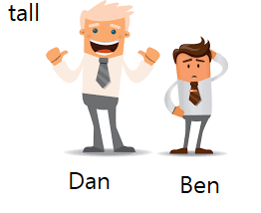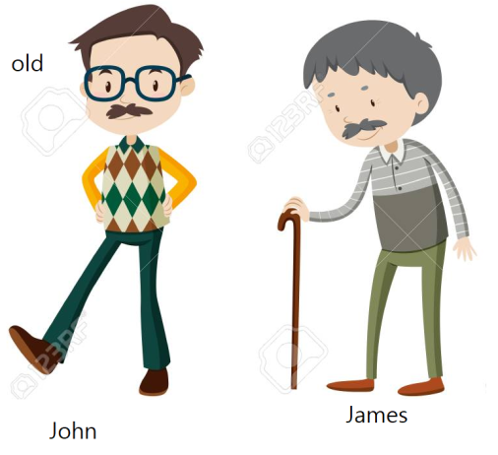
Answer: ______________________________________. Answer: ______________________________________.

3. 4.
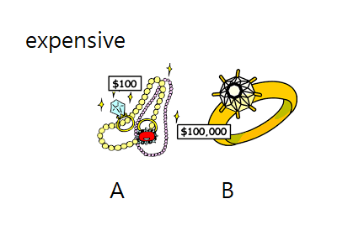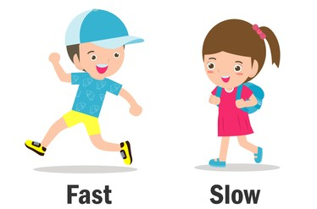
Answer: ______________________________________. Answer: ______________________________________.
Board Plan
S + V + more + Adjective + -er
A store $50
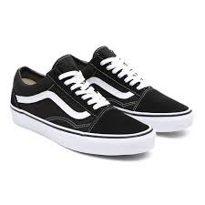 It is cheaper.
old
slow
nice
B store $100
It is more expensive.
beautiful
careful
interesting

Instructor’s Comments and Assessment
Pros
Cons
Change
Overall Comments
Grade
Above Standard 85%-100% | Standard 70%-84% | Below Standard 69%-0%
Instructor | Student Signature | Date
Taute, David

