Background Information Sheet
Name | Class | Date | Lesson Type | Plan type | Length
Esther Lee | TESOL | 2021/05/22 | Reading | PPP | 30 min

Lesson
Topic | The World’s Ugliest Color.
Main Aim | Students practice their reading comprehension using an authentic article.
Secondary Aim | Students practice their speaking fluency by sharing their ideas and thoughts.

Materials and References
Board and colored markers, worksheets, PC, PPT
Match the color game (Reference https://www.sketchbubble.com/en/presentation-color-personality.html )
Clipart (Reference https://www.pinclipart.com/maxpin/JJxJTh/ , https://www.pngkey.com/detail/u2q8y3q8q8w7w7y3_trash-can-clipart-proper-disposal-garbage-garbage-clipart/ )
Reading article (Reference https://time.com/4353765/worlds-ugliest-color-discourages-smoking/ )
Color Personality Test (Reference https://pt-br.facebook.com/incruit/photos/pcb.10155787451622031/10155787448902031/?type=3&theater )

Student Profile
Level | Upper Intermediate
Age | Adults | Number of Students | 4
Detail | This is a general English class and students are motivated to advance their English skills. The students are native Korean or lived in Korea for a long time. A few students have lived abroad and they all like to read.
Assumptions about students’ knowledge as required for this lesson:
- Students are able to understand that smoking is unhealthy for people and that there should be a way to avoid it.
- Students know the most of the vocabulary used in this lesson.
- Students are able to read both in detail and skim/scan.
- Students can learn to share and discuss their thoughts and experiences.

Anticipated Difficulties and their Solutions:
Check the equipment is working.
If the electricity or PC screen problem may occur, I can use paper copies instead of PPT. (Print in A4 size)
Make extra copies of articles and worksheets.

My Personal Aim
What I aim to demonstrate is the ability to write out a complete, detailed lesson plan and to make student centered lesson.

Stage Name: Lead-In
Purpose of this stage: To relax both the teacher and students. To focus attention on the lesson. To lead in to the topic, activating background knowledge – this will help to contextualize the text. This is a BEFORE READINING stage.
Materials: Worksheet(Match the color & meaning game.)
Timings | Interactions | Procedure
40 sec  2 min  30 sec | T  S - S  T - S | Instructions.  (Organize seating arrangements for all students to have partners, with one group of 2 sitting together, and all can easily see the board and the screen.)  Hello everyone,  Q: Do you know the psychological meaning of colors?  (Hold up a handout)  Let’s match the color to its psychological meaning.  Write down the alphabet in the matching color box.  Guess the possible meaning of the color if you don’t know the answer.  You must work together with your partner. (Pair the students)  You have 2 minutes.  I.C.Q – How many minutes do you have? (2 min)  (Hand out the worksheet.)  You may start. (Gesture)  Pair works.  Students discuss with their partners and write answers down.  Teacher:  Monitor for both students to work together.  Say ‘Times up.’ When the time is finished.  Feedback.  Nominate students for an answer.

Stage Name: Presentation
Purpose of this stage: To pre-teach keywords if necessary, and answer a guiding questions (such as a predicting task, or a specific question). These steps provide extra help for students to comprehend the text. This is a BEFORE READINING stage.
Materials: Board and colored markers, PPT1&2, PC
Timings | Interactions | Procedure
1 min  1 min  10 sec  1 min | T – S  T - S  T  S - S | Pre-teach Keywords: odious, repugnant  Odious /ˈəʊdiəs/  Elicit – (Show and point to PPT1)  Hook Q: What are the characteristic of this monster?  CCQ – Q1) Does this monster look ugly? (Yes)  Q2) Does it have a pleasant look? (No)  Q3) Does it looks like it deserve hatred or love? (Hatred)  Q4) Which one would be odious, angel or devil? (Devil)  Drill – Listen and repeat 3 times together (Gesture)  Let each student to take turn to say the word. (Gesture)  Monitor for correct pronunciation.  Board – Write ‘odious’ on the right of the board.  How many syllables? (3) Mark with a blue marker.  Where is the stress? (1st) Mark with a red marker.  What kind of word is it? (Adjective) Write next to a word.  Repugnant /rɪˈpʌɡnənt/  Elicit – (Show and point to PPT2)  Hook Q: How would you feel if you see this in real life?  CCQ - Q1) Do you strongly feel dislike when you look at this picture? (Yes)  Q2) Does it looks safe and harmless? (No)  Q3) Would it smell disgusting or not disgusting? (Disgusting)  Q4) How would you act if you smell something repugnant?  (Covering nose, frowning etc.)  Drill – Listen and repeat 3 times together (Gesture)  Let each student to take turn to say the word. (Gesture)  Monitor for correct pronunciation.  Board – Write ‘repugnant’ on the right of the board.  How many syllables? (3) Mark with a blue marker.  Where is the stress? (2nd) Mark with a red marker.  What kind of word is it? (Adjective) Write next to a word.  Guiding Question.  Talk to your partner.  Q: Do you think the colors are important in marketing and advertising?  You have 1 minute.  You may start. (Gesture)  Pair works.  Students discuss with their partner.  Teacher:  Monitor from a distance.  Say ‘Times up.’ When the time is finished.

Stage Name: Practice – Literal Comprehension
Purpose of this stage: is to get students to practice reading for literal detail. They will also practice fast reading (skimming and scanning). This is a WHILE READINING stage.
Materials: Reading material(article), Worksheet (Exercise 1)
Timings | Interactions | Procedure
30 sec  2 min  1 min  1 min | T  S  S - S  T - S | Instructions.  Hold up the reading material and worksheet.  Now, skim to read this article to find the answers for questions in exercise 1 only.  Write down the answer below the question.  Don’t do exercise 2.  You have 2 minutes.  I.C.Q – Do you skim to read the article for the answers? (Yes)  Do you need to read or answer exercise 2? (No)  How many minutes do you have? (2 min)  (Hand out the reading material and worksheet.)  You may start. (Gesture)  Individual work.  Students read the article for the 1st time and write answers for exercise 1.  Q1) What color is the Pantone 448 C? (Dark brown)  Q2) In what words the world's ugliest color described as? (Death, dirty, tar)  Q3) What is the purpose of using the ugly color on tabacco products?  (The purpose is to discourage smoking or to dissuade people from smoking.)  Q4) What kind of graphic is adopted along for the tabacco packaging? (Health warning)  Teacher:  Monitor and check if they are reading and writing down the answers.  Say ‘Times up.’ When the time is finished.  Pair checks.  Compare your answers with your partner.  You have 1 min.  Teacher:  Monitor from a distance.  Say ‘Times up.’ When the time is finished.  Feedback to check accuracy.  Nominate students to take turn for answers.
Stage Name: Practice – Interpretive Comprehension
Purpose of this stage: is to get students to get students to practice interpreting a text correctly This will require more detailed, careful reading, and thinking time to arrive at the correct answer. This is a WHILE READINING stage.
Materials: Reading material(article), Worksheet (Exercise 2)
Timings | Interactions | Procedure
30 sec  3 min  1 min  1 min | T  S  S - S  T - S | Instructions.  Listen again. This time, answer exercise 2.  You have 3 minutes but please do not rush.  If you think carefully for the question, you can find the answer.  Write your answer down.  I.C.Q – Do you need to rush to answer this question? (No.)  You may start. (Gesture)  Individual work.  Students read the article for the 2nd time and write answer for exercise 2.  Q1) Why did the writer say 'Ugly never looked so good' at the end of the article? How possible is that ugly is good?  (The ugliness of color gives a bad attention to people. By using this color on the tabacco packaging, it makes people not to choose or buy the tabacco products and it may reduce people's desire for the tabacco products. Therefore it may help people to avoid smoking. Ugly can be called good because its color is being used to help people to keep away from smoking which help to protect their health from tabacco products.)  Teacher:  Monitor from a distance.  Say ‘Times up.’ When the time is finished.  Pair checks.  Students compare their answer with their partner.  Teacher:  Monitor from a distance.  Say ‘Times up.’ When the time is finished.  Feedback to check accuracy.  Ask students for answer, check if others have the same or different answers.  Does anyone have a different answer?  Who agrees with this answer?
Stage Name: Production - Applied Comprehension
Purpose of this stage: is for students to practice their speaking fluency and is related to the lesson topic. This is an AFTER READINING stage.
Materials: N/A
Timings | Interactions | Procedure
20 sec  7 min | T  S - S | Instructions.  Talk to your partner freely,  Q: How does color affect you or people in everyday life?  For example, can you talk about why most of the fast-food places are colored in yellow or red?  You have 7 minutes.  I.C.Q – How many minutes do you have? (8 min)  You may start. (Gesture)  Pair works.  Students discuss freely with their partner.  Teacher:  Monitor from a distance and listen carefully for the use of their vocabulary.  Say ‘Times up.’ When the time is finished.
Stage Name: Warp-Up
Purpose of this stage: is to end the lesson on a positive note so that students feel they have achieved progress. This is an AFTER READINING stage.
Materials: For S.O.S activity - PPT, PC, Worksheet (Color Personality Test).
Timings | Interactions | Procedure
2 min  30 sec  1 min  1 min | T  T  S - S  SS – SS | Lesson feedback.  Tell the class what they did well, and what needs to improve.  Offer delayed corrections to the previous stage.  Share students’ use of the words with the whole class.  Dismissed.  S.O.S Activity.  Instructions. (Show and point to PPT3(S.O.S))  Q: Which one is your favorite color?  Talk to your partner about your favorite color and the result of this color personality test.  You have 1 min.  (Hand out the Color Personality Test and Result worksheet)  You may start. (Gesture)  Pair works.  Students discuss with their partner.  Teacher:  Monitor from a distance.  Say ‘Times up.’ When the time is finished.  Feedback.  Share your results with the whole class.  Students talk to each other about their result to the whole class.

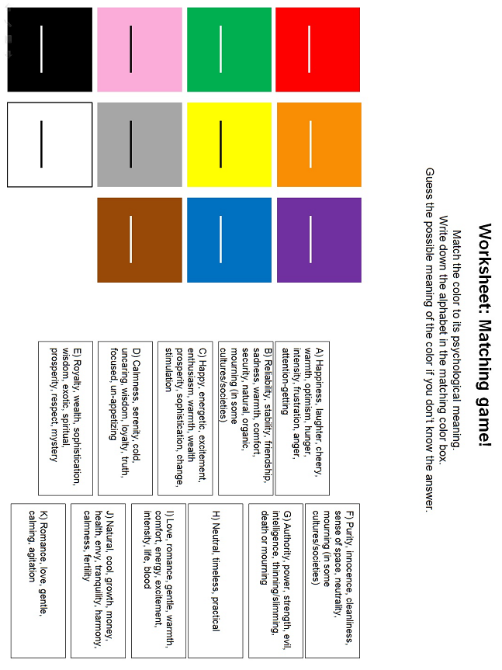

Match the color game worksheet.

Worksheet: Matching game! (Answer Sheet)

Red: I
Orange: C
Purple: E
Green: J
Yellow: A
Blue: D
Pink: K
Gray: H
Brown: B
Black: G
White: F

PPT1
https://www.pinclipart.com/maxpin/JJxJTh/
PPT2
https://www.pngkey.com/detail/u2q8y3q8q8w7w7y3_trash-can-clipart-proper-disposal-garbage-garbage-clipart/

This Is The World’s Ugliest Color
- And It Has An Important Job
BY CADY LANG
JUNE 1, 2016 2:56 PM EDT

The world’s ugliest color has been described as “death,” “dirty” and “tar,” but this odious hue is serving an important purpose: discouraging smoking.
Pantone 448 C, a “drab, dark brown” also called “opaque couché,” was specifically selected after three months and multiple studies by research agency GfK. The agency was hired by the Australian government to find a color that was so repugnant that if it was on tobacco products, it would dissuade people from smoking.
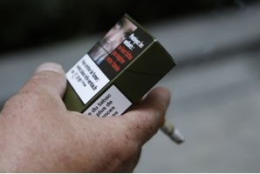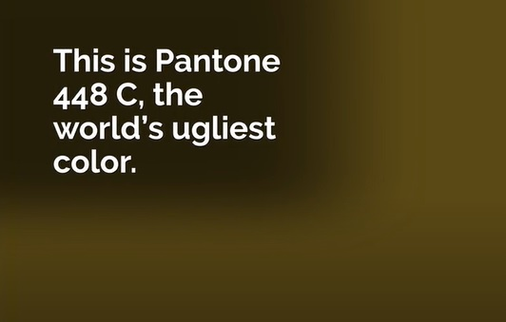
A man smokes a cigarette on September 25, 2014 in Paris,
holding a sample of a "plain cigarette packaging" cigarette box
(THOMAS SAMSON/AFP/Getty Images)

The new color was adopted for all tobacco packaging along with graphic health warnings. Now, other governments are following suit. The United Kingdom, Ireland and France have all passed “plain packaging” laws as well, using mockups using the same murky color. Ugly never looked so good.

Reference
https://time.com/4353765/worlds-ugliest-color-discourages-smoking/

Worksheet - The World's Ugliest Color

Exercise 1: Read the given article and answer the question.

Q1) What color is the Pantone 448 C?

Q2) In what words the world's ugliest color described as?

Q3) What is the purpose of using the ugly color on tabacco products?

Q4) What kind of graphic is adopted along for the tabacco packaging?

Worksheet - The World's Ugliest Color

Exercise 2: Read carefully, think, and write your answer.

Q1) Why did the writer say 'Ugly never looked so good' at the end of the article? How possible is that ugly is good?

Exercise 3: Talk to your partner freely about the question below. (No writing)
Q1) How does color affect you or people in everyday life?

Worksheet - The World's Ugliest Color
(Answer Sheet)

Exercise 1: Read the given article and answer the question.

Q1) What color is the Pantone 448 C?
(Dark brown)

Q2) In what words the world's ugliest color described as?
(Death, dirty, tar)

Q3) What is the purpose of using the ugly color on tabacco products?
(The purpose is to discourage smoking or to dissuade people from smoking.)

Q4) What kind of graphic is adopted along for the tabacco packaging?
(Health warning)

Exercise 2: Read carefully, think, and write your answer.

Q1) Why did the writer say 'Ugly never looked so good' at the end of the article? How possible is that ugly is good?
(The ugliness of color gives a bad attention to people. By using this color on the tabacco packaging, it makes people not to choose or buy the tabacco products and it may reduce people's desire for the tabacco products. Therefore it may help people to avoid smoking. Ugly can be called good because its color is being used to help people to keep away from smoking which help to protect their health from tabacco products.)

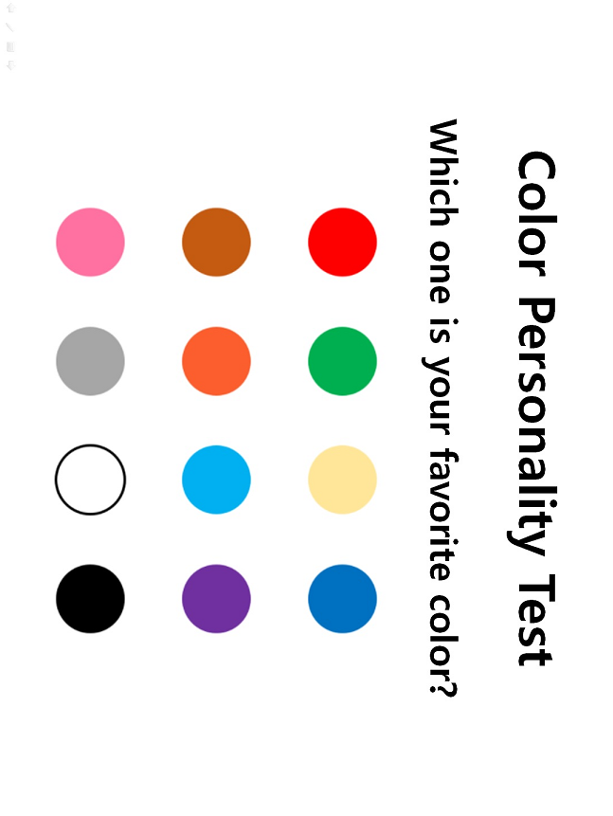
PPT3 / S.O.S Activity Worksheet
https://pt-br.facebook.com/incruit/photos/pcb.10155787451622031/10155787448902031/?type=3&theater

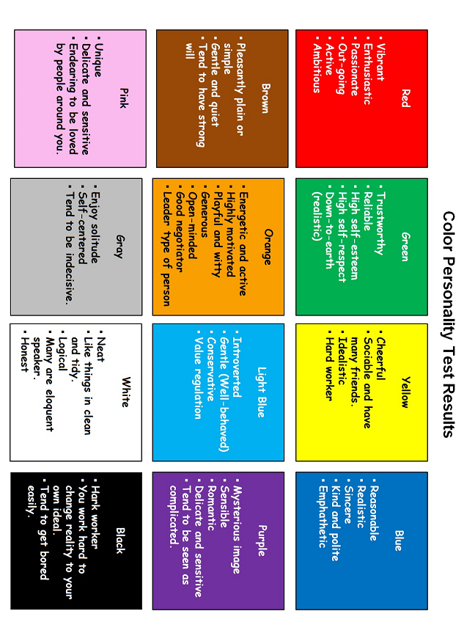
S.O.S Activity Worksheet
https://pt-br.facebook.com/incruit/photos/pcb.10155787451622031/10155787448902031/?type=3&theater

Instructor’s Comments and Assessment
Pros
Cons
Change
Overall Comments
Grade
Above Standard 85%-100% | Standard 70%-84% | Below Standard 69%-0%
Instructor | Student Signature | Date
Taute, David

