Name | Class | Date | Lesson Type | Plan Type | Length
AJ | 220TH_wk  TESOL | 05/29/21 | Reading | PPP | 30mins
Background Information Sheet

Lesson
Topic | 5 animal masters in disguise.
Main Aim | Ss practice their reading comprehension.
Secondary Aim | Ss practice their speaking fluency.

Materials and References
Board,pens,articles and worksheets.

Student Profile
Level | Intermediate
Age | 15 yrs. old | Number of Students | 4
Detail | Students are korean speakers and active to learn and develop their language skills.

Anticipated Difficulties and their Solutions:
PPT failure- print some materials, Anxiety- relax, prepare everything that you need and read the lesson plan before the class.

My Personal Aim
What I hope most to demonstrate in this lesson is the ability to
* Let the students completely understand the lesson.
*Students develop reading skills.
*Learn time management.

Page 1 of 6
Stage Name: Lead-in
Purpose of this stage: To relax both the teacher and students. To focus attention on the lesson. To lead in to the topic, activating background knowledge – this will help to contextualize the text. This is a BEFORE READING stage.
Materials: worksheet and pen.
Timing | Interaction | Procedure
1min  2mins  1min  2mis | T  S  S-S  T-S | “Hi guys, Good day! How's everyone? (Student answered) ok, I'm giving you a worksheet and you have to circle Wally in the crowd and other things that are indicated in the instruction. You must answer it as fast as you can because I'll give you only 2 minutes to find and circle the objects.” show Wally’s picture.  answer the worksheet  Students sharing answers and discuss.  Discuss the answer  “Is it hard to find Wally in the crowd?(yes) You think why is it hard to find Wally?  What are the factors?

Stage Name: Presentation
Purpose of this stage: To pre-teach keywords if necessary, and answer guiding questions (such as a predicting task, or a specific question). These steps provide extra help for students to comprehend the text. This is a BEFORE READING stage.
Materials: Board, printed materials and colored pens.
Timing | Interaction | Procedure
5mins | T-S  T-S | Pre-teach keywords  Elicit – “look at this picture can you tell me what you see?”(animals and trees) what is the specific term for this group of living things? Species.  CCQ –  1.Is this species a living organism?(yes)  2.Is this paper a sample of living organisms?(no)  Drill – Say species once and call individually to repeat the word.  Board –  Write down the word on the board.  How many syllables?(2)spe-cies  Where is the stress?(1st)mark with the red pen.  What kind of speech?(noun)

Page 2 of 6
2mins | T-S  T-S | Elicit – Look at the picture, can you describe what you see and can you see the man properly?(no)  What term or word can you define in this situation of a military personal in disguise? camouflage.  CCQ –  1.Is camouflage means to disguise or conceal?(yes)  2.Is it something that can be easily seen?(no)  Drill – ok ,listen and repeat 3 times(gesture) select individually.  Board –  write the word on the board  how many syllables?(3) cam-ou-flage  Where's the stress?(2nd) mark with red pen.  What part of speech?(noun)  Elicit – Can you explain what the lab personnel are doing?(mixing substance) can you give another term for mix? Blend.  CCQ –  1.Does the blend mean to mix with another to combine together?(yes)  2.At the picture does Wally unblend in the crowd?(no)  Drill – Say the word blend 3 times and call individuals to repeat the word.  Guiding Question  Have you ever seen insects or animals that looks-like their natural inhabitant or they blend to their environment? discuss.

Page 3 of 6
Stage Name: Practice – Literal Comprehension
Purpose of this stage: is to get students to practice reading for literal detail. They will also practice fast reading (skimming and scanning). This is a WHILE READING stage.
Materials: worksheets,pen and article.
Timing | Interaction | Procedure
1min  3mins  2mins  2mins | T  S  S-S  T-S | I'm holding up a worksheets and an article about the 5 animal masters in disguise.  You must underline the answers on your copy(article) or you can simply write it down.  Do you need to read the whole article?(no)I will give you 3 minutes to answer.  Students read the article and answer the worksheet.  Compare your answer.  Let's start to answer.  call students individually to answer.  Feedback.ok!good job guys.

Stage Name: Practice – Interpretive Comprehension
Purpose of this stage: is to get students to get students to practice interpreting a text correctly This will require more detailed,careful reading, and thinking time to arrive at the correct answer. This is a WHILE READING stage.
Materials: worksheet,pen and article.
Timing | Interaction | Procedure
30sec  2mins  1min  2mins | T  S  S-S  T-S | I have another worksheet. Please write down your answer to the bottom of the questions.  You have 2 mins to answer.  Students answer the interpretive question.  student to student discussion  Discuss the answer.  Feedback.

Page 4 of 6

Stage Name: Production - Applied Comprehension
Purpose of this stage: is for students to practice their speaking fluency and is related to the lesson topic. This is an AFTER READING stage.
Materials: no materials needed.
Timing | Interaction | Procedure
30sec  1min  2mins | T  S-S  T-S | Guys, did you ever play hide and seek in your childhood? If yes, how did you manage to hide yourself and not to be found? please discuss it with your partner.I'll give you 2 minutes to discuss.  Ss discussion  Ss sharing experience and teacher’s feedback.

Stage Name: Wrap-up
Purpose of this stage: is to end the lesson on a positive note so that students feel they have achieved progress. This is an AFTER READING stage.
Materials: no materials needed.
Timing | Interaction | Procedure
1 min | T | Great job guys,hopefully you learned a lot and i suggest to read more articles or any other reading materials to improve your vocabulary.  No homework for today, but we have a test for tomorrow, so take a review.  Enjoy the weekend.  dismissed.  SOS Games: Word ladders  In this activity, a word must be transformed step by step into a target word.To illustrate the idea,write the word run on the board and explain that the target word is fit. For each turn, only one letter can be changed. See if the class can find valid sequences together. Students need access to a dictionary in order to check if their words are valid. If you want to find possible word pairs,there is a site with a handy word ladder generator . Put the students in pairs and have them create their own word ladders to test their classmates with.

Page 5 of 6
Instructor’s Comments and Assessments

Pros
Cons
Change
Overall Comments
Grade
Above Standard 85%-100% | Standard 70%-84% | Below Standard 69%-0%
Instructor | Student Signature | Date
Taute, David

Page 6 of 6
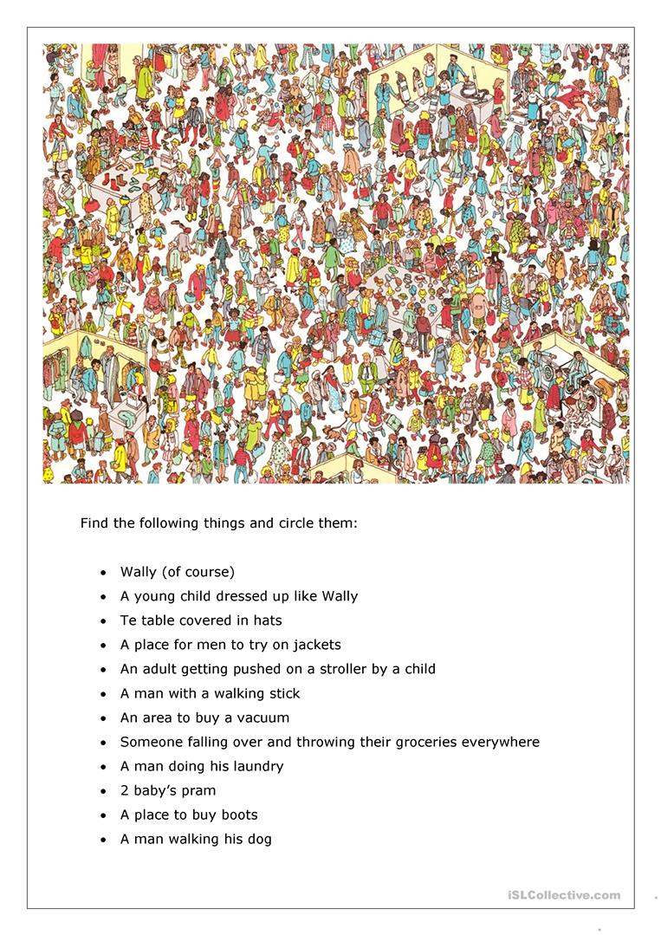
Literal questions:

1.What does the Malayan horned frog looks-like?

2.How cuttlefish avoid confrontations with other predators?

3.Arctic hare has a white fur but in summer month it turns into?

4.Where does the uroplatus gecko live?

Practice: interpretive

1.How camouflage help animals to survived?

2.Why these animals called the master of disguise?

