Background Information Sheet
Name | Class | Date | Lesson Type | Plan type | Length
Yoojin Cho | TESOL 220th WK | 05-22-2021 | Reading | PPP | 30 min

Lesson
Topic | How to make chocolate chunk cookies
Main Aim | Ss practice their reading comprehension.
Secondary Aim | Ss practice their speaking fluency.

Materials and References
Board, colored markers, reading material, worksheet (+answer sheet), and visible ingredient list, ppt
Book <Mastering the Art and Craft baking & pastry>

Student Profile
Level | Lower intermediate
Age | Teens | Number of Students | 4
Detail | This is a general English class and students are highly motivated learners. The students are from Korea and Philippines. They are accustomed to pair work because they have been in this class for last 3 months. It took them to open up to communicate freely in English at first, but they are getting used to it. They are stimulated on learning English from new study materials. Also, they are the visual learners.
Assumptions about students’ knowledge as required for this lesson:
Students are familiar with present tense.
Students practiced past and future tenses in grammar lesson.
Students know most vocabulary used in this lesson (from previous lessons).

Anticipated Difficulties and their Solutions:
Text level – The reading seems to be little difficult to the student’s level, but they can still assume the whole text and the questions from the activities will fit to their level.
Ss don’t know all the vocabulary in the text - Some words in the reading material can be difficult for students. I will selectively teach important keywords which are necessary to know to understand the text.
The computer could fail print A4 size pictures from PPT.

My Personal Aim
What I hope most to demonstrate in this lesson is the ability to be an involver type teacher.

Stage Name: Lead-in
Purpose of this stage: To relax both the teacher and students. To focus attention on the lesson. To lead in to the topic, activating background knowledge – this will help to contextualize the text. This is a BEFORE READINING stage.
Materials: visual ingredients list, board, colored markers.
Timings | Interactions | Procedure
3 min | T-S | Write – How to make chocolate chunks cookies.  T – Hello everyone. Does everyone like cookies?  Look at these. I brought some cookie ingredients. Can anyone guess the name?  (S – I love cookies. Flour, sugar, butter, chocolate chips)

Stage Name: Presentation
Purpose of this stage: To pre-teach keywords if necessary, and answer a guiding questions (such as a predicting task, or a specific question). These steps provide extra help for students to comprehend the text. This is a BEFORE READINING stage.
Materials: PPT, board, colored markers
Timings | Interactions | Procedure
1 min  1 min  1 min  1 min  10 sec  1 min  1 min | T-S  T-S  T-S  T-S  T  S-S  T-S | Pre-teach keywords  Elicit – Show the dough and baked cookie. leaven .  “This is before and this is after baking. What happened? How different are these?”  (It got bigger.)  CCQ – Does it get bigger? (Yes,)  Is this after baking? (Yes.)  Do you think I added something to make it leaven? (Yes.)  Drill – Listen and repeat 3 times together. Leaven (Gesture)  Individual drilling for correct pronunciation.  Board – Write “leaven” on the right top corner of the board.  How many syllables? (2) Mark with a blue pen. leav-en  Where is the stress? (1st) Mark with a red pen.  What type of word is it? (verb)  Elicit – Point to the PPT-keyword 2 periodically.  “What is going on here?” (She exercises regularly/ periodically)  CCQ – Does she repeating the same thing? (Yes.)  Does she go to work out regularly? (Yes.)  Drill – Listen and repeat 3 times together. (gesture)  Individual drilling for correct pronunciation.  Board – Write “periodically” on the right top corner of the board.  How many syllables? (6) Mark with a blue pen. pe-ri-od-i-cal-ly  Where is the stress? (3rd) Mark with a red pen.  What type of word is it? (adverb)  Elicit – Point to the PPT-keyword 3 incorporated.  “How can you describe this? (point to the right side)” (They are combined/incorporated.)  CCQ – Is the small piece included? (Yes)  Are these separated? (No.)  Are these combined altogether? (Yes.)  Drill – Listen and repeat 3 times together. (Gesture)  Individual drilling for correct pronunciation.  Board – Write “incorporated” on the right top corner of the board.  How many syllables? (5) Mark with a blue pen. in-cor-po-rat-ed  Where is the stress? (2nd) Mark with a red pen.  What type of word is it? (adjective)  Elicit – Point to the PPT-keyword 4 alternatively .  “This road was under construction, so he had to reroute. How can you describe his situation with the right road?” (He alternatively drove to the right road.)  CCQ – Is he possible to use another road? (Yes,)  Did he choose to go to the right road instead of the left side? (Yes.)  Drill – Listen and repeat 3 times together. Alternatively (Gesture)  Individual drilling for correct pronunciation.  Board – Write “alternatively” on the right top corner of the board.  How many syllables? (5) Mark with a blue pen. al-ter-na-tive-ly  Where is the stress? (2nd) Mark with a red pen.  What type of word is it? (adverb)  Guiding Question  T - Do you have baking or cooking experience? Share your partner about how you made it.  Students discuss the question with a partner.  (I baked cookies with my mom when I was young. I added eggs to flour and sugar and mixed and then baked in the oven.)  Feedback. Nominate a few students to share their ideas.
II

Stage Name: Practice – Literal Comprehension
Purpose of this stage: is to get students to practice reading for literal detail. They will also practice fast reading (skimming and scanning). This is a WHILE READINING stage.
Materials: Worksheet, board, colored markers
Timings | Interactions | Procedure
30 sec  4 min  1 min  1 min | T  S  S–S  T-S | Instructions. Hold up the worksheet, point to exercise A.  T – Read the recipe and answer the questions. You can also check the 2nd page if needed.  T - I’ll give you 4 minutes to finish this. This is individual work and don’t unfold.  ICQ  - How many minutes do you have? (4 miniutes)  - Do you work with your partner? (No)  Hand out.  Students read the whole text for the 1st time and write answers on the worksheet.  Pair check.  Feedback to check accuracy.

Stage Name: Practice – Interpretive Comprehension
Purpose of this stage: is to get students to get students to practice interpreting a text correctly This will require more detailed, careful reading, and thinking time to arrive at the correct answer. This is a WHILE READINING stage.
Materials: Worksheet, board, colored markers
Timings | Interactions | Procedure
30 sec  3 min  1 min  1 min | T  S  S–S  T-S | Instructions. Hold up the worksheet, point to exercise B.  T – Now, unfold the paper and do exercise B.  T - I’ll give you 3 minutes to finish this. This is individual work.  ICQ  - How many minutes do you have? (3 miniutes)  Students read for the 2nd time. Students write their answers down.  Pair check. Monitor.  Feedback to check accuracy.

Stage Name: Production - Applied Comprehension
Purpose of this stage: is for students to practice their speaking fluency and is related to the lesson topic. This is an AFTER READINING stage.
Materials: board, colored markers
Timings | Interactions | Procedure
30sec  5min  1min | T  S-S  T-S | Instructions. Pair students.  T – Talk to your partner about your favorite dessert and where did you eat or what would you like to add to your own cookies.  Students share their experience.  Monitor from a distance.  T – Time’s up!  Feedback. Nominate a few students to share.

Stage Name: Wrap-up + SOS activity
Purpose of this stage: is to end the lesson on a positive note so that students feel they have achieved progress. This is an AFTER READINING stage.
Materials: PPT, board, colored markers
Timings | Interactions | Procedure
1min  1min  2min  2min | T  T  S-S  T | Lesson feedback. Tell the class what they did well, and what needs to improve.  Offer delayed corrections to the previous stage.  T – Good job everyone today. If read and think carefully you can always find the answers from the text.  Set homework.  T – No homework today.  Inform students about the topic for the next lesson.  “In the next class, we are going to learn how to make the world best brownie”.  Dismissed.  ________________________________________________________________________________________________  [SOS activity]  Show PPT.  Group students  T – Here are some 2 words sentence. Make 2 words sentences as many as you can. I will give you 2 minute(or more). This is competition! Let’s begin!  Make students to write on the board.  Count and tell the winner.

<Lead-in>

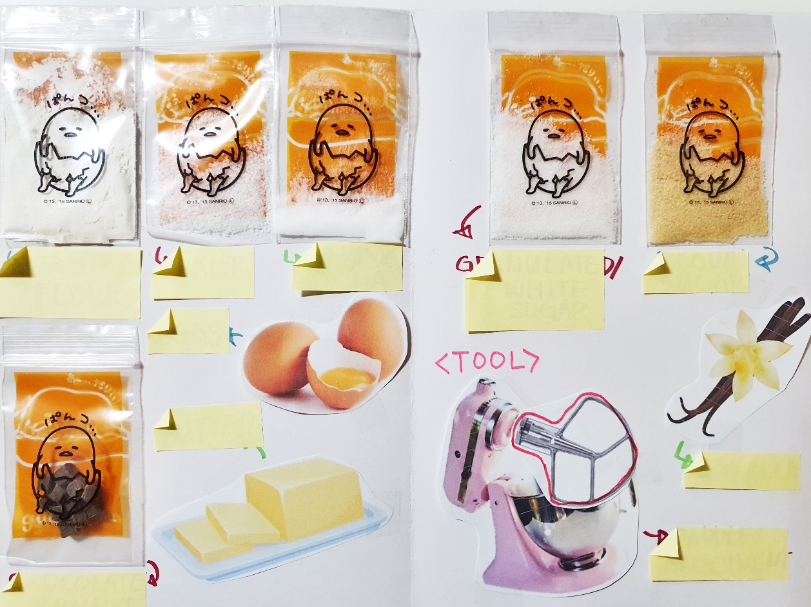
<Reading material 1>
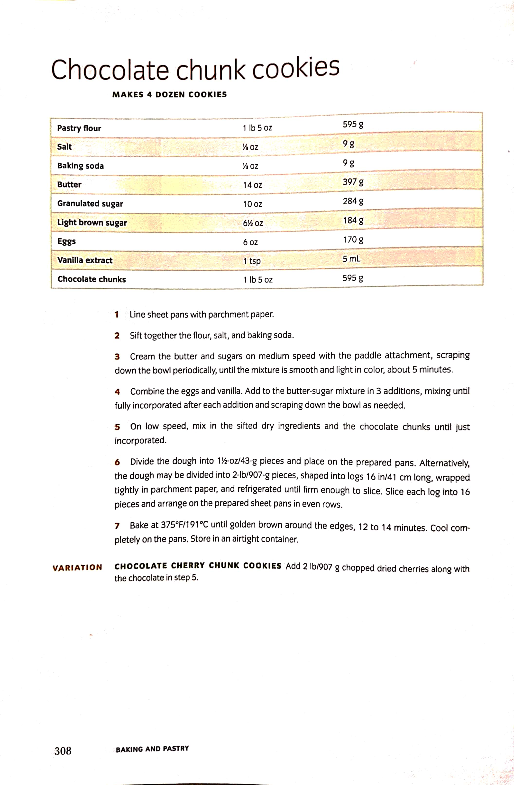
<Reading material 2>
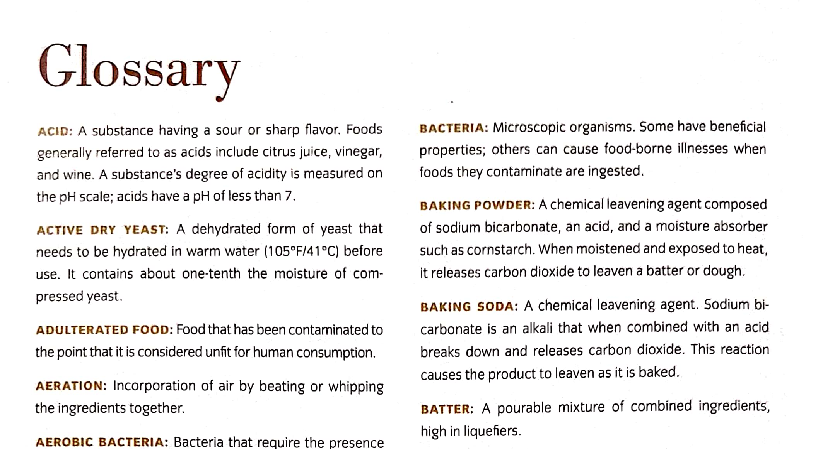

<Reading material 3>

<Board Plan>
Leav/en (v.)
pe/ri/od/i/cal/ly (adv.)
How to make chocolate chunks cookies in/cor/po/rat/ed (adj.)
al/ter/na/tive/ly (adv.)

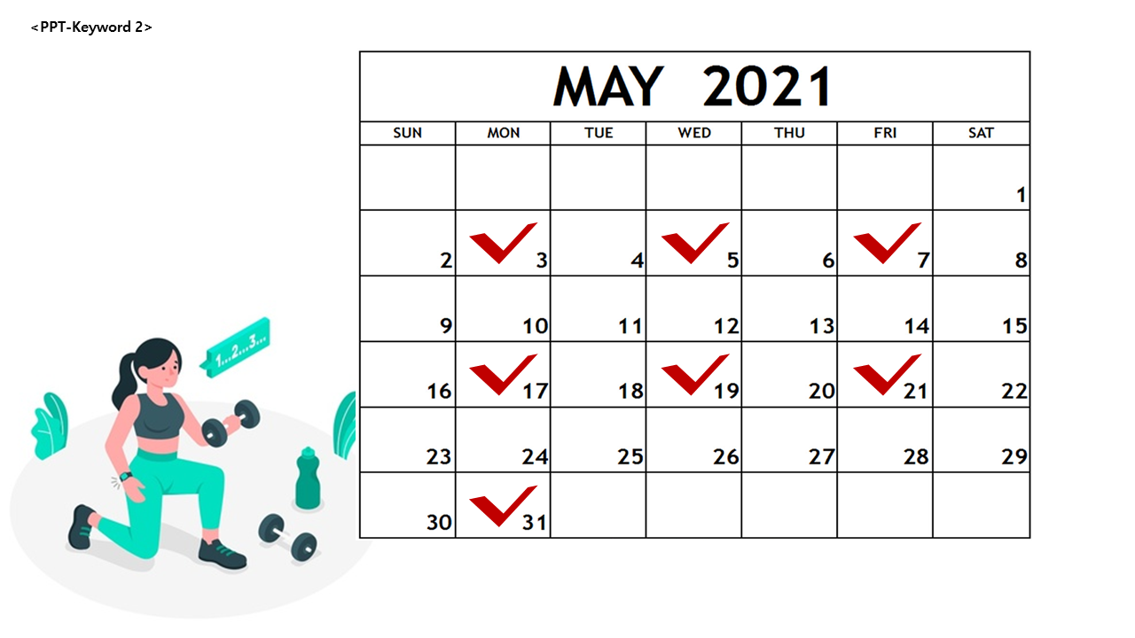
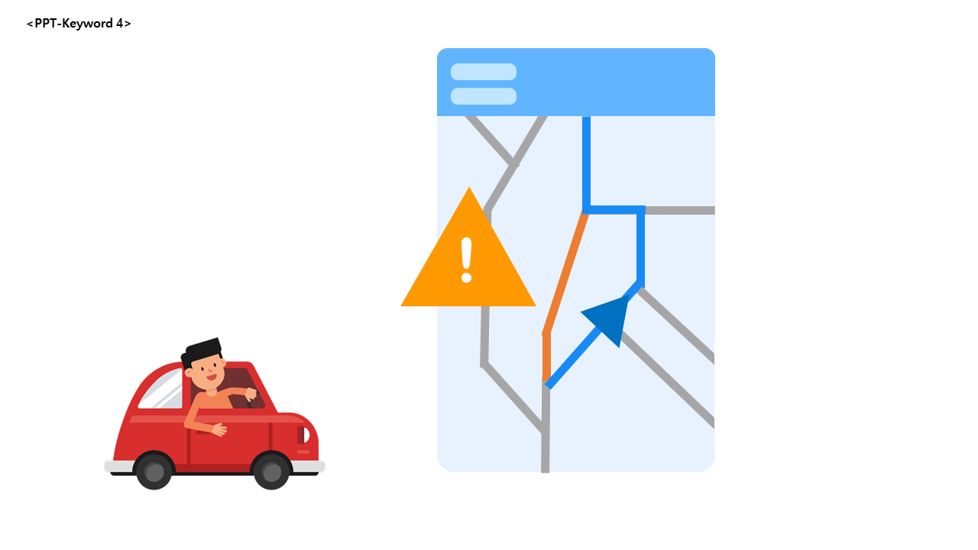
Worksheet: Reading Lesson 5/22

Exercise A
Read the questions and write your answer.

- What can you make from this recipe? (2 correct answers)
:

- How long do you cream the butter and sugars?
:

- In #6 alternative method, after shaping, what do you need to do to slice the dough?
:

- How long do you bake?
:

_________________________________________________________________________________________________________
Exercise B - Read the question and write your answer.

Q: When do you add baking soda and why?
:

Worksheet: Reading Lesson 5/22 – ANSWER SHEET

Exercise A
Read the questions and write your answer.

- What can you make from this recipe? (2 correct answers)
: chocolate chunk cookies, chocolate cherry chunk cookies

- How long do you cream the butter and sugars?
: Cream about 5 minutes.

- In #6 alternative method, after shaping, what do you need to do to slice the dough?
: Wrap the dough and keep it in the refrigerator until firm enough to slice.

- How long do you bake?
: for 12 to 14 minutes until golden brown around the edges.

_________________________________________________________________________________________________________
Exercise B - Read the question and write your answer.

Q: When do you add baking soda and why?
: It is one of the dry ingredients so in stage 5. It leavens the dough while baking so it should be added before baking while mixing the dough to be incorporated.

Instructor’s Comments and Assessment
Pros
Cons
Change
Overall Comments
Grade
Above Standard 85%-100% | Standard 70%-84% | Below Standard 69%-0%
Instructor | Student Signature | Date
Taute, David

