Background Information Sheet
Name | Class | Date | Lesson Type | Plan type | Length
Summer | TESOL | 22/05/2021 | Reading | PPP | 30min

Lesson
Topic | beautiful growth
Main Aim | Ss practice their reading comprehension.
Secondary Aim | Ss practice their speaking fluency.

Materials and References
worksheet, whiteboard, makers(black, blue, red, green), computer(for music : https://www.youtube.com/watch?v=oKb1XUSw2zA)

Student Profile
Level | beautiful growth
Age | Adult | Number of Students | 4
Detail | This is a general English class and students are interactive learners. The students are 3 Koreans and a Filipina. They are accustomed to pair work, but still need to be relaxed before they open up to communicate freely. They tend to favor the visual learner mode.

Anticipated Difficulties and their Solutions:
Anxiety : before the class, check if everything is ready.
Ss don’t know some vocabulary : take a note on the board, talk about it after reading, before doing worksheets
Some of students finish quicker than others : let them do paircheck and help others.
They sit scattered way : make them sit together with a partner beside her/him.
Ss need more time to do worksheet or talk: give extra 1 min.
Computer doesn’t work : Prepare Bluetooth speaker or no use

My Personal Aim
What I hope most to demonstrate in this lesson is the ability to
* Let students understand what they read.
* Write more detailed lesson plan.

Stage Name:Lead-in
Purpose of this stage:To relax both the teacher and students. To focus attention on the lesson. To lead in to the topic, activating background knowledge – this will help to contextualize the text. This is a BEFORE READINING stage.
Materials: -
Timing | Interaction | Procedure
30 sec  2 min  30 sec | T  whole  T-S | Hi, everyone.  Let’s talk about when you grow up.  What Are you different from now?  (Brainstorm) Could you share anyone?  (gesture making them pay attention to me.)  Ok. Good job.  (If They talk about eating food a lot… )  I heard that all of you had a lot of food when you grew up. So did I.

Stage Name:Presentation
Purpose of this stage:To pre-teach keywords if necessary, and answer a guiding questions (such as a predicting task, or a specific question). These steps provide extra help for students to comprehend the text.This is a BEFORE READINING stage.
Materials: whiteboard, makers(black, blue, red, green), pictures(A4)
Timing | Interaction | Procedure
3 min  10 sec  1 min  50 sec | T-S  T  S-S  T-S | Before reading, we will check keywords here.  Pre-teach keywords  ravenous  Elicit – show Ss picture1.  CCQ – 1) Do you think she is extremely hungry? (Yes.)  2) Does she have greed for food? (Yes.)  3) Do you think both animals and people feel hungry? (yes).  Drill – 1) Everyone together, listen and repeat it three times…..  (Check and correct pronunciation, using proper gesture.)  2) (After writing the word on the board) how many syllables? (rav/en/ous 3)  3) Which syllable is stressed? (1st rav)  4) What part of speech is ravenous? (A adjective.)  compound  Elicit – show Ss picture2.  CCQ – 1) Does it have two or more parts? (yes.)  2) Is it simple? (No.)  3) Is it a combination? (yes)  Drill – 1) Everyone together, listen and repeat it three times…..  (Check and correct pronunciation, using proper gesture.)  2) (After writing the word on the board) how many syllables? (com/pound 2)  3) Which syllable is stressed? (1st com/ When it is used as a verb, 2nd)  4) What part of speech is compound? (A adjective.)  proboscis  Elicit – show Ss picture3  CCQ – 1) Is it long thin mouth of insects? (yes.)  2) Does it look like a tube? (yes.)  3) Is it flexible? (yes)  Drill – 1) Everyone together, listen and repeat it three times…..  (Check and correct pronunciation, using proper gesture.)  2) (After writing the word on the board) how many syllables? (pro/bos/cis 3)  3) Which syllable is stressed? (2nd)  4) What part of speech is compound? (A noun.)  Have you seen something transform from babies to adults?  Let students discuss the question with a partner.  Feedback. Nominate a few students to share their ideas. (Optional.)

Stage Name:Practice – Literal Comprehension
Purpose of this stage:is to get students to practice reading for literal detail. They will also practice fast reading (skimming and scanning). This is a WHILE READINING stage.
Materials: whiteboard, makers(black, blue, red, green), worksheets
Timing | Interaction | Procedure
30 sec  2 min  1 min  1 min | T  S  S-S  T-S | Instructions.  I have two papers. One is the material we will read. The other one is worksheets.  (Hand out a passage first and show Ss worksheet.)  Do not turn over this paper.  Only Answer the questions on the worksheet 1, reading a passage..  You have 3 multiple questions that you have to choose only one option and 1 short-answer question.  I will give you 2 minutes for this.  Will you turn it over? (No.)  How many minutes do you have? (2mins)  Start with clapping.  Students read the whole text for the 1sttime, and write answers on the worksheet.  (clap twice.) Ok. Let’s Pair check.  Feedback to check accuracy.

Stage Name:Practice –Interpretive Comprehension
Purpose of this stage:is to get students to get students to practice interpreting a text correctly This will require more detailed, careful reading, and thinking time to arrive at the correct answer.This is a WHILE READINING stage.
Materials: whiteboard, makers(black, blue, red, green), worksheets
Timing | Interaction | Procedure
30 sec  3 min  1 min  2 min | T  S  S-S  T-S | Turn over the paper. Worksheet2 needs you to think more.  Answer and write down the reason you chose that from the passage.  I will give you 3 minutes for this.  How many minutes do you have? (3mins)  The answers have reasons in the passage? (Yes.)  Students read for the 2nd time. Students write their answers down.  Pair check. Monitor.  Feedback to check accuracy.

Stage Name:Production - Applied Comprehension
Purpose of this stage:is for students to practice their speaking fluency and is related to the lesson topic.This is an AFTER READINING stage.
Materials: whiteboard, makers(black, blue, red, green), worksheets
Timing | Interaction | Procedure
1 min  7 min  1 min | T  S-S  T-S | Could you talk about your growth?  From babies to children, children to teenagers, teenagers to adults  What did you need? What did you do? What did you feel?  Share your partner freely.  I will give you 7minutes. (clap)  Students discuss.  (clap twice)  Feedback. Students share their ideas with the class. (Optional.)

Stage Name:Wrap-up
Purpose of this stage:is to end the lesson on a positive note so that students feel they have achieved progress.This is an AFTER READINING stage.
Materials: whiteboard, makers(black, blue, red, green),
Timing | Interaction | Procedure
3 min | T | Good job, today. Did you enjoy it? (students answer)  I have some suggestions. Look at the board.  (Offer delayed corrections to the previous stage.)  I’m glad to hear about your youth.  Today’s homework is taking a note some vocabularies that you are confused about the meaning  and making a sentence using that word.  We will talk about happy Summer vacation next time.  see you on next Saturday.

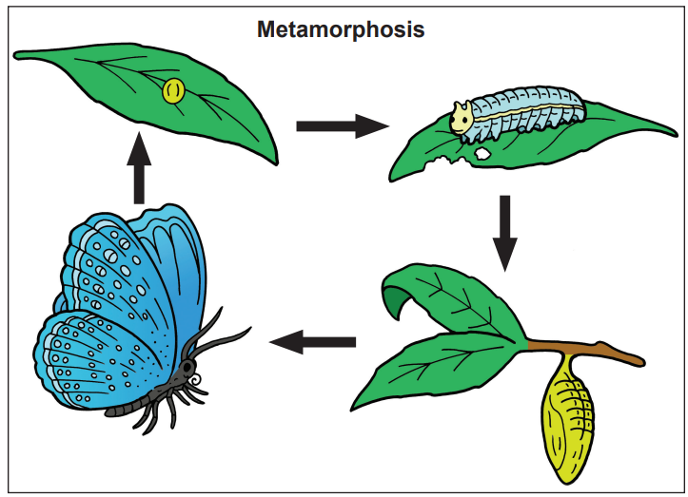
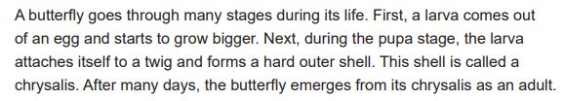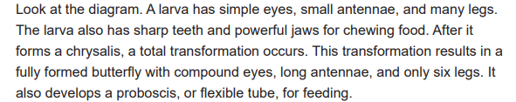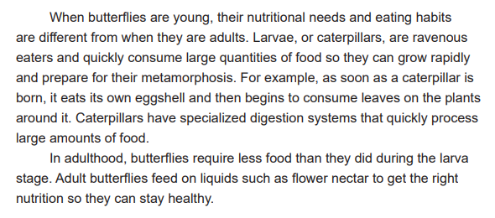
Worksheet 1

1. According to the passage, which words show the correct order of a butterfly’s metamorphosis?
a) Larva→ Pupa→ Egg→ Adult
b) Egg→ Larva→ Pupa→ Adult
c) Pupa→ Larva→ Egg→ Adult
d) Egg→ Pupa→ Larva→ Adult

2. What 5 parts does larva have based on the passage?
Answer : ____________________________________________________________________________________________

3. According to the passage, why does the larva have sharp teeth and powerful jaws?
Answer : ____________________________________________________________________________________________

4. What kinds of food does the larva eat? Adult butterfly?
Answer : ____________________________________________________________________________________________

Worksheet 2

1. What is one physical change that occurs during metamorphosis?
Answer : ____________________________________________________________________________________________
_______________________________________________________________________________________________________
_______________________________________________________________________________________________________

2. Why are the eating habits of caterpillars different from the eating habits of adult butterflies?
Answer : ____________________________________________________________________________________________
_______________________________________________________________________________________________________
_______________________________________________________________________________________________________

Worksheet 1 – Answer Key

1. According to the passage, which words show the correct order of a butterfly’s metamorphosis?
a) Larva→ Pupa→ Egg→ Adult
b) Egg→ Larva→ Pupa→ Adult
c) Pupa→ Larva→ Egg→ Adult
d) Egg→ Pupa→ Larva→ Adult

2. What 5 parts does larva have based on the passage?
(simple eyes, small antennae, many legs, sharp teeth and powerful jaws)

3. According to the passage, why does the larva have sharp teeth and powerful jaws?
(for chewing food)

4. What kinds of food does the larva eat? Adult butterfly?
(eggshell, leaves, liquids such as flower nectar)

Worksheet 2 – Answer Key

1. What is one physical change that occurs during metamorphosis?
The number of legs decreases. (Many legs --- only six legs)

2. Why are the eating habits of caterpillars different from the eating habits of adult butterflies?
Because caterpillars need a lot of food to help them grow

picture 1

picture 2

picture 3
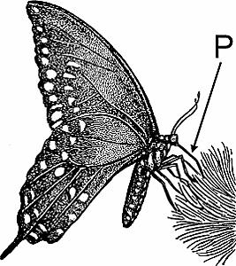
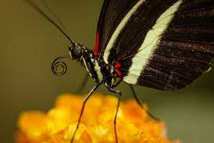
Instructor’s Comments and Assessment
Pros
Cons
Change
Overall Comments
Grade
Above Standard 85%-100% | Standard 70%-84% | Below Standard 69%-0%
Instructor | Student Signature | Date
Taute, David

