Background Information Sheet
Name | Class | Date | Lesson Type | Length
Ceci | 221WD | 05/26/2021 | Speaking | 20 min

Lesson
Topic | Our neighborhood
Main Aim | Students will practice speaking fluency
Secondary Aim | Students will become more confident in speaking to others
Materials and References
https://allesl.com/einsteins-riddle/; board; markers; worksheets; worksheet clues.

Student Profile
Level | Advanced
Age | 19+ | Number of Students | 5
Detail | Class is made up of 5 adult students who are very good with conversation.  Although they are good at conversation, they lack confidence in their English.
Assumptions about students’ knowledge as required for this lesson:
They like riddles and puzzles that help them think.

Anticipated Difficulties and their Solutions:
If a student does not talk with others-I will encourage other students to include that student in the conversation.

My Personal Aim
What I hope most to demonstrate in this lesson is the ability to not talk as much so my students have more time to talk to each other and practice their English.

Stage Name: Pre-Task
Purpose of this stage: Create interest in the topic. Brainstorm ideas which will be useful for the next stage. Students must be given a communicative task e.g. discuss, arrange/sort, create a list, etc.
The aim is to relax students, activate their background information, and gather useful ideas for the lesson.
Materials: worksheet
Time | Interaction | Procedure
30sec  1min  1min | T  S-S  T-S | Who here remembers the neighborhood they grew up in?  Turn and talk to your partner, what kind of neighborhood did you grow up in? how has it changed over the years or what kind of neighbors did you have? For example: the neighborhood I grew up in was loud because it was full of children for a couple of years then become really quiet once all the children grew up and left. (Gesture for them to start talking) you have 1 min.  Partner discussion  Times up here is a worksheet we will be doing today. You will be working in groups to fill in the blanks. Before we start check the vocabulary if there is a word you do not know ask your partner or another student.

Stage Name: Task Preparation
Purpose of this stage: This is a student centered stage, to give students time to prepare and practice a speaking task which they will perform in Task Realization. Clear detailed instructions or a demonstration must be provided so students know what is expected. Prepared materials may be provided to assist their preparation. Monitor and offer brief tips if necessary.
Materials: worksheet clues;
Time | Interaction | Procedure
1min  2min  2min  1min | T-S  S-S  S-S  S-S | You all will be given 3 clues each that will help you fill in the blanks but you can’t show your partners. You must help each other by talking and explaining your clues to solve the riddle. Once you get your clues you can begin you will have 5 mins.  ICQ- do you show your partners your clues? (no)  Do you need to talk and help each other? (yes)  How many min will you have? (5min)  Make their groups (2 groups 1 group of 3 one group of 2)  Give them their clues then gesture for them to begin.  Students help each other fill in the blanks.  Students switch partners by moving one seat over.  Students switch one more time moving one seat over.  Teacher monitors closely gives help when needed.

Stage Name: Task Realization
Purpose of this stage: This is a very student centered stage to allow for maximum speaking fluency practice. Monitor discretely and take note of incorrect language. Students perform their task without interruptions from the teacher. Classroom management may be an important consideration here.
Materials:
Time | Interaction | Procedure
30sec  6min | T  S-S | Times up, now let’s fill in the blanks as a group. You can talk freely and share your clues with everyone to solve the riddle. you all must agree on the answers. You will have 6 min. (gesture to begin).  Open discussion  Students work together to solve the riddle correctly.  Teacher monitors from distance.  While monitoring draw worksheet on the board.

Stage Name: Post Task
Purpose of this stage: To end the lesson with a final student centered task such as voting, summarizing, discussing, deciding etc. The teacher may offer delayed error correction to the previous stage, as well as mention positives and points to improve for next time such as useful strategies.
Materials: board; markers;
Time | Interaction | Procedure
30sec  2min  2min  30sec | T  S-S  T-S  T | Everyone let’s all stand up and work together to write the answers on the board.  Communicate and help each other. If you don’t finish in time that is okay, we will go over it together you have 2 mins.  They board the answers.  Check answers together.  Feedback- positively commend them for their participation.  It was a hard riddle but you all did great.
Worksheet with clues and answer key:
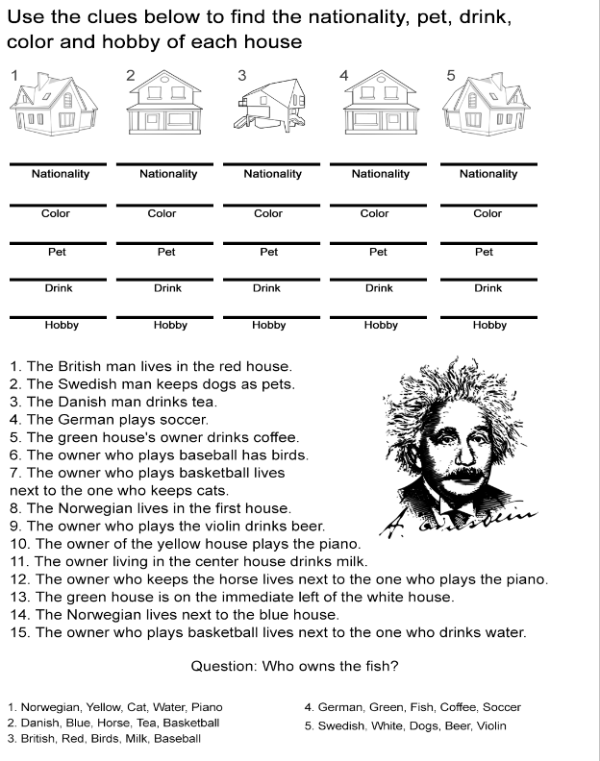

Board plan

 | 1. |  | 2. |  | 3. |  | 4. |  | 5.
Nationality
color
pet
drink
hobby

Instructor’s Comments and Assessment
Pros
Cons
Change
Overall Comments
Grade
Above Standard 85%-100% | Standard 70%-84% | Below Standard 69%-0%
Instructor | Student Signature | Date
Taute, David

