Background Information Sheet
Name | Class | Date | Lesson Type | Plan type | Length
Nakyoung Kim | TESOL | 6 June 2021 | Reading | PPP | 25min

Lesson
Topic | What is ‘learning teaching’?
Main Aim | Students practice their reading comprehension using a textbook.
Secondary Aim | Students practice their speaking fluency.

Materials and References
Worksheet, board pens, board, textbook

Student Profile
Level | Advanced level
Age | Adults | Number of Students | 5
Detail | This is an ELT (English Language Teaching) class and students are highly internally motivated learners. The students are 4 Koreans and 1 American. They are all adults. They have attended an ELT class for the last 6 weeks. The 2 groups of 2 or 3 students will work together, followed by sharing their ideas with the whole class. They still have to be relaxed before they will open up communicate freely. They tend to favor the visual learner mode.

Anticipated Difficulties and their Solutions:
If I feel nervous in the beginning of lesson, I will have nice and warm up talks to make atmosphere good and then start the lesson by following the planned teacher talk.
If students do not have a textbook, I will give them a piece of paper with drawing (Scrivener, 2011, p. 381) and reading material (Scrivener, 2011, p. 380).

My Personal Aim
What I hope most to demonstrate in this lesson is the ability to write a complete, detailed lesson plan here.

Stage Name: Lead-in
Purpose of this stage: To relax both the teacher and students. To focus attention on the lesson. To lead in to the topic, activating background knowledge – this will help to contextualize the text. This is a BEFORE READINING stage.
Materials: List all materials that will be needed in this stage.
Timing | Interaction | Procedure
10 sec  50 sec  1 min | T  S-S  T-S | Greet. Organize horse-shoe seating arrangements.  Hello everyone, do you have your textbook? Open your book at page 381. Look at the drawing. Talk to your partner about what you can see from this drawing. (A teacher or trainee teacher thinks about his/her anxiety and difficulties in making a lesson plan.) Two or three students work together. Use gesture.  Brainstorm. Students talk to their partners. Monitor for any use of key words.  Feedback. Gesture to each group and ask: Tell me about your ideas. (What can you see from this drawing?) Do you have experience that you worry about making a lesson plan or learning teaching? If so, tell me about it. Gesture for each group and ask.

Stage Name: Presentation
Purpose of this stage: To pre-teach keywords if necessary, and answer a guiding questions (such as a predicting task, or a specific question). These steps provide extra help for students to comprehend the text. This is a BEFORE READINING stage.
Materials: List all materials that will be needed in this stage.
Timing | Interaction | Procedure
1 min  1min  1min  1min  10 sec  1 min  50 sec | T-S  T-S  T-S  T-S  T  S-S  T-S | Pre-teach keywords  Elicit – Draw two curved arrows intertwined on the board. Also, draw three curved arrows intertwined on the board. Ask: What are these? (These are intertwined curves)  CCQ – Look at each one. Are they twisted together? (Yes)  Are they two or more things twisted? (Yes)  Are they difficult to be separate? (Yes)  Drill – Listen and repeat 3 times together. (Gesture.) /ˌɪntəˈtwaɪn $ -tər-/  Nominate 2 or 3 individually.  Board – Write intertwine on the left of the board.  How many syllables? (in‧ter‧twine, 3) Mark with a blue pen.  Which syllable is stressed? (in‧ter‧’twine, 3rd) Mark with a red pen.  Which part of speech is managed? (verb)  Elicit – Draw a woman holding a chalk and standing in front of the board. Write her name on the board. Write her age as 20 years old. Ask: What does she do? (She is a teacher) It seems her first day of teaching as she introduces her name on the board. How can we describe her? (She is green new teacher)  CCQ – Is she young? (Yes)  Does she have the lack of experience? (Yes)  Does she look like a veteran teacher? (No)  Drill – Listen and repeat 3 times together. (Gesture.) /ɡriːn/  Nominate 2 or 3 individually.  Board – Write green on the left of the board.  How many syllables? (1)  Which syllable is stressed? (1st) Mark with a red pen.  Which part of speech is managed? (adjective)  Never change  Elicit – Draw this:  Past I have made the decision! Future  What expression can we use in this situation?  CCQ – Is it fixed? (Yes)  Does it enable to be changed? (No)  Is it the final decision? (Yes)  Drill – Listen and repeat 3 times together. (Gesture.) /set ɪn ˈkɒŋkriːt/  Nominate 2 or 3 individually.  Board – Write ‘set in concrete’ on the left of the board.  How many syllables for concrete? (con‧crete, 2) Mark with a blue pen.  Which syllable is stressed? (‘con‧crete, 1st) Mark with a red pen.  Which part of speech is managed for ‘set in concrete’? (idiom)  Elicit – Draw a man wearing glasses and looking something through a magnifying glass. Which adjective can we use in this situation?  CCQ – Does he intend to examine something? (Yes)  Does he aim at finding out more about something? (Yes)  Is he curious to know more about something? (Yes)  Drill – Listen and repeat 3 times together. (Gesture.) / ɪkˈsplɒrətəri /  Nominate 2 or 3 individually.  Board – Write ‘exploratory’ on the left of the board.  How many syllables for exploratory? (ex‧plor‧a‧to‧ry, 5) Mark with a blue pen.  Which syllable is stressed? (ex‧’plor‧a‧to‧ry, 2nd) Mark with a red pen.  Which part of speech is managed? (adjective)  Guiding Question  What does a trainee teacher do when learning teaching? Talk to your partners.  Students discuss with their partners.  Feedback. Nominate a few students to share their ideas with the class. Tell me about your ideas. (E.g. attending TESOL course, reading this textbook again, etc.)

Stage Name: Practice – Literal Comprehension
Purpose of this stage: is to get students to practice reading for literal detail. They will also practice fast reading (skimming and scanning). This is a WHILE READINING stage.
Materials: List all materials that will be needed in this stage.
Timing | Interaction | Procedure
30 sec  2min  30 sec  30 sec | T  S  S-S  T-S | Instructions. From now, you will practice your reading comprehension using a textbook. Page 380 please. You will read only 4 paragraphs on the topic of ‘what is learning teaching’. Do you read only 4 paragraphs? (Yes)  Hand out worksheets. You can answer these questions in exercise one only. Write your answers next to the questions. Do we need to read the questions for exercise 2? (No) Do you have a pen or pencil ready? (Yes)  Students read four paragraphs for the first time, and write answers on the worksheet.  Pair check. Compare your answers with your partner. Monitor.  Feedback to check accuracy.

Stage Name: Practice – Interpretive Comprehension
Purpose of this stage: is to get students to get students to practice interpreting a text correctly This will require more detailed, careful reading, and thinking time to arrive at the correct answer. This is a WHILE READINING stage.
Materials: List all materials that will be needed in this stage.
Timing | Interaction | Procedure
10 sec  2 min  1 min  50 sec | T  S  S-S  T-S | Instructions. This time, answer exercise 2. This question is more difficult but you can answer if you think about what you read carefully.  Students read the four paragraphs for the second time, and write their answers on the worksheet.  Pair check. Compare your answers with your partner. Monitor.  Feedback to check accuracy.

Stage Name: Production - Applied Comprehension
Purpose of this stage: is for students to practice their speaking fluency and is related to the lesson topic. This is an AFTER READINING stage.
Materials: List all materials that will be needed in this stage.
Timing | Interaction | Procedure
10sec  6 min 20sec  1 min | T  S-S  T-S | Instructions. Now, turn over your worksheet. Talk to your partners about a question in exercise 3.  You should talk freely. You have about 6 minutes.  Students discuss. Monitor from a distance.  Feedback. Students share their ideas with the whole class.  Use gesture. From this group, could you tell us about your ideas? Do you agree or disagree? Why?

Stage Name: Wrap-up
Purpose of this stage: is to end the lesson on a positive note so that students feel they have achieved progress. This is an AFTER READINING stage.
Materials: List all materials that will be needed in this stage.
Timing | Interaction | Procedure
2 min | T | Lesson feedback. Tell students what they did well, and what needs to improve.  Provide delayed corrections to the previous stage.  Set homework. For homework, summarize the answers of exercise 3 by writing no more than 300 words. It is due tomorrow.  Inform students about the topic for the next lesson. We will do a linguistic lesson tomorrow.

Drawing
Scrivener (2011, p. 381)
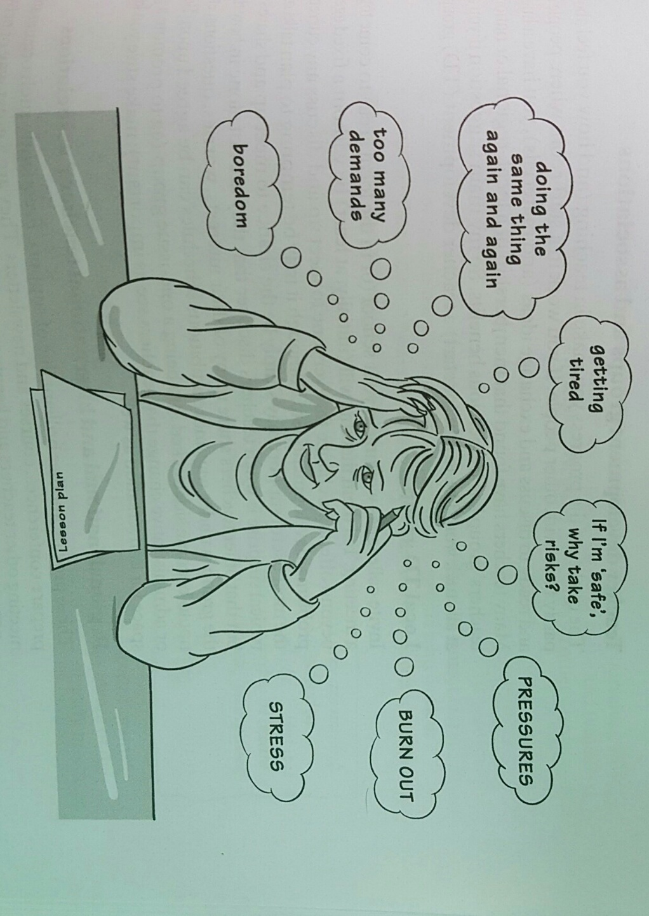

Reading material
Scrivener (2011, p. 380)

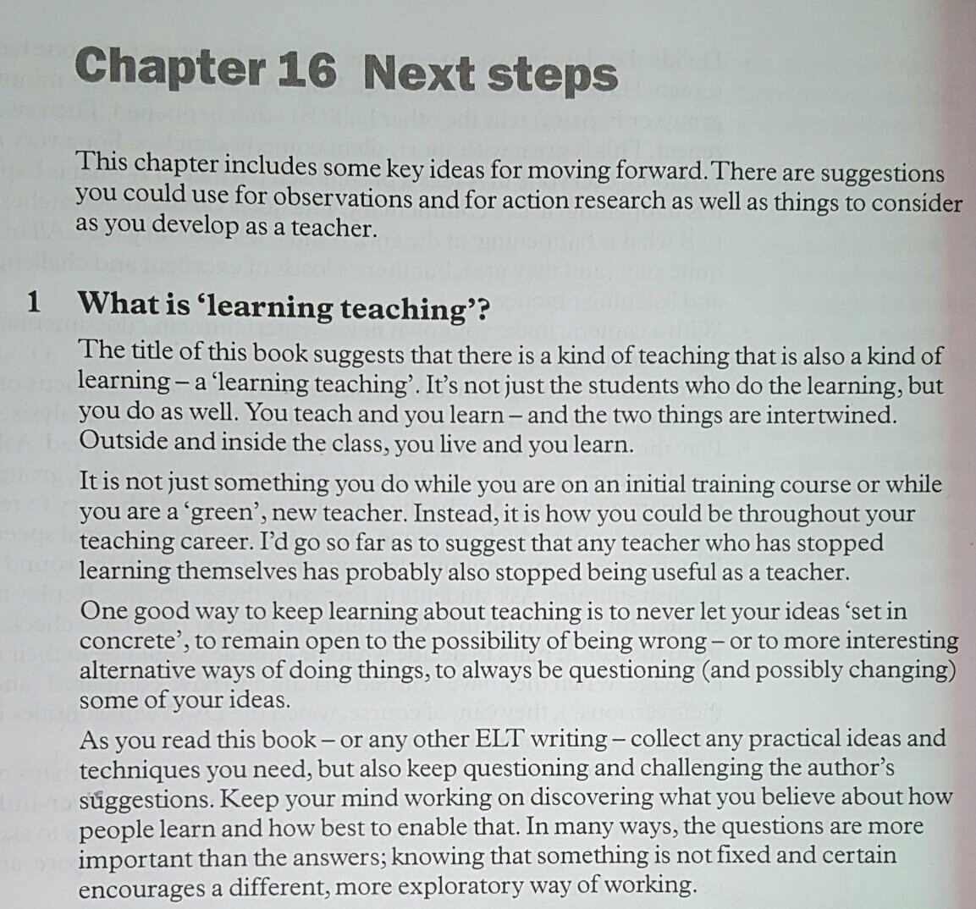

Worksheet1 – What is ‘learning teaching’?

Exercise One: Read and write the answer next to the question.
- Students do the learning but teachers do the teaching only. True or false?

- What are two things intertwined?

- How will teachers, who stop learning themselves, become?

- What is NOT one good way to keep learning about teaching?
- To let your ideas ‘set in concrete’
- To remain open to the possibility of being wrong
- To remain open to more interesting alternative ways of doing things
- To always be questioning and possibly changing some of your ideas
- What does knowing that something is not fixed and certain encourage?

Exercise Two: Read and write the answer next to the question.
- The textbook notes one good way to keep learning about teaching. Are there any other ways to keep learning about teaching?

Exercise Three: Discuss the question
“Doing the learning would determine how a teacher could be throughout his/her teaching career” Do you agree or disagree? And why?

Answer Sheet – What is ‘learning teaching’?

Exercise One: Read and write the answer next to the question.
- Students do the learning but teachers do the teaching only. True or false?
False. (Students do not just the learning but a teacher does the learning as well.)
- What are two things intertwined?
A teacher teaches and a teacher learns. / teaching and learning
- How will teachers, who stop learning themselves, become?
They will stop being useful as teachers.
- What is NOT one good way to keep learning about teaching? 1)
- To let your ideas ‘set in concrete’
- To remain open to the possibility of being wrong
- To remain open to more interesting alternative ways of doing things
- To always be questioning and possibly changing some of your ideas
- What does knowing that something is not fixed and certain encourage?
A different, more exploratory way of working
Exercise Two: Read and write the answer next to the question.
- The textbook notes one good way to keep learning about teaching. Are there any other ways to keep learning about teaching?
To interact with colleagues about each other’s lessons,
To learn from the feedback of students, etc.
Instructor’s Comments and Assessment
Pros
Cons
Change
Overall Comments
Grade
Above Standard 85%-100% | Standard 70%-84% | Below Standard 69%-0%
Instructor | Student Signature | Date
Taute, David

