Background Information Sheet
Name | Class | Date | Lesson Type | Plan type | Length
Jihyeon Im | TESOL | 11 / 08/ 21 | Reading | PPP | 30 min

Lesson
Topic | Your Cousin, the Chimpanzee
Main Aim | Students practice their reading comprehension
Secondary Aim | Students practice their speaking fluency

Materials and References
board, board pen, worksheet, pen, PPT, computer with a screen, reading material

Student Profile
Level | Intermediate
Age | Teenager (13-18) | Number of Students | 3
Detail | Students are consisted of teenagers. They are middle and high school students. As their English level is ‘Intermediate’ currently, they need to be able to understand and speak more vocabulary and become familiar with various reading materials.

Anticipated Difficulties and their Solutions:
- Some students may not understand the reading material due to a lack of vocabulary knowledge let them know some keywords before they read the material
- Some students only read the material but do not talk in the class do pair/group work
- Computer/Screen malfunction Use the printed paper or the board

My Personal Aim
What I aim to demonstrate is the ability to write out a complete, practical lesson plan

Stage Name: Lead-in
Purpose of this stage:
- To make students talk themselves more freely and improve confidence to interact with a teacher and other students
- To introduce the topic or something relating to the topic
Materials: board, board pen
Timing | Interaction | Procedure
30 sec  2 min  30 sec | T  S-S  T-S | Greet and give an instruction.  Hello everyone!  Do you think animals have rights like a human? Should we respect the animals? Discuss with your classmates freely.  Students discuss.  Feedback if necessary.

Stage Name: Presentation
Purpose of this stage:
- To help students understand the context and/or think about the topic
- To have students know some relevant vocabulary
Materials: board, board pen, computer with a screen
Timing | Interaction | Procedure
1 min  1 min  30 sec  3 min  30 sec | T-S  T-S  T  S-S  T-S | Pre-teach keywords – relative, ancestor  Elicit – point to PPT showing the below picture  There are grandparents, aunt, nephew and so on.  How do they look like? ----------------------------------------- (relative)  CCQ  - Are they a member of family? ---------------------------------- <Yes>  - Is an uncle your relative? ------------------------------------- <Yes>  - Is your friend your relative? ------------------------------------- <No>  Drill – listen and repeat 3 times together. Nominate 1 or 2 individually.  Board – write the word on the board and ask questions  - How many syllables?----- <3> Mark with a blue pen  - Which syllable is stressed? -------- <1st> Mark with a red pen  - What form is this word? --- <n. and adj.> Write with a green pen  Elicit  Think about your family member who lived 100 years ago. How can we call the family member? ----------------------------------------------------- <ancestor>  CCQ  - Are they still our family member? ------------------------------- <Yes>  - Did they live short time ago? ------------------- <No, long time ago>  Drill – listen and repeat 3 times together. Nominate 1 or 2 individually  Board – write the word on the board and ask questions  - How many syllables?----- <3> Mark with a blue pen  - Which syllable is stressed? -------- <1st> Mark with a red pen  - What form is this word? --- <n.> Write with a green pen  Guiding Question.  Do you know about chimpanzees? Chimpanzees are highly intelligent and they can solve several problems by themselves. Do you think chimps need to be stuck in the zoo? Talk with your classmates about this. I will give three minutes to talk.  Students discuss.  Feedback if necessary.

Stage Name: Practice – Literal Comprehension
Purpose of this stage:
- to make sure students understand correctly through literal questions
Materials: worksheet, pen, reading material
Timing | Interaction | Procedure
30 sec  3 min  1 min  30 sec | T  S  S-S  T-S | Instructions. Set the purpose for reading. Hand out the reading material and the worksheet A.  Now, you need to read an article about the chimps. After reading the article, highlight for the answers. For tips, you also need to look carefully at photos and other paragraphs and/or sentences. You have only 3 minutes. So, only highlight for the answers!  I.C.Q – To find the answers, what do you only need to do? --- <highlighting>  Students read the whole text for the 1st time, and highlight answers on the reading material  Share their answers one another.  Check accuracy.

Stage Name: Practice – Interpretive Comprehension
Purpose of this stage:
- to make sure students can answer for the question(s) asking about information not directly mentioned
- to help students understand the overall context
Materials: worksheet, pen, reading material
Timing | Interaction | Procedure
30 sec  5 min  1 min  1 min | T  S  S-S  T-S | Instructions. Set the purpose for reading. Hand out the worksheet B.  Now, you need to read an article once again and answer for the interpretive questions. This time, answer for the worksheet ‘B’.  I.C.Q – which worksheet do we need to answer this time? -- <Worksheet B>  Students read for the 2nd time. Students write their answers down.  Share students’ answers.  Give the correct answer.

Stage Name: Production - Applied Comprehension
Purpose of this stage:
- To help students discuss about something relating to the topic
- To practice their speaking fluency
Materials: Worksheet
Timing | Interaction | Procedure
30 sec  6 min  1 min | T  S-S  T-S | Instructions. Give students a question to discuss in pairs or groups.  Now, let’s think more about the topic. How do you think about chimpanzees is staying in the zoo? Do you agree or disagree with it? You can discuss with your classmates. I will give some minutes to talk each other.  Students discuss.  Feedback if necessary.

Stage Name: Wrap-up
Purpose of this stage:
- To help students reconsider what they have learned
- To make sure students have interest for the following lesson
Materials: N/A
Timing | Interaction | Procedure
1 min | T | Tell the students what they did. If necessary, offer delayed corrections to the previous stages.  Set homework.  Write an essay in 200 words how you think about chimps are staying in the zoo.

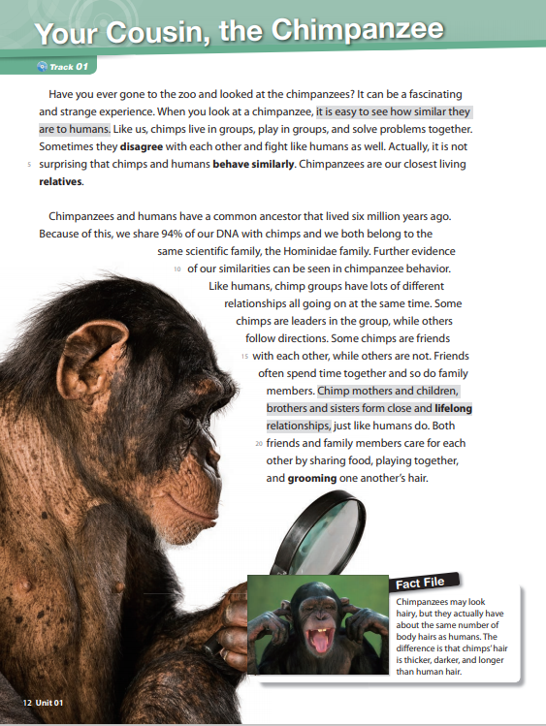

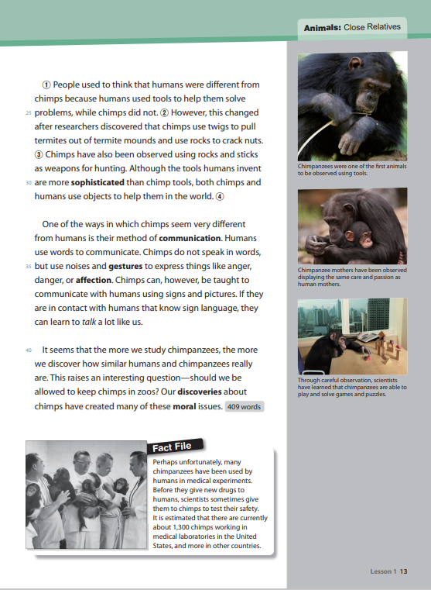

Worksheet A

Q1. What the differences between chimpanzee hair and human hair?

Q2. What do chimpanzees and humans have in common?

Q3. How are monkeys used for medical experiments?

Q4. What changed people’s thinking about whether chimpanzees use tools?

Worksheet B

Q1. What does the author think about chimps in zoos?

Worksheet C

Q1. Do you agree that chimpanzees should stay in zoos?

Answer Sheet A

Q1. What the differences between chimpanzee hair and human hair?
- Chimps’ hair is thicker, darker, and longer than human hair

Q2. What do chimpanzees and humans have in common?
- Like humans, chimp groups have lots of different relationships all going on at the same time

Q3. How are monkeys used for medical experiments?
- Scientists give drugs to monkeys for the safety test

Q4. What changed people’s thinking about whether chimpanzees use tools?
- People’s thinking was changed by researchers’ discovery. Researchers discovered that chimps use twigs to pull termites out of termite mounds and use rocks to crack nuts.

Answer Sheet B

Q1. What does the author think about chimps in zoos?
- The author seems to disagree with allowing to keep chimps in the zoo. The authors say it is strange to see chimpanzees in a zoo but it is not surprising that chimps and humans behave similarly.

Instructor’s Comments and Assessment
Pros
Cons
Change
Overall Comments
Grade
Above Standard 85%-100% | Standard 70%-84% | Below Standard 69%-0%
Instructor | Student Signature | Date
Taute, David

