**Background Information Sheet**

|  |  |  |  |  |  |
| --- | --- | --- | --- | --- | --- |
| **Name** | **Class** | **Date** | **Lesson Type** | **Plan type** | **Length** |
| 김성은 (Lily) | 224WK | 09/11/2021 | Grammar | PPP | 25 min |

|  |  |
| --- | --- |
| **Lesson** | |
| **Topic** | Bear is bigger than ant. |
| **Main Aim** | Students will learn comparative. |
| **Secondary Aim** | Students will practice their speaking fluency using comparatives. |

|  |
| --- |
| **Materials and References** |
| Board and colored markers, worksheets, pen and pencil. |

|  |  |  |  |  |  |
| --- | --- | --- | --- | --- | --- |
| **Student Profile** | | | | | |
| **Level** | | Lower Intermediate | | | |
| **Age** | | Children(6-12) | | **Number of Students** | 1 |
| **Detail** | | Student is native Korean. She never lived abroad before but she is very passionate and motivated to learn. | | | |
| **Assumptions about students’ knowledge as required for this lesson:** | | | | | |
| * Students know the basic vocabulary used in this lesson. * Students have learned about the subject and ‘be’ verb relationship. * Students know how to make the negative form using ‘not’. | | | | | |
| **What language difficulties to expect when presenting, and how to deal with it:** | | | | | |
| 1. **Meaning:** Student will feel much easier if I show her a clear visual context. It will be better than explaining. After elicit the model sentence, ask meaning based C.C.Q to check her understanding. 2. **Form:** Student may confuse about using “than”. Highlight the target language in a different color.   E.g. “A is **bigger(smaller) than** B.” (ex; Bigger with red, than with blue)   1. **Pronunciation:** Students may not know where to put natural sentence stress. Drill several times chorally, then individually. Ask, “Which words sound stressed?” Board the stress markers in red. | | | | | |
| **Anticipated Classroom Management Difficulties and their Solutions:** | | | | | |
| Student might feel difficult about using comparatives. Let her do the worksheet so that she can practice enough.  Consider manageable learning. If I tried to teach a lot during this lesson could lead to anxiety, rushing, and a lot of teacher talk. For this lesson I will manage this by selectively presenting only a few new concepts about the comparative. The remaining new language points can be presented in the next lesson. | | | | | |
| **My Personal Aim** | | | | | |
| What I hope most to demonstrate in this lesson is the ability to   * present the target language using a situational context. * be an involver type teacher. | | | | | |
| **Stage Name:** Lead-in  **Purpose of this stage:** To relax both the teacher and students. To focus attention on the lesson. Create a situation for students to experience or think about, and then to elicit the target language. | | | | | |
| **Materials:** List all materials that will be needed in this stage. | | | | | |
| **Timings** | **Interactions** | | **Procedure** | | |
| 2 min | T-S | | “Hello Judy, Look at this bear.” **Draw a big bear.**  “Tell me about this bear.” Make a sentence. (Bear is big.)  **Write down “Big” under the bear.**  **Draw a small ant.** “Tell me about this ant.” Make a sentence. (Ant is small.)  **Write down “Small” under the ant.**  **Draw a (>) between the bear and the ant.**  **Point to the bear.** “Judy, bear is~?” **Elicit a model sentence.** *“Bear is bigger than ant.”* | | |
| **Stage Name:** Presentation  **Purpose of this stage:** Make the students think about the situation. To clarify the meaning, form, and pronunciation features of the target language. | | | | | |
| **Materials:** List all materials that will be needed in this stage. | | | | | |
| **Timings** | **Interactions** | | **Procedure** | | |
| 20 sec  2 min  1:40 min  2 min | T  T-S  T-S  T-S | | **Board the model sentence (if students are unable to tell you, just board it).**  **Board it. *“****Bear is bigger than ant.”*  “Ant is smaller than bear.”  “Bear is not smaller than ant.”  **Meaning : CCQ – ask questions.**   1. **(Draw a tall apple tree on the left) “**Who can eat the apples?**”** (Bear). (Because bear is bigger than ant.) 2. **(Draw a short flower on the right)** “Who can live inside the flower?” (Ant) (Because ant is smaller than bear.) 3. **(Draw a bag)** “Can bear go into this bag?” (No)   (Because bear is bigger than bag.)  **Form : Ask questions, highlight the information on the board.**   1. “Can we say ‘Bear is big than ant’?” (No) 2. “Can we say ‘Bear is than bigger ant’?” (No) 3. Why? (Because -er + than in the base form = comparative.) 4. Bear is / bigger**(comparative)** than / ant. **(Use blue marker)**   **Pronunciation : Drill the spoken form, focusing on contractions, stress and intonation.**   1. “Judy, listen. Bear is <bigger> than ant.” **Manage your tone.** 2. “Judy, which word is stressed? **(Use red marker to stress; “bigger”)** 3. Say and gesture “Judy, Listen and repeat: [Bear is bigger than ant.]” x3 4. Drill will be energetic and enthusiastic, using natural intonation and stress. 5. Nominate the student for individual drilling. **(Use gestures)** | | |
| **Stage Name:** Controlled Practice  **Purpose of this stage:** students practice working with the form (scrambled sentences, split sentences, select the correct form of the verb, correct incorrect sentences, and change one form into another form). Accuracy must be checked. | | | | | |
| **Materials:** List all materials that will be needed in this stage. | | | | | |
| **Timings** | **Interactions** | | **Procedure** | | |
| 1 min  1 min  1 min | T  S  T - S | | **Instructions. Hold up the worksheet. Point to exercise A.**  “Judy, now you will do exercise A. In the exercise, you will see the word to use in the middle of every sentence. Please fill out the blank using those words. The answer must be in ‘-er than’ form.”  **ICQ.** “Where can you find the word to use?” (In the middle)  “Which form do you must use?” (-er than)  **T – Hand out the worksheet.**  **Student do exercise.**  **Feedback to check accuracy. Board correct answers visually. (ex; taller)** | | |
| **Stage Name:** Less Controlled Practice  **Purpose of this stage:** students practice working with the meaning (match a timelines to sentences, choose the sentence that matches a picture, gap-fill a paragraph). Accuracy must be checked. | | | | | |
| **Materials:** List all materials that will be needed in this stage. | | | | | |
| **Timings** | **Interactions** | | **Procedure** | | |
| 30 sec  2:30 min  30 sec | T  S  T-S | | **Instructions. Hold up the worksheet. Point to exercise B.**  “Judy, please turn over your worksheet. Now you will do exercise B. In the exercise, you need to draw a very simple picture which are matching with (the meaning of comparative) sentence.”  **ICQ.** “What do you need to do?” (Draw a simple picture)  “Pictures must match with?” (Sentence)  **Student do exercise.**  **Feedback to check accuracy. Give student compliments.** | | |
| **Stage Name:** Production – Freer Practice  **Purpose of this stage:** is to get students to practice the grammar communicatively. | | | | | |
| **Materials:** List all materials that will be needed in this stage. | | | | | |
| **Timings** | **Interactions** | | **Procedure** | | |
| 30 sec  7 min  1 min | T  T-S  T | | **Instructions.**  “Judy, I have 6 flashcards with topics. I will ask you the question and you need to answer each question around 1 minute. For example, if I ask you “Is dog cuter than cat?”, you can answer “Dog is cuter than cat, because~”.  **Students do a productive task which requires natural communication.**  **Teacher be poker to make good communication between students. (Scaffolding)**  **Feedback.** | | |
| **Stage Name:** Wrap-up  **Purpose of this stage:** is to end the lesson on a positive note so that students feel they have achieved progress. | | | | | |
| **Materials:** List all materials that will be needed in this stage. | | | | | |
| **Timings** | **Interactions** | | **Procedure** | | |
| 1 min  10 sec  25 sec  25 sec | T – S  T  T  T | | **Offer delayed corrections to the previous stage.**   * “Look at the board. Here are some sentences I heard. Tell me how to correct them.” * Drill the new word if necessary.   **Lesson feedback. Tell her what she did well, and what needs to improve.**  “Judy, you did great today!”  **Set homework.**  “Judy, please make 5 comparative sentences on your own by using objects that you can find from your home and please bring it to next class!”  **Inform students about the topic for the next lesson.**  “Judy, we’re going to learn about comparative with using ‘more’ in our next lesson.  It will be exciting as today. So be ready!” | | |

**Worksheet – Exercise A**

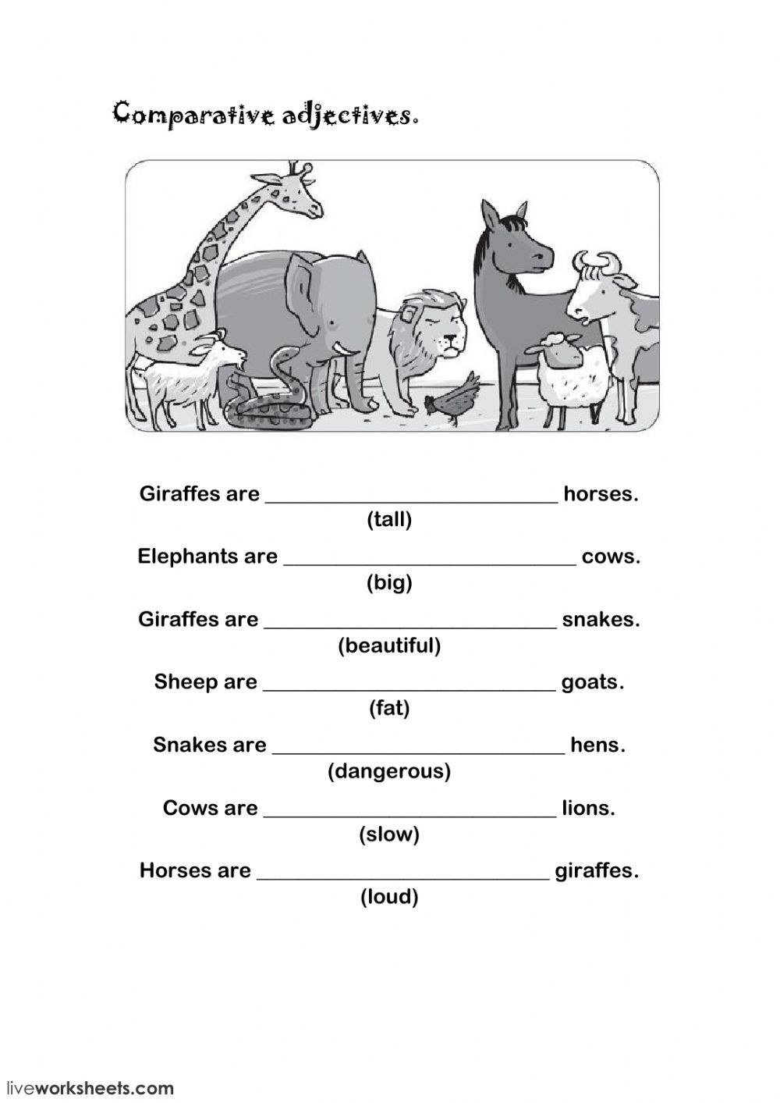

**Worksheet - Exercise B**

|  |  |
| --- | --- |
| 1. TV is bigger than phone. | 1. Snake is longer than pencil. |
| 1. Girl is not taller than boy. | 1. Pig is thinner than cow but fatter than dog. |

**Answer sheet – Exercise A**

1. Giraffes are taller than horses.
2. Elephants are bigger than cows.
3. Sheep are fatter than goats.
4. Cows are slower than lions.
5. Horses are louder than giraffes.

**Answer sheet – Exercise B**

|  |  |
| --- | --- |
| 1. TV is bigger than phone. | 1. Snake is longer than pencil. |
| 1. Girl is not taller than boy. | 1. Pig is thinner than cow but fatter than dog. |

**Instructor’s Comments and Assessment**

|  |  |  |
| --- | --- | --- |
| **Pros** | | |
|  | | |
| **Cons** | | |
|  | | |
| **Change** | | |
|  | | |
| **Overall Comments** | | |
|  | | |
| **Grade** | | |
| **Above Standard 85%-100%** | **Standard 70%-84%** | **Below Standard 69%-0%** |
| **Instructor** | **Student Signature** | **Date** |
| **Taute, David** |  |  |