Background Information Sheet
Name | Class | Date | Lesson Type | Plan type | Length
LING JIN | TESOL 225WD | 6/10/2021 | Listening | PPP | 35 min
Lesson
Topic | Meeting an old friend
Main Aim | Students will practice their listening comprehension using and integrated listening model.
Secondary Aim | Students will practice their speaking fluency
Materials and References
https://learnenghlish.britishcouncil.org/skulls/listening/intermediate-b1/meeting-an-old-friend; board pens; worksheet; pc, and audio equipment.

Student Profile
Level | Intermediate
Age | Adults | Number of Students | 10
Detail | This is an Intermediate English level class. The students are all career men and women. They are Korean and they are very highly motivated learners, but they are afraid to talk. They prefer Visual and Kinesthetic learning. Individually work is good but pair work is slightly lack of skills.Speaking and listening needs to improve.
Anticipated Classroom Management Difficulties and their Solutions
The audio equipment could fail → bring a set of portable speakers to use with my smartphone; print an A4 size picture of my PPT.
Nervousness at the start of the lesson → check the equipment is working; to start the lesson, sit down and follow the planned teacher talk.

My Personal Aim
What I aim to demonstrate is the ability to write out a complete, detailed lesson plan.

Stage Name: Lead-in
Purpose of this stage: to relax both the students and the teacher, to increase student talk through the sharing of ideas or experiences; to introduce the topic, or something topic-related.

Materials: photo
Time | Interaction | Procedure
30 sec  2 min  1 min  3’30’’ | T  S-S  T-S | Greet. Instructions.  Before the class start let the student make a seating arrangement. Each group has 2 people and make sure all can see the screen/board easily. Show Photo 1 (one man and one woman)  Hello class, Look at the picture and talk to your partner what kind of relationship are they? And what happen to them. Talk about your idea in 1 min.  Gesture for students to begin talking to their partners.  Students talk to their partners. Monitor for any use of key words.  Feedback. Gesture to a few groups and ask-“ share about your group ideas”

Stage Name: Presentation
Purpose of this stage: To offer any needed help which students may need in order to comprehend the text more easily. This includes teaching from 1 to 4 key words using the C.C.C. technique, and asking a guiding question which will allow students the opportunity to think of and share ideas they are likely to encounter when listening This encourages the use of their schema when comprehending a text.

Materials:
Time | Interaction | Procedure
2’17”  10 sec  2 min  2min  6’27’’ | T-S  T  S-S  T-S | Pre-teach keywords : predictable; anniversary  Elicit – Look at the photo1, what is it looks like?（they are predict future.）  What we can call this kind of situation? ( predictable )  CCQ – Does the weather predictable? (Yes.)  Does the result could predictable by ourselves? (YES)  Sometimes we can predictable the ending of TV drama stories. (Yes)  Drill – Listen and repeat three times together.(Gesture)  Nominate 3 or 4 students individually.  Board – Write the word predictable on the left of the board.  How many syllables? (4) mark with a green pen. [Pre-dict-a-ble]  Where is the stress? (dic) mark with a red pen.  What type of this word? (adj) mark with blue pen  Elicit- Look at this photo 2. What do you think of this picture? (seems celebrating a special event)  When people are celebrate or the special day in every years? ( anniversary)  CCQ- Does it a special and an important date? (YES.)  The special event happens every year. (Yes)  If public institutions have the anniversary date? (YES)  Drill- Listen and repeat three times together.(Gesture)  Nominate 3 or 4 students individually.(check if some students need correct pronunciation)  Board- Write the word anniversary on the left of the board.  How many syllables? (5) mark with a green pen. [ An-ni-ver-sa-ry.]  Where is the stress? (ver) mark with a red pen.  What type? (noun.) mark with blue pen  Guiding Question  Ok, now talk to your partners about  Do you have an old friend? How long the old friend do you have and how to maintain the relationship?  Students discuss the question with a partner.  Feedback. Nominate a few students to share their ideas, and try to draw out the ideas that what happened to them during years, are they married or not and if they were in charge of their dream work?

Stage Name: Practice - Literal Comprehension Listening
Purpose of this stage: For students to listen for the first time in order to get the facts. This may include the overall idea or topic of the text; to notice who the speakers are, where they are; and perhaps why they are speaking, The responses are short, objective, and are only a surface understanding. This is an accuracy focused stage.

Materials:
Time | Interaction | Procedure
40 sec  2’26”  2 min  1 min  6’06’’ | T  S  S-S  T-S | Instructions. Set the purpose for listening. Hand out worksheets.  Hold the 1st worksheet.  You will listen to a conversation between man and woman. As you listen, you must answer first 4 questions. If you finished and surely about your answer then you have a choice to do extra 2 questions. It’s optional. Write the answers next to the questions.  I.C.Q – Do you need to answer all 6 questions? No.  Do you have to finish first 4 questions? Yes  Do you have a pen to answer your questions? Yes  Students listen for the 1st time, and write answers on the worksheet.  Pair check. Compare the answer with your partner.( distance monitor)  Feedback to check accuracy.  Ask student for answer, checking if others have the same or different answers.  How many students have different answers? How did you know why Selina left London?

Stage Name: Practice - Interpretive Comprehension Listening
Purpose of this stage: Students listen a second time, more carefully, to infer or interpret meaning of the literal facts. This is still an accuracy focused stage- answers need to be checked for accuracy. Students are required to think about the why in order to support their answers. They may need to focus on things like the overall situation, tone of voice, multiple pieces of information or a single statement to explain the unspoken, intended meaning.
Materials:
Time | Interaction | Procedure
40 sec  2’26”  1 min  2 min  6’06’’ | T  S  S-S  T-S | Instructions. Set the purpose for listening. Hand out worksheet 2.  This is the second worksheet.  Listen again and answer the second of worksheet Q1. Do not answer Q2.  The question is more difficult, read the question and think about what you need to figure out from this conversation. Please listen carefully and write your answers in the blank part.  You do not need rush, I will give you two minutes to think and to write.  I.C.Q – Do you have time to write? (Yes, we will have 2min to write )  Do you need to answer Q2? (No. only Q1.)  Students listen for the 2nd time.  Pair check. Monitor. If students need, then replay the audio a 3rd time.  Feedback to check accuracy.  Nominate a few students read their answers, and see if the rest of students are agree with.  Share what is your answer in the class.

Stage Name: Production - Applied Comprehension Speaking
Purpose of this stage: For students to practice their speaking fluency. Therefore this stage should be no less than 5 minutes to allow students to practice Give them a few questions to help them communicate without intervention from the teacher. This is a fluency focused stage.

Materials:
Time | Interaction | Procedure
1 min  8 min  1 min  10’00 | T  S-S  T-S | Instructions. Give students a question to discuss in pairs or groups.  We have 5 groups in this class. So please discuss Exercise 3 with your partner and talk about your opinion.  Write them in the blank part of worksheet. Please feel free to talk and remember how it will applied to yourself or to your life. You have 8minute  I.C.Q – Do you need share your idea with partner? (Yes.)  Does the question needs relate to yourself or your life? (YES)  Ok, start it.  Students discuss. Monitor from a distance.  If the students finished earlier (before 5min.), I will give them back up questions.  Let students talk more and share with whole class also.  Feedback. Students share their ideas with the class.

Stage Name: Wrap-up
Purpose of this stage: To end the lesson on a positive note, This will give students a sense of accomplishment, encourage students to continue progressing, and realize how to improve in future. A teacher may also get valuable feedback from students regarding the activities used in the lesson.

Materials:
Time | Interaction | Procedure
3 min | T | Lesson feedback. Tell the class what they did well, and what needs to improve.  Set homework.  There is another listening as your homework.  After listening write your opinion that if you agree or disagree the topic that they are talking about.  Due it next class and we will discuss H/W for 10min.  Inform students about the topic for the next lesson.  For our next class, we will take reading and writing class. Turn to page 65 – Unit 6.  There is a short reading. It will be tough for few students. You can do some preview and check the Vocabulary if you want.

Instructor’s Comments and Assessment
Pros
Cons
Change
Overall Comments
Grade
Above Standard 85%-100% | Standard 70%-84% | Below Standard 69%-0%
Instructor | Student Signature | Date
Taute, David

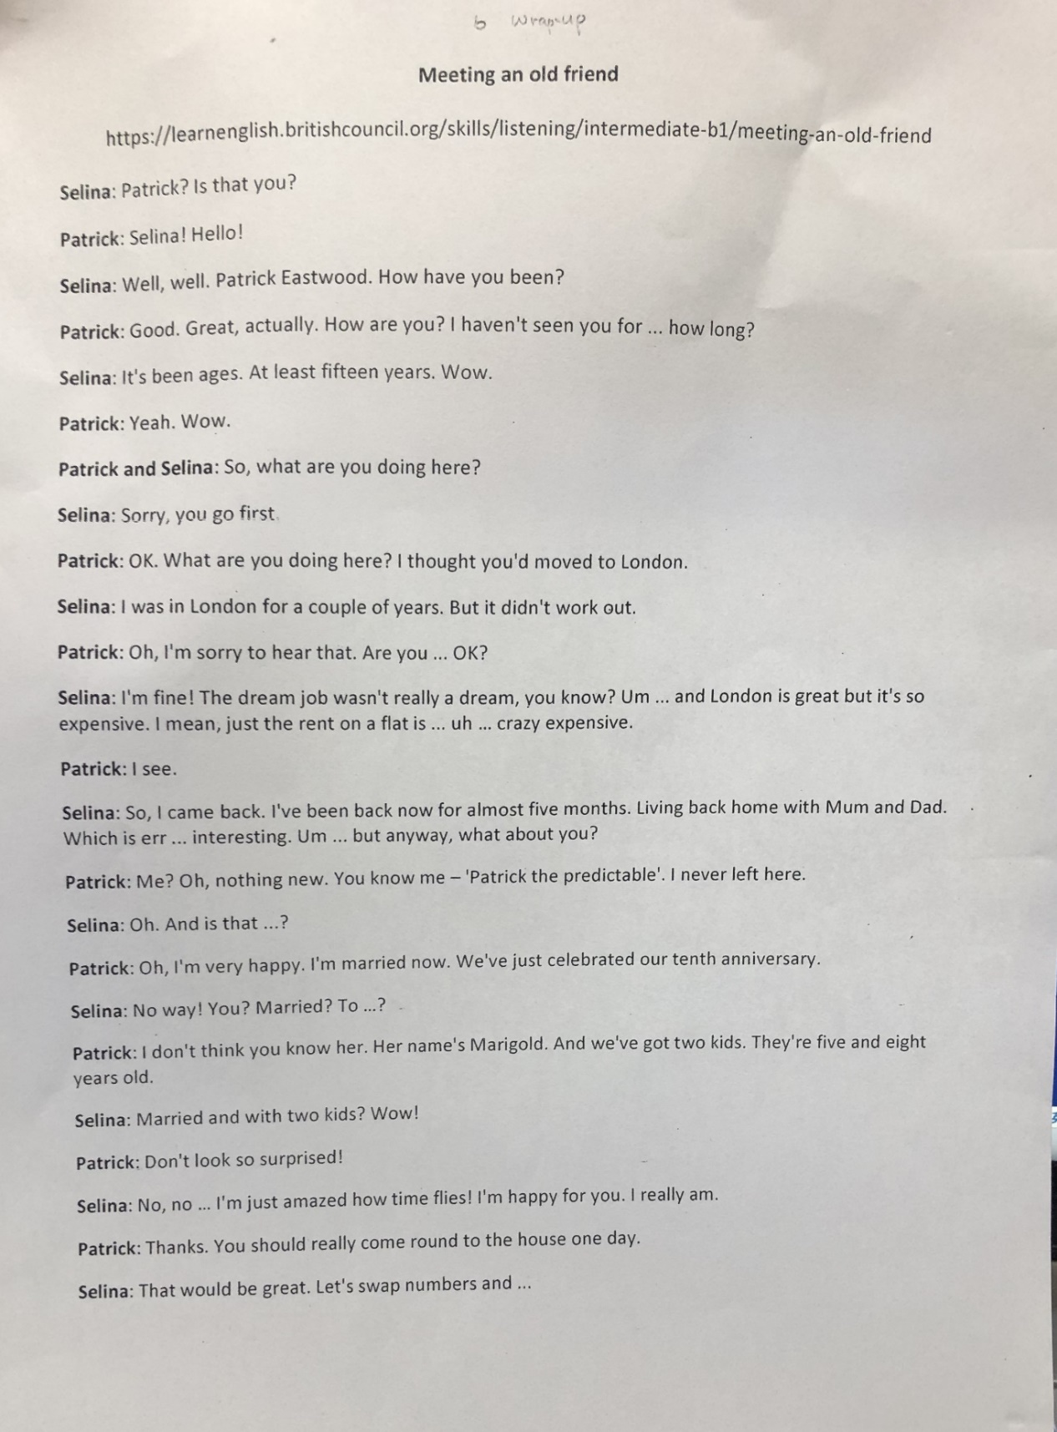
Transcript
Time: 2 min 24 seconds

Worksheet 1 – Meeting an old friend

Exercise 1:
Q1: listen and write the correct answer next to the question.

- How long did they haven’t seen each other?
- Does Selina lived in London before?
- Does Patrick celebrated his tenth marriage anniversary?
- What did Selina do at the end of conversation?

Extra question. (Optional)

- Why does Selina backed to her own hometown?
- How old are Patrick’s two kids?

Worksheet 2 – Meeting an old friend

Exercise 2:
Q1: why Selina mentions dream job wasn’t really a dream?

Exercise 3:
Talk to your partner about below questions. Share the ideas in the class.

- Have you ever joined any old friends’ anniversary? What kind of role are you play?

- What kind of predictable things happened in your life?

Answer sheet 1 – Meeting an old friend

Q1: listen and write the correct answer next to the question.
- How long did they haven’t seen each other? (fifteen years)
- Does Selina lived in London before? (Yes)
- Does Patrick celebrated his tenth marriage anniversary? Yes
- What did Selina do at the end of conversation? Swap numbers.
Extra question. (Optional)
- Why does Selina backed to her own hometown? (London is too expensive to stay alive)
- How old are Patrick’s two kids? (five and eight)
Answer sheet 2– Meeting an old friend

Exercise 2:
Q1: why Selina said dream job wasn’t really a dream?
In my point of view Selina said why dream job wasn’t really a dream because of expensive cost. London is great but if you want to have dream job you have to pay a crazy expensive rent on a flat. But in a highly cost city not only pay for the rental but also for living expenses. So after few years Selina found it didn’t work out, then back to hometown.

Photo 1

Photo 2

