Background Information Sheet
Name | Class | Date | Lesson Type | Length
Ericka | 225WD | Oct. 13, 2021 | Speaking | 20 min

Lesson
Topic | Important inventions to me
Main Aim | Students will practice their speaking fluency.
Secondary Aim | N/A
Materials and References
https://en.islcollective.com/english-esl-worksheets/vocabulary/technology/inventions/66483; worksheets; board and board pens

Student Profile
Level | Advanced
Age | Adult | Number of Students | 1
Detail | Ling is a Chinese-Korean student who is trilingual in Mandarin, Korean and English. She has a cheerful personality with lots of imagination and energy. She prefers visual and kinesthetic learning, but not confident in her grammar.
Assumptions about students’ knowledge as required for this lesson:
Inventions linked to our daily life are used in this lesson and assume the student would be familiar with the topic. Student can talk based on her experience.

Anticipated Difficulties and their Solutions:
The student might only answer in short sentences → provide an example; ask related questions; clear instructions to be given.

Nervousness at the start of the lesson → check your materials; to start the lesson, follow the planned teacher talk.

My Personal Aim
What I hope most to demonstrate in this lesson is the ability to write out a Task-Based Learning plan and perform a good speaking microteaching lesson.

Stage Name: Pre Task
Purpose of this stage: Create interest in the topic. Brainstorm ideas which will be useful for the next stage. Students must be given a communicative task e.g. discuss, arrange/sort, create a list, etc. The aim is to relax students, activate their background information, and gather useful ideas for the lesson.

Materials: N/A
Time | Interaction | Procedure
30 sec  2 min  30 sec  1 min 30 sec | T  S  T  S | Organize seating arrangement so that the student is not too far away from the teacher.  Good morning! Can you tell me 2 innovators or inventors in our history and explain why you have chosen them?  (For example, An Chulsoo – A doctor, programmer and CEO of AnLab, invented Antivirus software)  Student talks about 2 innovators/inventors.  One of the most important invention is smart phone. How did smart phone change your life?  Is it possible to live without it?  What functions do you use?  Student talks to the teacher.

Stage Name: Task Preparation
Purpose of this stage: This is a student centered stage, to give students time to prepare and practice a speaking task which they will perform in Task Realization. Clear detailed instructions or a demonstration must be provided so students know what is expected. Prepared materials may be provided to assist their preparation. Monitor and offer brief tips if necessary.

Materials: Worksheet 1
Time | Interaction | Procedure
1 min  1 min | T  S | Instructions.  Now, it’s time for some individual work.  I will hand out a worksheet and you will see a list of inventions which are linked to our daily life. Rank them from 1 (the most important to you) to 5 and write them in the box at the bottom.  I.C.Q – How many inventions do you need to choose for ranking? (5)  Where do you write them? (At the bottom box)  How do you rank the most important thing to you? 1 or 5? (1)  Do you have a pen or pencil ready? (Yes)  Hand out the worksheet 1.  You have 1 minute.  Student makes her own ranking.

Stage Name: Task Realization
Purpose of this stage: This is a very student centered stage to allow for maximum speaking fluency practice. Monitor discretely and take note of incorrect language. Students perform their task without interruptions from the teacher. Classroom management may be an important consideration here.
Materials: Worksheet 1
Time | Interaction | Procedure
15 sec  5 min  1 min  2 min | T  S  T  S | Can you explain your TOP 5 ranking with your detailed reason?  Student talks about her TOP 5 ranking.  Teacher talks about her TOP 5 ranking (refrigerator, computer, internet, KF94 mask, washing machine) and asks the student why disagree or agree.  Student agree/disagree, persuade, suggest and talks about her final/revised TOP 5 ranking.

Stage Name: Post Task
Purpose of this stage: To end the lesson with a final student centered task such as voting, summarizing, discussing, deciding etc. The teacher may offer delayed error correction to the previous stage, as well as mention positives and points to improve for next time such as useful strategies.
Materials: Worksheet 2
Time | Interaction | Procedure
1 min  1 min  15 sec  1 min  2 min | T  S  T  S  T | Instructions.  Now, I will hand out another worksheet and you will see some interesting inventions. Please tell me which one you like most with your detailed reason.  I.C.Q – How many inventions do you need to choose? (1)  Are you choosing the one you like or dislike? (The one I like)  Hand out the worksheet 2.  I will give you 1 minute to make your decision.  Student makes her choice.  Can you tell me which one you like most with your detailed reason.  Student talks about her choice.  Lesson feedback. Tell the student what was good, and what needs to improve.  Offer delayed error correction.  Inform the students about the topic for the next lesson.  Tomorrow we will do a writing lesson about a response to a complaint.  Dismissed. See you tomorrow!

Worksheet 1

Inventions

Which of these inventions do you think are the most important? Rank them from 1 (the most important to you) to 5.

Television | Internet | Car | Smart watch | Computer
Robotic vacuum cleaner | Microwave | Airplane | Drying machine | Fuel
Air Fryer | Kakao Talk | Remote control | Credit card | KTX
Hairdryer | Bluetooth speaker | Dishwasher | Google | Post-it notes
Tablet | Microscope | Air purifier | Drive-through cafe | KF94 Mask
Massage chair | Printer | Refrigerator | Air conditioner | Washing machine

Your ranking | Inventions
1
2
3
4
5

Worksheet 2

These are real inventions. (Whether or not you believe it!). Which one do you like most?
An umbrella for dogs  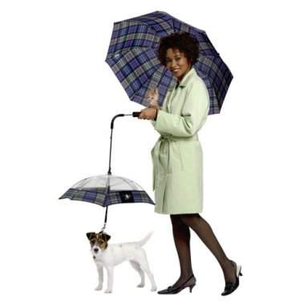 | A microphone-shape sponge  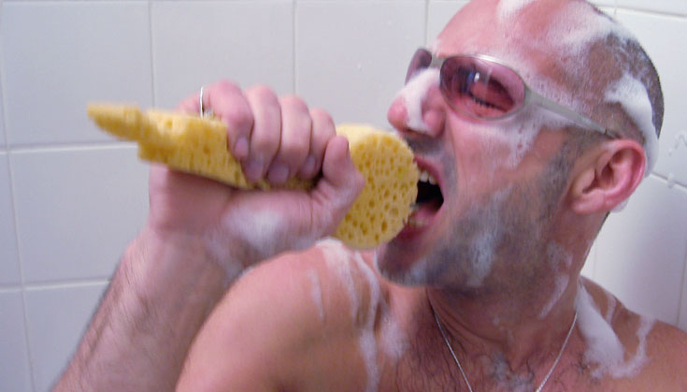
Windshield wipers for glasses  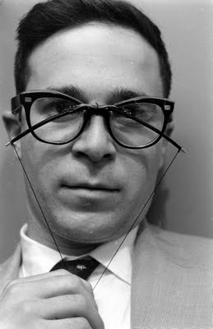 | Hug-me pillow
A baby stroller and scooter  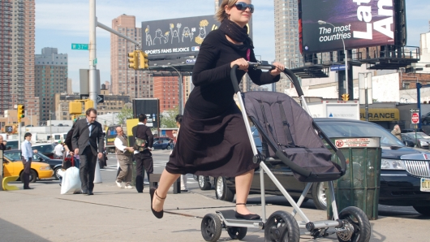 | Piano doorbell  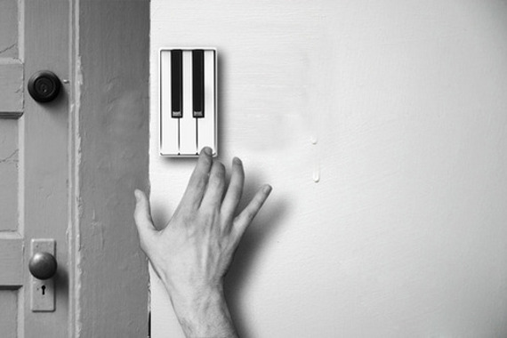

Instructor’s Comments and Assessment
Pros
Cons
Change
Overall Comments
Grade
Above Standard 85%-100% | Standard 70%-84% | Below Standard 69%-0%
Instructor | Student Signature | Date
Taute, David

