Background Information Sheet
Name | Class | Date | Lesson Type | Plan type | Length
Ericka | 225 WD | Oct. 20, 2021 | Grammar | PPP | 25 min

Lesson
Topic | My best friend
Main Aim | Student will learn comparative adjectives
Secondary Aim | Student will practice her speaking fluency to talk about how her best friend is different from others.

Materials and References
https://en.islcollective.com/english-esl-worksheets/grammar/adjectives/its-cool-be-different-comparative/96581; PPT; worksheet; reference sheet; board and board pens

Student Profile
Level |  | Lower Intermediate
Age |  | 10 years old |  | Number of Students | 1
Detail |  | The student is Chinese-Korean and is motivated to learn English. She is confident when speaking, but weak in grammar.
Assumptions about students’ knowledge as required for this lesson:
- The student knows the vocabulary used in this lesson
- The student has learned about the subject and ‘be’ verb relationship
- The students knows present simple and adjectives.

Anticipated Difficulties for this Lesson and their Solutions:
- The student will have difficulties to memorize comparative form of adjectives. Reference sheet (rules of comparative adjectives) will be given to the student.
- The student may not know where to put natural sentence stress. Drill several times individually. Ask, “Which words are stressed?” Board the stress markers in red.
- The computer could fail print an A4 size picture of my PPT.

My Personal Aim
What I hope most to demonstrate in this lesson is the ability to perform manageable learning.

Stage Name: Lead-in
Purpose of this stage: To relax both the teacher and students. To focus attention on the lesson. Create a situation for students to experience or think about, and then to elicit the target language.

Materials: Picture in PPT
Timings | Interactions |  | Procedure
1 min | T-S |  | Good morning!  Show the picture in PPT. Please look at the picture.  Point to Son Heungmin. Do you know who he is? (Yes, Son Heungmin)  Which sport is he playing? (Soccer) Point to the soccer ball. So this is a…..(soccer ball)  Point to Ryu Hyunjin? Do you know who he is? (Yes, Ryu Hyunjin)  Which sport is he playing? (Baseball) Point to the baseball. So this is a….(baseball)  Tell me about the balls’ size. (A soccer ball is big. A baseball is small)  Can you tell in one sentence? (A soccer ball is bigger than a baseball.)
Stage Name: Presentation
Purpose of this stage: Make the students think about the situation. To clarify the meaning, form, and pronunciation features of the target language.

Materials: board, board pens
Timings | Interactions |  | Procedure
30 sec  30 sec  3 min  1 min | T  T-S  T-S  T-S |  | Board the model sentence (A soccer ball is bigger than a baseball.).  CCQ  - Are we talking about 2 kinds of balls? (Yes)  - Is the size of a soccer ball and a baseball the same? (No)  Form  Look at the sentence.  Where is the adjective? (bigger)  You can make a comparative adjective by adding +er to the adjective.  tall(er) / late(r) / (more) beautiful  Later, I will give you a reference sheet which shows the rules for comparative adjectives.  Where is the subject? (A soccer ball)  What is “is”? (a be verb)  Where is the object? (a baseball)  Can we put “a baseball” in the front? (Yes)  Can we put “a soccer ball” at the end? (Yes)  Then how should the adjective change? (smaller)  S + be + Comparative adj. + than + O  A soccer ball is bigger than a baseball.  tall(er)  late(r)  (more) beautiful  A baseball is smaller than a soccer ball  **Other comparative expressions (much better / any better & as….as / than) will be covered in a different lesson.  Drill  Now, don’t look at the board. Listen and repeat 5 times. (Gesture)  Which words are stressed? (soccer ball, bigger, baseball)  Mark the stress in the model sentence with a red pen.
Stage Name: Controlled Practice
Purpose of this stage: students practice working with the form (scrambled sentences, split sentences, select the correct form of the verb, correct incorrect sentences, and change one form into another form). Accuracy must be checked.

Materials: Worksheet, reference sheet, board, board pens
Timings | Interactions |  | Procedure
1 min  3 min  1 min | T  S  T – S |  | Instructions. Hold up the worksheet, point to exercise A.  I will hand out a worksheet and a reference sheet which shows the rules for comparative adjectives. You must only answer to exercise A. Complete the sentences with the correct comparative adjective. Don’t do exercise B.  ICQ  - Can you use the reference sheet? (Yes)  - Do you need to answer questions in exercise B? (No)  - Do you have a pen or pencil ready? (Yes)  Hand out both the worksheet and the reference sheet.  Student does a worksheet.  Feedback to check accuracy.  Ask the student for answers.  Board incorrect answers visually.
Stage Name: Less Controlled Practice
Purpose of this stage: students practice working with the meaning (match a timelines to sentences, choose the sentence that matches a picture, gap-fill a paragraph). Accuracy must be checked.

Materials: Worksheet, reference sheet, board, board pens
Timings | Interactions |  | Procedure
30 sec  3 min  1 min | T  S  T-S |  | Instructions.  Now, turn over your worksheet. It’s time for exercise B. Look at the details of Tom and Jane and complete the comparative sentences. You can use the reference sheet again.  Student does a worksheet.  Feedback to check accuracy.  Ask the student for answers.  Board incorrect answers visually.
Stage Name: Production – Freer Practice
Purpose of this stage: is to get students to practice the grammar communicatively.

Materials: N/A
Timings | Interactions |  | Procedure
30 sec  7 min | T  S-T |  | Instructions.  Tell me about your best friend? Why is she/he your best friend and how is your best friend different from your other friends?  Student talks about her best friend using the target language naturally.
Stage Name: Wrap-up
Purpose of this stage: is to end the lesson on a positive note so that students feel they have achieved progress.

Materials: Board, board pens
Timings | Interactions |  | Procedure
2 min | T – S |  | Lesson feedback. Tell the student what was good, and what needs to improve.  Offer delayed corrections to the previous stage.  Board the wrong sentences  - “Look at the board. Here are some sentences I heard. Tell me how to correct them.”  Set homework.  Please do your worksheet again without using the reference sheet.  Inform students about the topic for the next lesson.  Tomorrow we will do a reading lesson about a message to a new friend.  Dismissed. See you tomorrow!

Picture in PPT

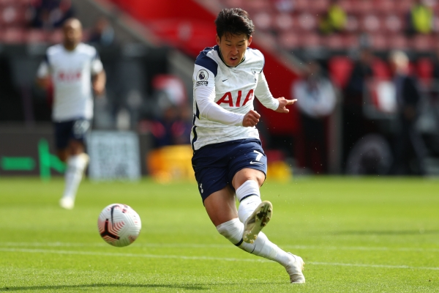
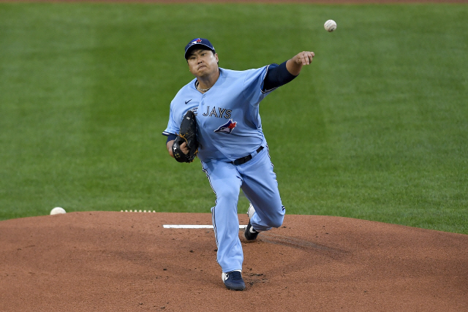

Reference sheet 1
Rules for comparative adjectives.
1. One-syllable adjectives (regular comparison)
Adjective | Comparative | Rules
old | older | Most adjectives: + er
tall | taller
late | later | Adjectives ending in e: + r
nice | nicer
fat | Fatter | One vowel + one consonant: double consonant
thin | thinner

2. Irregular comparison
Adjective | Comparative
good / well | better
bad / badly | worse
far | further / farther

3. Two-syllable adjectives
Adjective | Comparative | Rules
happy | happier | Adjectives ending in y: +ier
easy | easier
simple | simpler | Adjectives ending in an unstressed vowel, l or e(r)
clever | cleverer

4. Longer adjectives (two-syllables or more)
Adjective | Comparative | Rules
expensive | more expensive | use more
serious | more serious
Worksheet

Exercise A

Complete the sentences with the correct comparative adjective.
(Example) The girl is taller than the boy. (tall)

1. Winter is …………………………. than Spring. (cold)
2. Planes are …………………………… than trains. (fast)
3. English is …………………………….. than Korean. (difficult)
4. Fruit and vegetables are …………………………… than fast food. (healthy)
5. Tom’s garden looks …………………………. than Jane’s garden. (good)

Exercise B

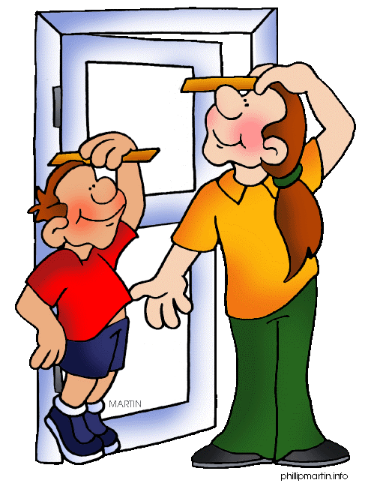
Tom and Jane are friends. Pay attention to the details and complete the comparative sentences. Use the adjectives in the bracket.
Tom
Jane
 | Tom | Jane
Age | 15 | 14
Height | 150 cm | 158 cm
Eyes | Brown | Blue
Feeling | Happy | Sad
Personality | Calm | Funny

(Example) Jane is taller than Tom. (tall, small)

1. Tom is …………………………. than Jane. (old, young)
2. Jane is …………………………. than Tom. (funny, calm)
3. Tom’s eyes are …………………………. than Jane’s eyes. (dark, bright)
4. Tom is …………………………. than Jane. (happy, sad)

Answer sheet

Exercise A:

1. Winter is colder than Spring. (cold)
2. Planes are faster than trains. (fast)
3. English is more difficult than Korean. (difficult)
4. Fruit and vegetables are healthier than fast food. (healthy)
5. Tom’s garden looks better than Jane’s garden. (good)

Exercise B

1. Tom is older than Jane. (old, young)
2. Jane is funnier than Tom. (funny, calm)
3. Tom’s eyes are darker than Jane’s eyes. (dark, bright)
4. Tom is happier than Jane. (happy, sad)

Instructor’s Comments and Assessment
Pros
Cons
Change
Overall Comments
Grade
Above Standard 85%-100% | Standard 70%-84% | Below Standard 69%-0%
Instructor | Student Signature | Date
Taute, David

