Background Information Sheet
Name | Class | Date | Lesson Type | Plan type | Length
LING JIN | TESOL 225th WD | 10/27/2021 | Reading | PPP | 30min

Lesson
Topic | Winter Wonderland
Main Aim | Student practice reading comprehensive.
Secondary Aim | Student practice speaking fluency base on the reading material.

Materials and References
Text book-Reading article, pc, worksheets, board and mark pen.

Student Profile
Level | Intermediate.
Age | Adults. | Number of Students | 1
Detail | Korean student has ability to talk different kinds of topics.

Anticipated Difficulties and their Solutions:
Nervousness – check the materials and start the lesson, try to follow the lesson plan.

My Personal Aim
What I hope most to demonstrate in this lesson is the ability to
- get students understand and interpretive the articles naturally.
- Get students speaking fluency use own words.

Stage Name: Lead-in
Purpose of this stage: To relax both the teacher and students. To focus attention on the lesson. To lead in to the topic, activating background knowledge – this will help to contextualize the text. This is a BEFORE READINING stage.
Materials: Text book-Reading article, pc, worksheets, board and mark pen.
Timing | Interaction | Procedure
20 sec  1min  10sec  1min.  2’30’’ | T  S  T  S | Good Morning Ericka,  Do you know any winter special festival program? Have you seen or heard it before?  If yes, can you tell me about it? If no, show the article picture right away.  Hand out reading article. .  Here is our material. Look at this picture (point the picture on the top of reading material), what kind of information could we get from it?  (It is winter, seems some carvings/sculptures are made of snow and ice. For festival)

Stage Name: Presentation
Purpose of this stage: To pre-teach keywords if necessary, and answer a guiding questions (such as a predicting task, or a specific question). These steps provide extra help for students to comprehend the text. This is a BEFORE READINING stage.
Materials: Text book-Reading article, pc, worksheets, board and mark pen.
Timing | Interaction | Procedure
1min  1min  1 min  2min  5’ | T-S  T  S-T | Pre-teach keywords: sculpture, wonderland, amazing  Elicit- Great! Point article picture  What we can call this kind of carving work in another word? (sculpture)  CCQ –  Could we use wood or stone material to make a sculpture (YES)  Are these sculptures relate to the art? (YES)  Is it easy to carve by non-professional people? (No)  Drill – Listen and repeat 3times. (choral and individual drilling for correct pronunciation)  Board – highlight special areas of pronunciation  How many syllables? 2 syllables - sculp-ture. Mark with a green pen.  Where is stress? Sculp. Mark with a red pen.  What types of world? Noun. Mark with a blue pen.  Elicit- point to the whole article picture ask student,  What we can call this beautiful and incredible place? (wonderland)  CCQ-  Can we call ugly and unpleasant place as wonderland? (NO)  Can we see the Wonderland anywhere? (NO)  Is this kind of unbelievable and great place? (YES)  Drill – Listen and repeat 3times. choral and individual drilling for correct pronunciation  Board – highlight special areas of pronunciation  How many syllables? 3 syllables - won-der-land. Mark with a green pen.  Where is stress? Won. Mark with a red pen.  What types of world? Noun. Mark with a blue pen.  Elicit –When we see this sculptures or situation how can we describe or express it in one word？(amazing)  CCQ-  Is it a feeling that makes you feel pleasure? (YES)  Can we use amazing to describe something makes you feel very surprised?(YES)  Does incredible also means amazing? (YES)  Drill – Listen and repeat 3times. choral and individual drilling for correct pronunciation  Board – highlight special areas of pronunciation  How many syllables? 3 syllables. a-maz-ing. Mark with a green pen.  Where is stress? maz. Mark with a red pen.  What types of world? Adj. Mark with a blue pen.  Guiding Question  Ericka, Have you ever made a snowman or any characters snowman in Winter? How was it?  (Fun, difficult made a shape…)

Stage Name: Practice – Literal Comprehension
Purpose of this stage: is to get students to practice reading for literal detail. They will also practice fast reading (skimming and scanning). This is a WHILE READINING stage.
Materials: Text book-Reading article, pc, worksheets, board and mark pen.
Timing | Interaction | Procedure
30 sec  4min  1 min  5’30’’ | T  S  S-T/T-S | Instructions: Here is worksheet. You can scan and skim the article to find the answer quickly.  There are 5 questions on the worksheet 1. You can high light the answer or underline it.  Give you 4min. Don’t do worksheet 2.  ICQ – Do you need fast reading or slow reading? (fast) Do you need deeply understanding?(No)  Hand out worksheets.  Student reads for the first time.  Check answer together. Feedback to check accuracy.

Stage Name: Practice – Interpretive Comprehension
Purpose of this stage: is to get students to get students to practice interpreting a text correctly This will require more detailed, careful reading, and thinking time to arrive at the correct answer. This is a WHILE READINING stage.
Materials: List all materials that will be needed in this stage.
Timing | Interaction | Procedure
30 sec  5 min  2min  7’30’’ | T  S  S-T/ T-S | Instructions.  There is one interpretive question on the worksheet 2.  Read carefully and write your answer on the worksheet 2 as much as you can. You have 5min.  I.C.Q- Do you need reading fast? (NO) Do you need to highlight your answer? (NO.)  Hand out worksheets.  Student reads for the 2nd time.  Check the answer.(there is no exactly same answer, key point mentioned will be okay)

Stage Name: Production - Applied Comprehension
Purpose of this stage: is for students to practice their speaking fluency and is related to the lesson topic. This is an AFTER READINING stage.
Materials: Text book-Reading article, pc, worksheets, board and mark pen.
Timing | Interaction | Procedure
1min  7min  8’ | T  S-S | Instructions. Show Photo 1- Photo 4 and  Connect to your general knowledge and share your opinions.  Q1: Is it worth to visit Winter Wonderland for Snow Festival annually?  Q2: What kind of Wonderland Place would you like to visit?

Stage Name: Wrap-up
Purpose of this stage: is to end the lesson on a positive note so that students feel they have achieved progress. This is an AFTER READINING stage.
Materials: Text book-Reading article, pc, worksheets, board and mark pen.
Timing | Interaction | Procedure
1’30’’ | T | Tell the student what she did well, and what needs to improve. Offer delayed corrections to the previous stage if it necessary. Set homework. Read again and base on your understanding to use your own words to interpretive whole article “Winter Wonderland” next class by oral.

Worksheet 1
Scan and skim the article to find the answer quickly. You have 4min.
There are 5 questions on the worksheet 1. You can high light the answer or underline it.
- People shovel the snow into large piles do what?
- Why are there artists come to visit Sapporo?
- How many hours are these artists work for a day?
- Why people like the sculptures?
- What did high school students do?

Worksheet 2
Read carefully and think about the questions. Write your answer as much as you can. You have 5min.
Why the Snow Festival is attracted by people and artists？

Answer sheet 1
Scan and skim the article to find the answer quickly.
There are 5 questions on the worksheet 1.Find answer high light or underline. Give you 5min.
- People shovel the snow into large piles do what?
Piles of snow become outdoor cafes, concert stages, and beautiful sculptures.
- Why are there artists come to visit Sapporo?
To participate in the annual sculpture competition
- How many hours a day were these artists working on made sculpture?
11 hours or 12hours a day
- Which year does the Snow Festival started?
They were not just regular snowman.
- What did high school students do?
Had a great idea and built six large snow sculptures.

Answer sheet 2
Read carefully and think about the questions. Write your answer on the worksheet 2 as much as you can. You have 7min.
Why the Snow Festival is attracted by people and artists and how does it became popular?
Because people like to see these unusual sculptures and they really like them, also the artists from all over the world, they wants to participate in the annual sculpture competition. In 1950, some high students made six huge sculpture and people like them, then it became popular until now.

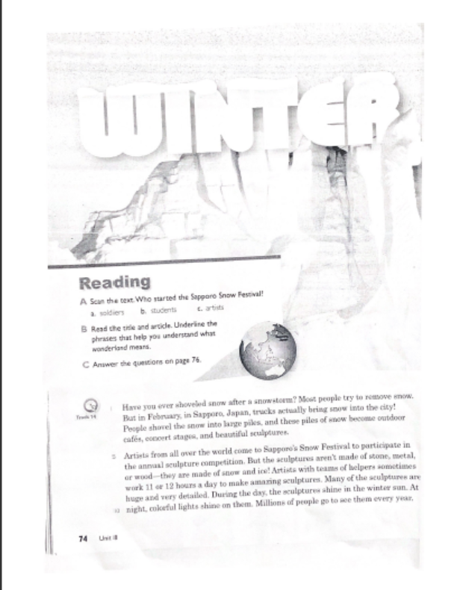

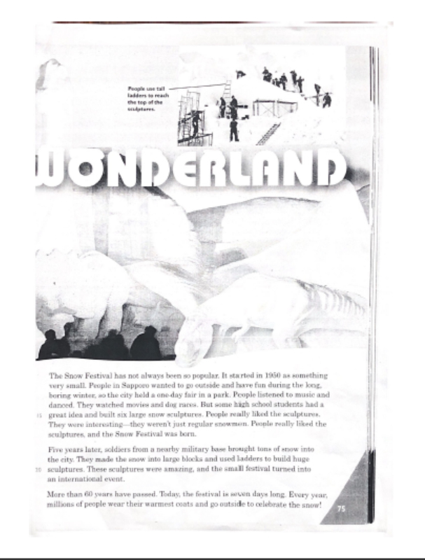

Photo 1

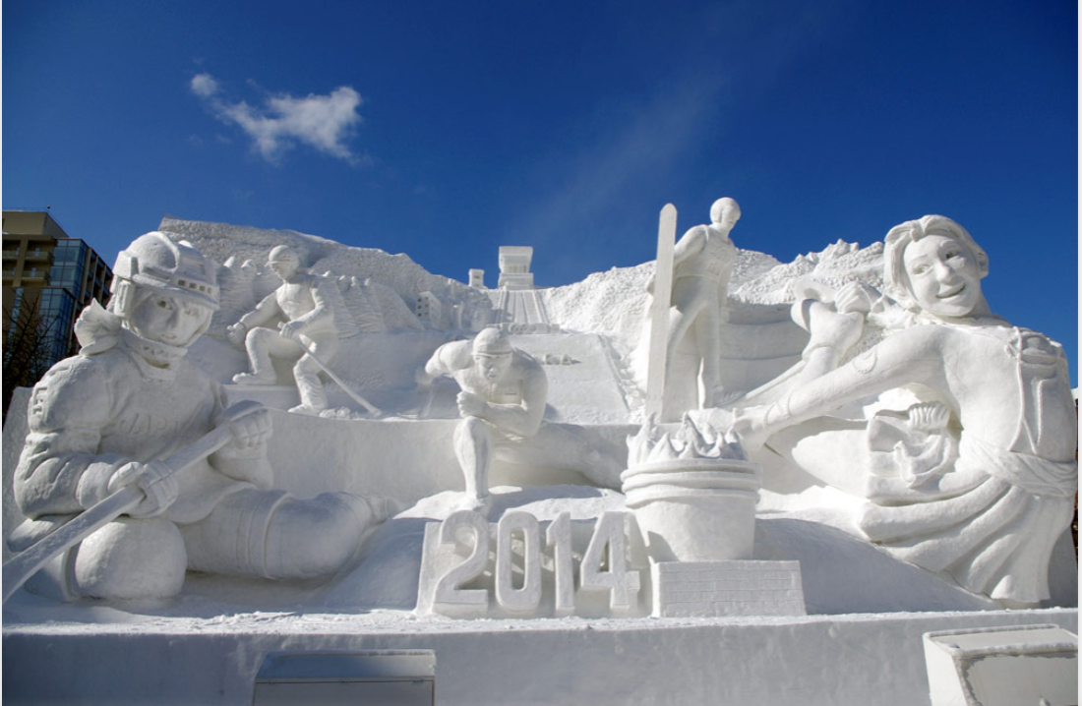
Photo 2
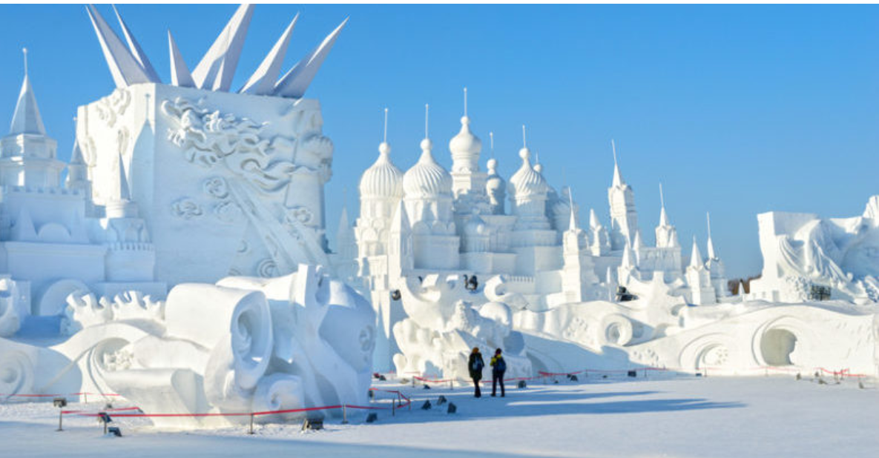

Photo 3
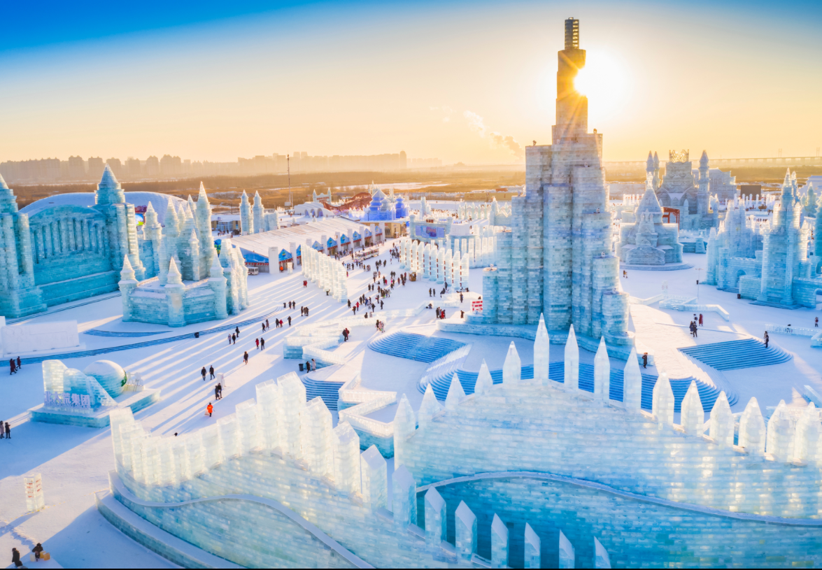
Photo 4
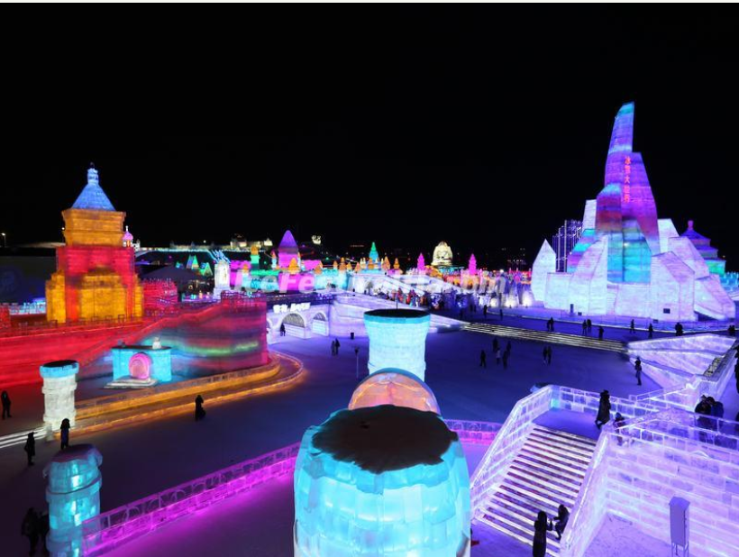
Instructor’s Comments and Assessment
Pros
Cons
Change
Overall Comments
Grade
Above Standard 85%-100% | Standard 70%-84% | Below Standard 69%-0%
Instructor | Student Signature | Date
Taute, David

