Reading Lesson

Topic: A lion called Christian

Instructor:
Gina Han

Level:
Intermediate
Students:
8
Length:
45min

Materials:
- Lap-top with video clips and PPT slides, projector
- Reading texts, worksheets (question, vocabulary, essay), printed pictures and text cards (for game)
- Board & markers
- Love cushion

Aims:
- To help Ss improve reading skills by skimming and scanning
- To practice listening and speaking through Q&A, discussion and game
- To learn vocabulary through the reading text and game
- To encourage Ss to read with interest and apply the knowledge into speaking

Language Skills:
- Listening: student talk, teacher talk, discussion and game
- Speaking: prediction, answers, student talk, discussion and game
- Reading: PPT slides, reading text, game
- Writing: essay assignment, worksheet

Language Systems:
- Lexis: vocabularies in the reading material
- Discourse: group discussion

Discourse:

Assumptions:
- Ss are familiar with teacher’s teaching style.
- Ss are adults. (age 20 and up)
- Ss are familiar with reading.
- Ss do not have hatred toward animals.

Anticipated Errors and Solutions:

- If Ss cannot understand the video contents,
- Explain short story about the video before showing the video.

- If Ss do not know some words and teacher skips,
- Ss ask teacher the words.
- Encourage them to use dictionary.

- If the PPT slides do not work,
- Print out picture resources as realia, and play video clip individually.

- If time is short during the post-activity
- Shorten the activity time.

References:

- Video clip: http://www.youtube.com/watch?v=Sju3kSTAzdI
- Prepare pictures and text cards

Lead - In (1 min)
Materials: cushion

Time | Set Up | Student Activity | Teacher Talk
1 min | Whole class | Ss guess and respond. | Show the cushion to Ss.  Ask Questions to Ss.  CCQ  1. What is written on this cushion?  2. Do you believe in love between human and dog?  3. What about wild animals?

Pre-Activity (11 min)
Materials: Board & markers, lap-top, projector, vocabulary worksheets

Time | Set Up | Student Activity | Teacher Talk
2 min  5 min  2 min  2 min | Whole class  Whole class  Whole class  Whole class | Ss listen.  Ss watch the video.  Ss listen.  Ss work on the worksheet. | Show PPT slides and briefly explain about the video to Ss.  Play the video.  Ask questions to check if Ss understood the video.  CCQ  1. What was the lion’s name?  2. Did they keep the lion until he’s dead?  Pre-teach words Ss might not know.  (Just explain the meaning if time is short.)  Hand out Ss the vocabulary worksheet.

Main-Activity (21 min)
Materials: Board & markers, lap-top, projector, reading texts, question worksheets

Time | Set Up | Student Activity | Teacher Talk
7 min  6 min  3 min  5 min | Whole class  Whole class  Whole class  Whole class | Ss read the text.  Ss work on the worksheet.  Ss check their answers.  Ss watch the video again. | Hand out the reading text to Ss.  Let them read it.  Hand out the question worksheet to Ss.  Let Ss discuss in pair and write down the answers.  (If time is short, hand out the worksheet with the reading text at the same time.)  Check the answers with Ss.  Play the video again.  Tell Ss to remember the reading story while watching.

Post-Activity (12 min)
Materials: pictures and text cards, essay worksheets

Time | Set Up | Student Activity | Teacher Talk
10 min  2 min | Group/Whole class  Whole class | Ss change the seat and listen.  Ss listen. | Play “Find the picture!” game.  Instruction  - Prepare pictures.  - Spread them on the empty desk.  - Let Ss sit surrounding the desk.  (Or just spread pictures on the desk where Ss already sit.)  - Divide Ss in two groups.  - Read short paragraphs.  - While listening, Ss try to find the matching picture which describes the paragraph.  - Keep on reading and collecting. (Each team should compete against each other to snatch the picture quickly.)  - The team that gets the most pictures wins.  Give Ss an assignment.  Hand out essay worksheets.  Finish the lesson.

A lion called Christian

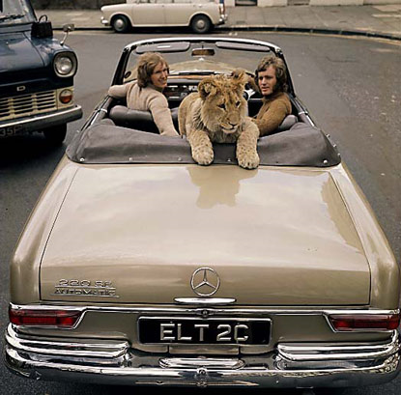

LONDON — The “Christian the lion” video, which shows a full-grown lion hugging and kissing his former caretakers in a heartwarming reunion, has become an Internet sensation, logging more than 4 million views on YouTube.
According to the Los Angeles Times, the video has all the right ingredients of a smash hit: The lion’s menacing slink towards the camera, then the look of recognition on its face as it lunges towards the young men to embrace them, with Whitney Houston’s I Will Always Love You playing in the background for full sentimental effect.
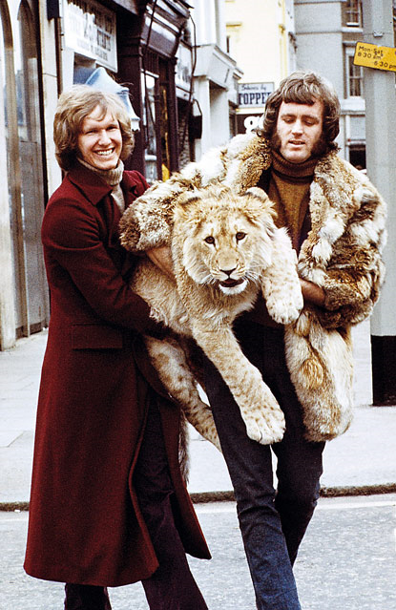
While walking through London's Harrods department store in 1969 which sold exotic animals, Ace and John spotted two lion cubs for sale. Passing on the female cub, they purchased the male weighing 16 kg at the time. Harrods happily agreed to part with the cub for 250 guineas, because he was becoming too much of a handful for the department store. Just the night before he had escaped and wreaked havoc in the carpet department.
Inspired by the Bible and a sense of humor, Ace and John named the lion “Christian", and kept it in their living room. They became local celebrities, the Daily Mail said, parading the cub around London, taking it to restaurants and even playing football with it. Using their tone of voice, they trained Christian about what was appropriate and what wasn't.
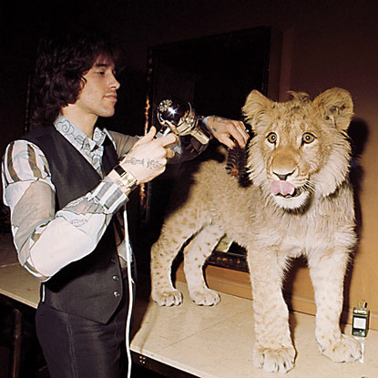
“He could tell by the tone of our voice,” John explained. “He knew that we wanted him to calm down, not now, let’s go, that sort of thing. We were very fortunate that we got it right. We ended up with a wonderful animal. He never bit anybody.”

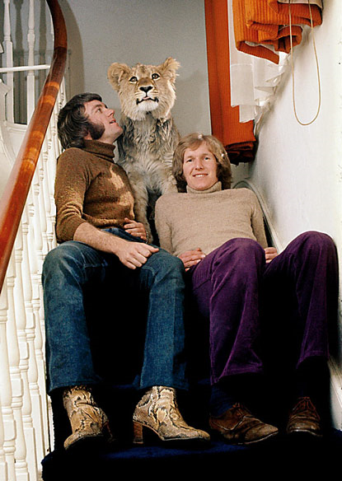
But Christian soon grew to 84 kg and his food bills became exorbitant. Also, they weren’t worried about Christian attacking anyone. It was more that he was so big he could break a window just by leaning on it. They knew the lion couldn’t stay with them much longer.
With the help of George Adamson known as "Lion Man," Christian was taken to his new home in the wilderness of Kenya, East Africa. When the two friends felt sure Christian had a new family and a safe territory, they went back to their lives in London. One year after releasing Christian into the wild, John and Ace traveled to Kenya to check on him.
The men were told the lion would probably not recognize his old caretakers. But as the video shows, Christian not only recognized them, but ran to them and hugged them. He even introduced them to his wife, as if they were old friends.
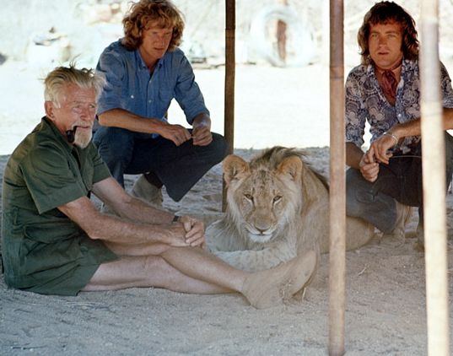
“Christian stared at us in a very intense way,” Ace was quoted by the Daily Mail as saying. “Then, as if he became convinced it was us, he ran towards us, threw himself on to us, knocked us over, knocked George over and hugged us, like he used to, with his paws on our shoulders.
The next day, Christian walked back into the bush, where his lionesses and cubs were waiting. He was never seen again — but the power of the Internet guarantees that he will never be forgotten.
______________________________________________________________________________
Vocabulary

cub - young wild animal such as a lion, wolf, or bear.
smash hit - very popular show, play, or song.
menacing - Acting in a way that is dangerous or threatening to someone else
slink - move quietly and secretively.
lunge - move in that direction suddenly
handful - difficult to control

Question Worksheet
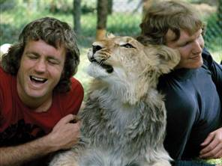
1. What was the song title in the background music of the video played on Youtube?

2. Where did Ace and John buy the lion cub?

3. Was it legal to buy exotic animals in London in 1969?

4. Where did the name ‘Christian’ come from?

5. Why did they decide to release Christian into the wild?

6. Where did they send him to?

7. Why did George say that Christian might not recognize his old caretakers?

8. Why didn’t Christian attack them when they met again in Kenya?

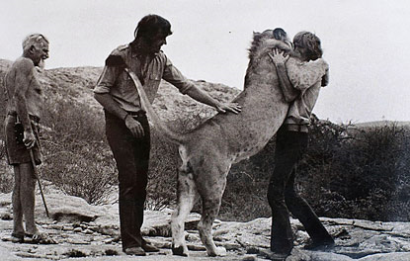
9. They could send Christian to the zoo. Why do you think they sent him to the wild?

10. Would you keep a lion or lioness cub at home if it were legal in Korea?

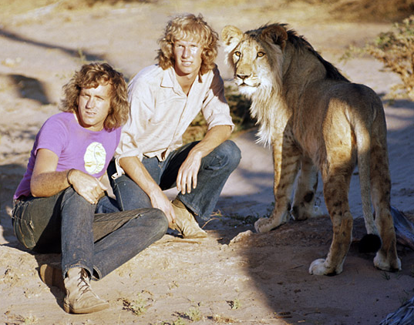
11. If you had to buy a wild animal, what would you buy? And, why?

Vocabulary worksheet

Select the correct meaning for each word.

cub ____

smash hit ____

menacing ____

slink ____

lunge ____

handful ____

- Acting in a way that is dangerous or threatening to someone else

- Young wild animal such as a lion, wolf, or bear

- Difficult to control

- Very popular show, play, or song

- Move in that direction suddenly

- Move quietly and secretively

Essay sheet
Draw a picture of your favorite animal, and describe why you like it. (150 words)

Christian “On TV”
Christian the lion explores his new home, a flat above Sophisticat furniture store on King’s Road in London, England.
---------------------------------------------------------------------------------------------------------------------
Christian selects an outfit
Christian the lion discovers a drawer full of clothing in John and Ace’s flat on th King’s Road.
--------------------------------------------------------------------------------------------------------------------
Christian the lion with one of his favorite toys: a waste paper basket.
“He loved toys,” recalls John, “he loved waste paper baskets; you could chew it, shred it, and wear it on your head…”
--------------------------------------------------------------------------------------------------------------------
Christian’s Favorite Spot
Christian the lion on his favorite spot on the stairs, joined by John and Ace.
---------------------------------------------------------------------------------------------------------------------Christian the lion ponders Easter chicks.
It was an amazing situation because we thought that a great big paw was going to come down on this poor little chick, y’know, but none of it. He was so gentle.
---------------------------------------------------------------------------------------------------------------------
Christian the lion is fascinated by a young boy in London. He was like another person.
---------------------------------------------------------------------------------------------------------------------
Christian the lion wrestles with John at a country estate 30 miles outside of London, the closest the cub had ever been to the wild.
---------------------------------------------------------------------------------------------------------------------
Christian the lion’s first steps at Kora Nature Reserve, his new home in Africa. Ace and John keep an eye out for crocodiles.
------------------------------------------------------------------------------------------------
Christian the lion keeps a watchful paw on John during his first night in Africa.
“The first night in Africa was a bit embarrassing really,” remembers John. “Well of course he slept on one of the beds, with a pillow!”

