Reading Lesson Plan
(The Legend of King Arthur)

Lee, Chang Ho
Kim, Ju Hee

Times Media TESOL, Class #39
Instructor Diane Gardner-HoFatt
May 27, 2009

Reading Lesson Plan

The Legend of King Arthur

Instructor:
Chang H. Lee
Ju-Hee Kim (Judy)
Level:
Pre-intermediate
Students:
12 students
Length:
50 minutes

Materials:
- White board, some markers (black, red, blue → one for each color)
- Pictures of “The Legend of King Arthur” (3 sets of copies, A set of Big pics for T)
- Reading materials (12 copies)
- Reading Questions (12 copies)
- Post activity Worksheets (12copies)
- Picture of Zorro (1 copy)

Aims:
- Students will learn what legend is.
- Students will practice skimming and scanning through the reading.
(The Legend of King Arthur)
- Students will make their time line.
- Students will learn about Key vocabulary.

Language Skills:
  - Speaking: discussion, T → S response, S → T response, S → S response
  - Listening: discussion, T → S response, S → T response, S → S response
  - Writing: Time line worksheet, Answering literal questions
  - Reading: Story of King Arthur, Worksheets

Language Systems:
- Functions: Using past tense for what has happened in the past.
- Lexical: Key vocabulary (Legend, Castle, knight, battle, sword, wizard)
- Grammar: Simple past tense

Assumptions:

- Students already know past simple ( regular/ irregular verb)
- Students will naturally use past tense when they talk about their time line.
- Students know how to tell dates in English
- Students can read simple articles

Anticipated Errors and Solutions:

- Students do not have strong vocabulary background
→ Pre-teach some key vocabulary
→ Ss can understand reading by guessing from the context.

- Students may make mistakes on (past tense, incorrect answers for reading Q.)
→ I will give error correction for grammar if Ss make common mistakes.
(Only after group discussion in post activity)
→ I will let Ss to reread particular sentences to enhance reading comprehension.

- If I am running out of time, during post activity
→ I will not ask every Ss to share their life time line.

- If I have extra time during post activity
→ I will try to share every Ss’ life time line.

References: adapted from American Cutting Edge Level 1 (Longman module 10) pg 86-87.

Pre-Activity
Materials: Picture of Zorro, Pictures of story (3 sets), White board, Markers
Time  3 min  7 min  2 min  3 min | Set Up  Whole class  Whole class  Whole class  Groups | Procedure:  - Introduce topic  T: Are you guys having good time?  T: Do you know this person? (hold up the picture of Zorro)  T: Who is he? (Zorro)  T: What do we know about him?  A: famous, hero, helped poor people  T: Is the story about Zorro true or not?  S: Yes it can be true or Not.  T: what do we call this kind of story?  S: History /Legend  T: History → Somebody recorded the truth in the book  Legend → It’s not recorded,  but it was delivered by people to people.  T: Today we are going to read about The Legend of King Arthur. (Write the topic on board)  - Pre-teach vocabulary  T: I want you to form in groups  (divide Ss into 3 groups of 4)  T: Here are some pictures of the story about King Arthur.  (Pass out the one set of pictures to each group)  T: Elicit vocabularies from picture.  (List of vocab: Castle, knight, battle, sword, wizard)  Castle (pic #2)  T: What building do you see at the back?  S: Castle, kingdom, house, etc.  T: Very good! Who lives in this place?  (I will try to elicit.)  S: Castle (If not said correctly → give the word)  Sword (pic #1)  T: Someone is holding something in the picture.  What do we call this thing? (knife)  T: Okay very close but it’s bigger and longer than knife.  What do we call it?  S: Sword (If not said correctly → give the word)  Battle (pic #3)  T: People are fighting in the picture.  They are fighting to take someone’s land.  What do we call this kind of fight?  S: Battle (If not said correctly → give the word)  Knight (pic #6)  T: You can people around table.  They are talking about tomorrow’s fight.  What do we call these people?  S: Solders → very good  T: However, these people carry swords and ride horses.  What is another word for solders?  S: Knight (If not said correctly → give the word)  Wizard (pic #5, #2)  T: A person is wearing a hat. What do we call this person?  He has a magical power.  S: Magician → Good but we say wizard  (Repeat the new words with Ss)  - Concept Checking Questions  Does the Knight ride horses? → YES  Does the King live in the castle? → YES  Does wizard have magical power? → YES  Is a sword a long knife? → YES  Do people fight for land in the battle? → YES  - Prediction  Instruction  In your group, please put the pictures in order. After you put pictures in order, I want you to think what the story is. Think about what happens in the story. I will give you 3 minutes.  CCQ  - What are we doing first?  (We have to put the pictures in order.)  - Then what do we do?  (We think about what happens in the story.)  - For how long? (3 minutes)  Discussion (Predictions aren’t confirmed.)  T: What is your first picture?  - Okay! Then what’s next? → next → next etc  - If Ss have different ideas, then share their story.

Main Activity
Materials: Reading materials (12 copies), Reading questions (12 copies)
Time  5 min  2 min  5 min  5 min  5 min | Set Up  Groups  Whole class  Individual /  Groups  Groups  Groups | Procedure:  - Checking Prediction  T: Let’s check our story by reading Arthur’s story. Read individually, I will give you 3 minutes to read through the article. In your group, discuss with partners to put the pictures in correct order.  CCQ  What are you going to do?  Who are you working with?  How many minutes do you have?  T: Okay, time! Tell me the correct order. Which picture is the first, and the second, and etc?  (If there’s a mistake, give them 1 minute to read again and check the answer again.)  (Check the answer until they have correct order)  - Checking Main Idea (Skimming)  (Q: How did he become a great king?) → Write on board  T: Can you answer this question?  (If Ss can’t answer, let them read the article again.)  T: Let’s read the article again. I will give 1 minute to read through the article to find the answer for the question.  → If they can answer the question, share their ideas.  - Literal Questions (Scanning)  Please read through the reading. I am going to give out worksheets. I will give you some questions and you will answer these questions individually first. When you finish, check the answers in your group. I will give you 3 minutes.  (Hand out the reading question worksheets)  CCQ  What are you going to do first?  What do you do next?  How many minutes do you have?  Checking Answers  (If Ss answer it wrong, let them reread for a minute)  - Was Arthur a Scottish king or English king?  (English king)  - Where was Arthur born?  (Castle of Tintagel)  - What was the name of Arthur’s sword?  (Excalibur)  - When did Arthur find his magical sword?  (Fifteen)  - Who helped Arthur to become a king?  (Merlin)  - Where is a famous Round Table?  (Castle of Camelot)  - Was the sword disappeared?  (Yes)  - Did he die in the story?  (No)  Error Correction  (If Ss don’t give a correct answer, I will tell them particular sentences to reread. Then I will check the answer again.)  - Interpretive Questions  T: Here is another question for you.  Why do you think Merlin raised Arthur instead of his parents? (Write it on board)  Please think about this question in your group and discuss why Merlin raised Arthur. I will give you 3 minutes.  (T monitors about Ss’ activity and make note on common mistakes.)  CCQ  What are you going to do first?  What do you do next?  How many minutes do you have?  Checking Answers  Okay let’s share some of your ideas.  (Ss response to T)  There is not correct answer. You did good job.  - Applied Questions  T: If you were Arthur, how would you save your kingdom instead of throwing the sword? (Write it on board)  Please think about this question in your group and discuss how you would do differently. I will give you 3 minutes.  (T monitors about Ss’ activity and make note on common mistakes.)  CCQ  What are you going to do first?  What do you do next?  How many minutes do you have?  Checking Answers  Okay let’s share some of your ideas.  (Ss response to T)  Very good! You guys have great imagination.
Post Activity
Materials: Time line worksheets (12 copies)
Time  5 min  3 min  5 min | Set Up  Individual  Groups  Whole Class | Procedure:  Instruction  You have read about Arthur’s life time. Now you are going to talk about your life time. I will hand out the worksheet where you will fill out your life time. You will see Chang’s time line as an example. Think about interesting events in your life and fill out the chart. Work for 5 minutes individually.  CCQ  What do we do?  Do you work alone?  For how long?  (Look around the class and help Ss if they need help)  (Check whether Ss finish their time line)  (If not finished be flexible and give an extra minute)  Instruction  Okay class! Time! I think you have finished your time line. I want you to share your work in your group.  (The same group which was in reading activity)  Tell your story to your group members. I will give you 3 minutes to share your story.  CCQ  What do you share in your group?  How much time do you have?  (Look around the classroom to have active communication)  (T monitors about Ss’ activity and make note on common mistakes.)  Error Correction  (Tell Ss about common errors)  Tell Ss about the notes I took during Ss’ discussion activity.  Sharing Stories in Class  Let’s share your story to the class. Does anybody want to share your story? (choose one person if nobody volunteers)  (Don’t ask every Ss to tell their story if I am out of time)  Did you guys have good time?  I hope you enjoyed today’s reading.  I will see you tomorrow.

The Legend of King Arthur

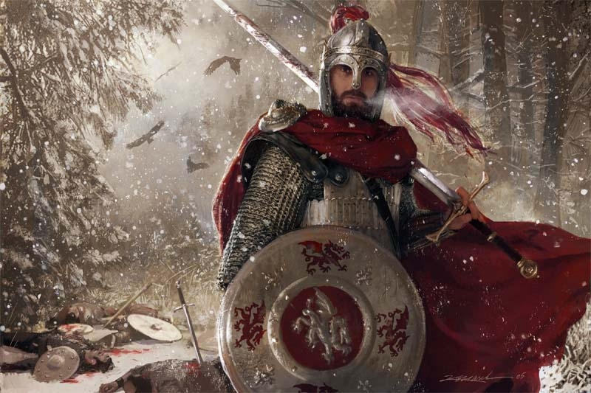
King Arthur was born at the Castle of Tintagel, in England. Arthur was raised by a wizard Merlin. Merlin became Arthur’s friend and teacher. He taught Arthur everything he needed to know to become king. One day, when Arthur was fifteen, he went out with Merlin. They were near a lake when they saw the white arm of a lady in the water. In her hand there was a magic sword, Excalibur. The Lady of the Lake gave the sword to Arthur. Everyone knew then that he was their next king. With the help of Excalibur, Arthur became a good knight and a great king. He lived in the castle of Camelot, where there was a famous Round Table. There Arthur and his knights sat to talk about their battles. One day, in a terrible battle against the forces of evil, Arthur was badly wounded. As he lay dying, he told one of his men to throw Excalibur back into the lake, and the hand of the Lady of the Lake took back the sword. Excalibur disappeared forever. However, his wound was healed, and the evil forces were disappeared.

Reading Questions
(※ Answer these questions individually after reading the article.)

- Was Arthur a Scottish king or English king?

- Where was Arthur born?

- What was the name of Arthur’s sword?

- When did Arthur find his magical sword?

- Who helped Arthur to become a king?

- Where is a famous Round Table?

- Was the sword disappeared?

- Did he die in the story?

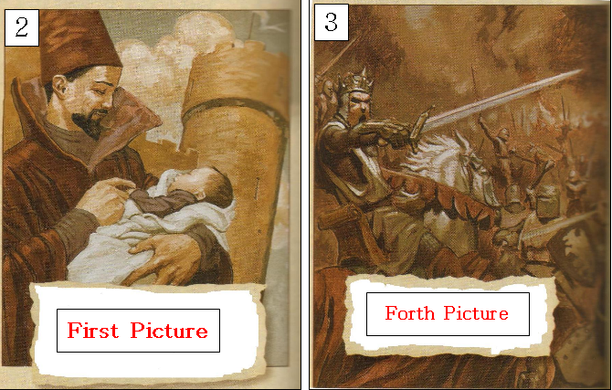
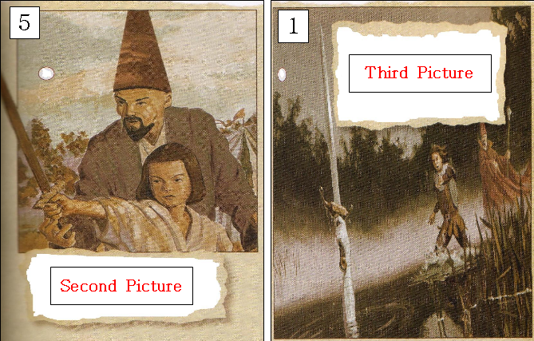
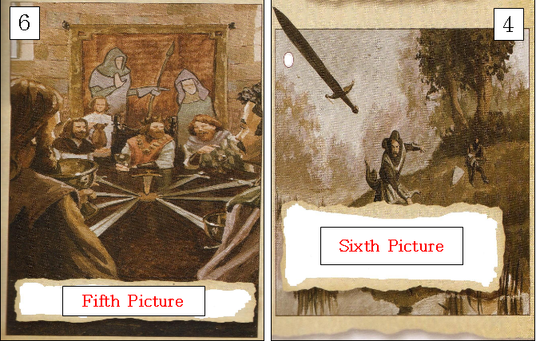

Correct Order is (2 → 5 → 1 → 3 → 6 → 4)

Life Time Line
※ Below chart is the Chang's life time line
1976 | 1979 | 1982 | 1989 | 1993 | 2001
Age 1 | Age 4 | Age 7 | Age 14 | Age 18 | Age 26
I was born in Milan. | My brother was born. | I started school. | My family moved to London. | I travelled to Africa. | I got my first job.

※ Fill in the Below chart with your life events to create your own time line. When you finish filling the chart, share your life time line with your partner.
Age | Age | Age | Age | Age | Age



