Speaking Lesson Plan

Instructor:
Tarry, Natasha
Tarry
Ta
Tarry
t
Tarry

Level:
Beginners
Students:
12

Length:
50 min

Topic : How was your vacation?

Materials:
Pictures (x6)
Model dialogue (x12), worksheet (x12)
Task cards (x12), white board & markers, papers.

Aims:
-Ss will ask and describe past experiences using the simple past tense.
-Ss will work in groups, make stories, and share them together.
-Ss will speak while discuss in a group and practice model dialogue.
Language Skills:
Speaking: Prediction, dialogue, pair work, answering, group discussion
Listening: To the teacher, each other
Writing: Fill the circle on the worksheets, task cards while they make stories.
Reading: Dialogue, comprehension with worksheets, partner’s cards in groups.

Language Systems:
Functions: Sharing experience and information with group, discussing.
Grammar: Regular & irregular verbs, the Past simple tense (was /were…..)

Assumptions:
- Ss know the grammar – past simple tense.
Ss have experience and information about vacation
Ss are familiar with doing activities individually and in groups.
- Ss know regular & irregular verbs.

Anticipated Errors and Solutions:
- Ss may not able to understand the key vocabulary
(Repeat explanation of the meaning and give another example)
- Ss may not understand the instruction of the activities well
(Repeat instructions and do CCQ again).
- Ss may not have experience about vacation
(Let Ss imagine and tell them some example).
- Ss might not make interesting sentences on their task cards.
(Encourage them to use their imagination, make it interesting.)

References:
Adapted from Firsthand-1, 2007 Marc Helgesen, Steve Brown, Tom Mandeville.
http://wwp.greenwichmeantime.com/time-zone/usa/image…

Lead - In
Materials:
Time  2 min. | Set Up  Whole class | Procedure:  -Greeting-  Hello everybody! How are you?  Did you have a nice week? What did you do?  (Ask the Ss. Let them answer.) Wonderful!

Presentation (8)
Materials: white board, marker, pictures, worksheet (Model dialogue)
Time  5mins  3min | Set Up  Whole  class  Whole class | Procedure:  I. Elicitation (Guessing about the subject)  Introduction  -Provide pictures.  -Tell Ss think about the pictures.  -Elicit regular verbs and irregular verbs from Ss.  Demonstration  Summer is here. What do you look forward to during summer? (vacation)  Did you have good times on vacation?  Look at the picture! How do you feel ?  When you go on vacation, what do you do?  (visit, go, eat, watch…….)  Remember your last vacation?  Where did you go? What did you do?  (visited, went, ate, watched…-write past simple tense on the board).  Give me more another examples.  II. Elicitation ( Introduce the topic)  Instruction  -Get Ss elicit regular verbs and irregular verbs.  - Tell Ss make a sentences with verbs (use past simple verbs)  -write on the board.  -Ask when the past tense is to be used.  -Ask some Ss to speak a sentence what they made.  Demonstration  How can you change the verb to the past simple?  eg. Go –went, visit- visited, eat- ate, watch-watched…)  How do you call these verbs?  Why do you call them regular verbs/ irregular verbs?  Can you think about more regular verbs and irregular verbs?  Ok now you can make a sentence with these verbs.  eg: I went to Canada for vacation.  I ate some delicious food in the restaurant.  We visited Rome.

Practice (20)
Materials: Model dialogues (x12), worksheets (x12), task cards (x12)
Time  5min  5 min  10 min | Set Up  Individually  pairs  Individually  Pairs  Whole  class | Procedure:  I. Controlled  Instruction  -Tell Ss that they are going to read a dialogue individually  and then practice with a partner.  -Demonstrate intonation.  -read it once and then change roles.  -give Ss 5min.  -Let them practice the dialogue.  - monitor Ss and do error correction.  -(Provide dialogues for Ss)  Demonstration  Now you are going to read a dialogue individually and when you finish it, read the dialogue with your partner with emotions and intonations.  And then change role.  You have 3 minutes.  CCQ  What are you going to do first?  Are you working alone?  What are you doing together?  How are you reading the dialogue? (Emotionally)  How much time do you have?  II. Less controlled  Instruction  -Demonstrate what Ss have to do.  -Let Ss think of a vacation or trip they took.  - (Provide worksheets)  -Tell Ss to fill in the circle on the worksheet in each one.  -Allow Ss time to think and do the task.  -Tell Ss to ask the partner using questions in the circle.  - Find out about partner’s trip.  -Change roles.  ( partner ask at least 5 questions).  -Give them 5 min.  Demonstration  (Draw the design on the board and write a few notes in the circles. Give a sample of the story.)  Look at the circle! I will give you an example of my story.  Then my partner will ask me the questions in the circles.  After that change roles.  Now think about your vacation or trip you took.  I will give you worksheets. You can fill the each circle and talk about your vacation with your partner.  Partner has to ask at least 5 questions.  I will give you 5 min.  CCQ  What are you going to do first? Then…?  Who are you working with?  How much time do you have?  III. Free -<Your past>  Instruction  -Give Ss a piece of paper and ask them to write  interesting true items. (Give them 1 min.)  -Tell Ss not to show the other students what they are writing.  - When they have done that ask them to make a circle.  -Mix their cards together and place them face down on the table in the middle of circle.  -Ask Ss take turns choosing a card and read it aloud then guess who wrote it.  -Give a point if someone guesses right.  -The student who guesses correctly must ask a follow –up question.  Demonstration  Now I am going to give a piece of paper. You can write down one interesting item about your past.  Don’t show the other students what you are writing.  And when you have done that make a big circle.  Then place your card face down on the table in the middle of circle.  Take turns choosing a card. If someone picks their own,  They return it and if they pick someone else’s, they must read it aloud. Then they can guess who wrote it. If you are right, you can get a point.  If you are wrong, the next person can guess.  The person who guesses correctly must ask a follow-up question to elicit details.  CCQ  What are you going to do first?  Where do you have to write about your past?  Are you working alone?  What do you guess?

Production (20)
Materials: papers
Time  15mins  5mins | Set Up  Groups  Whole class | Procedure:  Instruction  - make 4 groups.  - Let Ss discuss about their last special vacation.  - Ask Ss to make a story using their experiences  With simple verbs in the past tense.  - Give them 10min.  - Let each group give a story presentation.  Demonstration  Let’s make 4 groups.  You are going to discuss your last special vacation in a group. Make up a story by using your experiences together. When you write a story you can use past simple verbs.  When you finish it, you have to give the story presentation.  You have 10 min.  CCQ  What do you have to do first?  What are you going to discuss?  Which tense do you have to use when you make up a story?  What are you going to do last?  Feedback  Check their story and do error correction if necessary.  Assignment  Let Ss to write about their last weekend.  Conclusion  Today we talked about your last vacation. And we learned about past simple verbs.  All of you did a good job today!  Have a good day everyone. See you next time.

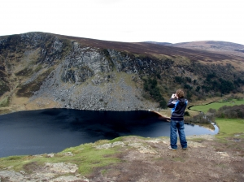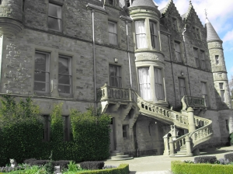

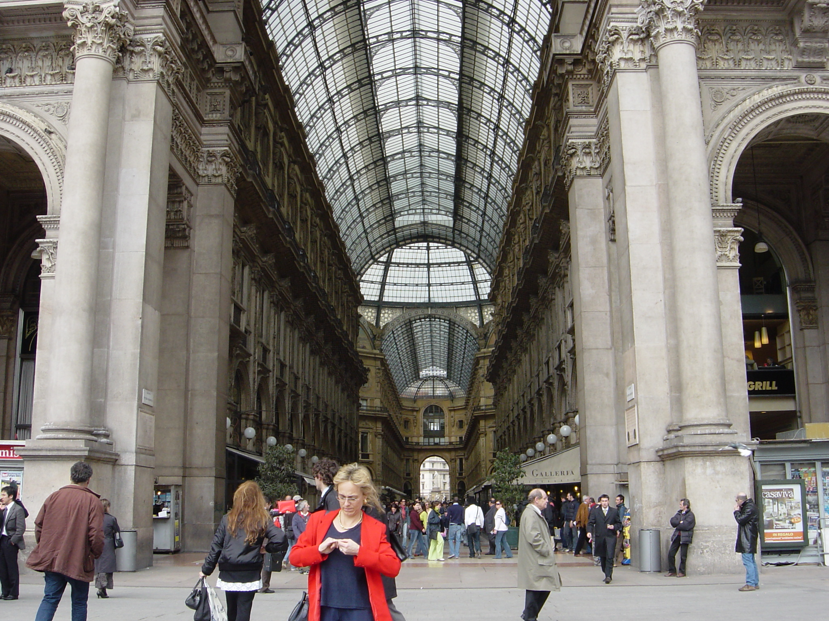

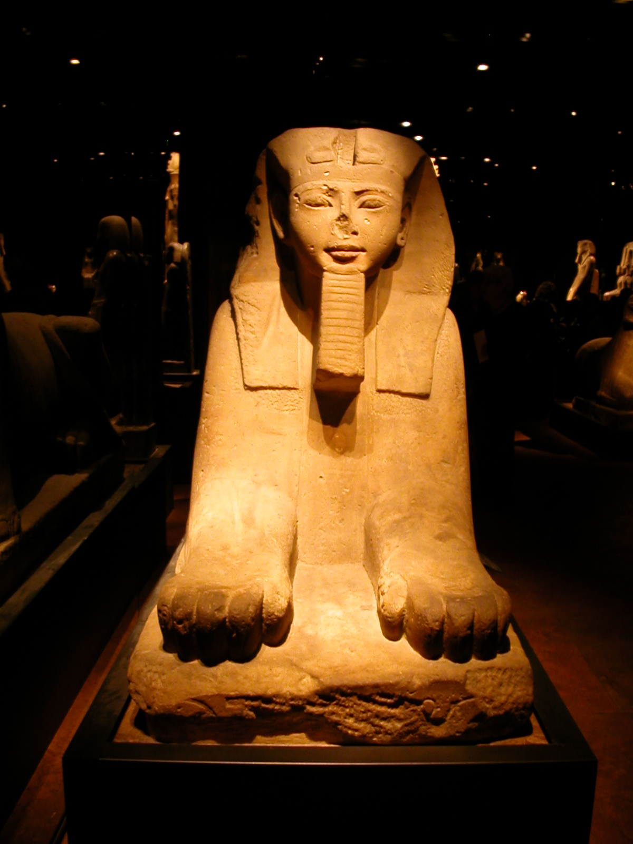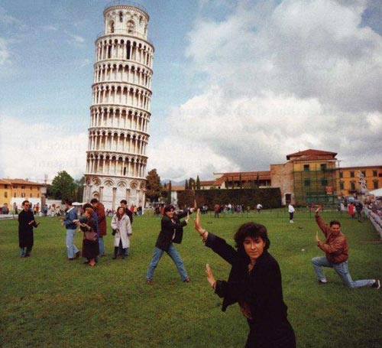

Model Dialogue

A: Hi, How was your vacation?
B: Pretty good.

A: Where did you go?
B: I went to San Francisco.

A: Really? You were lucky. Who did you go with?
B: I went with a friend.

A: What did you do there?
B: I went to Golden Gate Park. It was great.

A: What did you visit there?
B: I visited Chinatown. The food was wonderful.

Model Dialogue

A: Hi, How was your vacation?
B: Pretty good.
A: Where did you go?
B: I went to San Francisco.
A: Really? You were lucky. Who did you go with?
B: I went with a friend.
A: What did you do there?
B: I went to Golden Gate Park. It was great.
A: What did you visit there?
B: I visited Chinatown. The food was wonderful.

Model Dialogue

A: Hi, How was your vacation?
B: Pretty good.
A: Where did you go?
B: I went to San Francisco.
A: Really? You were lucky. Who did you go with?
B: I went with a friend.
A: What did you do there?
B: I went to Golden Gate Park. It was great.
A: What did you visit there?
B: I visited Chinatown. The food was wonderful.

Model Dialogue

A: Hi, How was your vacation?
B: Pretty good.
A: Where did you go?
B: I went to San Francisco.
A: Really? You were lucky. Who did you go with?
B: I went with a friend.
A: What did you do there?
B: I went to Golden Gate Park. It was great.
A: What did you visit there?
B: I visited Chinatown. The food was wonderful.

Where did you go?



